Layout for Voizfonica software

Front page

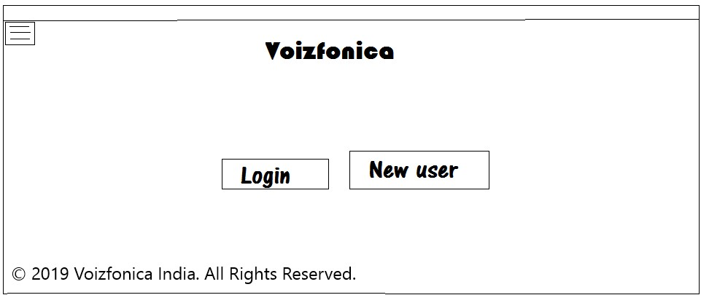

Existing user login

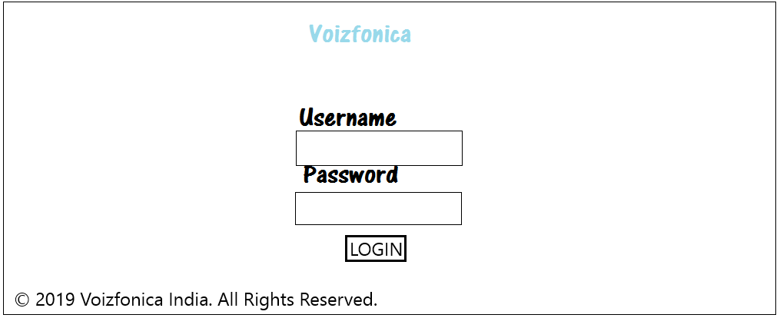

Create new account

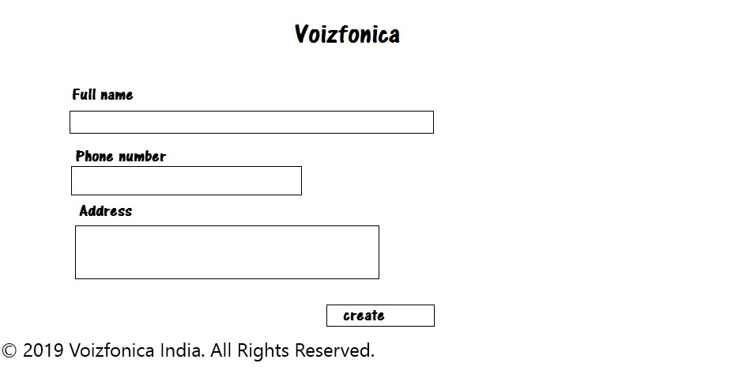

Menus

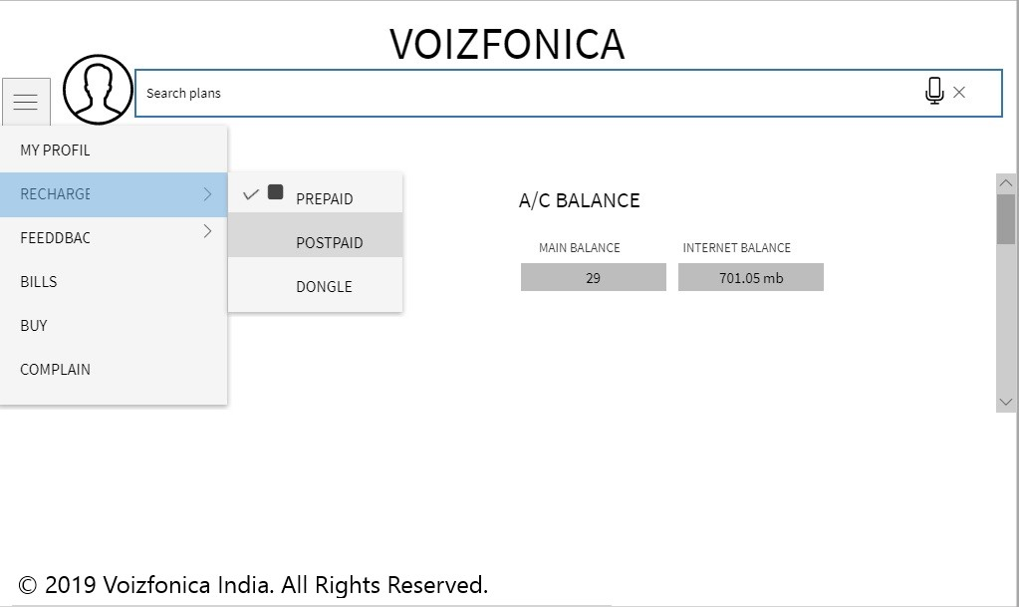

User profile:

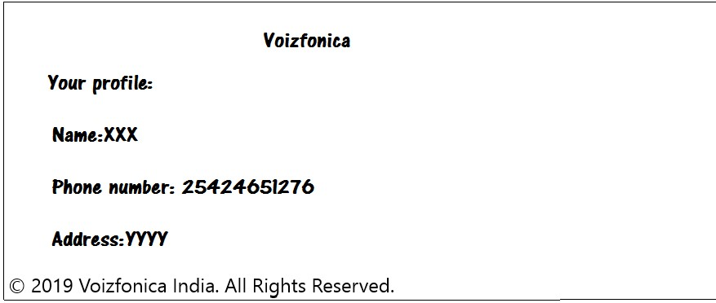

Recharge->Prepaid

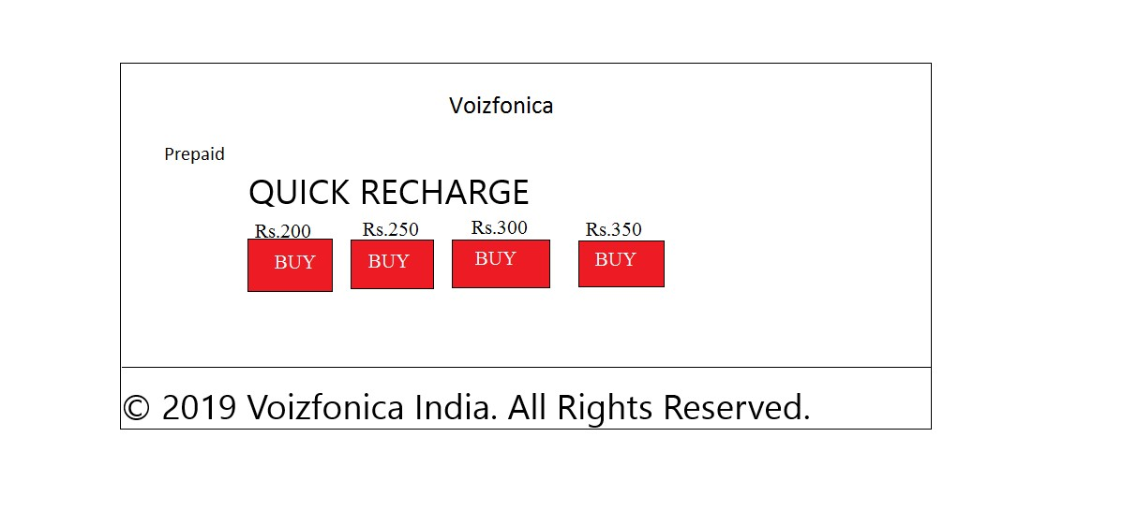

Recharge->Post paid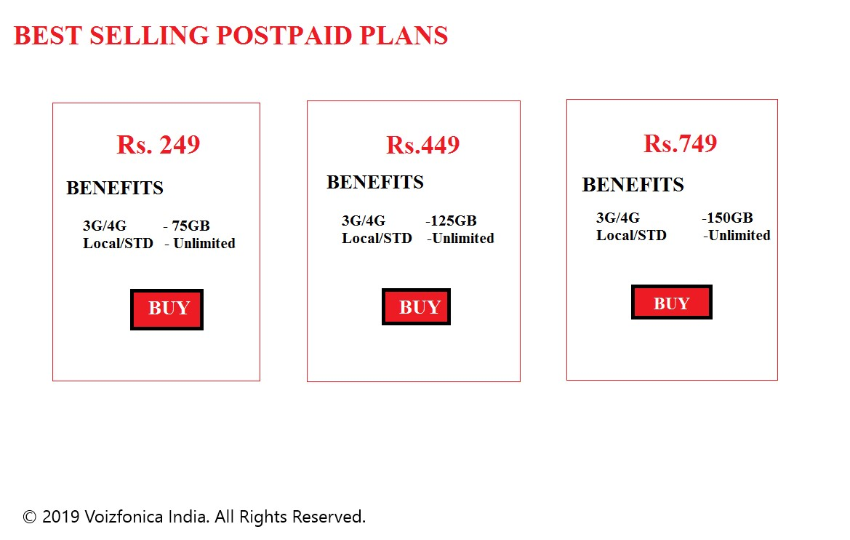

Recharge->Dongle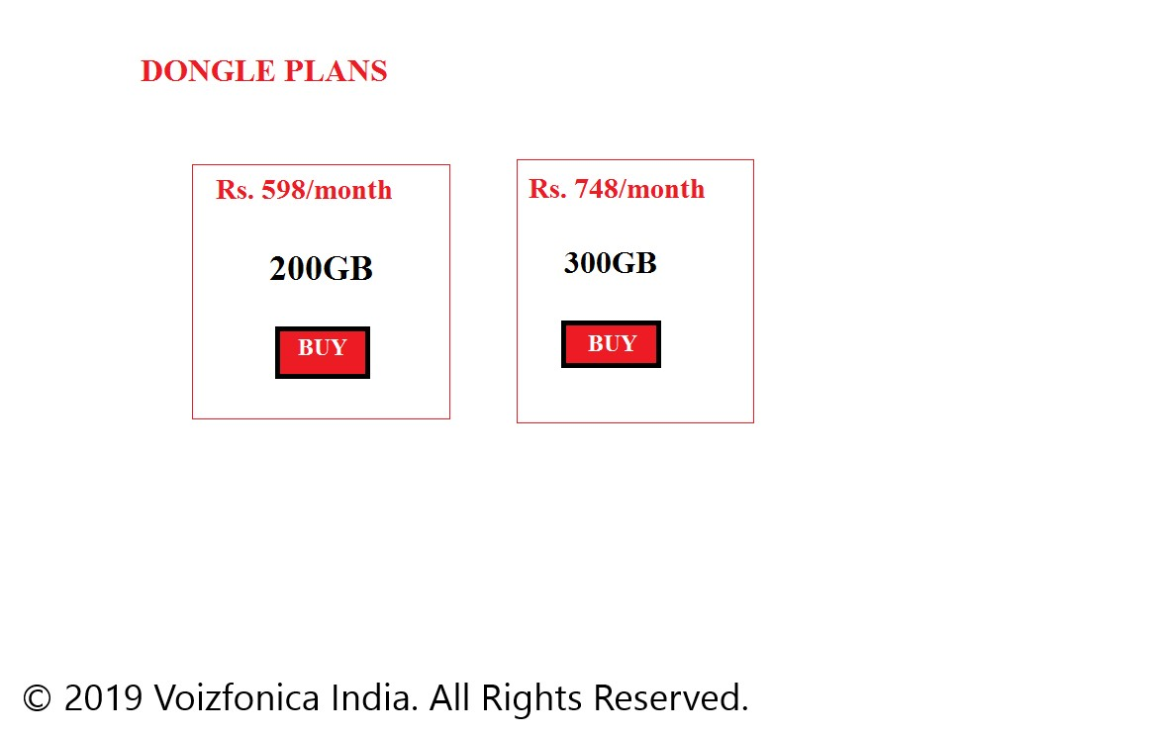

Feedback

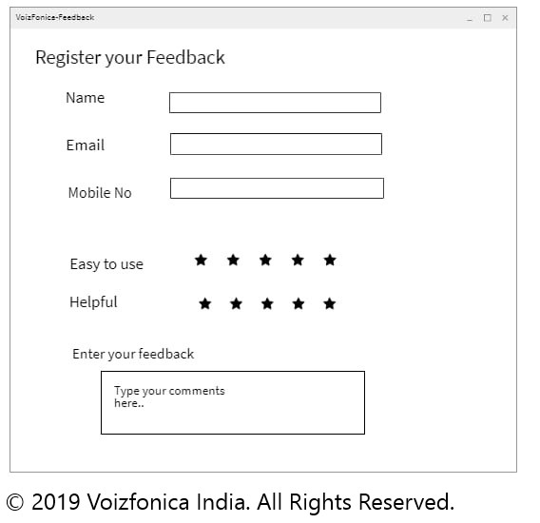

Bills

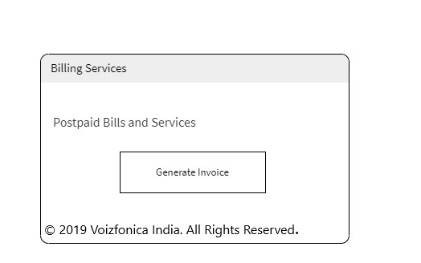

Buy

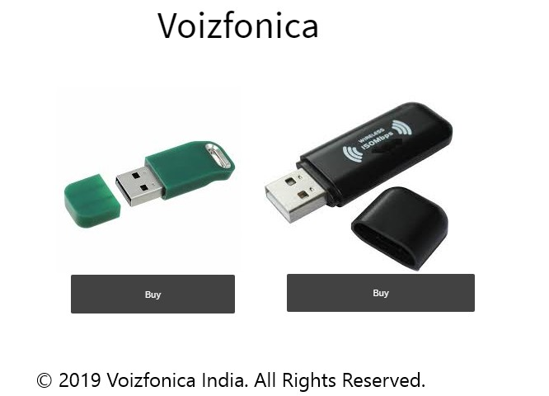

Complaints

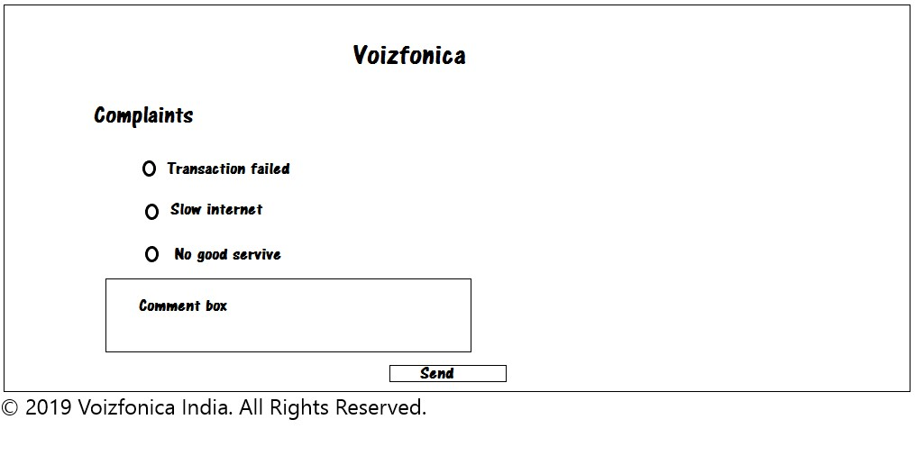

Software requirements:

* Front end: HTML,CSS,AngualrJS,Bootstrap.
* Back end: Java framework,Spring,SQL Database.

Hardware Requirements:

* Operating System:Windows.
* Server requirements for developer, QA.
* Processor (CPU) with 2 gigahertz (GHz) frequency or above.
* A minimum 4 GB of RAM.
* Monitor Resolution 1024 X 768 or higher.
* A minimum of 20 GB of available space on the hard disk.
* Internet connection with a speed of 4 Mbps or higher.