**LAMP INSTALLATION**

**ON VIRTUAL BOX**

Guided by: Submitted by:

Ms. ANKITHA PHILIP VISHNU

Dept. of Computer Application RMCA_B_Batch

Amal Jyothi College Of Engineering Roll No : 50

**LAMP INSTALLATION PROCEDURE**

**Step 1: Install oracle virtual box.**

Download link : <https://www.virtualbox.org/wiki/Downloads>

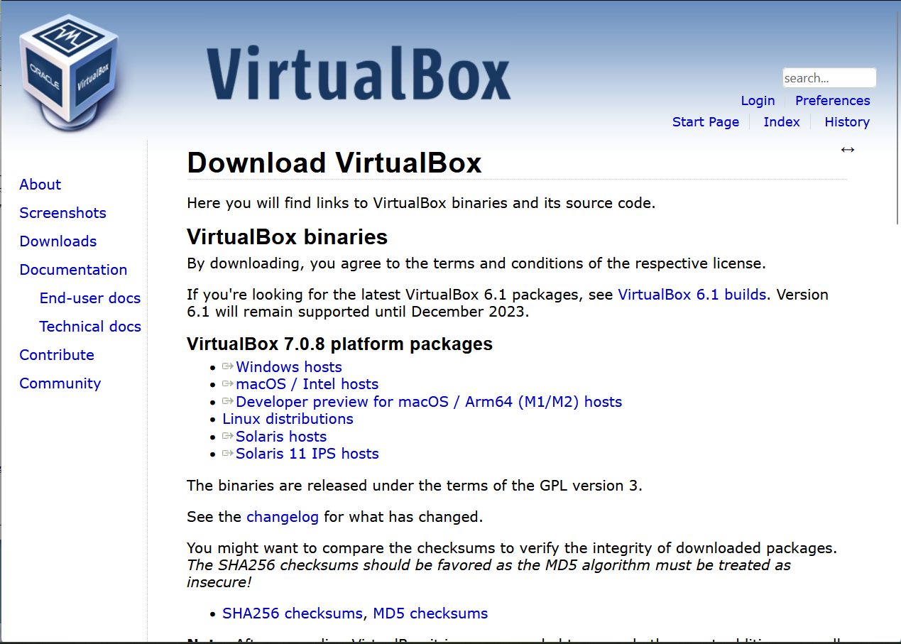

**Step 2: Create new virtual machine in oracle virtualbox.**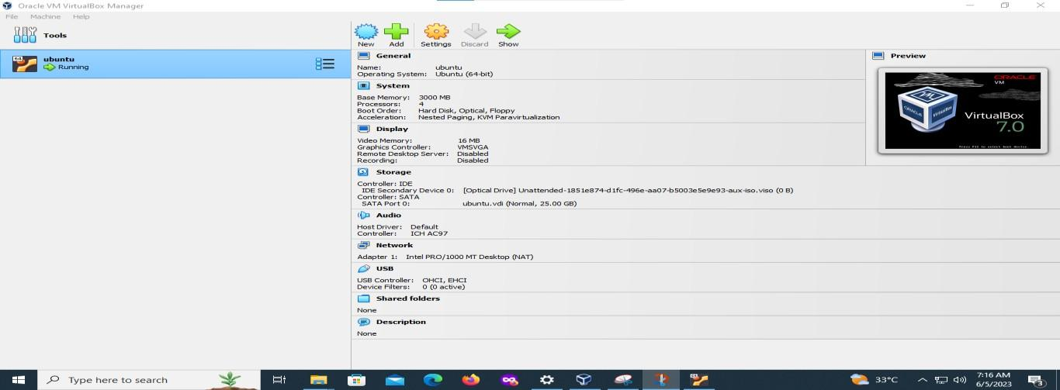

**Step 3: virtual machine configuration.**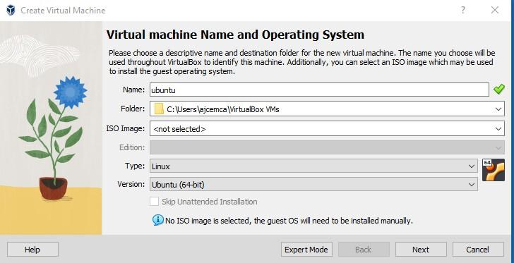

**Step 4: install ubuntu.**

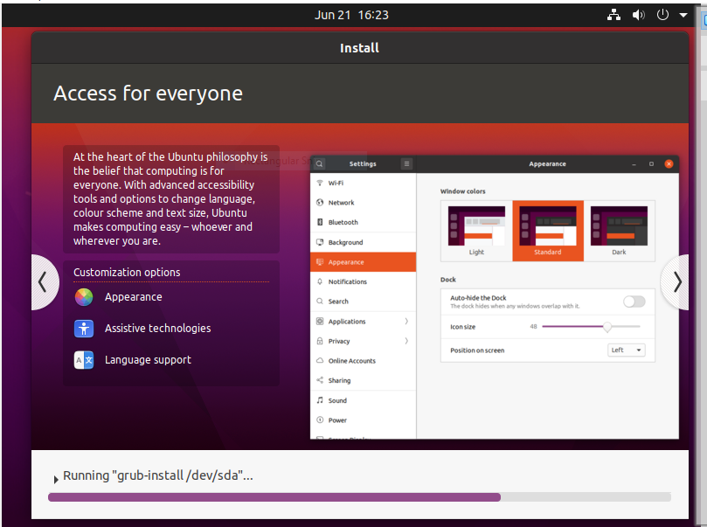

**Step 5: Set virtual machine(ubuntu) on running mode.**

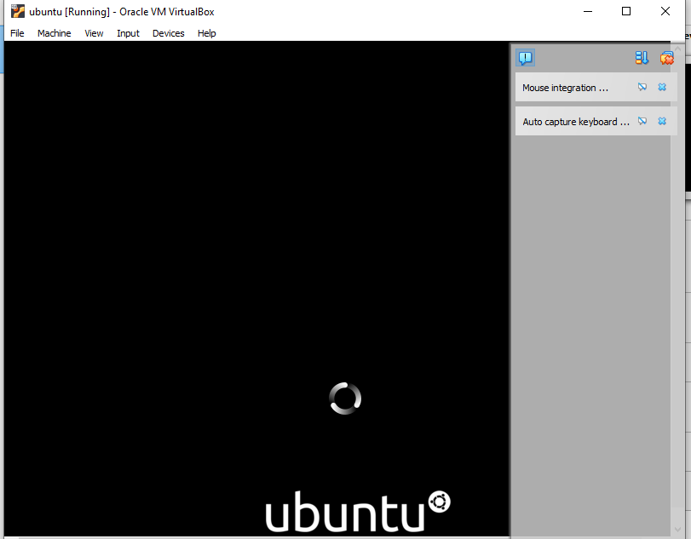

**Step 6: Sign in to your Linux console.**

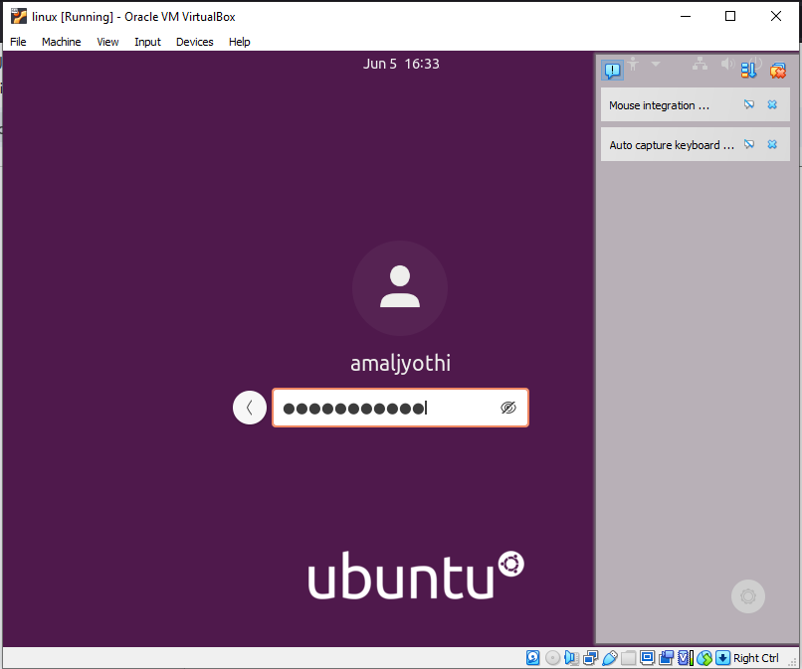

**Step 7: Open Linux terminal and switch to super user.**

**Command: sudo su**



**Step 8: Update package index files on the system.**

**Command: sudo apt-get update**

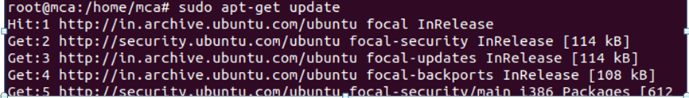

**Step 9: install Apache2.**

**Command: sudo apt-get install apache2**

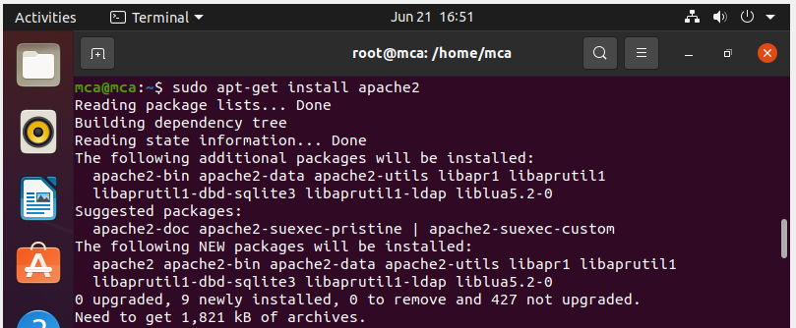

**Step 10: Post successful installation, Apache starts automatically. To manually start apache, we can use the following command;**

**Command: sudo service apache2 start**

**Step 11: Check the status of the apache web server, including whether it is running or not.**

**Simply we can open any browser and search for localhost, it shows the current status of apache web server.**

**Command: sudo systemctl status apache2**

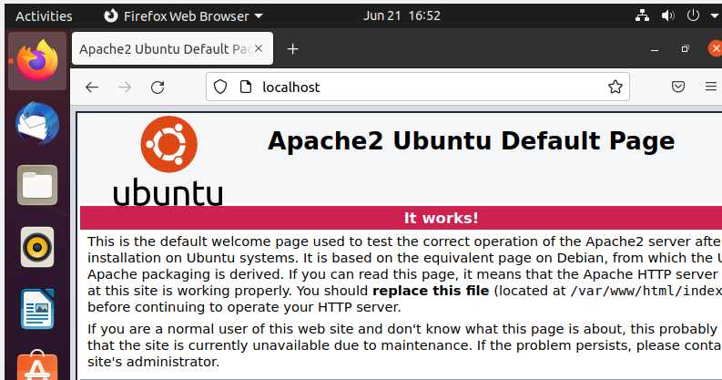

**Note: Apache Installation Complete…!**

**Step 12: Install mysql.**

**Command: sudo apt-get install mysql-server**

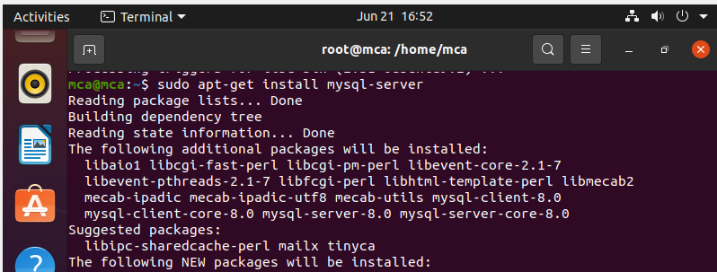

**Step 13: Display mysql server status.**

**Command: systemctl status mysql**

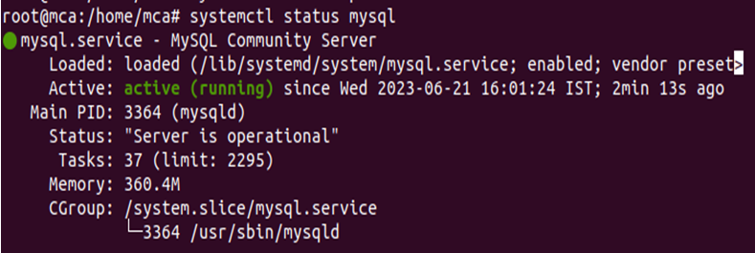

**Step 14: Start mysql service.**

**Command: mysql**

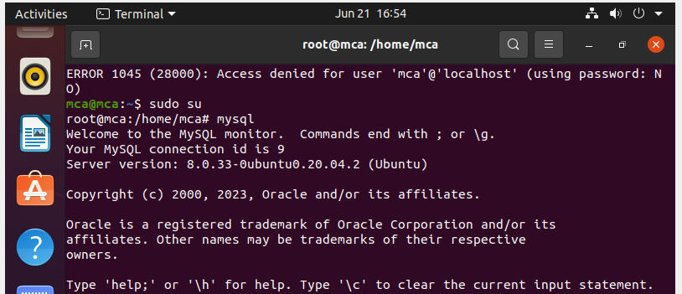

**Step 15: Create database and show databases including the newly created database.**

**Command: create database db1;**

**show databases;**

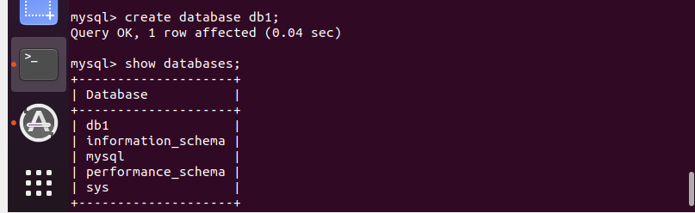

PHP installation → 27/06/2023

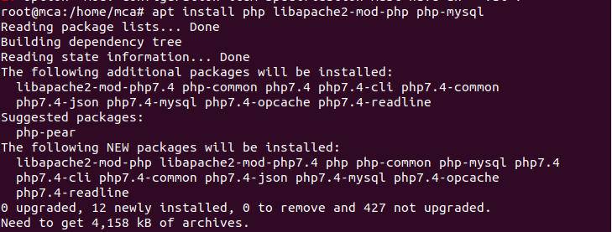

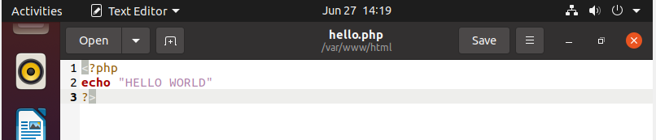



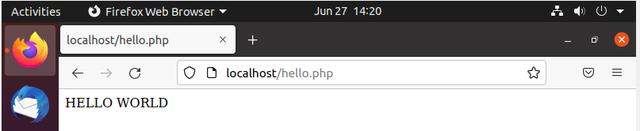

php info

