**STEPS TO INSTALL AND MANAGE VMs USING KVM/QEMU**

**1. Installing KVM/QEMU**

1. egrep -c '(vmx|svm)' /proc/cpuinfo

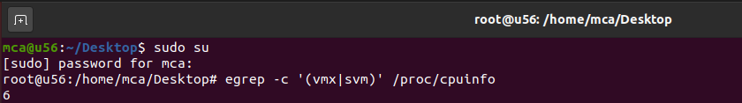

2. sudo apt install cpu-checker

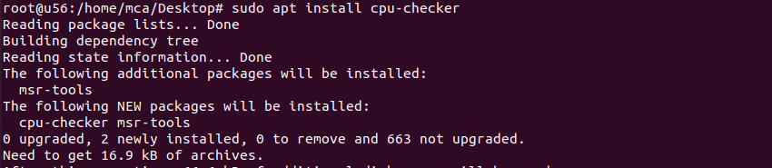

3. sudo kvm-ok



4. sudo apt install qemu-kvm libvirt-daemon-system libvirt-clients bridge-utils

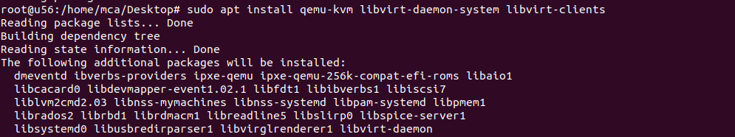

5. sudo systemctl status libvirtd

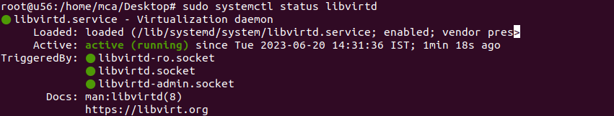

6. sudo systemctl enable --now libvirtd



7. sudo apt install virt-manager

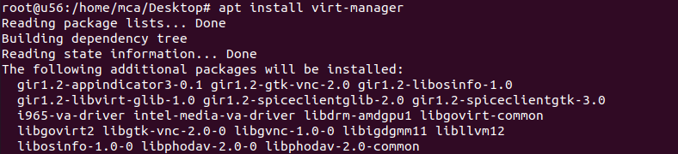

8. sudo virt-manager

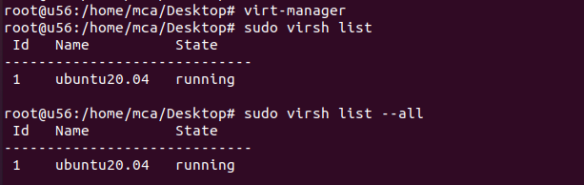

2. Installing VM - using ISO image

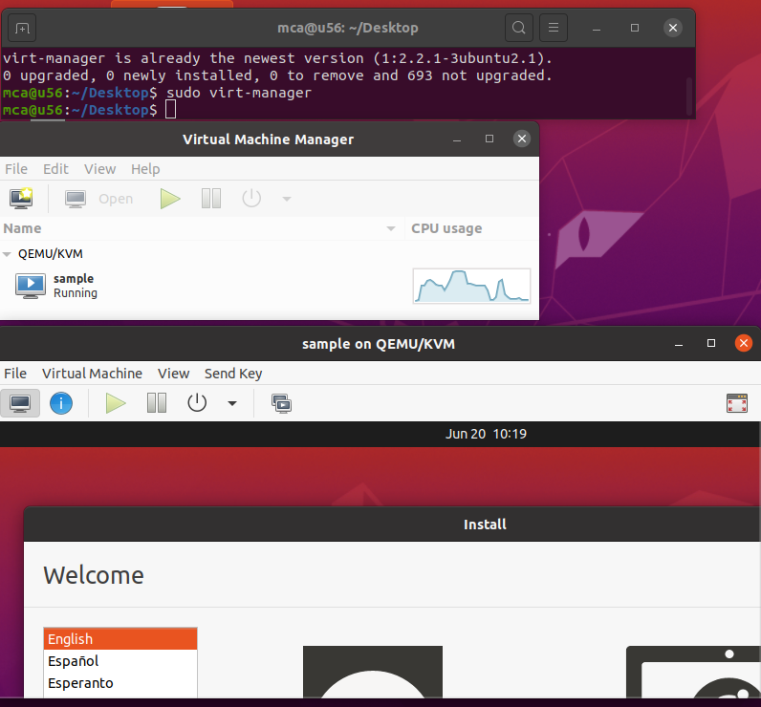

3. Managing VMs using Virt-Manager



1. sudo virsh list

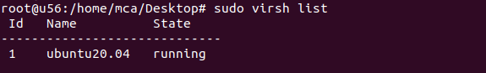

2. sudo virsh list –all

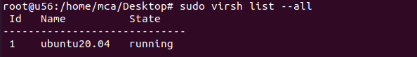

3. sudo virsh nodeinfo

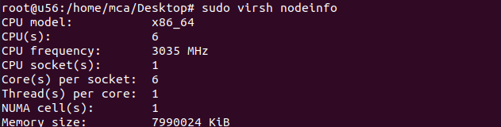

4. sudo virsh help list

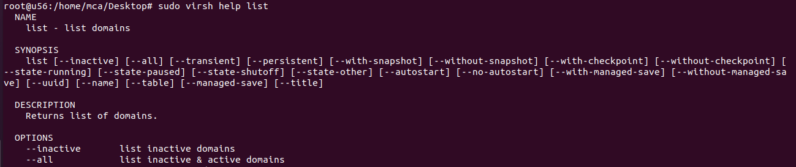

5. sudo virsh start <vmname>



6. sudo virsh reboot <vmname>



7. sudo virsh dominfo <vmname>

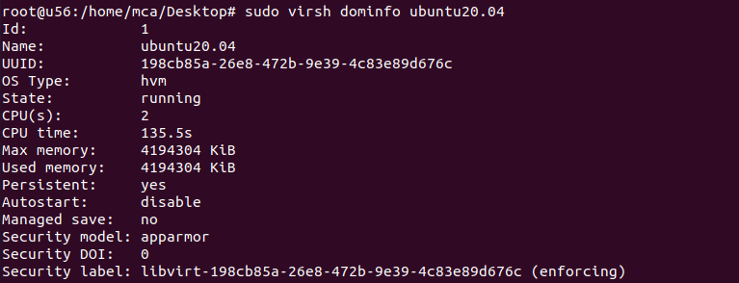

8. sudo virsh suspend <vmname>



9. sudo virsh resume <vmname>



10.sudo virsh shutdown <vmname>



11.sudo virsh save <vmname>



12.sudo virsh restore <vmname>



13.sudo virsh edit <vmname>

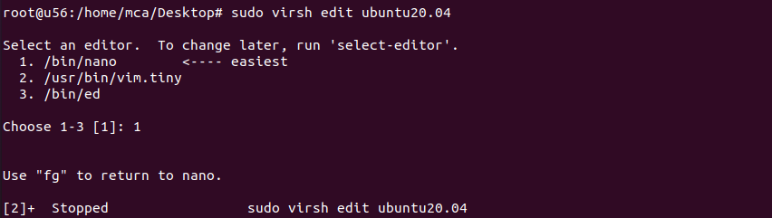

14.sudo virsh destroy <vmname>



15.sudo virsh undefine --domain <vmname> --remove-all-storage

