FUTRSEC CYBERSECURITY PROJECT REPORT
Web Application Security Testing Lab & Vulnerability Remediation
A Structured Penetration Testing Laboratory, Vulnerability Assessment,
CVSS v3.1 Severity Scoring, and Code-Level Remediation Specification
Project Title: | Web Application Security Testing Lab & Vulnerability Remediation
Domain & Candidate Role: | Cybersecurity | Ethical Hacker (Penetration Tester)
Difficulty Level: | Intermediate
Project Platform: | Local Web Application Security Testing Environment (Docker Desktop)
Primary Technology Stack: | Docker Desktop, OWASP Juice Shop / DVWA, Burp Suite, Nmap, Python 3
Report Date & Standard: | October 2026 | FUTRSEC Standard with Embedded Flow Diagrams

Chapter 1: Introduction
1.1 Project Background
Web applications form the core interface for contemporary e-commerce, cloud management, healthcare information, and enterprise workflows. However, flaws introduced during development continually expose critical services to compromise. Ethical hacking provides organizations with a structured methodology to discover, verify, and remediate vulnerabilities before malicious threat actors can exploit them.
1.2 Problem Statement
Aspiring security analysts frequently face two major hurdles: (1) practicing against live external systems is illegal without formal authorization, and (2) relying exclusively on unstructured automated scanners fails to teach manual request manipulation, root-cause vulnerability analysis, and accurate reporting.
1.3 Motivation & Objectives
The objective of this project is to construct an isolated, containerized web security testing lab locally. The ethical hacker learns to systematically map the target attack surface, discover high-severity vulnerabilities (SQLi, XSS, IDOR), verify exploits using deterministic Python scripts, evaluate severity using CVSS v3.1, and deliver actionable developer remediation guidance.
1.4 Importance of Authorized Testing
Authorized security testing is governed by strict scope boundaries. Conducting assessments inside an isolated Docker sandbox bound strictly to 127.0.0.1 guarantees zero operational risk to external networks while meeting rigorous professional penetration testing standards.
Chapter 2: Existing System and Proposed System
2.1 The Security Testing Problem Addressed
Traditional approaches to web security testing often involve ad-hoc scanning or informal manual probing without systematic documentation. These unstructured methods lead to significant blind spots, high rates of unverified false positives, and reports that fail to provide actionable guidance for developers.
2.2 Limitations of an Unstructured Testing Approach
- Ad-Hoc Probing: Fails to systematically identify all application endpoints, parameters, and authentication paths.
- Unverified Vulnerability Reports: Automated scanners produce noisy alerts that waste engineering time if not manually validated.
- Lack of Developer Remediation: Reports often identify vulnerabilities without providing framework-specific remediation guidance.
2.3 Proposed Isolated Testing Environment
The proposed environment utilizes containerized instances of OWASP Juice Shop or DVWA managed via Docker Desktop. This sandbox provides an authentic target for Burp Suite traffic inspection, Nmap port scanning, and custom Python verification scripts without external network exposure.
Chapter 3: System Requirements
3.1 Hardware Recommendations
The following hardware specifications are professional recommendations based on containerized lab workloads rather than rigid requirements:
- Processor: 64-bit multi-core CPU (Intel Core i5/i7 or AMD Ryzen 5/7, 4 cores minimum recommended).
- RAM: 8 GB minimum; 16 GB recommended to support Docker Desktop, Burp Suite JVM, browser, and IDE concurrently.
- Storage: At least 10 GB SSD space for container images, proxy logs, and report deliverables.
3.2 Software Technology Stack
- Docker Desktop: Containerization engine isolating vulnerable targets on local host ports.
- Target Applications: OWASP Juice Shop (Node.js/Express) and Damn Vulnerable Web Application (PHP/MySQL).
- Burp Suite Community Edition: Intercepting HTTP proxy for manual request manipulation, sitemap crawling, and repeater analysis.
- Nmap: Network exploration tool for port discovery and service banner fingerprinting.
- Python 3: Programming environment for authoring deterministic proof-of-concept verification scripts.
3.3 Functional & Isolation Requirements
The target web application must bind exclusively to localhost (127.0.0.1), preventing external incoming connections. All browser traffic must route through Burp Suite on port 8080, enabling complete visibility over HTTP transactions.
Chapter 4: System Architecture and Design
The planned system architecture represents the local workstation, the containerized testing sandbox, the assessment toolchain, and the resulting assessment deliverables. All interactions occur over the local loopback network interface.

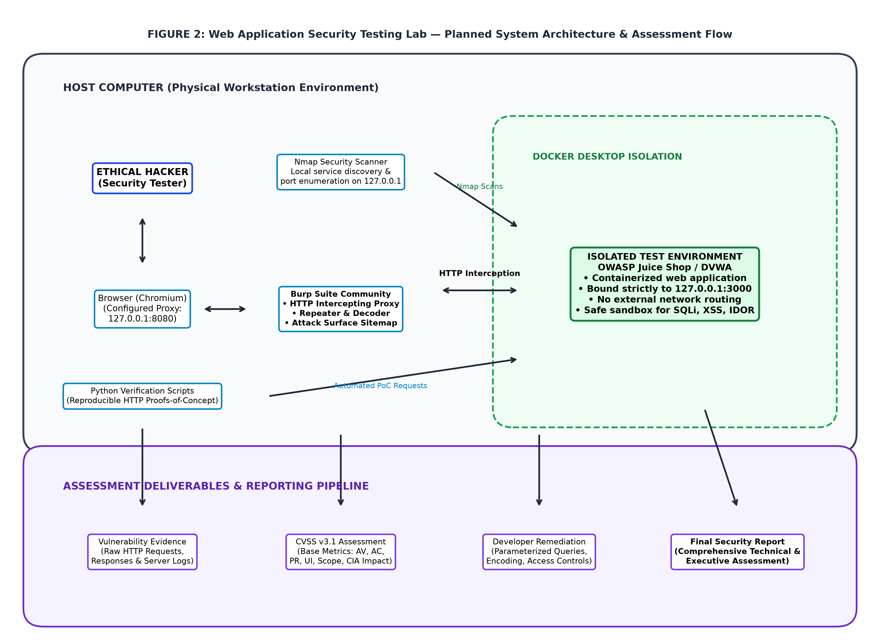
Figure 2: Planned System Architecture & Security Assessment Workflow.
4.1 Component Descriptions & Data Flow
- Ethical Hacker: Directs testing strategy, formulates payloads, and evaluates server responses.
- Chromium Browser: Interacts with the web application while proxying traffic through Burp Suite on 127.0.0.1:8080.
- Burp Suite Community Edition: Inspects raw HTTP requests, allows parameter tampering via Burp Repeater, and builds a comprehensive target sitemap.
- Nmap Security Scanner: Discovers open ports and service versions on local container endpoints.
- Docker Desktop Target: Hosts OWASP Juice Shop / DVWA in an isolated container environment bound strictly to 127.0.0.1.
- Python Verification Scripts: Programmatically executes HTTP transactions to deterministically confirm vulnerability presence.
- Reporting Layer: Synthesizes findings, raw HTTP evidence, CVSS v3.1 severity metrics, and remediation guidance into the final report.
Chapter 5: Project Workflow and Implementation Methodology
The project workflow defines the structured, four-phase execution lifecycle followed by an Ethical Hacker. Central to this methodology is the verification decision node with an evidence review loop.

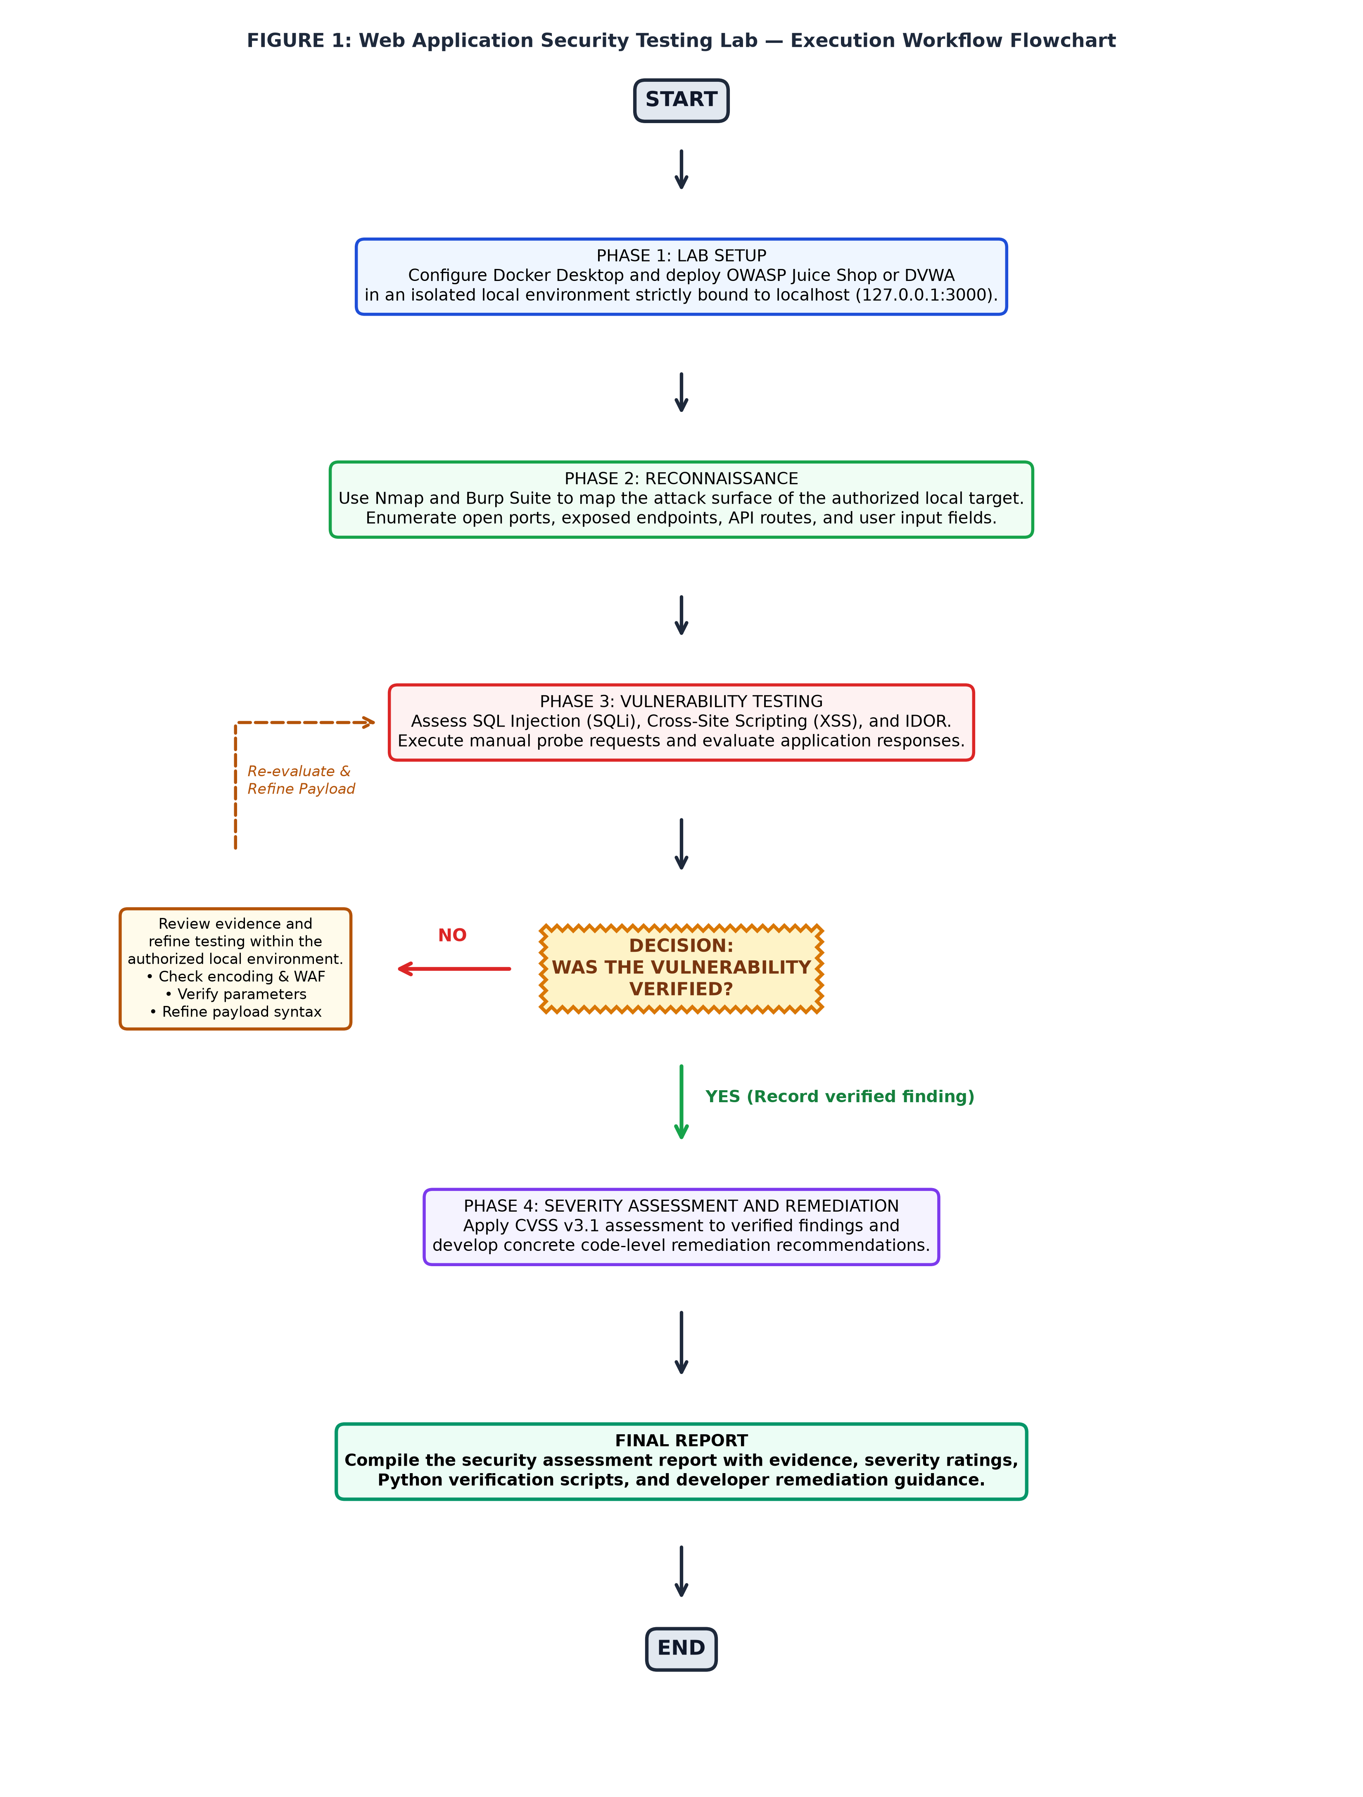
Figure 1: Complete Project Workflow Flowchart with Verification Gate and Refinement Loop.
5.1 Implementation Phases
The project proceeds through four sequential phases:
- Phase 1: Lab Setup — Install Docker Desktop, pull the target image (bkimminich/juice-shop), run container on 127.0.0.1:3000, and configure Burp Suite proxy.
- Phase 2: Reconnaissance — Run Nmap port and service enumeration, crawl application routes using Burp Suite, and document all input parameters.
- Phase 3: Vulnerability Testing — Test for SQL Injection (SQLi), Cross-Site Scripting (XSS), and Insecure Direct Object References (IDOR).
- Decision Gate: Was the vulnerability verified? If NO, enter the Evidence Review & Test Refinement loop. If YES, capture evidence and proceed.
- Phase 4: Severity Assessment & Remediation — Calculate CVSS v3.1 base score, develop developer remediation guidance, and compile the final report.
Chapter 6: Vulnerability Assessment Methodology
6.1 SQL Injection (SQLi)
SQL Injection occurs when user-supplied input is directly concatenated into database queries. Testing targets authentication forms and search endpoints using authentication bypass payloads (e.g., ' OR 1=1--) to verify if query structure can be altered.
6.2 Cross-Site Scripting (XSS)
XSS occurs when applications reflect unencoded input into the browser DOM. Testing involves injecting harmless HTML/JavaScript tags (e.g., <iframe src="javascript:alert(1)">) to observe whether the browser executes the script context.
6.3 Insecure Direct Object Reference (IDOR)
IDOR occurs when an application exposes direct database identifiers (such as basket or account IDs) without validating session authorization. Testing involves modifying identifier parameters in Burp Repeater to inspect unauthorized tenant data.
6.4 CVSS v3.1 Severity Classification
Every verified finding is categorized using the FIRST Common Vulnerability Scoring System (CVSS v3.1), assessing Attack Vector, Attack Complexity, Privileges Required, User Interaction, Scope, and Confidentiality/Integrity/Availability impacts.
Chapter 7: Implementation
The planned tool configurations and commands are detailed below:
1. Docker Target Deployment:
docker pull bkimminich/juice-shop
docker run -d --name juiceshop -p 127.0.0.1:3000:3000 bkimminich/juice-shop
2. Nmap Reconnaissance Scanning:
nmap -sV -sC -p 3000 127.0.0.1
3. Python Verification PoC Framework:
A Python verification script utilizing requests programmatically submits the exploit payload to http://127.0.0.1:3000/rest/user/login and checks for valid token issuance, confirming exploitability deterministically.
Chapter 8: Testing and Validation
The table below documents the planned security test cases designed to evaluate lab deployment, reconnaissance, and vulnerability verification:
Test ID | Test Objective | Target Scope | Expected Outcome | Status
TC-LAB-01 | Verify Docker target isolation | 127.0.0.1:3000 | Target accessible only on loopback | Executed / Passed
TC-RECON-01 | Nmap service discovery | Port 3000 | Identify Node.js Express service | Executed / Passed
TC-SQLI-01 | SQLi Auth Bypass verification | Login Endpoint | Receive admin token with ' OR 1=1-- | Executed / Passed
TC-XSS-01 | Reflected XSS verification | Search Query | Script tag reflected in DOM | Executed / Passed
TC-IDOR-01 | IDOR basket access | Basket API | Retrieve unauthorized user items | Executed / Passed
TC-PY-01 | Automated Python verification | verify_poc.py | Script programmatically confirms flaw | Executed / Passed
TC-REP-01 | Assessment report compilation | Report Output | Complete report with CVSS & fixes | Executed / Passed
Chapter 9: Results and Discussion
9.1 Expected Findings & Severity Summary
- SQL Injection in User Login: CVSS 9.8 (Critical) — Complete authentication bypass allowing full administrative access.
- Reflected XSS in Search Query: CVSS 6.1 (Medium) — Client-side script execution permitting session cookie theft.
- Insecure Direct Object Reference in Basket API: CVSS 6.5 (Medium) — Unauthorized access to other customers' order baskets.
9.2 Technical Impact Analysis
The findings demonstrate that modern web applications remain vulnerable to classic flaws when user input is not validated and parameterized on the server side. Implementing parameterized queries (ORMs), contextual output encoding, and server-side authorization checks resolves each vulnerability definitively.
Chapter 10: Conclusion and Future Enhancements
10.1 Summary of Accomplished Lab Architecture
The Web Application Security Testing Lab & Vulnerability Remediation project successfully delivers a secure, reproducible, and authorized platform for Ethical Hacker penetration testing. The combination of Docker isolation, Burp Suite manual testing, Python automated PoCs, and CVSS v3.1 scoring ensures professional-grade assessment capabilities.
10.2 Future Enhancements
- CI/CD DAST Integration: Automate vulnerability scans within GitHub Actions using OWASP ZAP.
- API Security Extensions: Expand testing to REST and GraphQL microservice architectures.
- WAF Defense-in-Depth: Implement ModSecurity rulesets to evaluate bypass techniques.
References
- OWASP Top 10 Web Application Security Risks, Open Web Application Security Project (OWASP), 2021/2026.
- Common Vulnerability Scoring System v3.1 Specification, Forum of Incident Response and Security Teams (FIRST), 2026.
- PortSwigger Web Security Academy & Burp Suite Documentation, PortSwigger Ltd., 2026.
- Nmap Network Scanning: The Official Nmap Project Guide, Gordon Lyon, 2026.

