Medical Definition of geopathology

*A science that deals with the relation of geographic factors to peculiarities of specific diseases*

*---As per Merriam Webster since 1828*

What is Geopathic Stress ?

Geo is a Greek word for Earth

Pathology means study of diseases

Stress means any tension resulting from adverse or demanding circumstances.

These are the Harmful energies coming from the earth.

Geopathology is a science that deals with the study of pathologic (sickening, harmful) energies emitted from the earth that interfere with the healthy functioning of cell metabolism in our body. Geopathic Stress mainly occurs from natural sources.  
European Science has researched this topic for nearly a century and provides important insights about the significance on long term and chronic health challenges.

Geopathology throughout history

The idea that some spots on the earth were better than others for people to live has been around for thousands of years. In fact, the ancient practice of Feng Shui has a lot more to do with finding an energetically optimal place to build a home than with where to hang wind chimes, place a mirror, or set a pair of porcelain love birds to enhance the "relationship corner".   
  
Old European traditions still describe scenarios where a herd of sheep was observed before a house was built. The spot where the sheep bedded down for the night would be the best area, specifically for the master bedroom, as it was free of Geopathic Stress.

Similar tradition was and is prevalent in India. A cow is left in the plot and where the cow relaxes and prefers to bed in the night is where the master room is made. Since cow is considered the most auspicious animal in India, its dung and urine are used to extensively to remove negative energy from the land.

Many include the electromagnetic rays emitting from the power lines, radio waves, mobile towers as part of Geopathology . But I totally disagree with this. The Vedic texts which were written in India by the sages thousand of years back did not calculate the earth energies in terms of the electrical energies. They were purly written on the fact that the earth energies had its good and bad impact. The term “shaila dosha ” in vedic text clearly means bhumi or earth and dosha means fault. Shaila dosha means the faults in the land. Geopathology also means fault from the land. This fault could be due to various reasons.

This clearly states that Geopathology term has been prevalent in history since ages

Vedic science also gives major importance to clearance and purification of the land.

As per oldest Vedic text **Vishwakarma Prakash** .Any land where there are bones, hair, termite, lack of vegetation, where lightening falls, land full of snakes and bats, owls, pigeons, honey comb. A land where cows, elephants and horses make crying sounds as they feel uncomfortable is also full of negative energy. These energies are felt by the animals as their 6th sense is much higher than a normal human being. They can sense various energies.

वज्राभि दूषिते भगे़

सर्प चॉणडॉलवेष्टिते ।

ऊलूकवासिते सप्तरात्रौ

काकाघिवासिते ।।

मृगाघिवासते रात्रौ गोमाजाराभिनादिते ।

वारणा श्वादिविरूते॥

कपोतकगृहावासे मधुनां निलये तथा ।

**Vishwakarma prakash chapter 1 shloka**

This was one of the Vedic ways of explaining why such event could happen in a plot. Similar explanation is given by many experts from European countries. Both are from different cultures but end prediction is same that why animals get disturbed. Similar description is found in vedic text Manasar and Mayamat and many more.

The first notable study in recent history was conducted by Gustav Freiherr von Pohl, a German aristocrat, in 1929. Freiherr von Pohl conducted an experiment where he dowsed a whole small town, Vilbisburg, for Geopathic Stress. He was accompanied by a policeman to insure that he did not ask questions of the town inhabitants. The results were then taken to the town mayor who compared the results with the town doctors' records of patients with cancer over the previous several years. The results produced a 100% correlation between cancer and Geopathic Stress. The experiment was repeated in larger and smaller towns with always the same results - 100% correlation. Naturally, those involved thought they had found a cure for cancer, but unfortunately, WW2 broke out, and the academics scattered and the knowledge was lost - for some time.

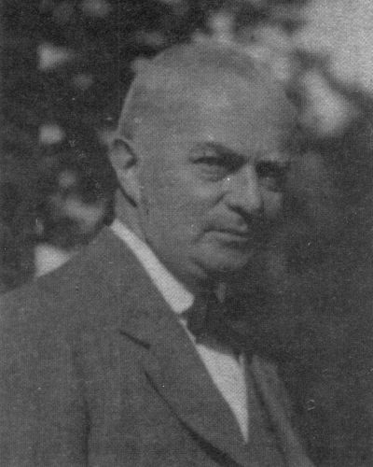

(F17) Gustav Freiherr von Pohl

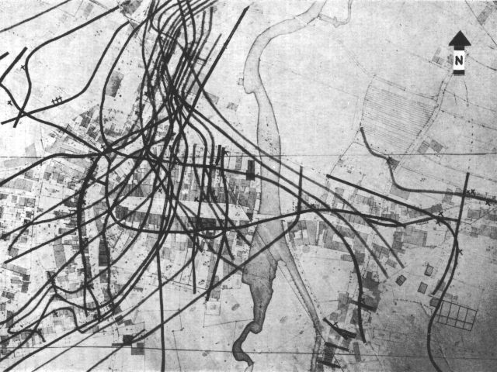

(F18) The **Map of Vilsbiburg**

The **Map of Vilsbiburg**, where Gustav Freiherr von Pohl marked the locations of all the cancer places during his investigation.  
All 54 people who died on [cancer](http://geopathology-za.wikidot.com/cancer) (indicated by crosses) had been living on the radiation areas, the flowing underground water (water veins) - indicated by the black lines in the map.

Recent Studies

A seven year study (1988-1995) in Germany conducted by Andreas Kopschina and Ursula & Wolfgang Daun, involving 8200 patients, measured the ability of patients to recover from chronic illness, regardless of the type of conventional or integrative therapy. 34% of patients were exposed to significant levels of Geopathic Stress. The study showed that until a person was taken off the Geopathic structure, their capacity to heal was greatly impaired.  
  
Ulrike Banis, MD, ND, author of "Geopathic Stress - and What You Can Do About It", has integrated the knowledge of Geopathic Stress into her medical practice with categorical success. From her former stance as a staunch skeptic she now reports, "...but my experience - being a medical professional myself - is that at least 30% of all chronic medical conditions are derived from this cause - or to put it differently, our patients would be, on average, 30% healthier if we manage to find good sleeping places for everyone."  
  
Dr. Banis uses dowsing to identify areas of Geopathic Stress for her patients. She recommends patients move their sleeping place to an area free of Geopathic Stress zones. She then prescribes homeopathic remedies to detox the body of the charge Geopathic Stress causes in a person's energy field.(Fn 5.1)

(F19)Andreas Kopschina

Sources of Geopathology –

1. Natural water lines
2. Geological fold
3. Gamma radiation
4. Hartmann grid
5. Curry lines
6. Benker line
7. Leylines
8. Planetary grid system
9. Becker Hagens grid
10. Mineral deposits
11. Coal pockets
12. Bones /hair below the earth/termites/ hard rocky land