PHASE – II SMART WATER SYSTEM

Implementing a linear regression model on an Arduino for a smart water system involves collecting data, training the model, and making predictions. A simplified step-by-step guide to demonstrate linear regression on an Arduino is given:

1. Collect Data:

Historical water consumption data and relevant features that may affect water usage, such as temperature, time of day, or occupancy are collected.

2. Data Preprocessing:

Collected data is cleaned and preprocessed. A suitable format for training the linear regression model on the Arduino is ensured.

3. Train the Linear Regression Model:

The linear regression model is trained on a more powerful machine (e.g., a PC) since Arduino's computational resources are limited. Python libraries like sci-kit-learn are used to do this. The model should predict water consumption based on input features.

4. Export the Model:

After training the model, it is exported in a format that can be loaded onto the Arduino. Some libraries like TensorFlow Lite for Arduino or Edge Impulse may help with model conversion.

5. Set Up the Arduino:

The necessary hardware components, including sensors, collect the input features (e.g., temperature sensors, occupancy sensors), and a display is used to show the predictions.

6. Load the Model onto the Arduino:

An appropriate library or framework is used to load the linear regression model onto the Arduino.

7. Collect Real-time Data:

The Arduino is set up to collect real-time data from sensors (e.g., temperature, time of day) that the model needs as input for making predictions.

8. Make Predictions:

The loaded linear regression model is used to make predictions based on the real-time sensor data. The Arduino will use the model to calculate the expected water consumption.

9. Display Results:

The predictions or results are displayed on the Blynk application.

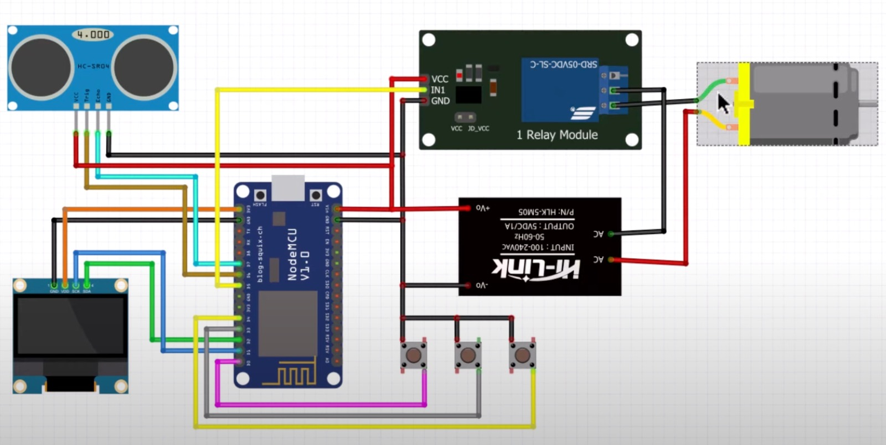

**Figure 1 HARDWARE SETUP OF SMART WATER SYSTEM**

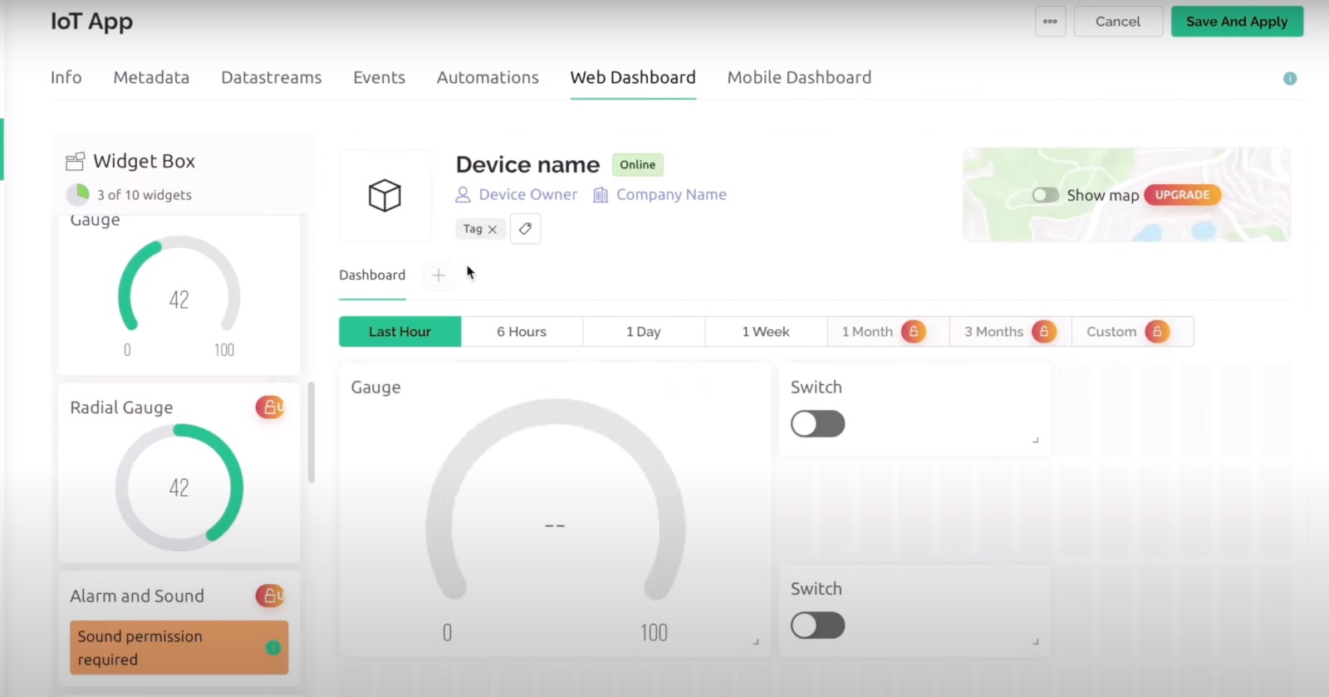

**Figure 2 BLYNK INTERFACE WITH SMART WATER SYSTEM**

**WATER CONSERVATION STRATEGIES**

Implementing water conservation strategies with the help of a smart water system can greatly enhance the efficiency and effectiveness of water resource management. Here are some water conservation strategies using a smart water system:

1. Real-Time Monitoring:

Smart meters and sensors can detect leaks, abnormal usage patterns, and inefficiencies immediately, allowing for quick intervention.

2. Leak Detection and Alerts:

Automated leak detection systems that can detect even small leaks and send instant alerts to property owners or maintenance personnel, are implemented. This helps prevent water wastage and costly damage.

3. Water Usage Analytics:

Collect and analyze historical water consumption data to identify trends and areas where water conservation efforts can be improved. Machine learning algorithms can provide insights and predictions.

4. Mobile Apps and User Engagement:

Mobile apps or web interfaces that allow users to monitor their water consumption and receive personalized conservation tips are developed. Gamification and incentives can encourage users to reduce water usage.

5. Automated Shutoff Systems:

Automated shutoff valves that can be controlled remotely or set to turn off the water supply during non-peak usage hours or when specific conditions are met (e.g., low occupancy), are installed.

6. Greywater Recycling:

Smart systems can manage the collection and treatment of greywater for reuse in non-potable applications like irrigation and toilet flushing.

7. Water Quality Monitoring:

Sensors are included to monitor water quality in the smart system. Detecting contaminants early can help prevent pollution and improve overall water quality.

8. Remote Control and Scheduling:

It enables users to remotely control water-consuming appliances and allows them to schedule tasks like dishwashing, laundry, and irrigation during off-peak hours.

9. Automated Appliance Efficiency:

Smart appliances like washing machines and dishwashers are connected to the smart system and their water usage is optimized based on load size and water availability.

10. Rainwater Harvesting Integration:

Rainwater harvesting systems are integrated with the smart water system to optimize the collection and use of rainwater for various purposes.

Smart water systems have the potential to transform water conservation efforts by providing data-driven insights, automation, and user engagement. These strategies can help communities and individuals reduce water usage, minimize wastage, and contribute to sustainable water management.