# 1. Generic Methods and Generic Classes

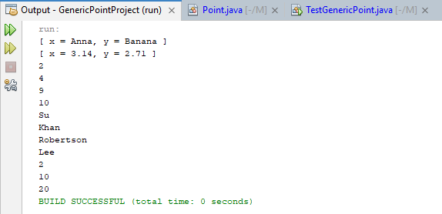

# 2. Java Collection Framework (LinkedList, ArrayList)

## a. List Iterator Interface

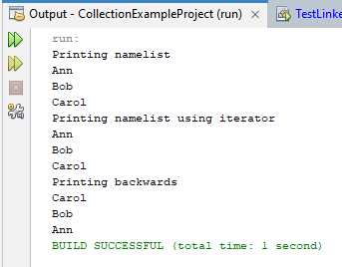

## b. TreeSet, HashSet, LinkedHashSet, TreeMap, HashMap, LinkedHashMap

### TreeSet

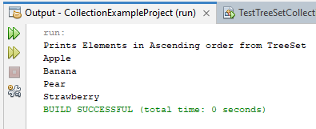

### HashSet

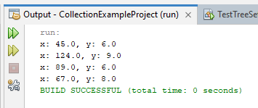

### LinkedHashSet

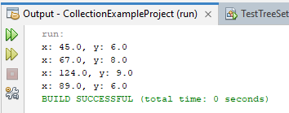

### TreeMap

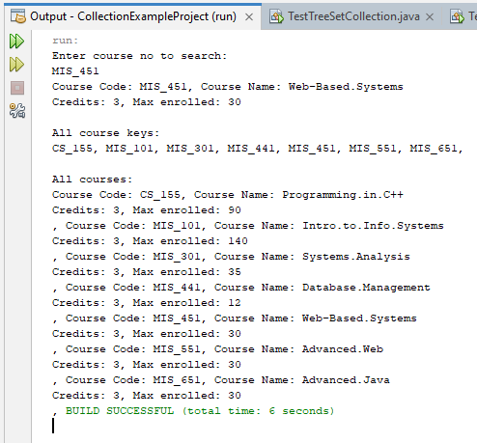

### HashMap

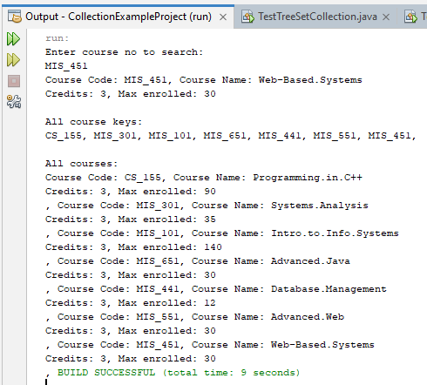

### LinkedHashMap

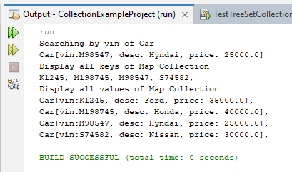

### CourseArrayList

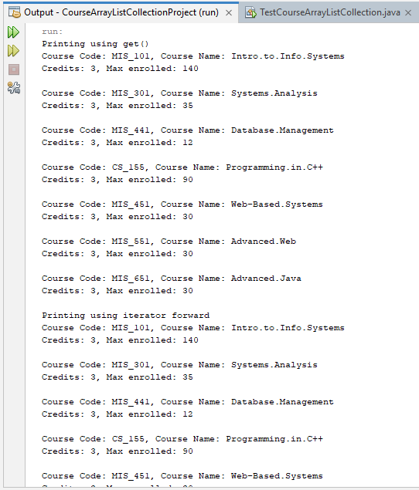

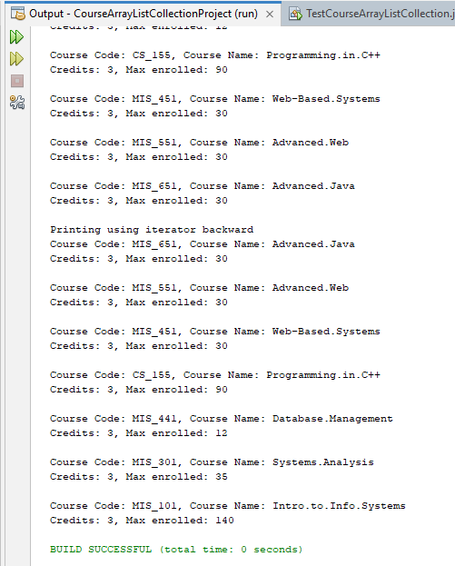

# 3. BookArrayListCollectionProject

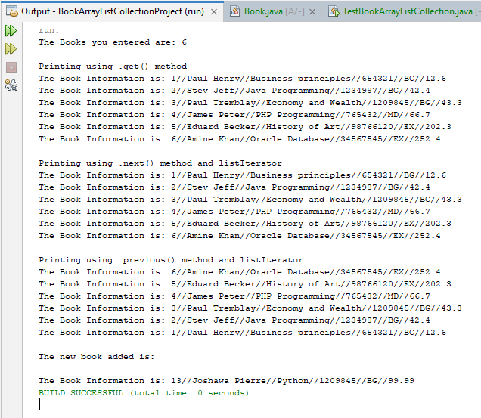

# 4. CollectionTripProject

## Printing from HashSet using loop vs using Iterator.

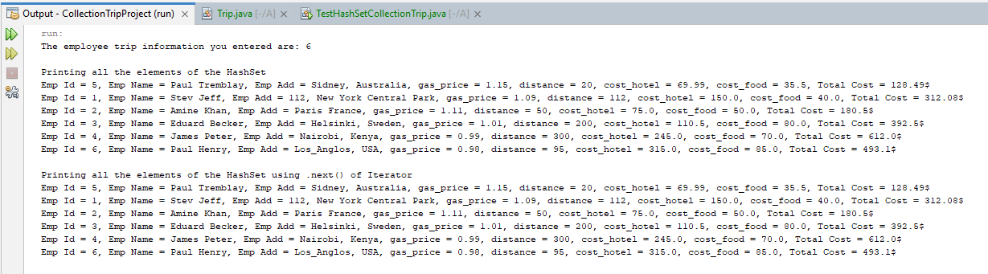

## Adding duplicate Object into HashSet

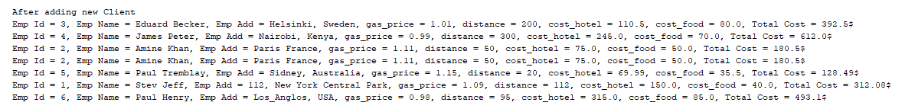

***The reason why the duplicate object was added because internally a HashSet uses the equals method and HashCode to compare objects, since each object has different reference addresses by default, they are considered as separate objects. To fix, this issue and to prevent duplicates from going into the HashSet we have to define custom equals() and hashCode() functions inside the Trip class.***

## Preventing duplicate Objects into HashSet

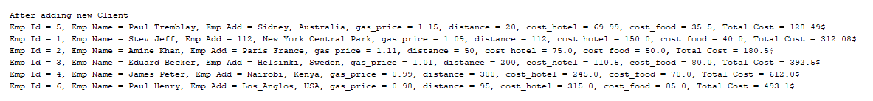

## Preserving Data order by using LinkedHashSet

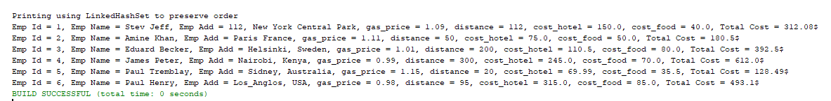

# Linked hash map and Linked List

## Displaying from Employee File

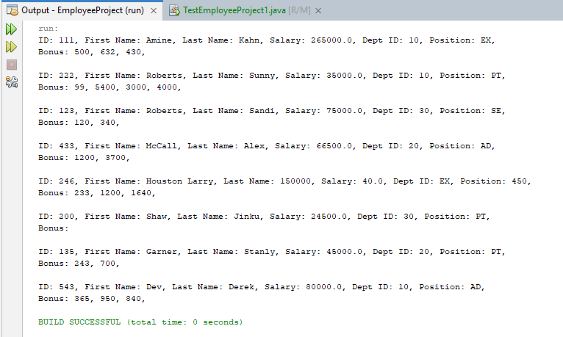

## Displaying from HashMap LinkedList

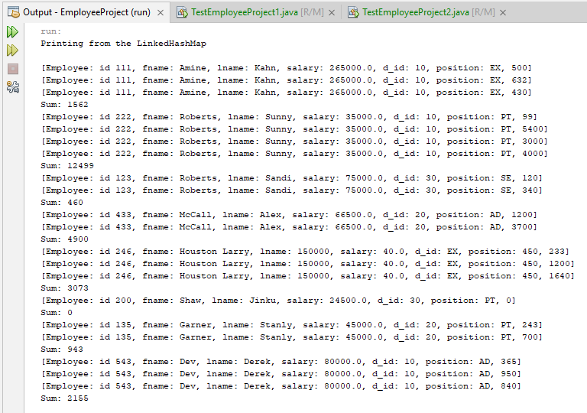

## Searching from HashMap LinkedList

