# Using Lambda Expressions

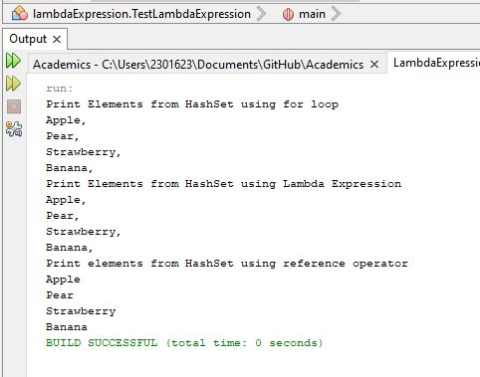

# Consumer and Function Interface

## Consumer

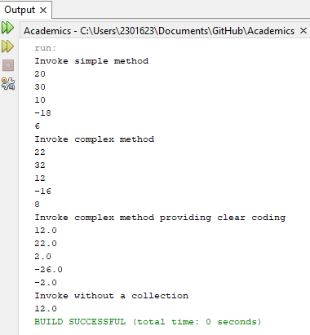

## Function

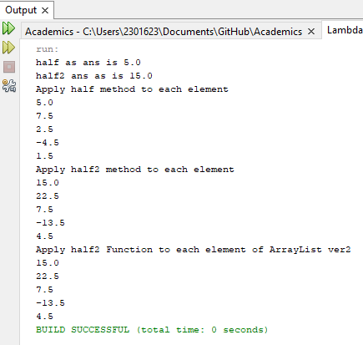

# 3. Predicate Interface and Optional class

## Car HashMap

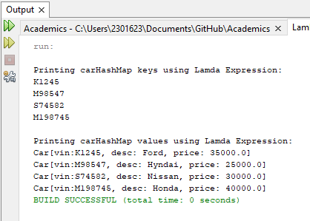

## Optional

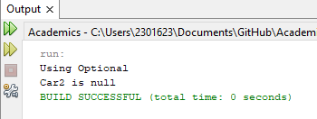

## Predicate

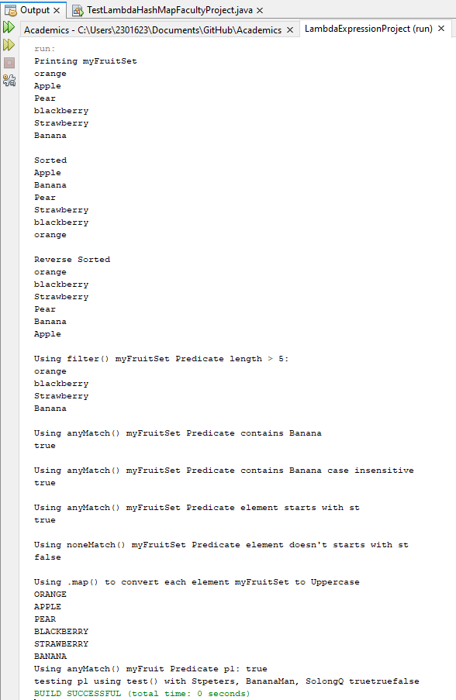

# 4. There’s no Number 4 as there’s a numbering mistake in the shared document

# 5. Applying Lambda Expressions to HashSet collection

# 6. Applying Stream Processing to Trip HashSet collection

# 7. Applying Stream Processing to HashMap collection

