# Array List Data Structure

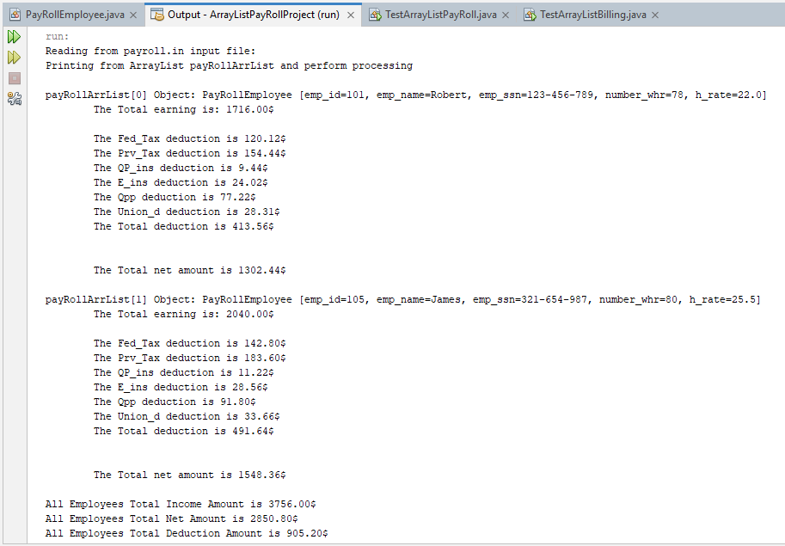

# Linked List Data Structure

## TestLinkedList1.java

## TestLinkedList1.PNG

## TestLinkedList2.java

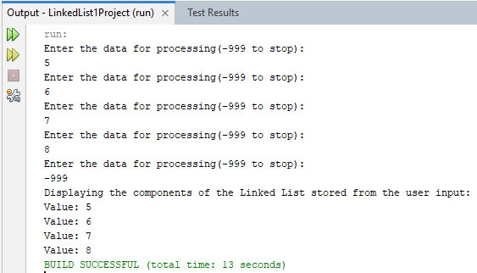

## TestFileToLinkedList2.java

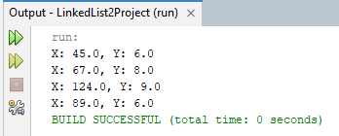

# Application of Linked List: Storing records of course.in file

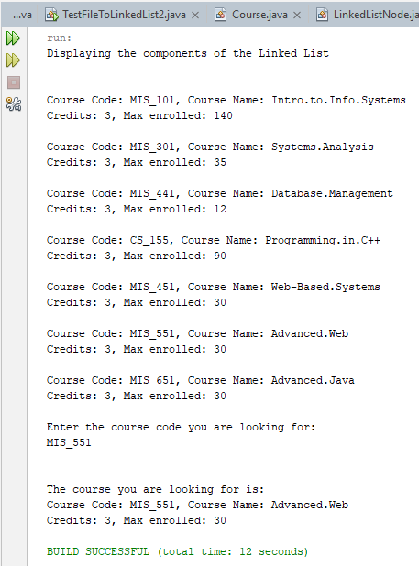

# Linked List Project: ProjectThreeLinkedList

