# 1

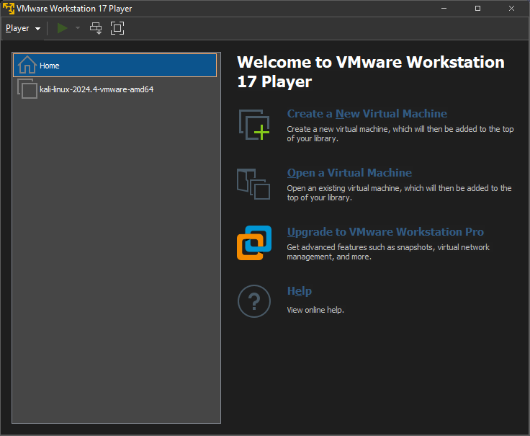

# 2 and 3

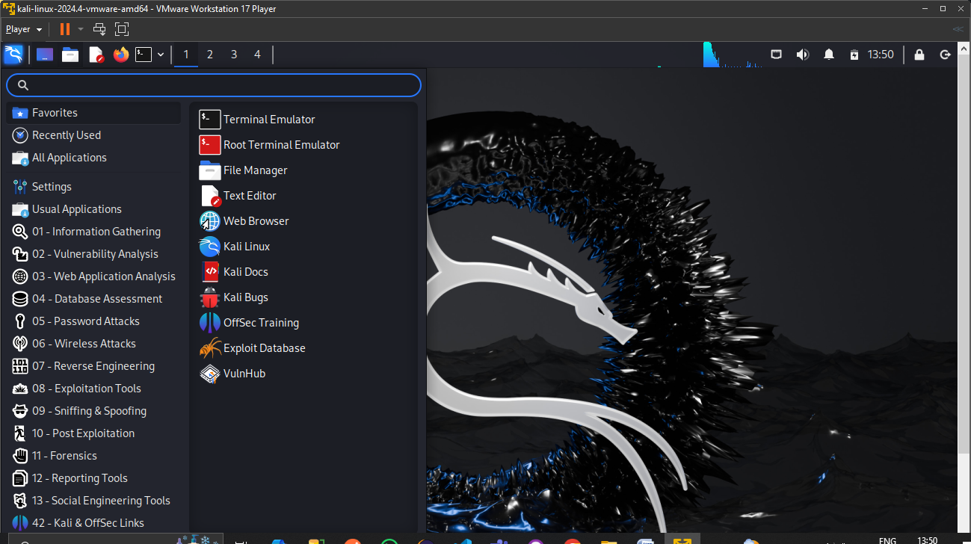

# 4a

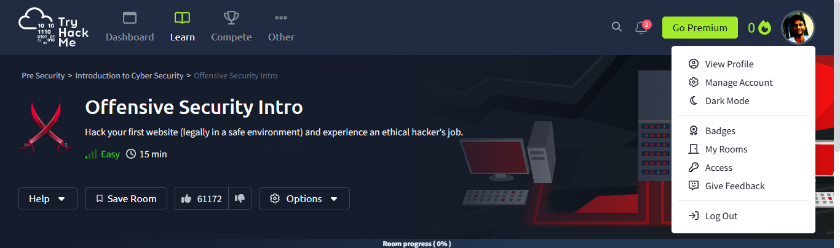

# 4b

1. What is the key term for devices that are connected together? Network
2. Who invented the World Wide Web? Tim Berners-Lee
3. …
   1. What does the term "IP" stand for? Internet Protocol
   2. What is each section of an IP address called? Octet
   3. How many sections (in digits) does an IPv4 address have? 4
   4. What does the term "MAC" stand for? Media Access Control
   5. Deploy the interactive lab using the "View Site" button and spoof your MAC address to access the site.  What is the flag? THM{YOU_GOT_ON_TRYHACKME}
4. …
   1. What protocol does ping use? ICMP
   2. What is the syntax to ping 10.10.10.10? ping 10.10.10.10
   3. What flag do you get when you ping 8.8.8.8? THM{I_PINGED_THE_SERVER}

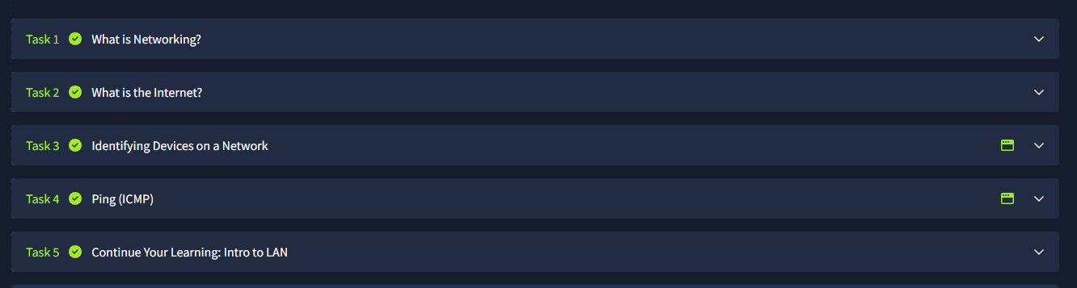

# 4c

1. …
2. …
   1. Which layer would choose to send data over TCP or UDP? 4 Transport Layer
   2. Which layer checks received information to make sure that it hasn't been corrupted? 2 Data Link Layer
   3. In which layer would data be formatted in preparation for transmission? Data Link Layer
   4. Which layer transmits and receives data? 1 Physical Layer
   5. Which layer encrypts, compresses, or otherwise transforms the initial data to give it a standardised format? 6 Presentation Layer
   6. Which layer tracks communications between the host and receiving computers? 5 Session Layer
   7. Which layer accepts communication requests from applications? 7 Application Layer
   8. Which layer handles logical addressing? 3 Network Layer
   9. When sending data over TCP, what would you call the "bite-sized" pieces of data? Segments
   10. **[Research]** Which layer would the FTP protocol communicate with? 7 Application Layer
   11. Which transport layer protocol would be best suited to transmit a live video? UDP
3. …
   1. How would you refer to data at layer 2 of the encapsulation process (with the OSI model)? Frames
   2. How would you refer to data at layer 4 of the encapsulation process (with the OSI model), if the UDP protocol has been selected? Datagrams
   3. What process would a computer perform on a received message? De-encapsulation
   4. Which is the only layer of the OSI model to add a *trailer* during encapsulation? Data Link
   5. Does encapsulation provide an extra layer of security **(Aye/Nay)**? Aye
4. …
   1. Which model was introduced first, OSI or TCP/IP? TCP/IP
   2. Which layer of the TCP/IP model covers the functionality of the Transport layer of the OSI model **(Full Name)**? Transport
   3. Which layer of the TCP/IP model covers the functionality of the Session layer of the OSI model **(Full Name)**? Application
   4. The Network Interface layer of the TCP/IP model covers the functionality of two layers in the OSI model. These layers are Data Link, and?.. **(Full Name)**? Physical
   5. Which layer of the TCP/IP model handles the functionality of the OSI network layer? Internet
   6. What kind of protocol is TCP? Connection-Based
   7. What is SYN short for? Synchronise
   8. What is the second step of the three way handshake? SYN/ACK
   9. What is the short name for the "Acknowledgement" segment in the three-way handshake? ACK
5. …
   1. What command would you use to ping the bbc.co.uk website? ping bbc.co.uk
   2. Ping *muirlandoracle.co.uk*  
      What is the IPv4 address? 217.160.0.152
   3. What switch lets you change the interval of sent ping requests? –i
   4. What switch would allow you to restrict requests to IPv4? -4
   5. What switch would give you a more verbose output? –v
6. …
   1. What switch would you use to specify an interface when using Traceroute? –i
   2. What switch would you use if you wanted to use TCP SYN requests when tracing the route? –T
   3. **[Lateral Thinking]**Which layer of the ***TCP/IP*** model will traceroute run on by default (Windows)? Internet
7. …
   1. What is the registrant postal code for facebook.com? 94025
   2. When was the facebook.com domain first registered (Format: DD/MM/YYYY)? 29/03/1997
   3. Which city is the registrant based in? Redmond
   4. **[OSINT]**What is the name of the golf course that is near the registrant address for microsoft.com? Bellevue Golf Course
   5. What is the registered Tech Email for microsoft.com? [msnhst@microsoft.com](mailto:msnhst@microsoft.com)
8. …
   1. What is DNS short for? Domain Name System
   2. What is the first type of DNS server your computer would query when you search for a domain? Recursive
   3. What type of DNS server contains records specific to domain extensions (i.e. *.com,* .co.uk*, etc)*? Use the long version of the name. Top-Level Domain
   4. Where is the very first place your computer would look to find the IP address of a domain? Hosts File
   5. **[Research]** Google runs two public DNS servers. One of them can be queried with the IP 8.8.8.8, what is the IP address of the other one? 8.8.4.4
   6. If a DNS query has a TTL of 24 hours, what number would the dig query show? 86400

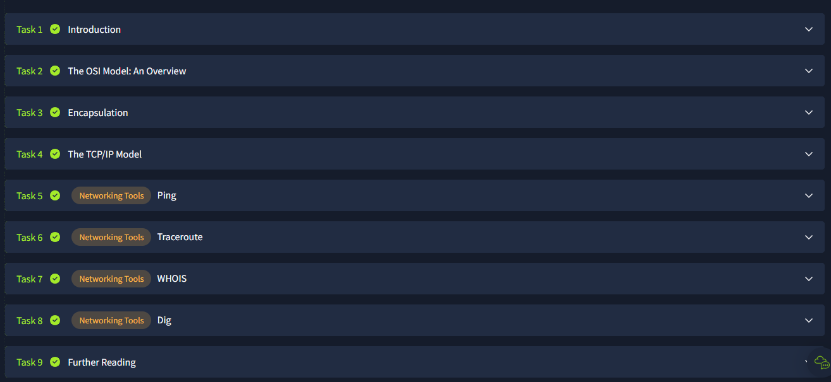

# 4d4d1.PNG4d2.PNG4d3.PNG4d4.PNG