1. **Cipher methods:**
   1. **Substitution Cipher Using Vigenere Square:** File attached with zip file
   2. **Transposition Cipher(Solution):** CIYSUTREAES TRTM
2. **Asymmetric Cryptography: Using RSA encryption and decryption:**
   1. Assume we convert B to a number 2, so we encrypt by powering and then finding the modulus: 2 ^ 13 mod 77 = 30, so cipher text is 30
   2. To decrypt the message, we do a similar process, we take the encrypted message, and power it to private key, and then find the modulus. So here it would be 30 ^ 37 mod 77 = 2.
   3. Create private key using Openssl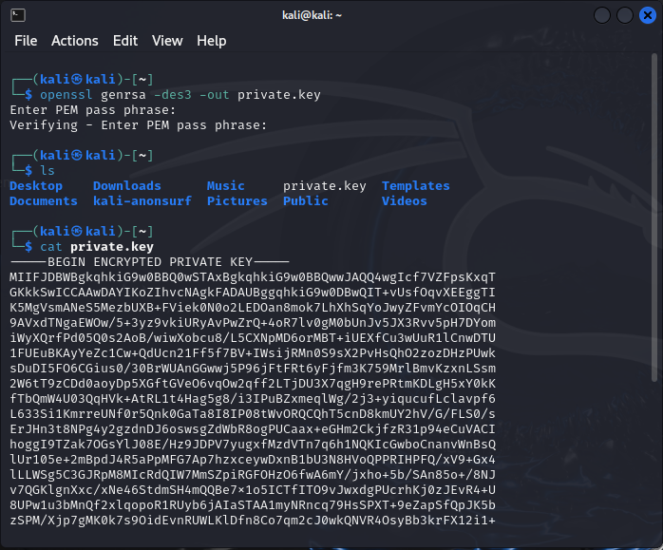
   4. Create public key using Open SSL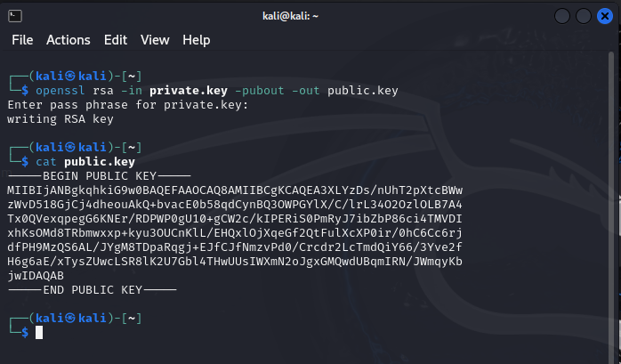
   5. Encrypt text file using public key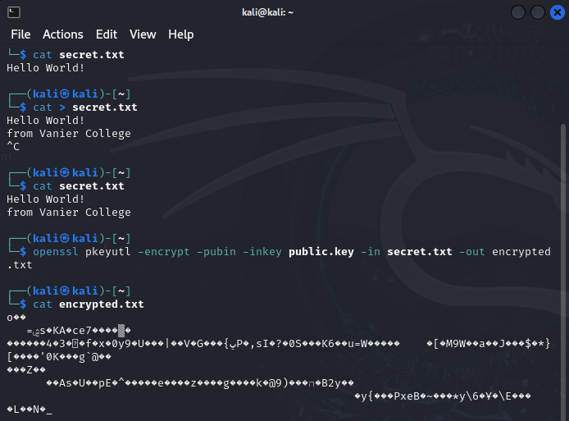
   6. Decrypt encrypted message using private key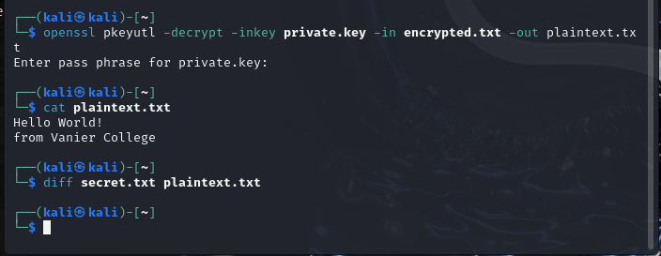
   7. Generate digital certificate using OpenSSL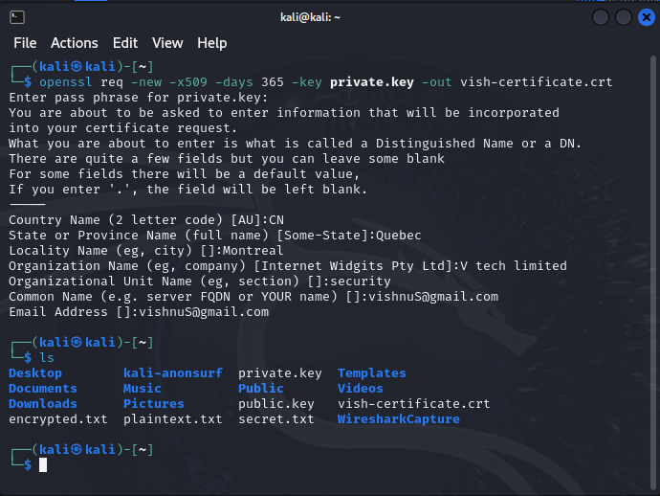
   8. Probe website to get information about SSL and TLS protocol connections being used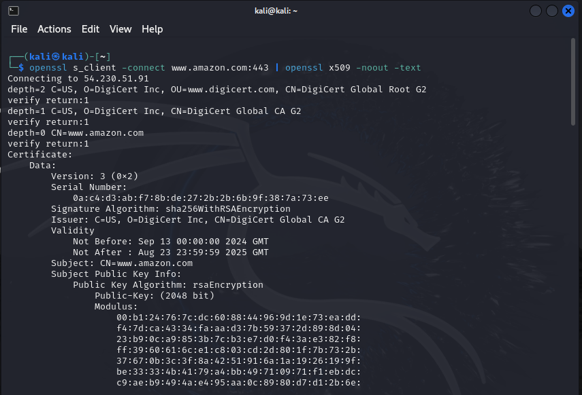
3. Nmap tool
   1. Scan amazon.com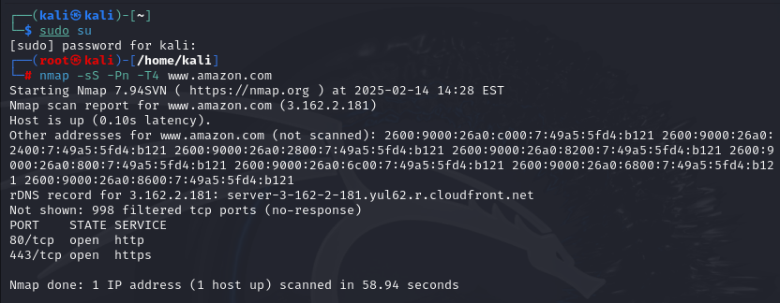
   2. Find and save IPs of connected devices on LAN, and do scans on them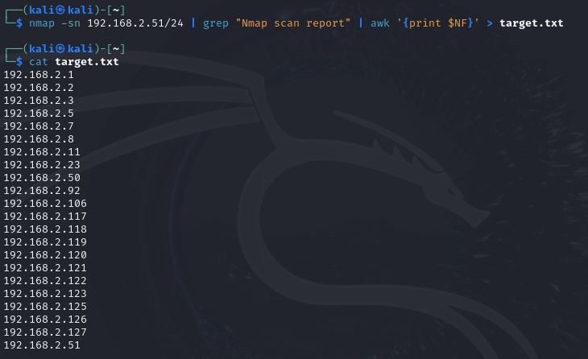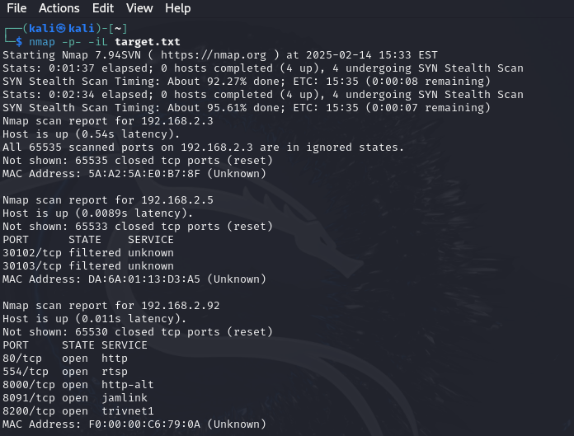
   3. Scan vaniercollege.qc.ca with specific ports