# PortSwigger Web Security

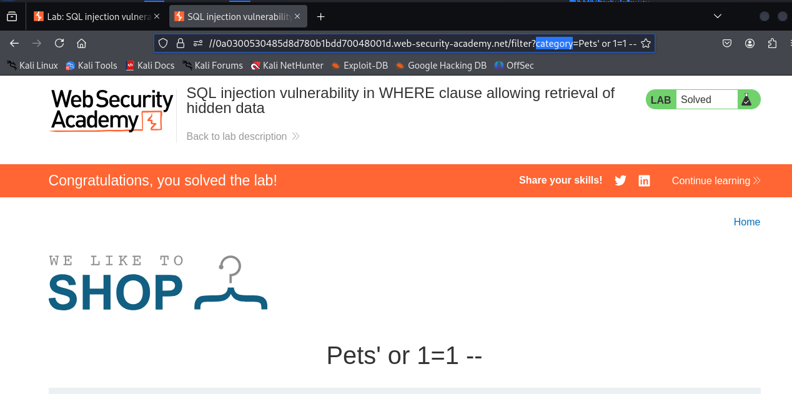

# Burp Proxy to intercept HTTP requests/response

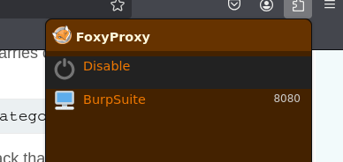

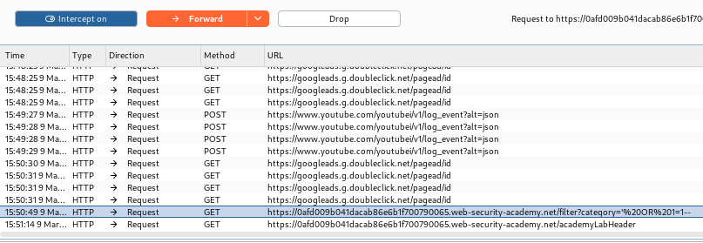

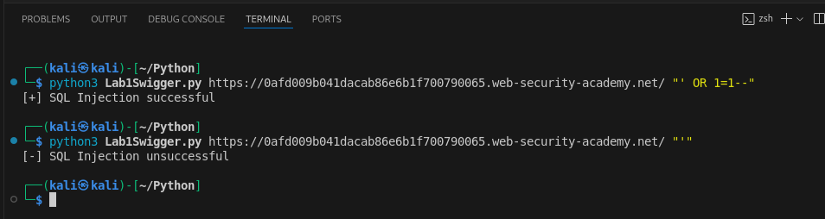

# Login bypass and UNION attack

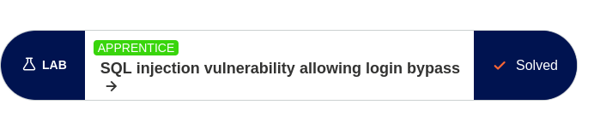



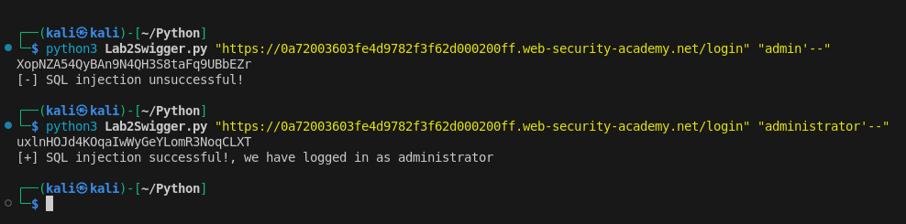

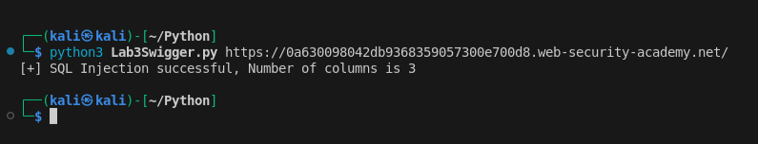

All text files and program code in python is attached with the zipfile.