# Network monitoring(TCP dump)

## Tcpdump –help

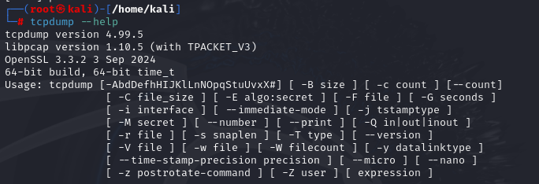

## Capture packets of current network

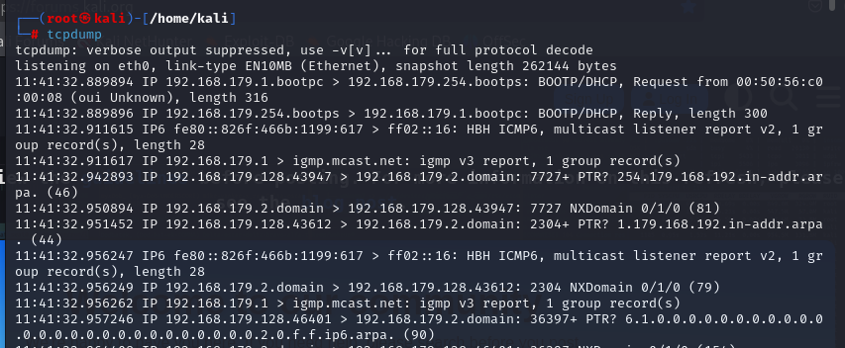

## Capture 4 packets from specific network interface

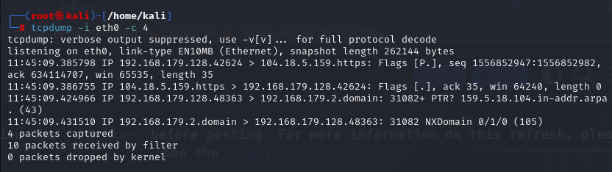

## Capture in ASCII format

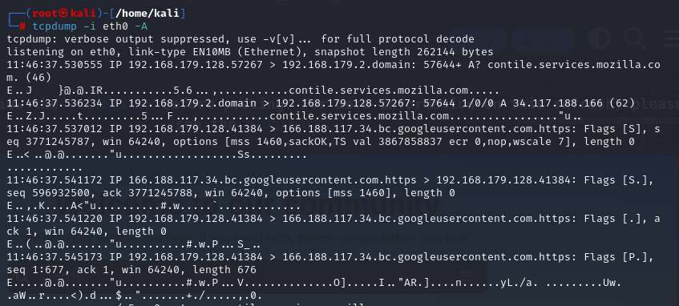

## Show available network interfaces

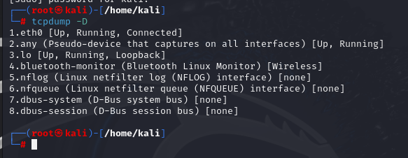

## Save captured packets into pcap file

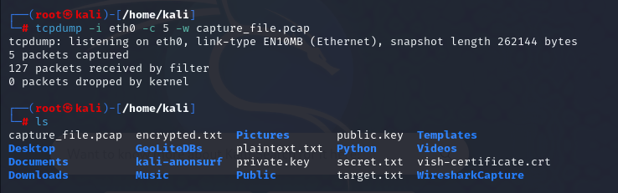

## Read from captured pcap file

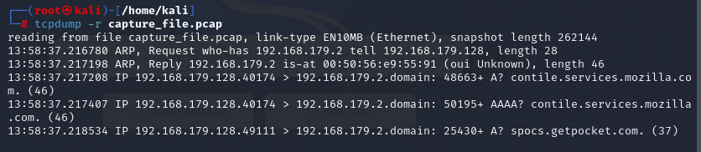

# Snort

## Installation and snort version

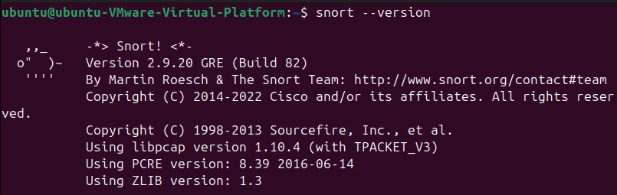

## Start snort, show IP addresses of target machine and attacker machine

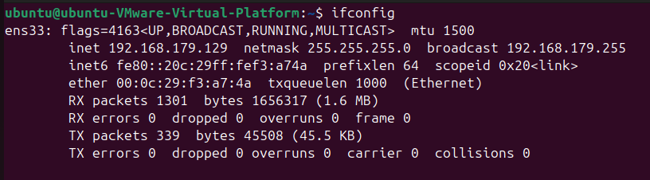

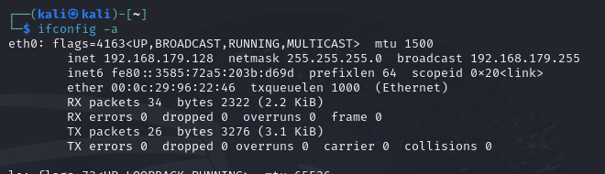

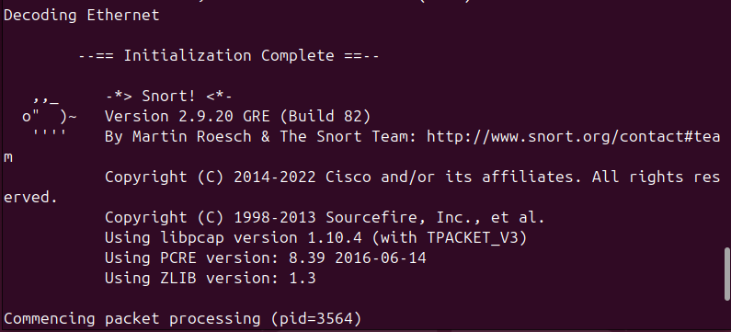

## Send SNMP message and detect it



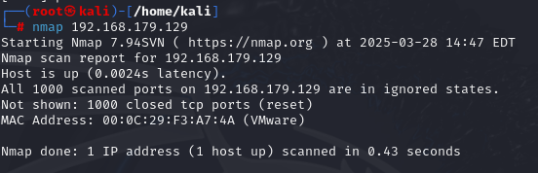

## Send ICMP message and detect

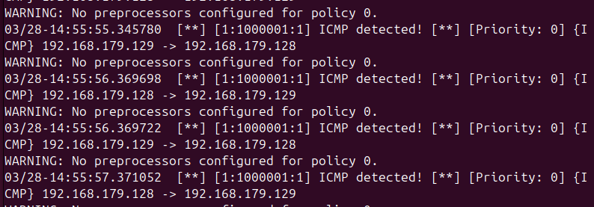

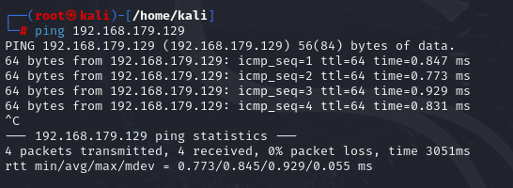

## Add SSH rule, and detect



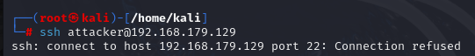

## Add HTTP rule, and detect



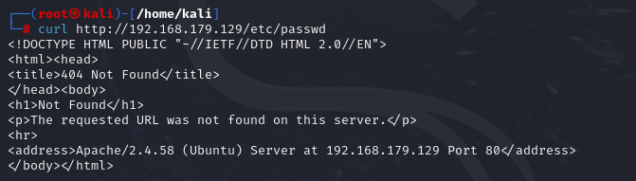

## 2 sub, Show local.rules file for snort

