Using CURL Tool
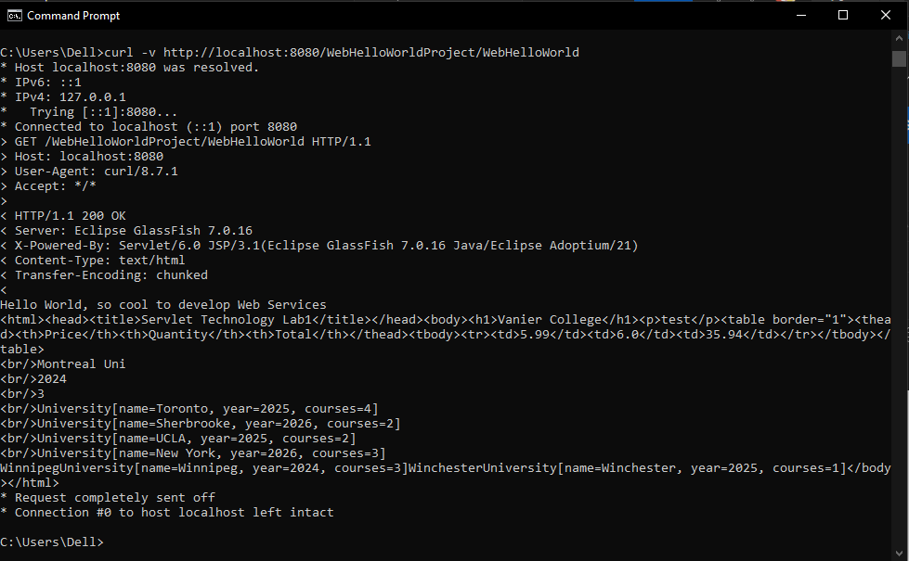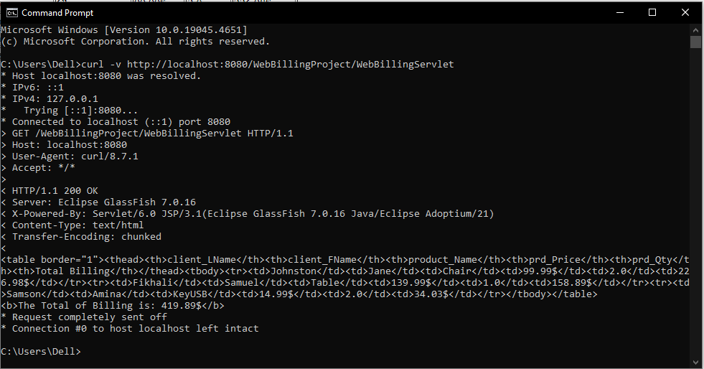
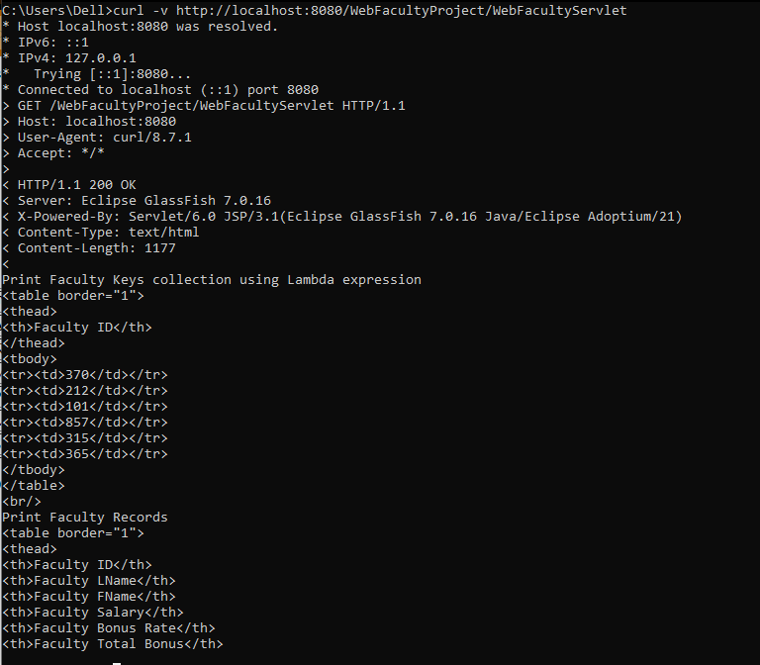

Using Postman Tool
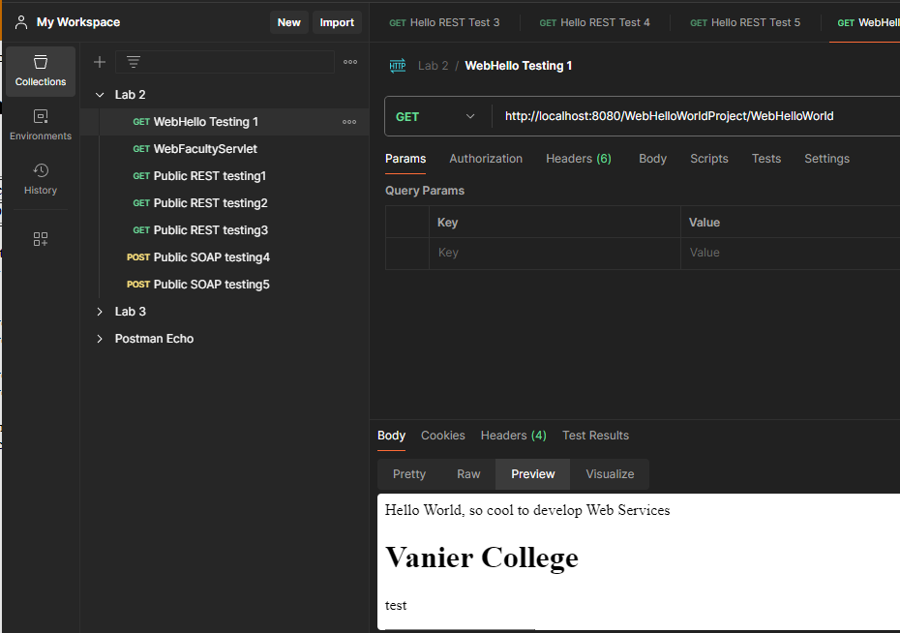
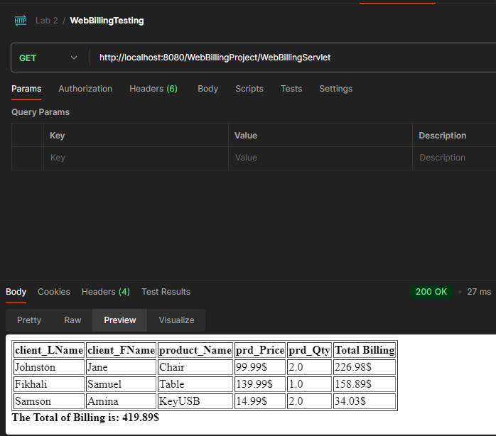
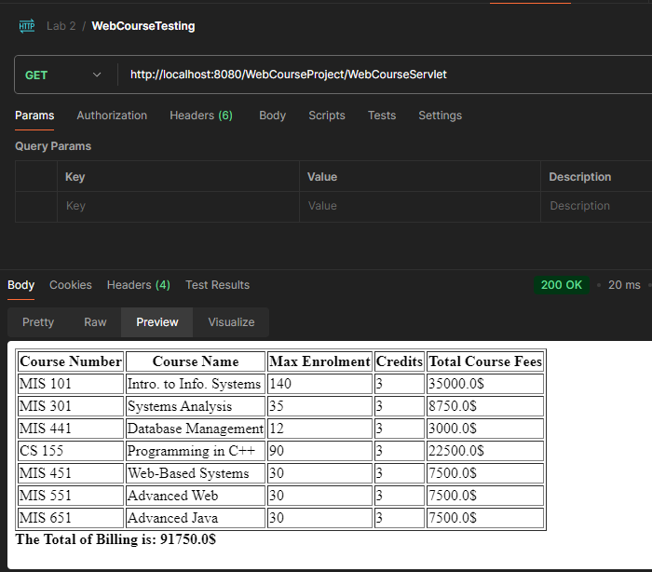

Using Public REST API used in Presentation 2
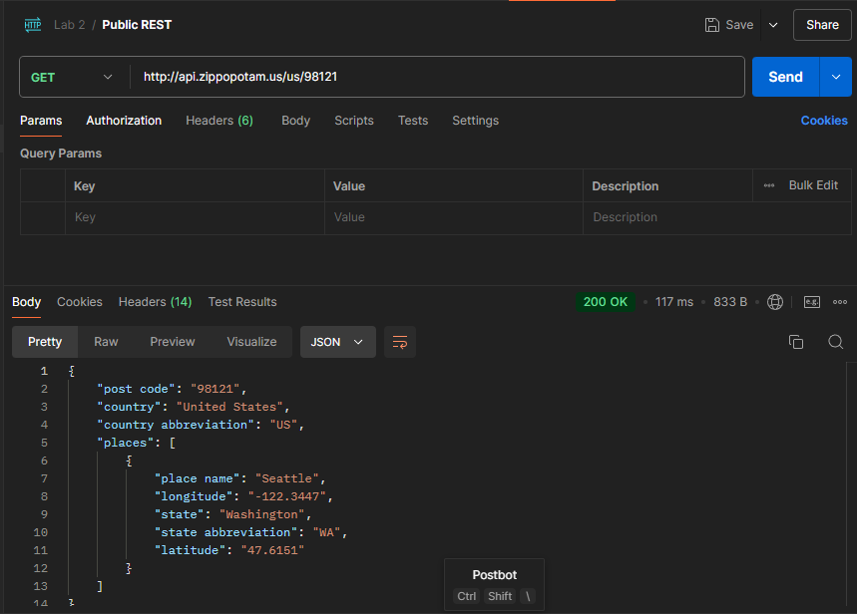
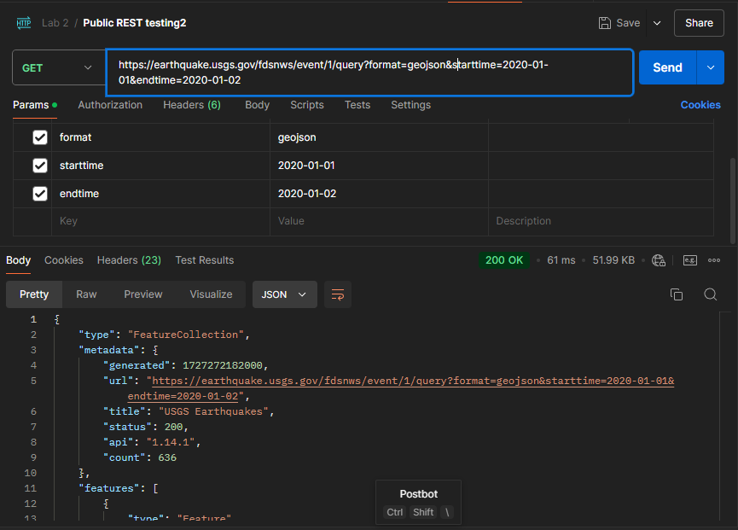
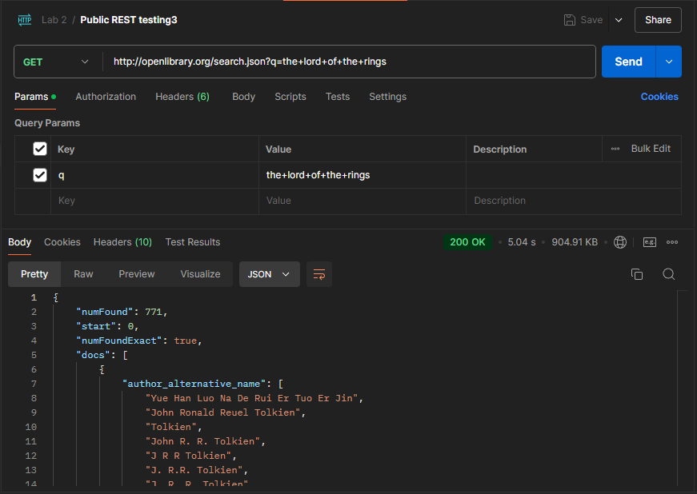

Using Public SOAP APIs used in Presentation 2
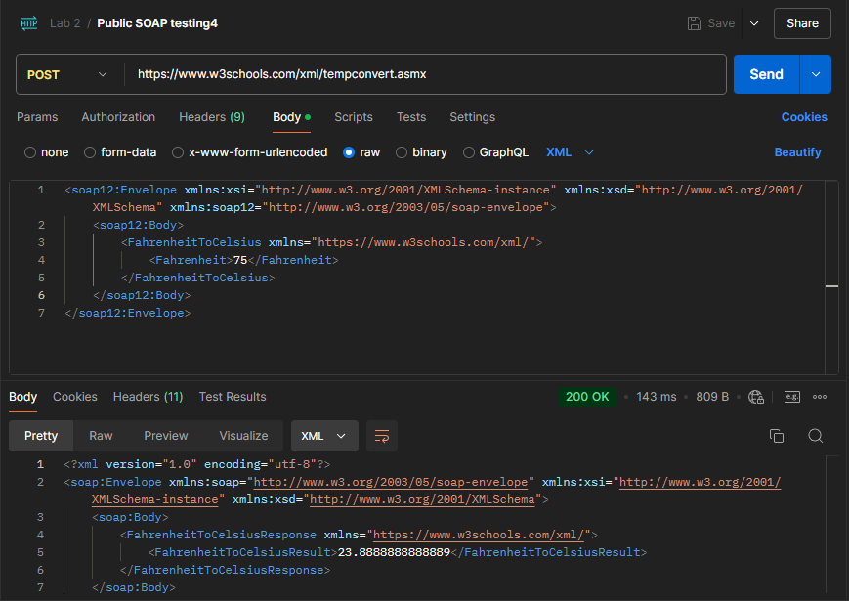
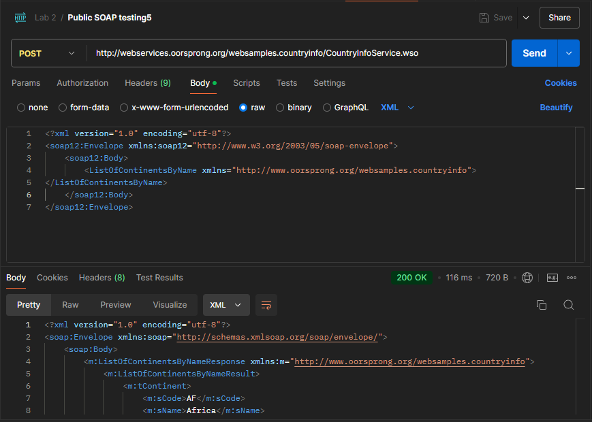
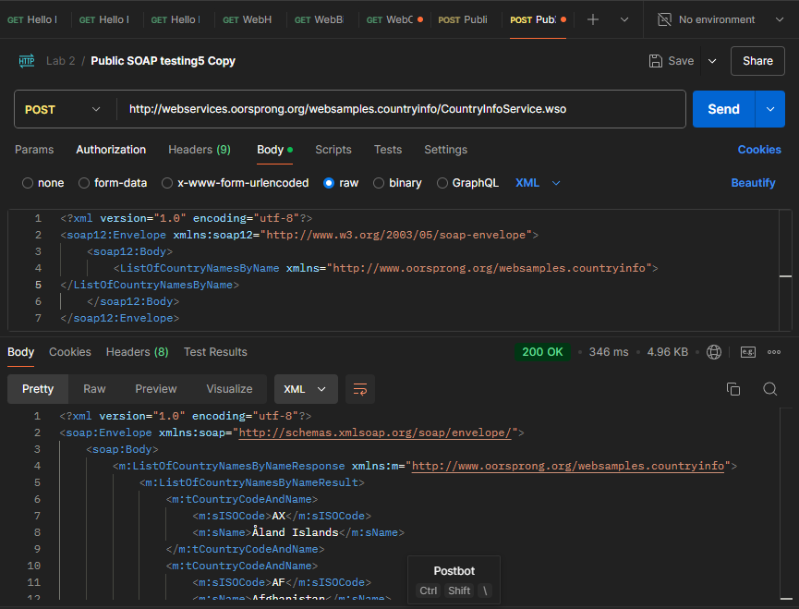

Public REST Resources OTHER THAN in Presentation 2
HTTP link request | https://cat-fact.herokuapp.com/facts/
Request Method used | GET
HTTP Response | [  {  "status": {  "verified": true,  "sentCount": 1  },  "_id": "58e008780aac31001185ed05",  "user": "58e007480aac31001185ecef",  "text": "Owning a cat can reduce the risk of stroke and heart attack by a third.",  "__v": 0,  "source": "user",  "updatedAt": "2020-08-23T20:20:01.611Z",  "type": "cat",  "createdAt": "2018-03-29T20:20:03.844Z",  "deleted": false,  "used": false  },  {
Data Format of Response | JSON
Overall Image Screenshot | 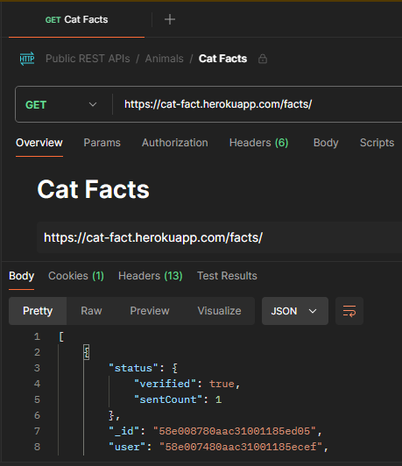

HTTP link request | https://api.ip2country.info/ip?98.234.97.10
Request Method used | GET
HTTP Response | <!DOCTYPE html>  <!--[if lt IE 7]> <html class="no-js ie6 oldie" lang="en-US"> <![endif]-->  <!--[if IE 7]> <html class="no-js ie7 oldie" lang="en-US"> <![endif]-->  <!--[if IE 8]> <html class="no-js ie8 oldie" lang="en-US"> <![endif]-->  <!--[if gt IE 8]><!--> <html class="no-js" lang="en-US"> <!--<![endif]-->  <head>  <title>api.ip2country.info | 522: Connection timed out</title>  <meta charset="UTF-8" />  <meta http-equiv="Content-Type" content="text/html; charset=UTF-8" />  <meta http-equiv="X-UA-Compatible" content="IE=Edge" />  <meta name="robots" content="noindex, nofollow" />  <meta name="viewport" content="width=device-width,initial-scale=1" />  <link rel="stylesheet" id="cf_styles-css" href="/cdn-cgi/styles/main.css" />
Data Format of Response | HTML
Overall Image Screenshot | 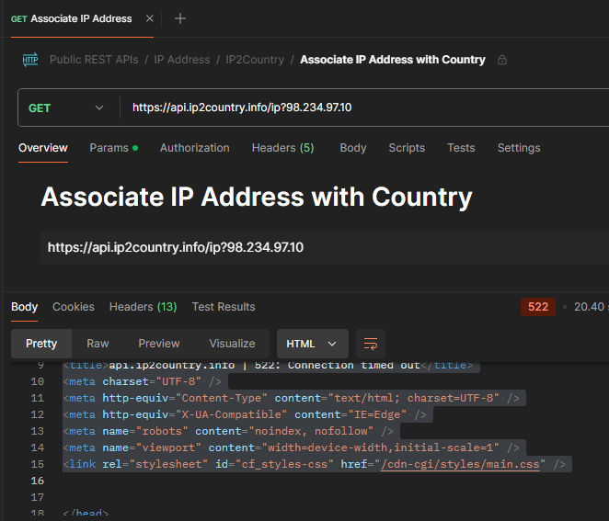

HTTP link request | https://pokeapi.co/api/v2/pokemon/ditto/
Request Method used | GET
HTTP Response | {  "abilities": [  {  "ability": {  "name": "limber",  "url": "https://pokeapi.co/api/v2/ability/7/"  },  "is_hidden": false,  "slot": 1  },  {  "ability": {  "name": "imposter",  "url": "https://pokeapi.co/api/v2/ability/150/"  },  "is_hidden": true,  "slot": 3  }  ],  "base_experience": 101,  "cries": {  "latest": "https://raw.githubusercontent.com/PokeAPI/cries/main/cries/pokemon/latest/132.ogg",  "legacy": "https://raw.githubusercontent.com/PokeAPI/cries/main/cries/pokemon/legacy/132.ogg"  },  "forms": [
Data Format of Response | JSON
Overall Image Screenshot | 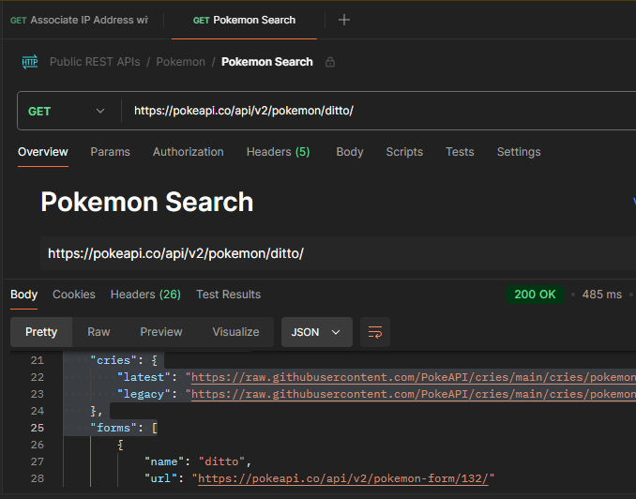

Public SOAP Resources OTHER THAN in Presentation 2
HTTP link request | http://www.dneonline.com/calculator.asmx
Request Method used | POST
Request Headers used | Content-Type: text/xml; charset=utf-8
Request XML body | <?xml version="1.0" encoding="utf-8"?>  <soap:Envelope xmlns:xsi="http://www.w3.org/2001/XMLSchema-instance" xmlns:xsd="http://www.w3.org/2001/XMLSchema" xmlns:soap="http://schemas.xmlsoap.org/soap/envelope/">  <soap:Body>  <Multiply xmlns="http://tempuri.org/">  <intA>111</intA>  <intB>999</intB>  </Multiply>  </soap:Body>  </soap:Envelope>
Response XML body | <?xml version="1.0" encoding="utf-8"?>  <soap:Envelope xmlns:soap="http://schemas.xmlsoap.org/soap/envelope/" xmlns:xsi="http://www.w3.org/2001/XMLSchema-instance" xmlns:xsd="http://www.w3.org/2001/XMLSchema">  <soap:Body>  <MultiplyResponse xmlns="http://tempuri.org/">  <MultiplyResult>110889</MultiplyResult>  </MultiplyResponse>  </soap:Body>  </soap:Envelope>
Overall image Screenshot | 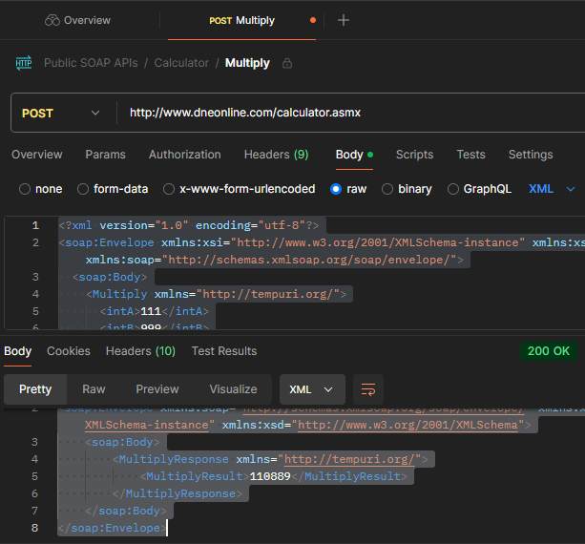

HTTP link request | http://webservices.oorsprong.org/websamples.countryinfo/CountryInfoService.wso
Request Method used | POST
Request Headers used | Content-Type: text/xml
Request XML body | <?xml version="1.0" encoding="utf-8"?>  <soap12:Envelope xmlns:soap12="http://www.w3.org/2003/05/soap-envelope">  <soap12:Body>  <ListOfCurrenciesByName xmlns="http://www.oorsprong.org/websamples.countryinfo">  </ListOfCurrenciesByName>  </soap12:Body>  </soap12:Envelope>
Response XML body | <?xml version="1.0" encoding="utf-8"?>  <soap:Envelope xmlns:soap="http://schemas.xmlsoap.org/soap/envelope/">  <soap:Body>  <m:ListOfCurrenciesByNameResponse xmlns:m="http://www.oorsprong.org/websamples.countryinfo">  <m:ListOfCurrenciesByNameResult>  <m:tCurrency>  <m:sISOCode>AFA</m:sISOCode>  <m:sName>Afghanis</m:sName>
Overall image Screenshot | 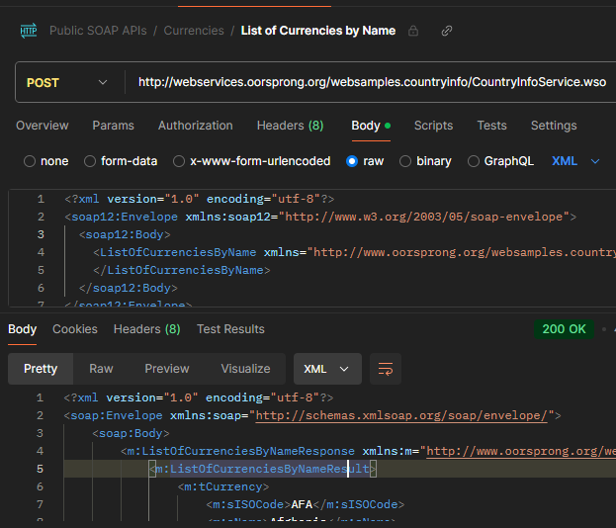

HTTP link request | http://webservices.oorsprong.org/websamples.countryinfo/CountryInfoService.wso
Request Method used | POST
Request Headers used | Content-Type: text/xml
Request XML body | <?xml version="1.0" encoding="utf-8"?>  <soap:Envelope xmlns:soap="http://schemas.xmlsoap.org/soap/envelope/">  <soap:Body>  <ListOfLanguagesByName xmlns="http://www.oorsprong.org/websamples.countryinfo">  </ListOfLanguagesByName>  </soap:Body>  </soap:Envelope>
Response XML body | <?xml version="1.0" encoding="utf-8"?>  <soap:Envelope xmlns:soap="http://schemas.xmlsoap.org/soap/envelope/">  <soap:Body>  <m:ListOfLanguagesByNameResponse xmlns:m="http://www.oorsprong.org/websamples.countryinfo">  <m:ListOfLanguagesByNameResult>  <m:tLanguage>  <m:sISOCode>abk</m:sISOCode>  <m:sName>Abkhazian</m:sName>  </m:tLanguage>
Overall image Screenshot | 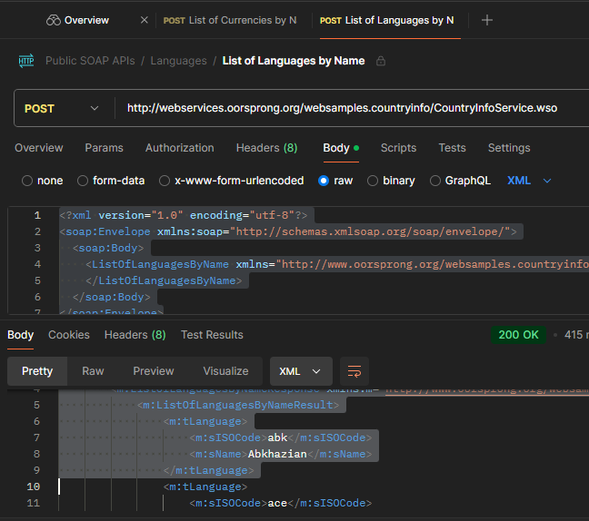

7.1 WebFacultyProject
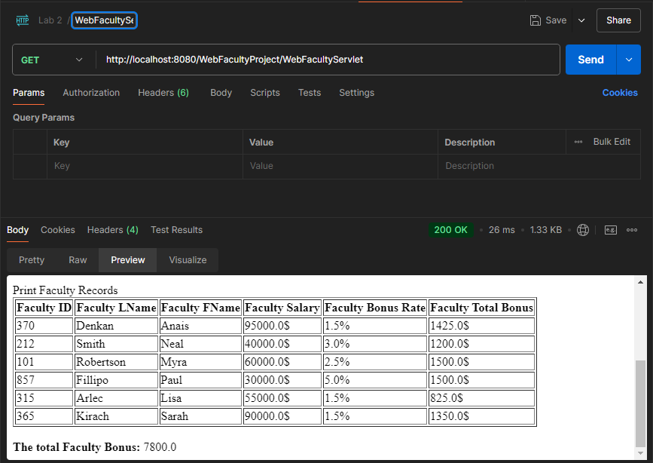

7.2 WebCarProject
