Biology

1. Cell

Basic structural organ and discovered by Robert hooke in 1665

Two categories Multicellular and Unicellular

A single-celled organism performs all the essential functions that a multicellular organism performs.

Unlike other organisms, Amoeba has no definite shape; so, it keeps on changing its shape.

Amoeba has pseudopodia, which means – **pseudo** means false and **podia** means feet

Protoplasm is known as living substance of the cell

The cells having nuclear substances without nuclear membranes are known as Prokaryotic cells , eg : bacteria and blue green algae

The cells having well organized nucleus with nuclear membranes are known as Eukaryotic cells , eg all multicellular organisms

1. Cell Structure Function

Cell membrane is also known as plasma membrane

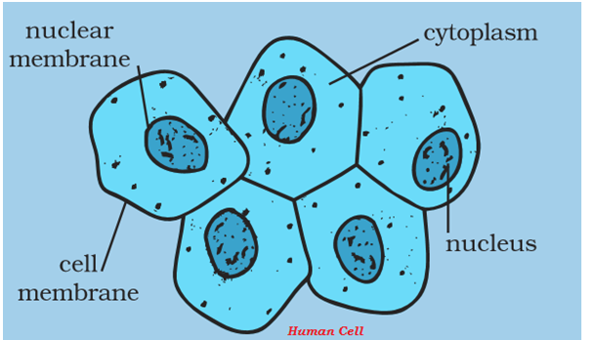

Plasma membrane is porous and allows certain number of elements inside and out

Central dense structure is known as Nucleus and almost spherical in shape

Jelly like substance b/w Nucleus and Plasma membrane is known as cytoplasm

Cytoplasm contains Motochondria,Ribosomes,Golgi bodies

Nucleus is separated from cytoplasm by a porus membrane known as nucleus mebrane

Nucleus contains threadlike structure known as chromosomes

Chromosomes contains genes which is responsible for inheritance properties.

Entire constituents of living cell is known as Protoplasm includes nucleus and cytoplasm

1. Plant Cell

Cell membrane gives shape to the cell

Cell wall is there , additional covering to cell membrane not present in animal cell

Cell wall gives rigidity , Protection from varying temperature high wind etc.

Cell wall present in bacterial cells

Size of smallest cell .1-.5 micrometer in bacterial cell , largest 170mm*130mm in ostrich egg

Size of cells doesn’t have any relation to size of the plant or animal

Small colored bodies in the cytoplasm of Leaf are known as plastids

Green colored plastids are Chlorophyll which is essential for photosynthesis

1. The Fundamental Unit of life   
    1674 – Leeuwenhoek , developed microscope

1831 – Robert brown discovered Nucleus

1839 – Purkinje discovered Protoplasm

Cell theory – cell is the basic unit of life all the animals and plants are made up of cells

1. Significant Characteristics of cells

Each cell has the aptitude to perform basic functions.

Each cell has specific components known as organelles .

Different organelles has different function and different cell also have different function

All cells are found to have same organelles irrespective of their different functions and organism they found in

1. Plasma Membrane or Cell Membrane

Outermost covering layer of the cell which allows certain materials to go inward and outward so it is known as Selectively permeable membrane

Movement is through osmosis

Cell wall : Additional protection layer present in Plants only made up of cellulose. It is out side plasma membrane

1. Nucleus

In Latin known as kernel

Have double layered covering known as Nuclear Membrane which lets certain materials inward (to nucleus) outward (cytoplasm)

Nucleus contains chromosomes , in a rod shaped structure visible only when cell is about to divide

Chromosomes contain DNA (Deoxyribo Nuclic acid – responsible for inheritance) and Protein

DNA also contains essential information to construct and organize cells and functional segments of DNA is known as genes.

DNA is present as chromatin material

Nucleus plays significant role in cell reproduction

1. Cytoplasm

Cells contains cytoplasm inside cell membrane which contains many biomolecules including proteins and nucleic acids

There are many structures present in cells known as organelles

1. Cell organelles

Link : https://www.tutorialspoint.com/biology_part1/biology_the_fundamental_unit_of_life.htm