This is the sample file for extracting the data from this pdf file. Hey, my name is Aman Bhatt.

[Python Module](https://dev.azure.com/ShorthillsCampus/Fresher-Training_2024/_workitems/edit/7900)

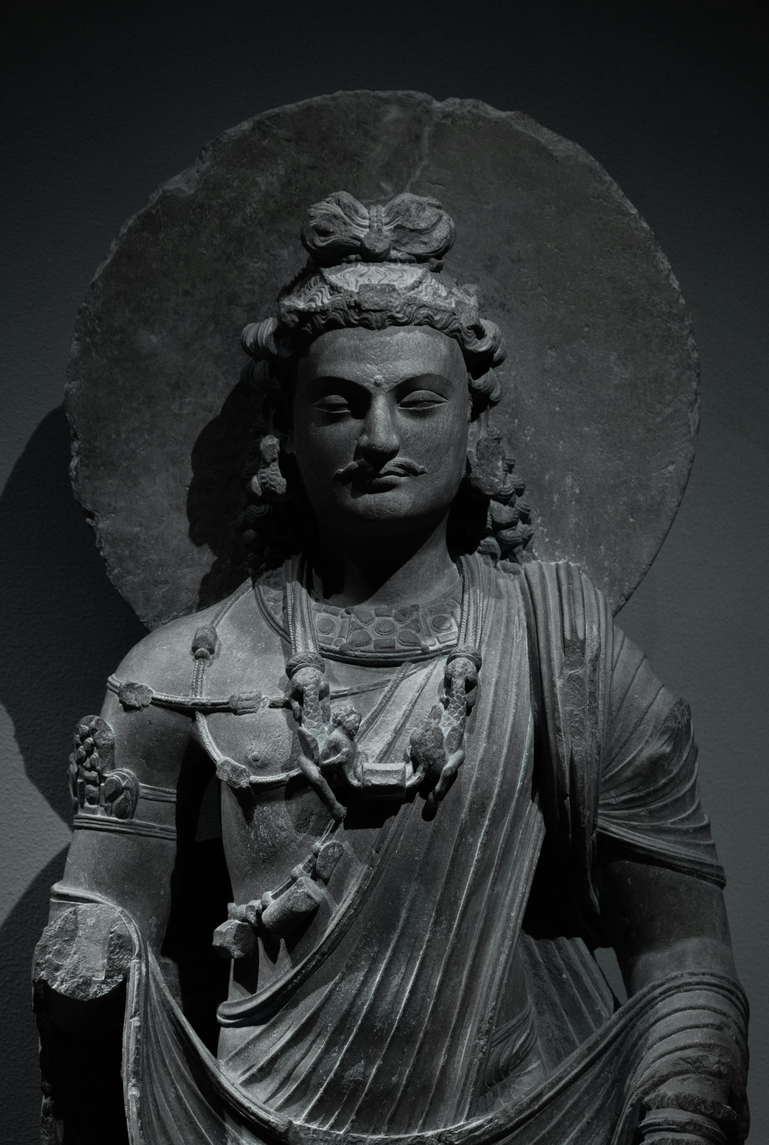

|  |  |  |
| --- | --- | --- |
| Serial Number | First Name | Last Name |
| 1 | Aman | Bhatt |
| 2 | Priyanshu | Kumar |
| 3 | Piyush | Bhandari |
| 4 | Harsh | Morya |
| 5 | Vishnu | Pillai |
| 6 | Cherav | Goyal |