**Program Structures & Algorithms**

**Spring 2022**

**Assignment No. 3**

Name: Vishnu Raj Rajagopal

NUID: 001520806

Section: 8

**Task:**

**1)** To Implement height-weighted Quick Union with Path Compression by filling the missing code in the class UF_HWQUPC.java

**Unit Test Screenshot:**

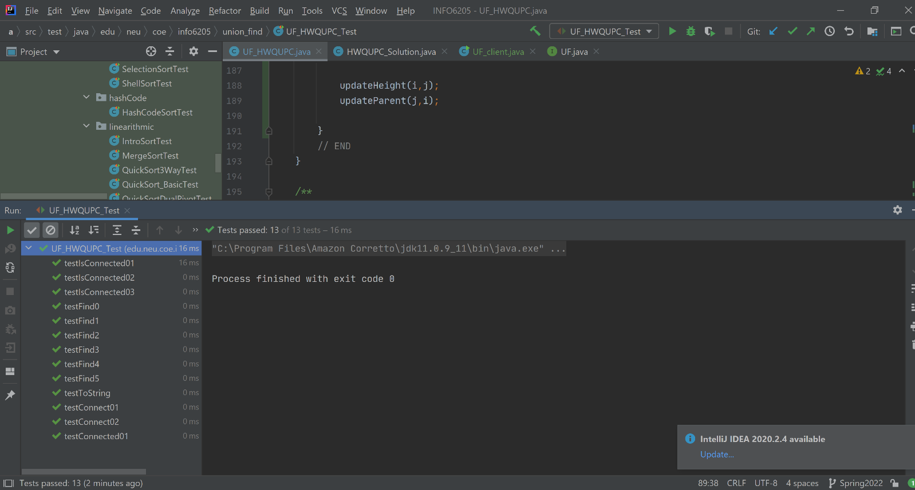

**2)** To develop a UF ("union-find") client that takes an integer value n from the command line to determine the number of "sites." Which then generates random pairs of integers between 0 and n-1, calling connected () to determine if they are connected and union () if not. This is implemented in the UF_client.java file.

**Output Screenshot:**

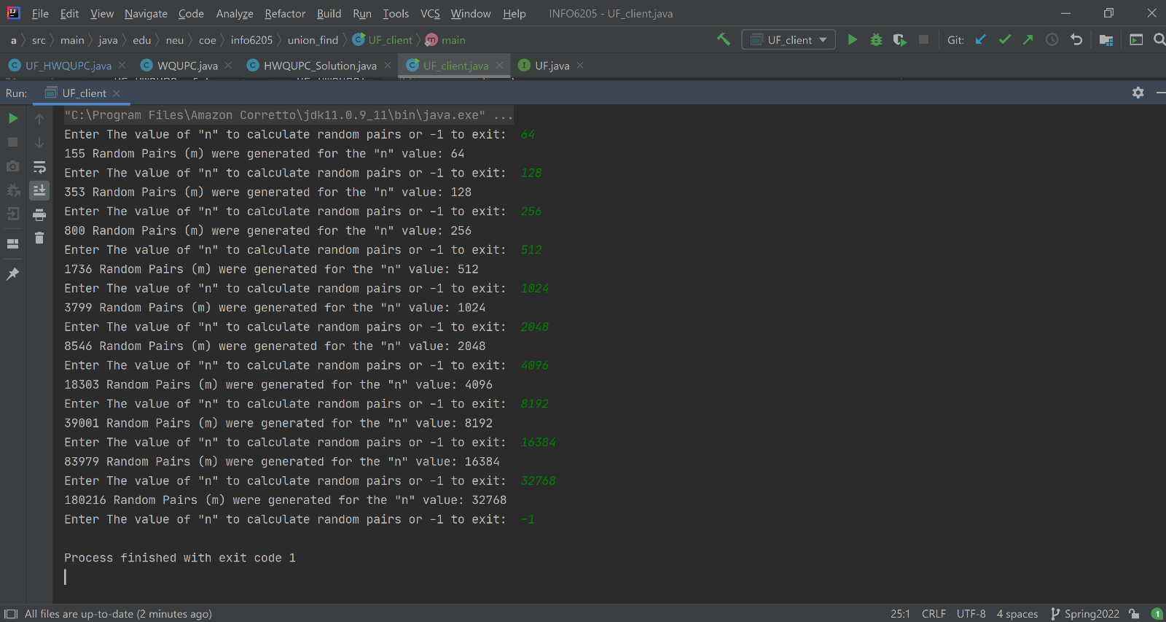

**3)** Relationship between **m** and **n:**

m ≈ 0.5 * n * ln(n)

**Evidence and Graph:**

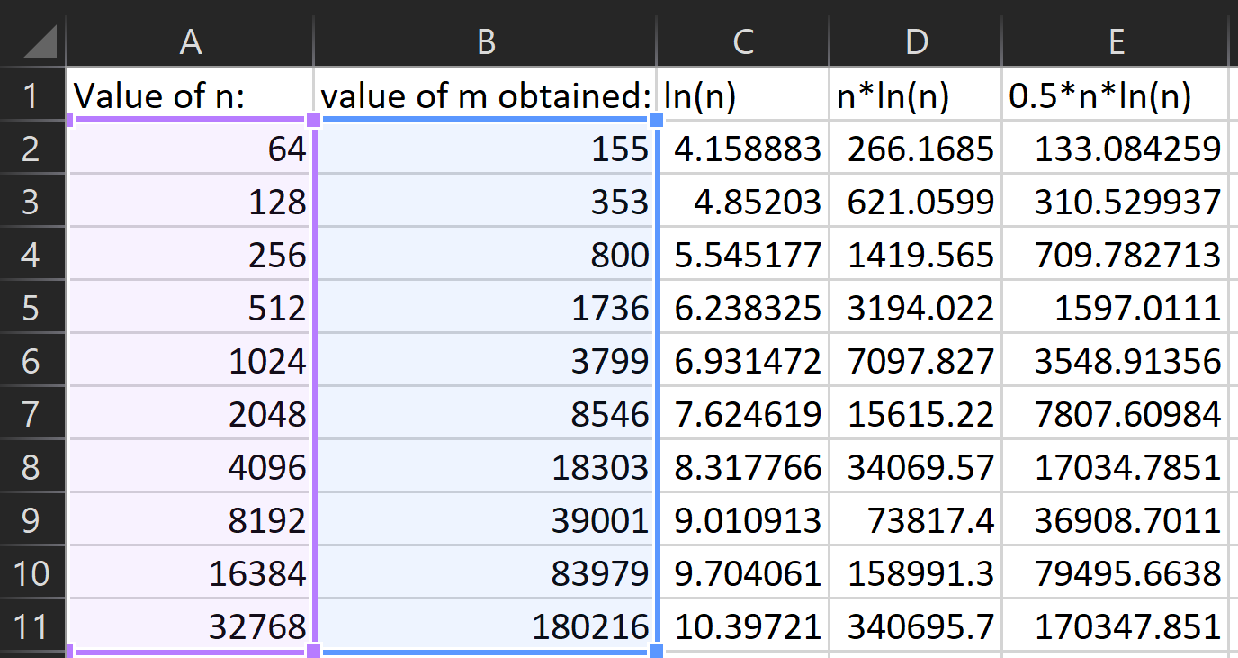

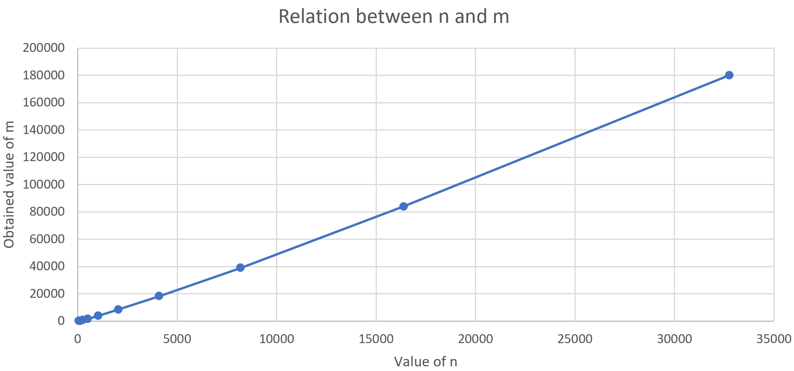

**Conclusion:**

* As Evidentfrom the graph, we see that the relationship between n and m is almost linear in nature when n increase by twice, the value of m becomes almost twice.