**Program Structures & Algorithms**

**Spring 2022**

**Assignment No. 4**

Name: Vishnu Raj Rajagopal

NUID: 001520806

Section: 8

**Task:**

**1)**To prepare a report that shows the results of Parallel Sort experiments and to draw a conclusion (or more) about the efficacy of parallelizing sort. The experiments should involve sorting arrays of sufficient size for the parallel sort to make a difference. You should run with many different array sizes (they must be sufficiently large to make parallel sorting worthwhile, obviously) and different cutoff schemes.

**Output Screenshot:**

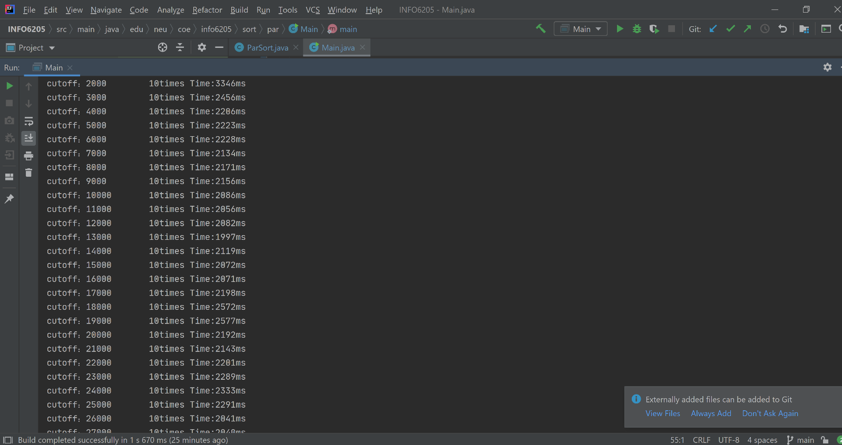

**Analysis:**

**Array Size = 100000**

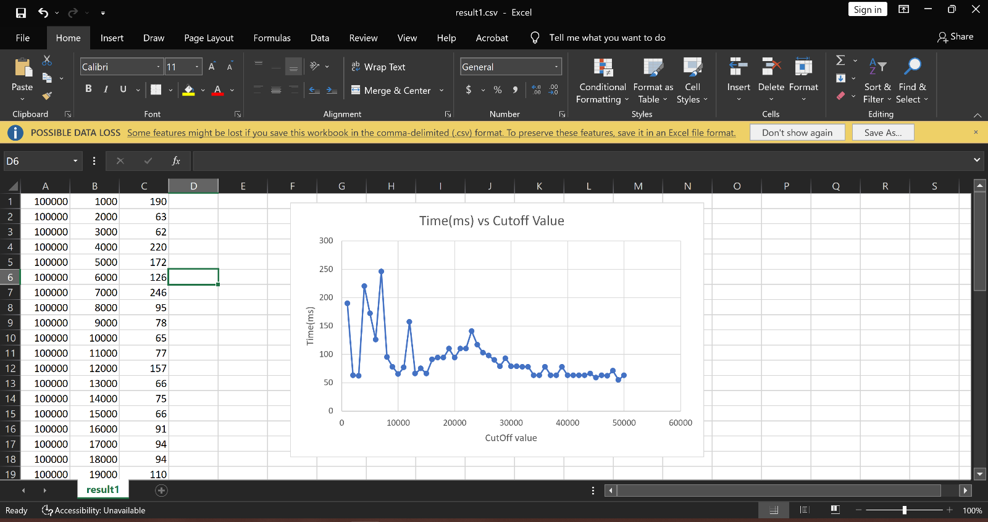

**Array Size = 200000**

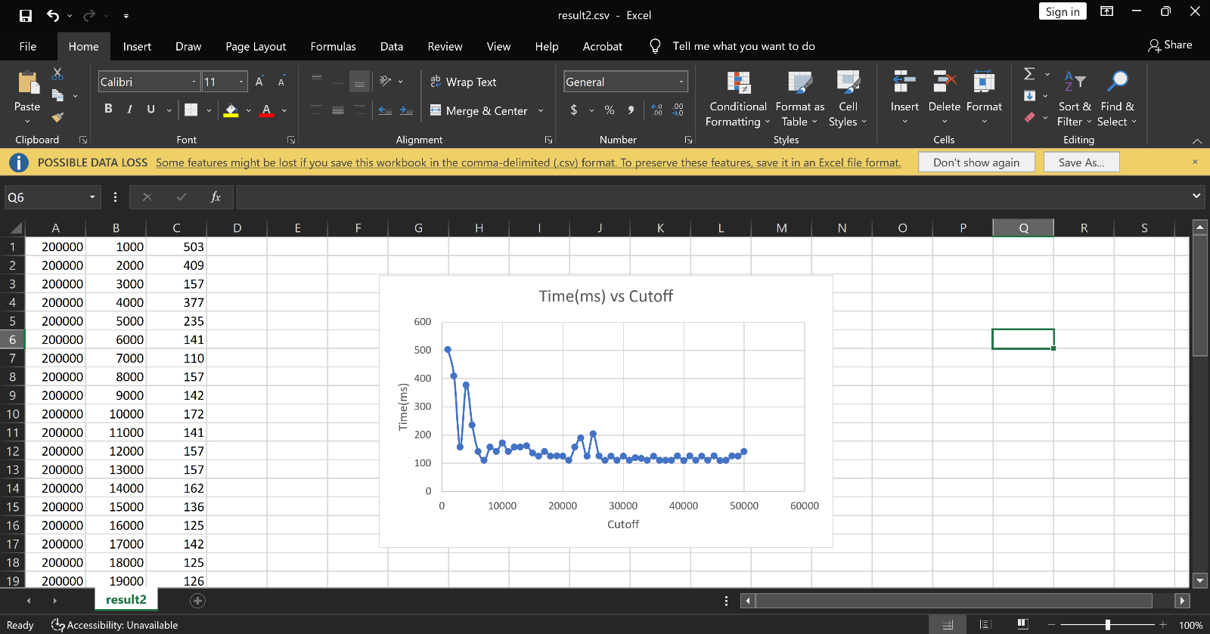

**Array Size = 400000**

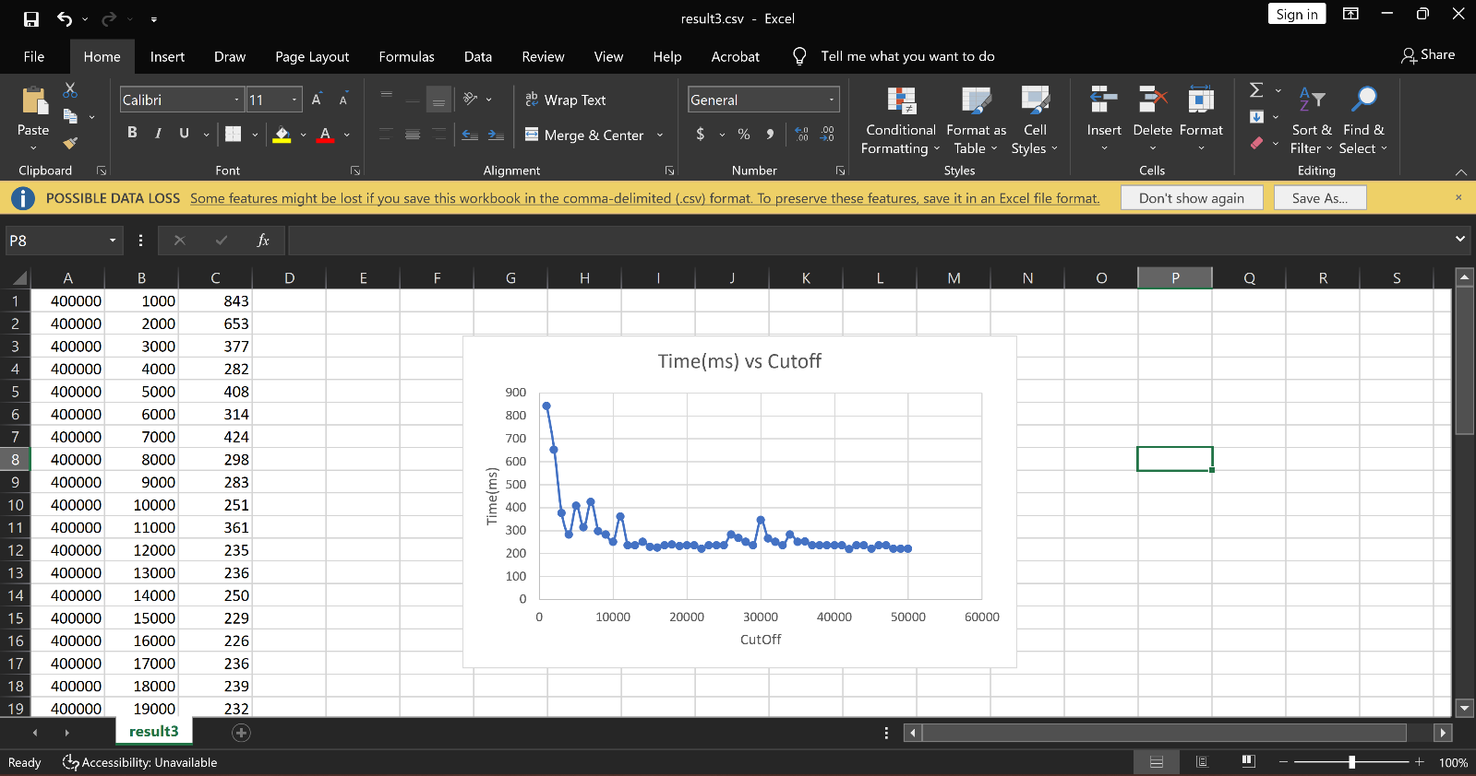

**Array Size = 800000**

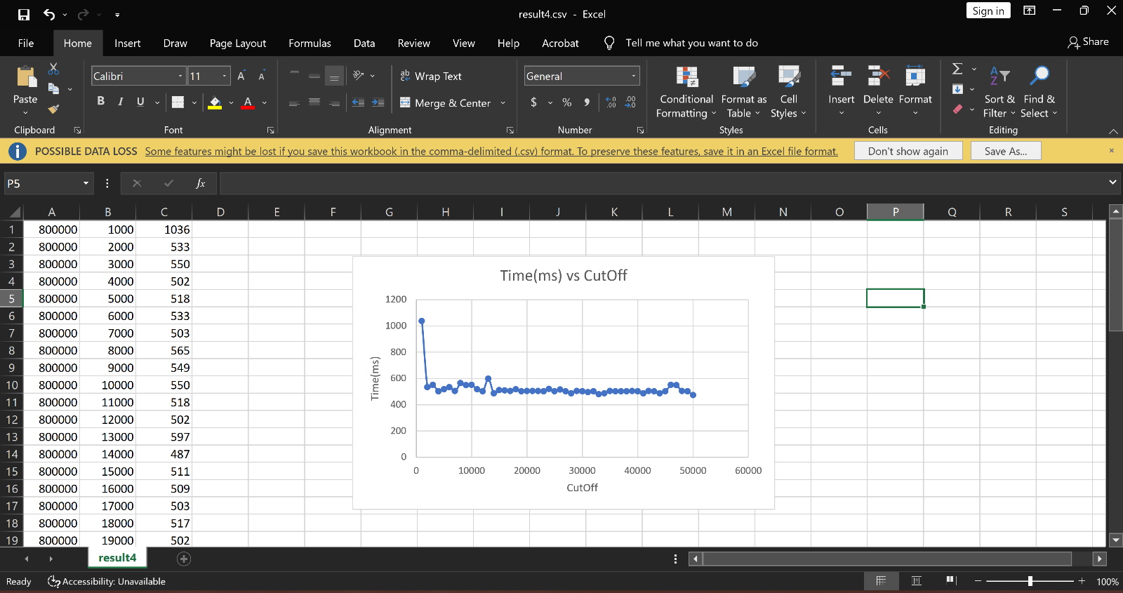

**Array Size = 1600000**

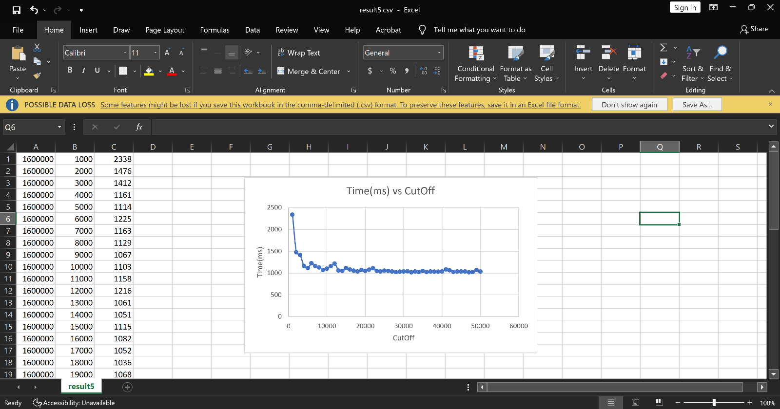

**Array Size = 3200000**

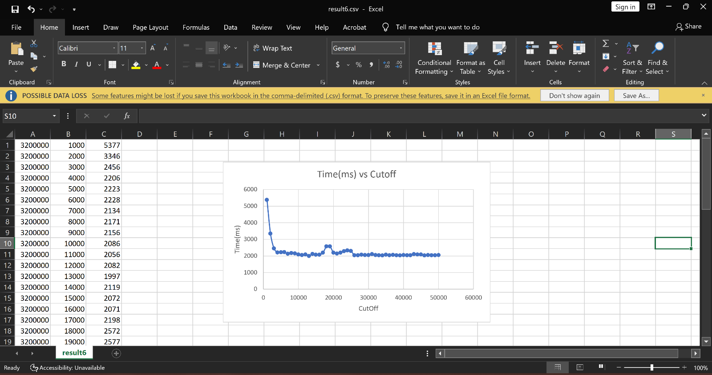

**Conclusion:**

By Varying the cutoff starting from 1000 and incrementing it by 1000 till the maximum of 50000 for various sizes of array we see that the when the cutoff value increases the time taken to sort parallelly reduces especially this change is very significant for the larger sized array