**Auto Suggestion Customer Name Using Javascript and Ajax**

To make the application more user friendly, the customer want to have auto suggestion like google suggestion to their application. The customer gave this requirement and asked for a proof-of-concept in a single page in their next release. The team had selected the customer name search field used in one of their page for this POC.   
The auto suggestion is triggered when the user enters some text in the input field. The entire customer name list is stored in a XML file which is used to provide the suggestion. Use ajax to load the xml file. 

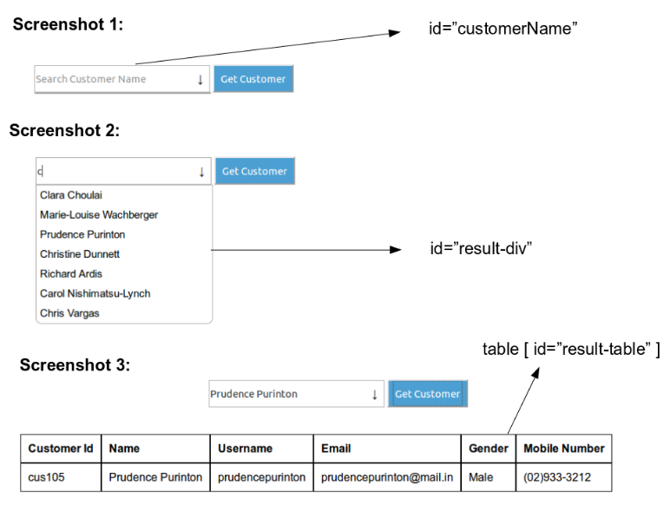   
When the user selects a customer and clicks on "Get Customer" button then display the customer details in a tabular format.