**Filter Customer Using Js**

Searching for a particular row in a bigger table is time consuming and lot of time was spent by the customers. To reduce the time they the team want to filter the records based on the value user type in the text field. Help the team to provide a proof-of-concept for them to include in their product.   
Use the customer details provided in the XML file.   
  
**Screenshot 1 :  
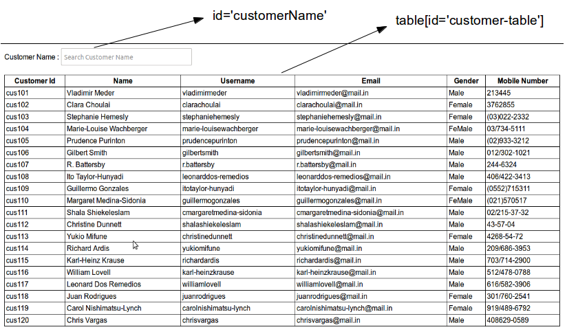**   
  
**Screenshot 2 :  
