# Project on sql sever

**AIM : TO EXTRACT OR RETRIVE DATA FROM DATA BASE ON OUR REQUIREMENT.**

DATA : DATA WAS PROVIDED BY OUR COLLEGE FACULTY ON COMPANY PRODUCT SALES .THE COMPANY DATABSE CREATED BY ME CONTAINS SEVERAL TABLES,HERE IS DATABASE DIGRAM TO UNDESTAND THOROUGHLY.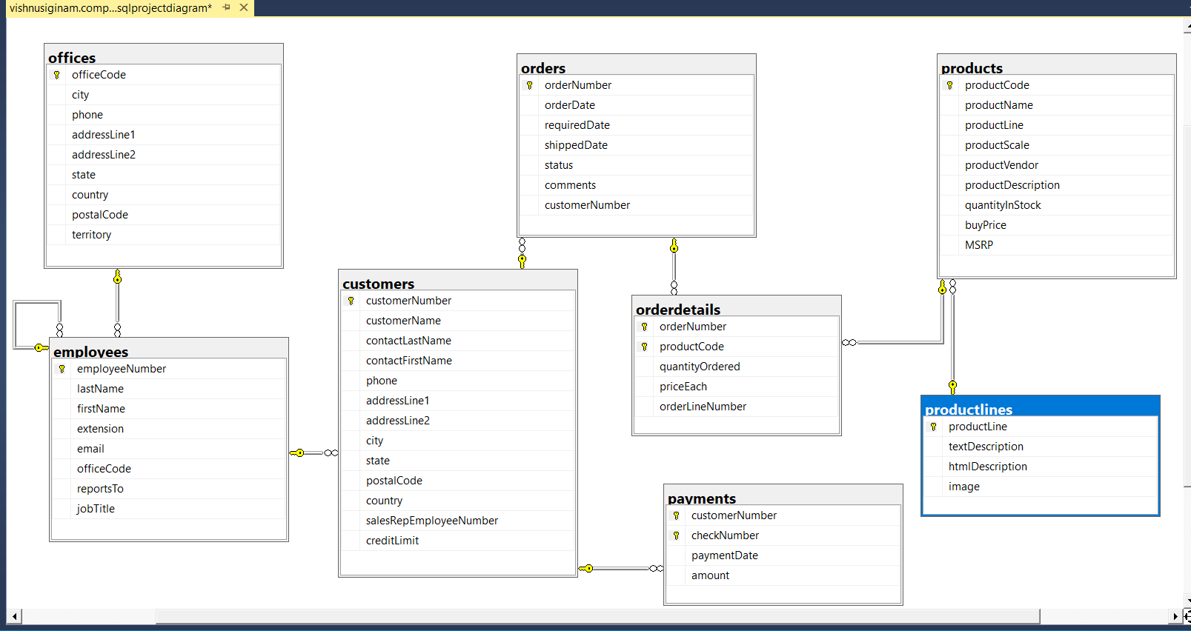

**QUERIES :**

**Q1) LIST THE CUSTOMERS KEPT ORDERS MORE THAN 100 PRODUCTS.**

**RESULT:**

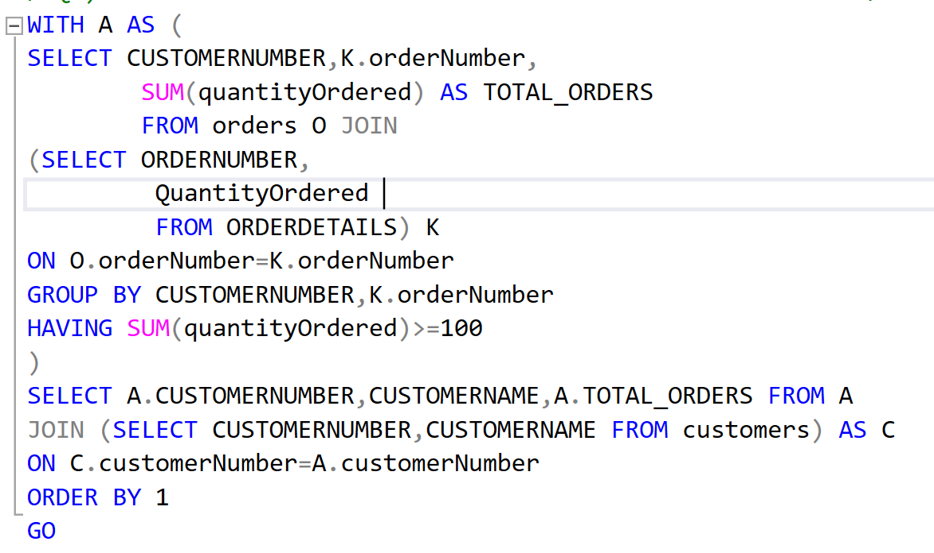

**PAGE:3**

**EXPLANATION:**

**FIRST I HAD RETRIVED QUANTITY OF ORDERS FROM ORDERDETAILS TABLE AND MENTIONED IT IN THE DERVIVED TABLE NAMED k. THEN I HAD JOINED THE TABLE K WITH ORDERS TABLE FOR GETTING THE ATTRIBUTE CUSTOMERNUMBER NEXT TO GET SUM OFTHE ORDERS KEPT BY CUSTOMERS REPEATEDLY OR SINGLE ORDER , I HAD USED AGGREGATE FUNCTION “SUM()”.**

**TO GET THE CUSTOMER NUMBER WHO’S ORDERS ARE GREATER THAN “100” I USED HAVING CLAUSE.I HAD CONCLUDED THE COMPLETE SENARIO IN COMMON TABLE EXPESSION NAMED A AND JOINED TABLE A WITH CUSTOMERS TO GET ATTRIBUTE CUSTOMER NAME.**

**Q2.) List the customers who has the second-highest number of orders .**

**RESULT:**

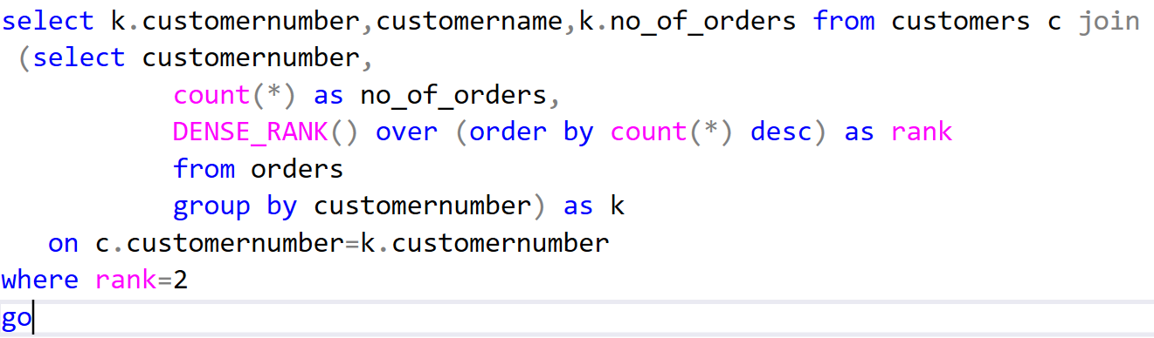

**Explanation:**

**I had aggregated the customer number by using “count()” function from table named orders. I mentioned it in derived table named k, then I joined the table with customers to get customername attribute.in derived table k, I had used “dense_rank()” function to get rank based on number of orders placed by customers. finally I had used where clause to filter data where customers can have same number of second highest number of orders.**

**Q3.) EMPLOYEE WISE AMOUNT GAINED FROM CUSTOMERS.**

**Result:**

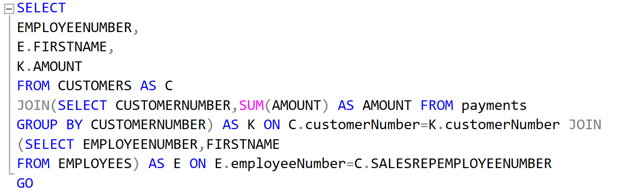

**Explanation: first I had retrieved customer numbers from payments table and**

**Page:4**

**got sum of amount paid by each customer by “sum()” function. then I joined the table with customers to get attribute employee number that employee number who had organised order matches with customer number in table k .**

**Then I joined with employees to get employee name attribute.**

**Q4.) list employee wise no of customers placed orders.**

**Result:**

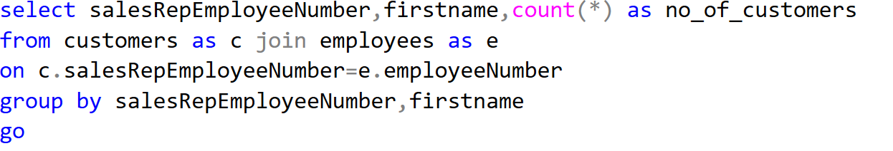

**Explanation:**

**From customers I got salesemployeenumber and I had joined with employees to get employee name attribute , we get the matching data . finally I had used aggregate function “count()”. To get employee wise number of orders.**

**Q5.) LIST OUT CUSTOMER DETAILS WHO PLACED ORDERS IN THE YEAR 2004.**

**RESULT:**

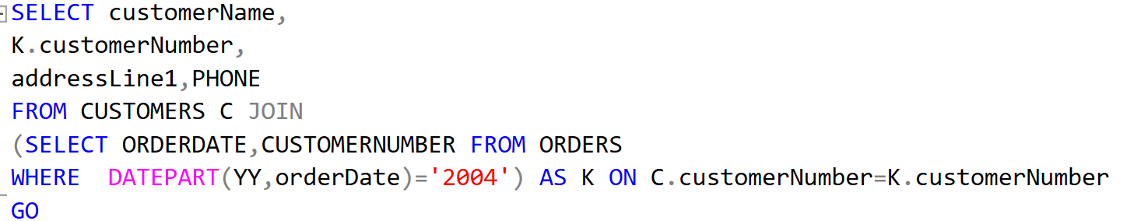

**EXPLANATION:**

**I GOT CUSTOMER DETAILS FROM CUSTOMERS TABLE . JOINED IT WITH ORDERS TO GET ORDERDATE ATTRIBUTE. FILTRED WITH WHERE CLAUSE USING “DATEPART()” FUNCTION RETRIEVED DATA OF CUSTOMERS PLACED ORDERS ON “2004” and MENTIONED IN DERIVED TABLE.**

**Q6.) PRODUCT WISE NUMBER OF ORDERS FOR THAT PARTICULAR PRODUCT.**

**Result:**

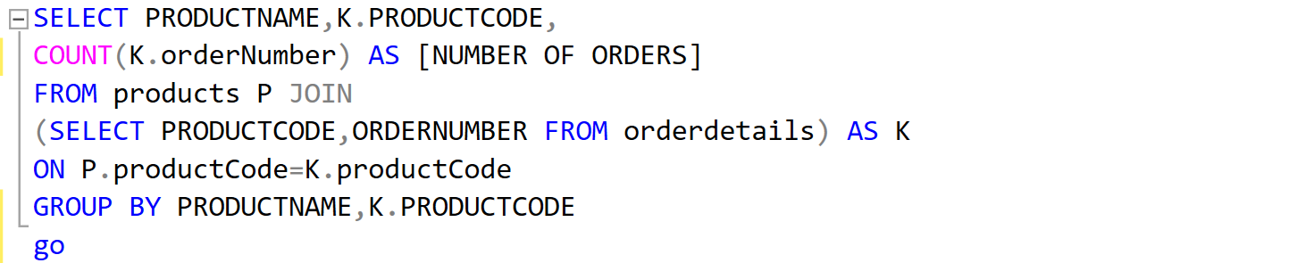

**Page.5**

**Explanation:**

**I HAD RETRIEVED ORDERNUMBER FROM OREDERDETAILS AND MENTIONED IT IN THE DERIVED TABLE JOINED IT WITH PRODUCTS TABLE TO GET PRODUCT NAME ATTRIBUTE AND USED AGGREGATE FUNCTION “COUNT()” TO GROUP THE DATA.**

**Q6.) HOW MANY CUSTOMERS DOES EACH OFFICE TOOK CARE OR EMPLYEES OF EACH OFFICE HANDLED HOW MANY CUSTOMERS.**

**Result:**

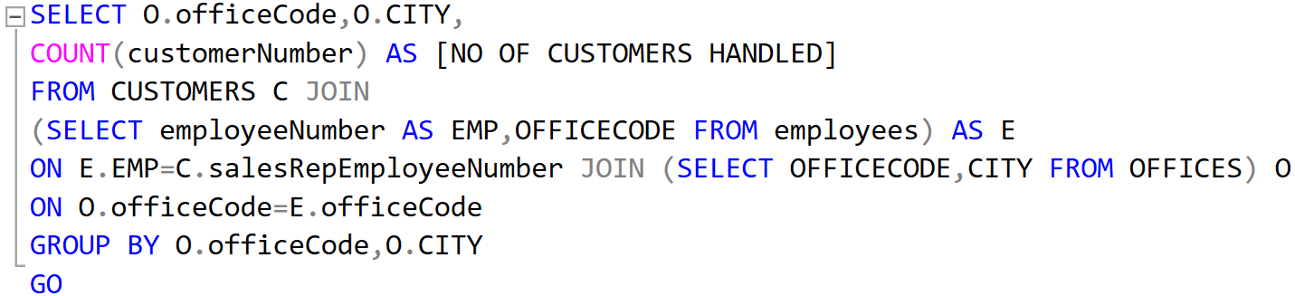

**Explanation:**

**I had selected employee number from employees mentioned in derived table as e and joined it with customers and used aggregate function “count()” to group customers joined this data with offices to get office code and its city attribute.**