**9.Creating a React Application named “cricketapp” with the following components:**

1. ListofPlayers :

* Declare an array with 11 players and store details of their names and scores using the map feature of ES6.

2 .IndianPlayers

**App.js:**

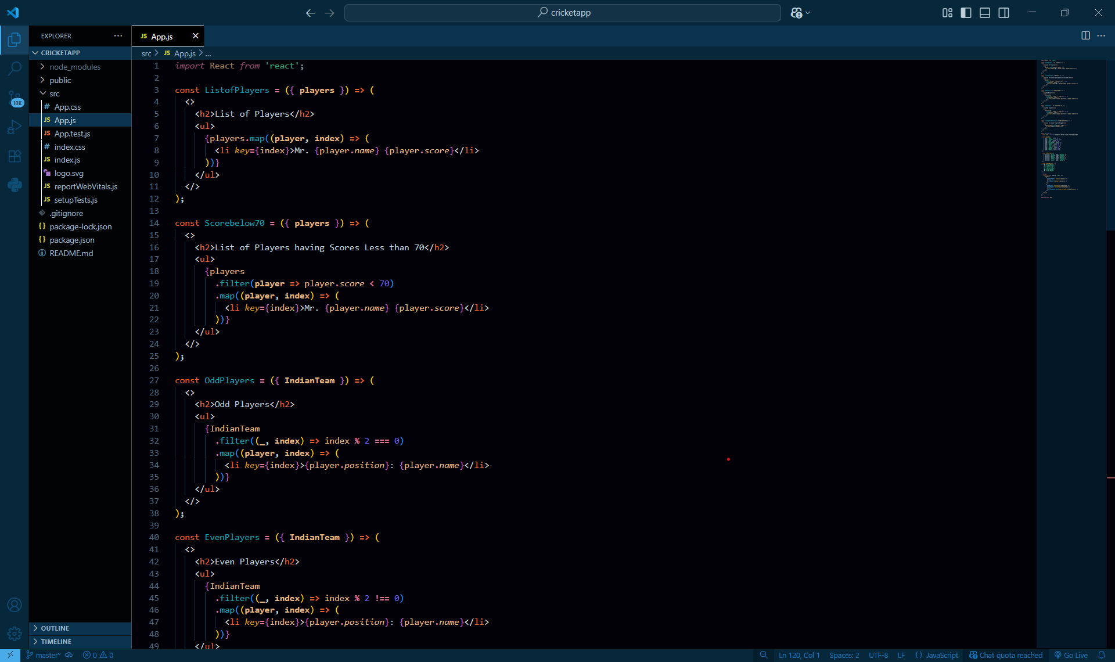

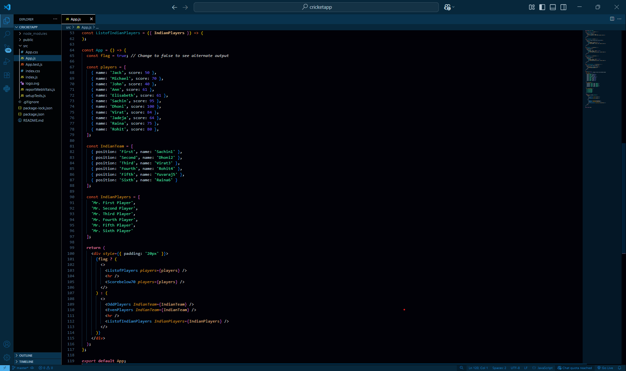

**Output:**

When Flag=true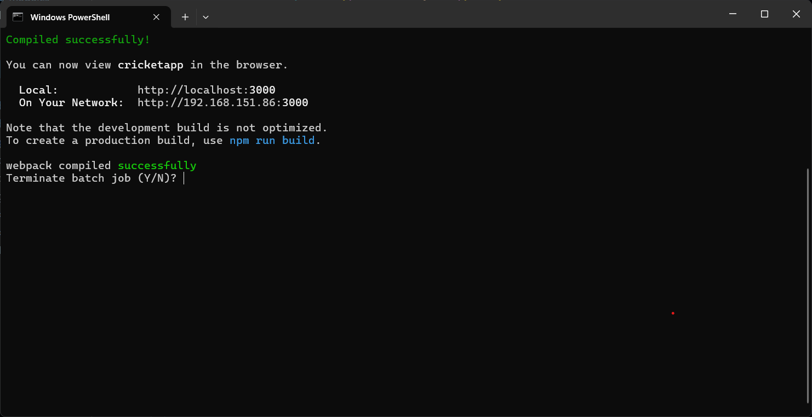

**Browser:**

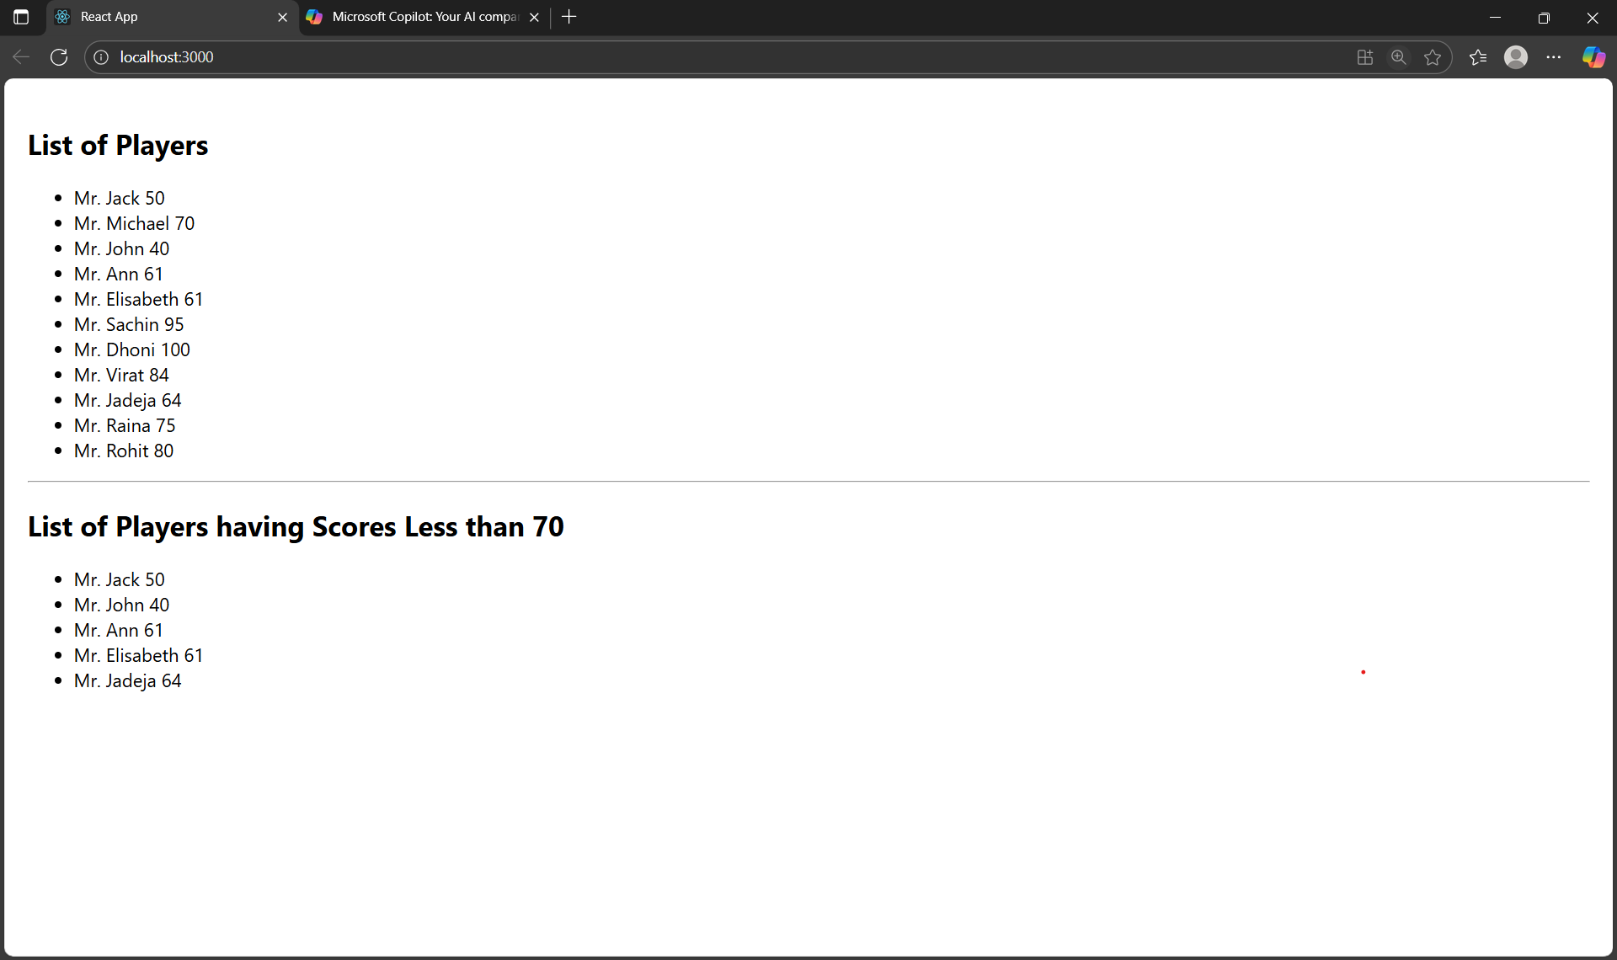

**When Flag=false**

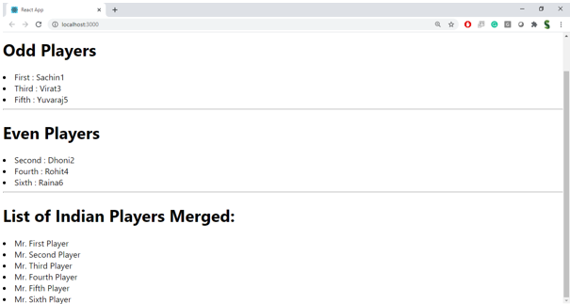

**10.Creating a React Application named “officespacerentalapp” which uses React JSX to create elements, attributes and renders DOM to display the page.**

**App.js:**

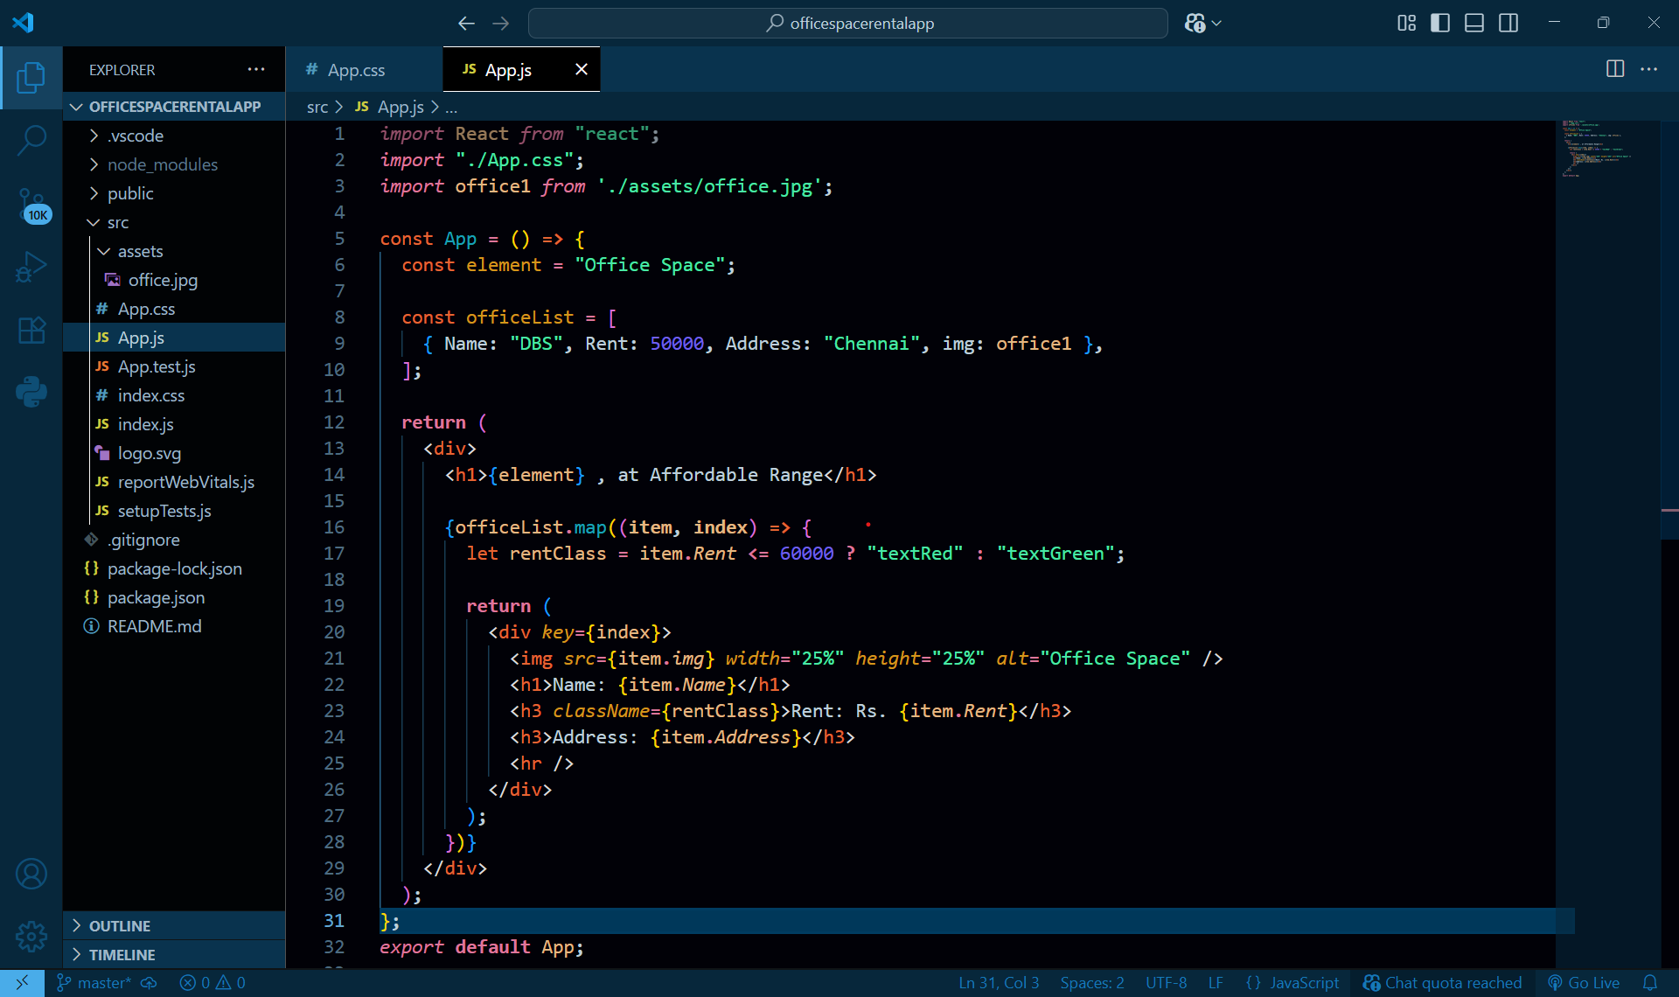

**Output:**

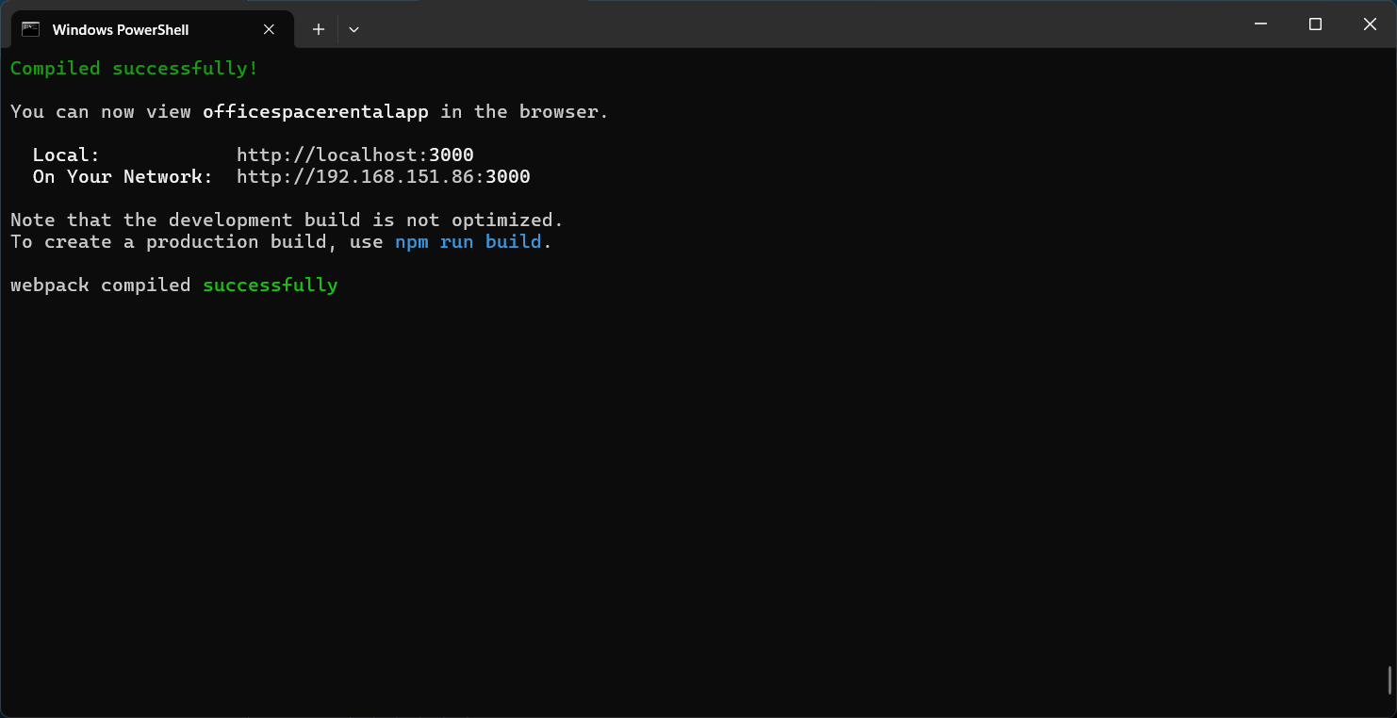

**Browser output:**

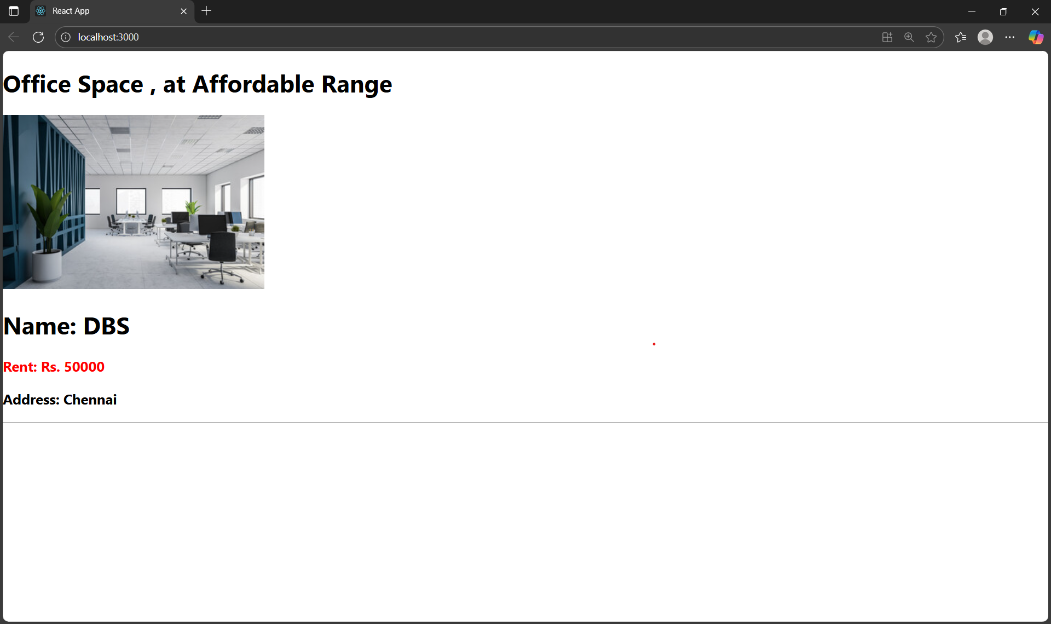

**11.**  **Creating a React Application “eventexamplesapp” to handle various events of the form elements in HTML.**

* 1. To increment the value
  2. Say Hello followed by a static message.

**App.js :**

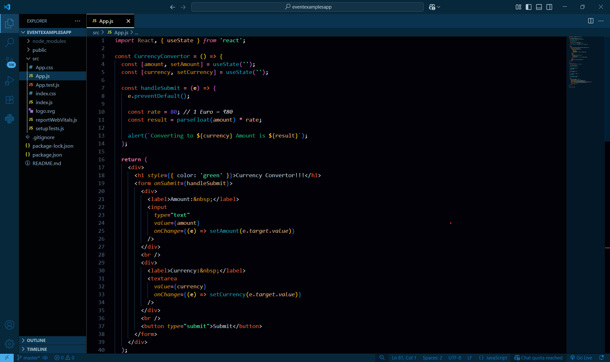

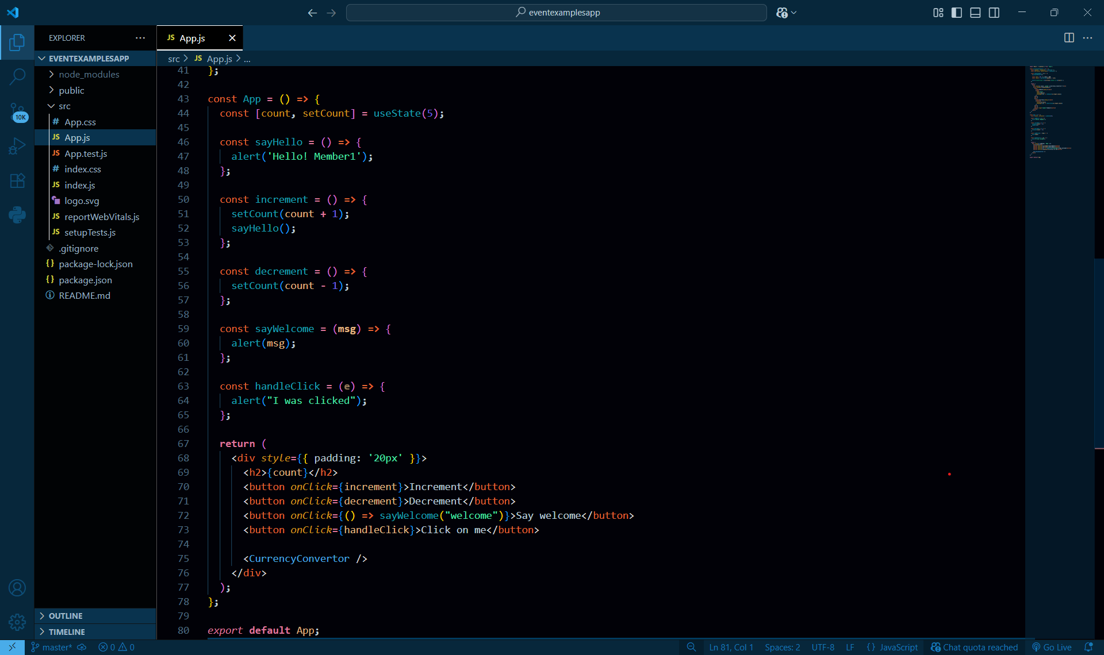

**Output :  
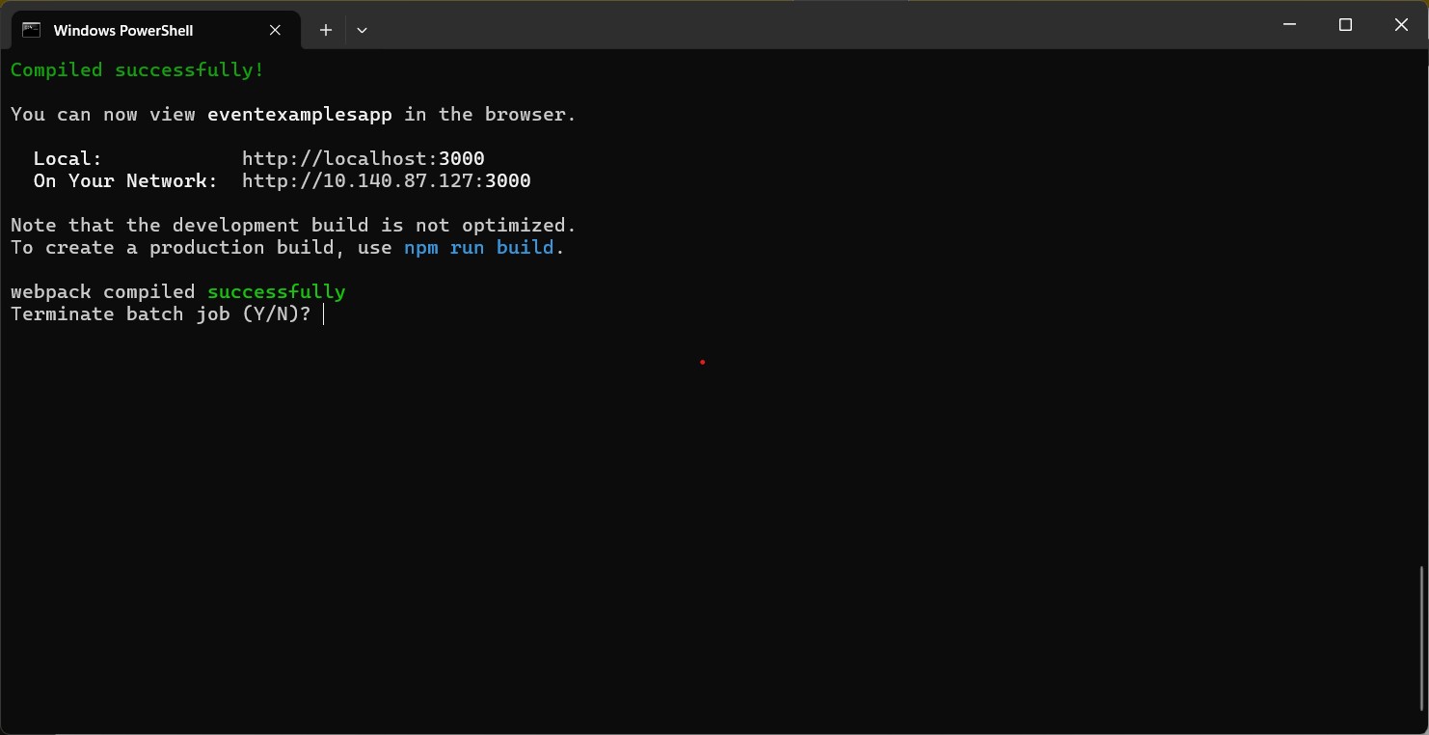**

**Browser :**

1. To increment the value
2. Say Hello followed by a static message.

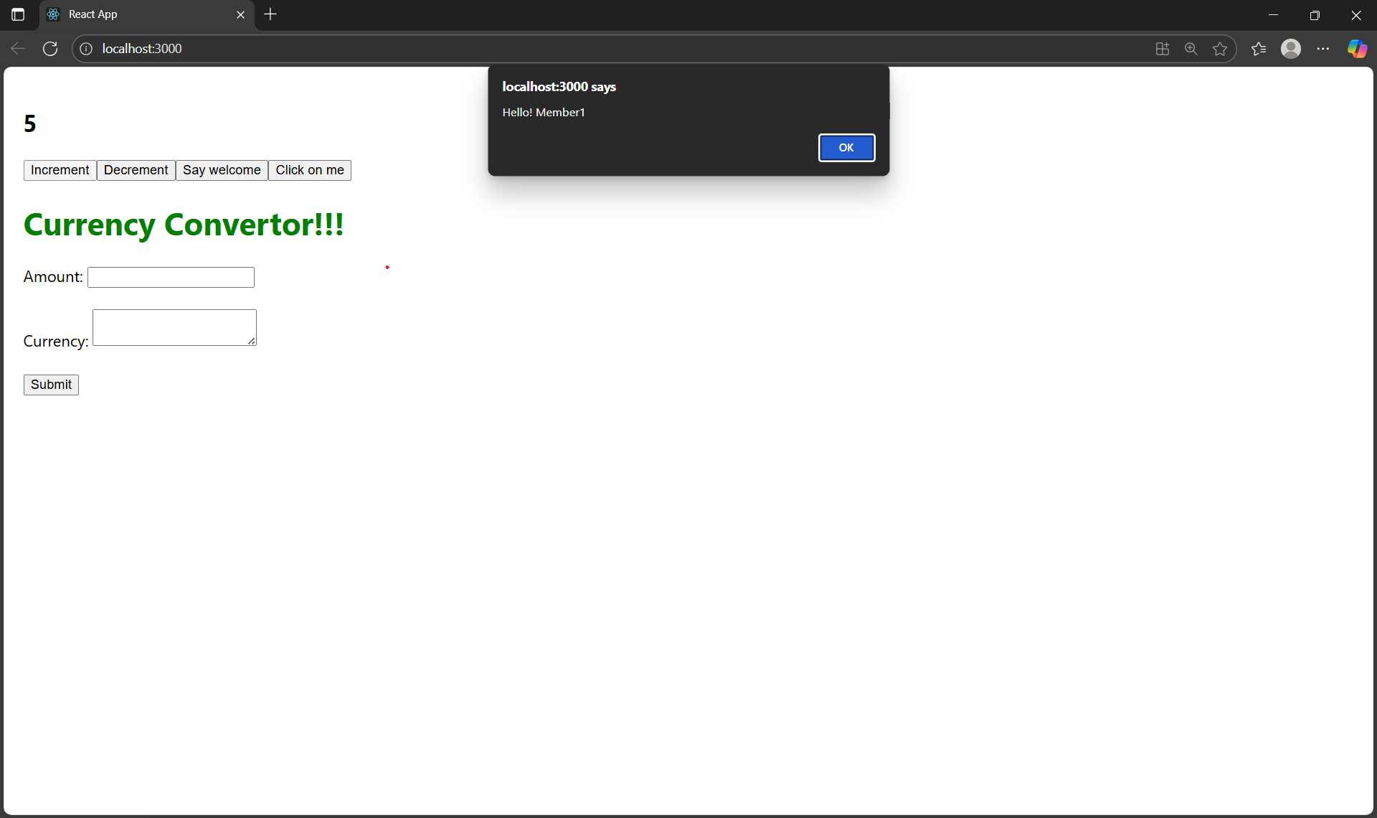

1. Create a button “Say Welcome” which invokes the function which takes “welcome” as an argument.

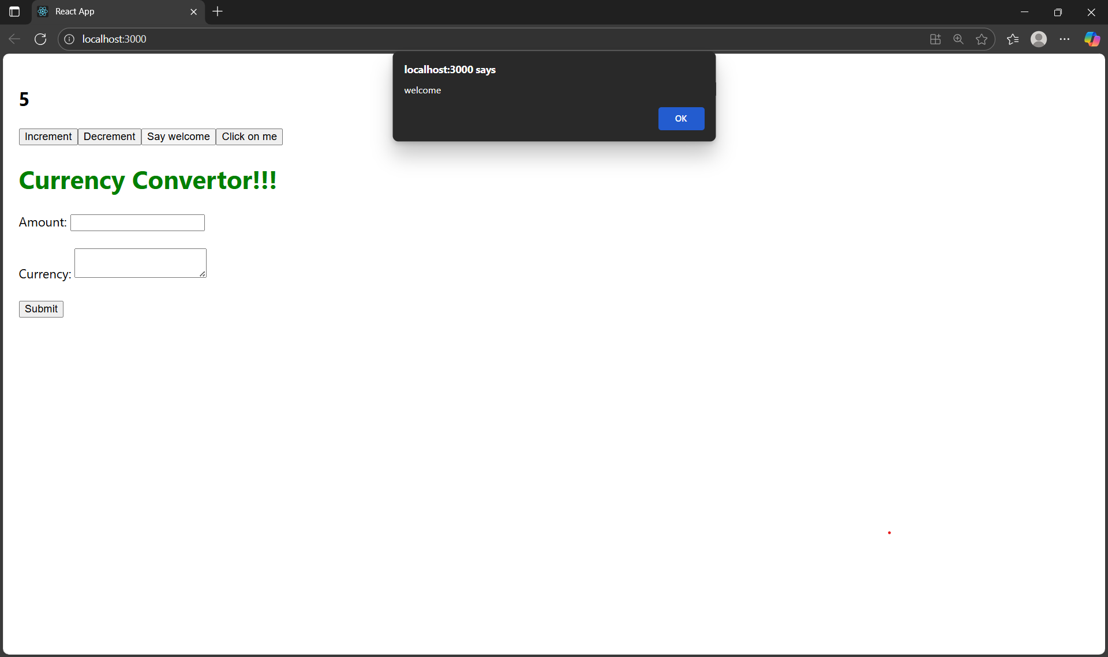

1. Create a button which invokes synthetic event “OnPress” which display “I was clicked”

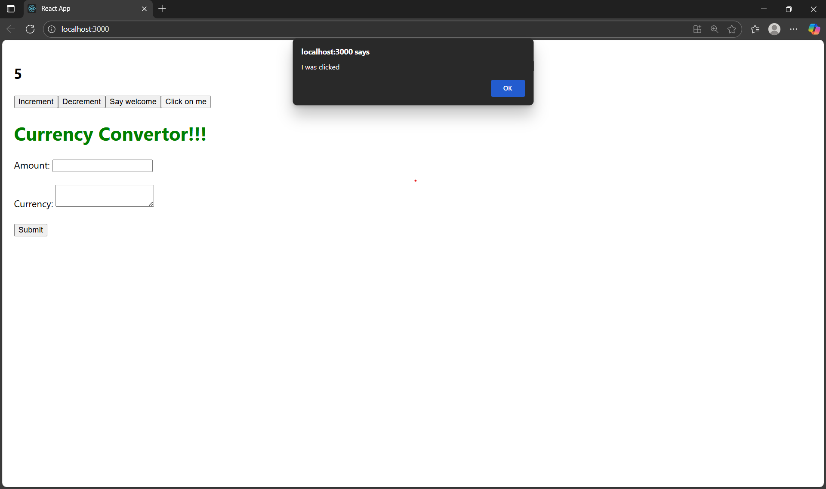

4.Create a “CurrencyConvertor” component which will convert the Indian Rupees to Euro when the Convert button is clicked.

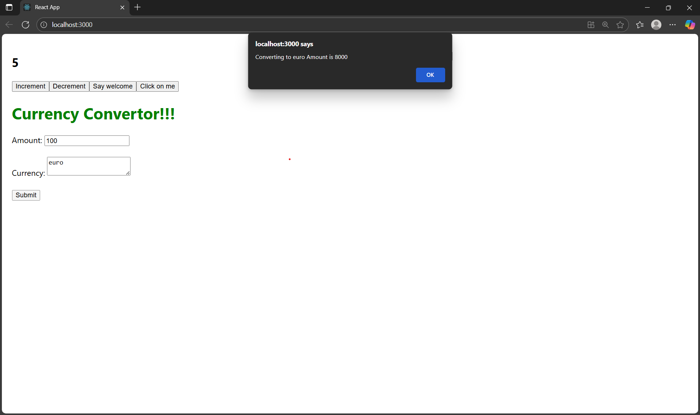

**12.Creating a React Application named “ticketbookingapp” where the guest user can browse the page where the flight details are displayed whereas the logged in user only can book tickets.**

**App.js**

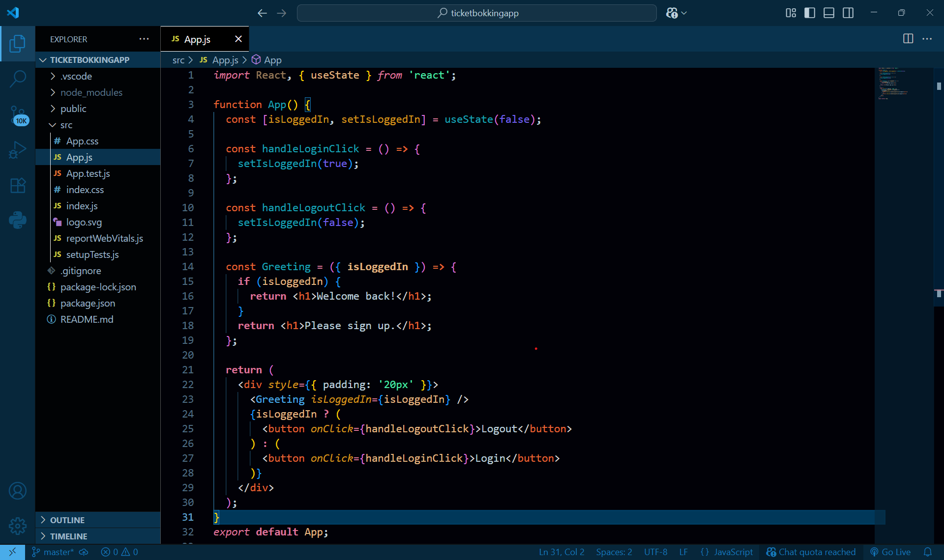

**Output :**

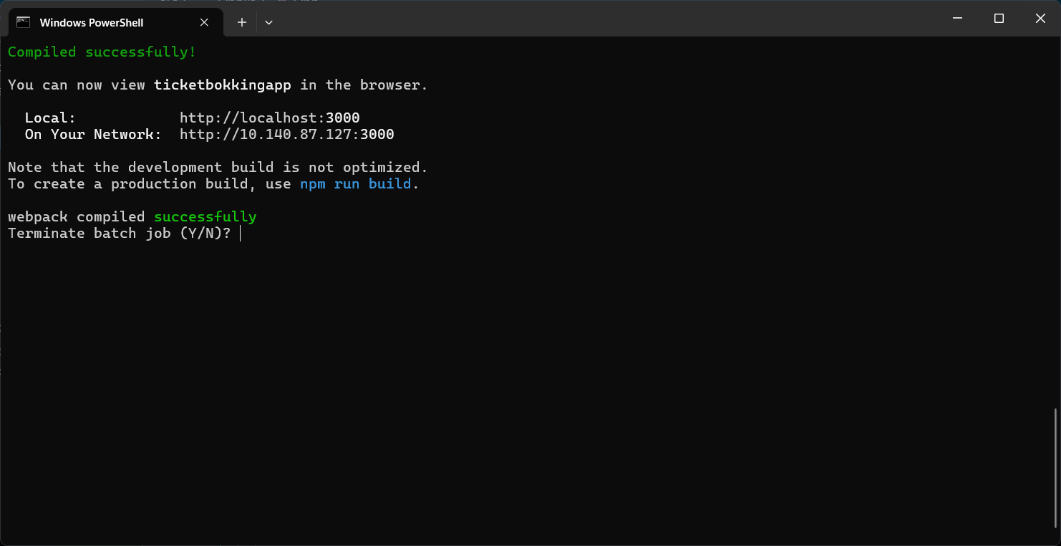

**Browser output:**

**1.** 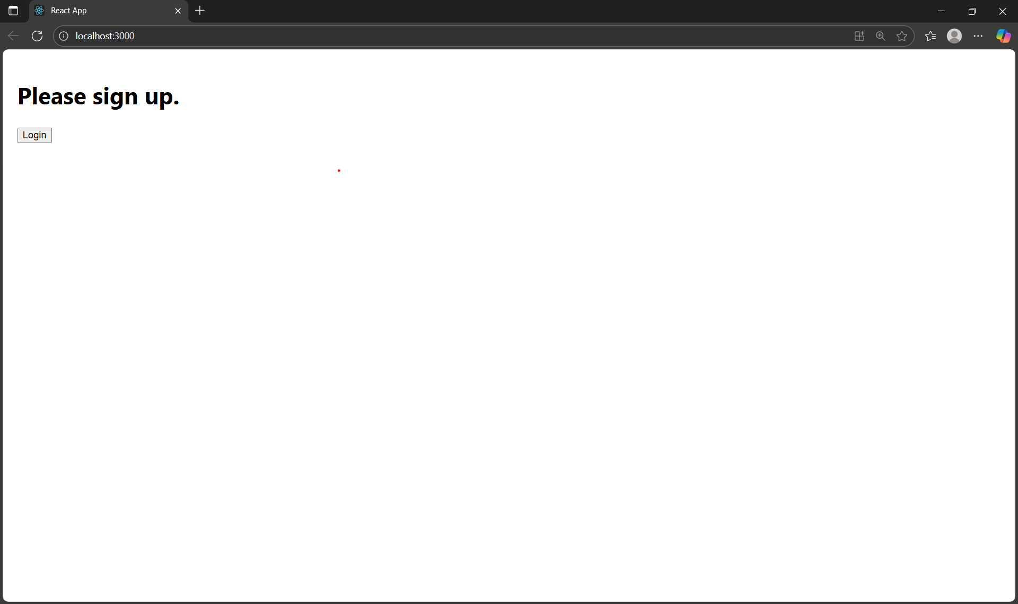2.

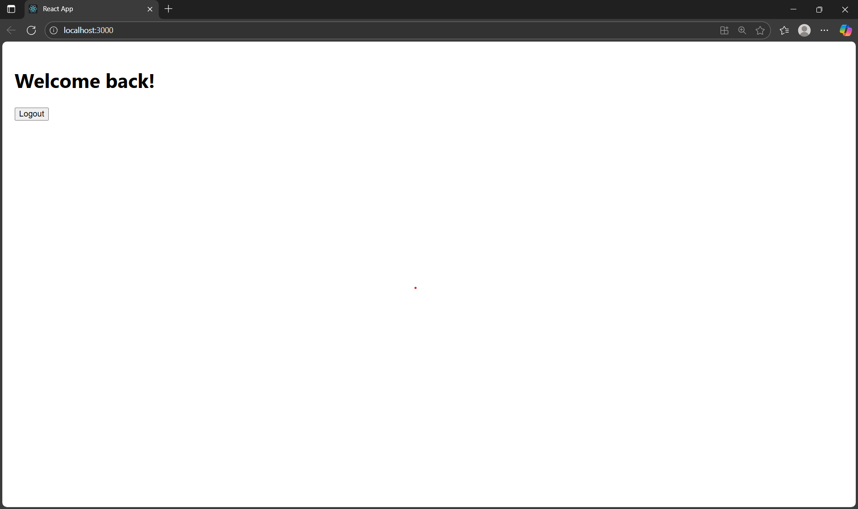

**13.** **Creating a React App named “bloggerapp” in with 3 components.**

**1st** **component**: bookdetails.js  
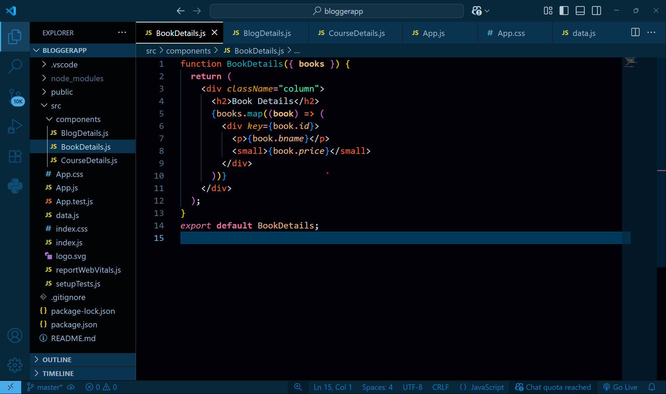

**2nd component:**blogdetails.js

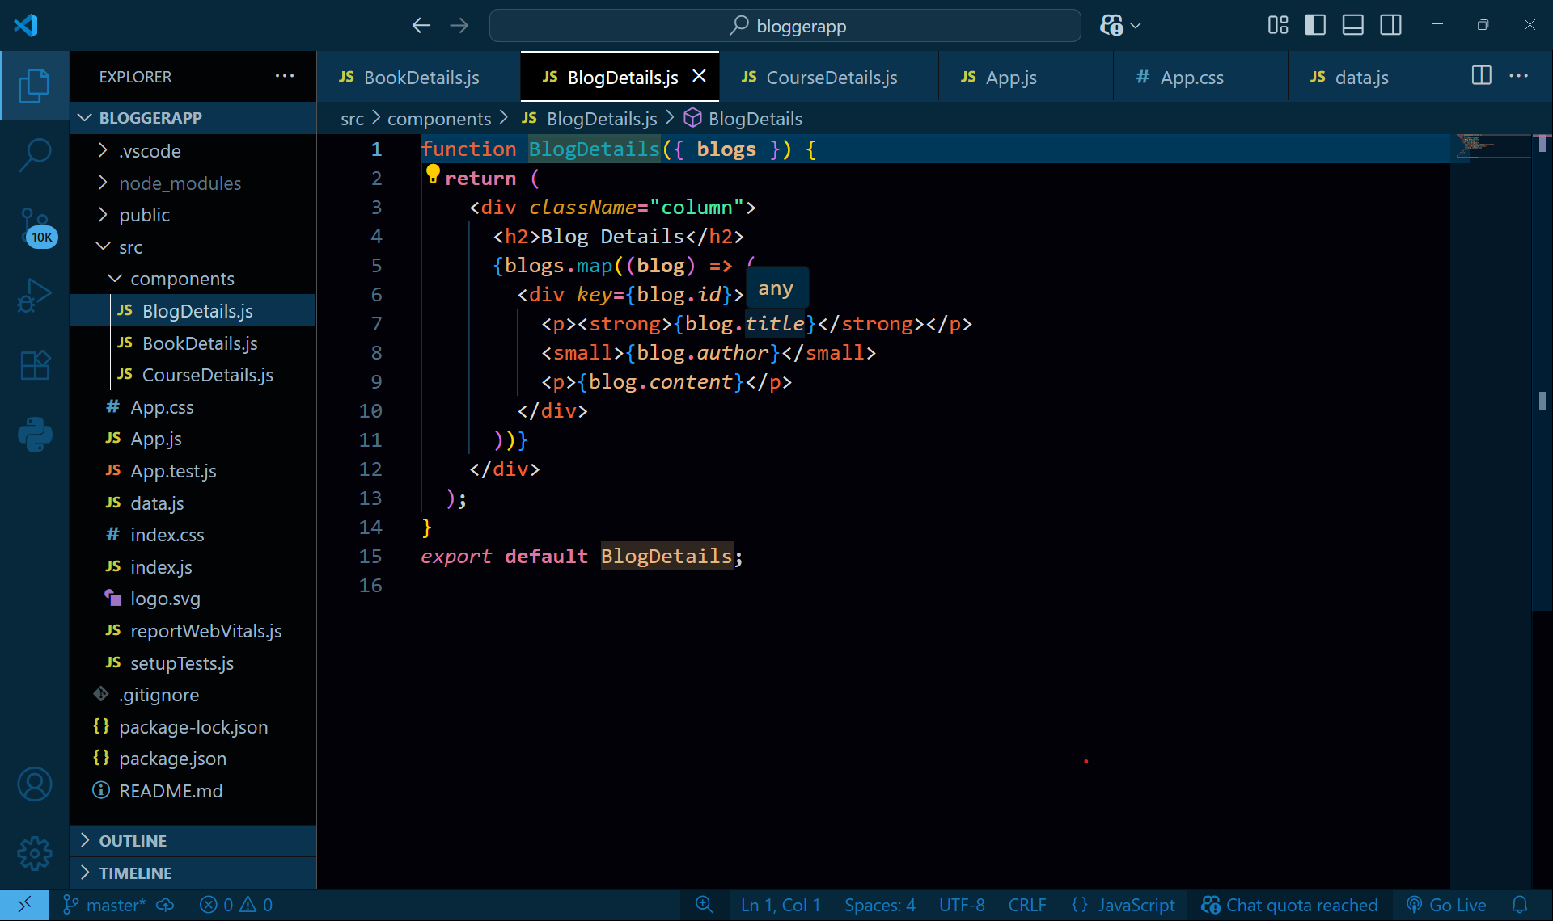

**3rd component:**coursedetails.js 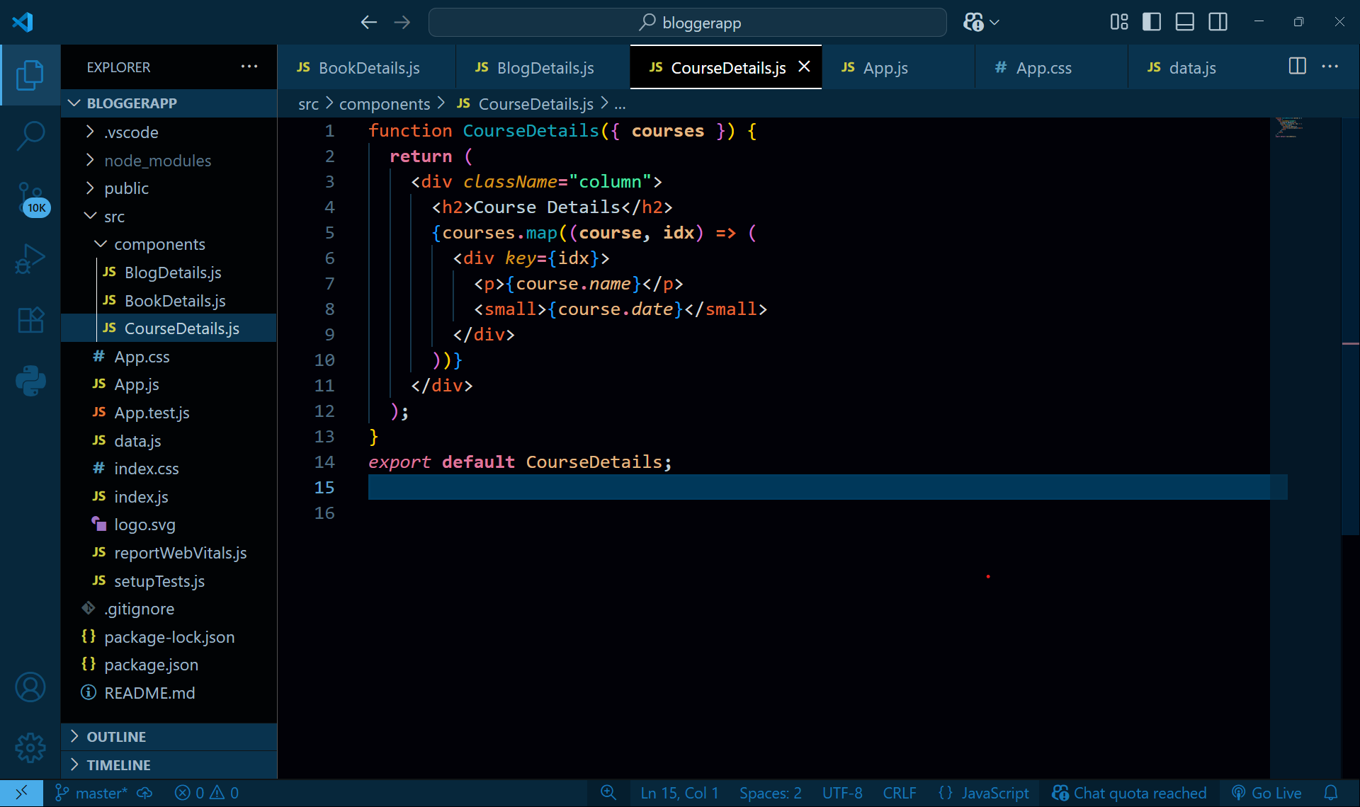

**App.js:**

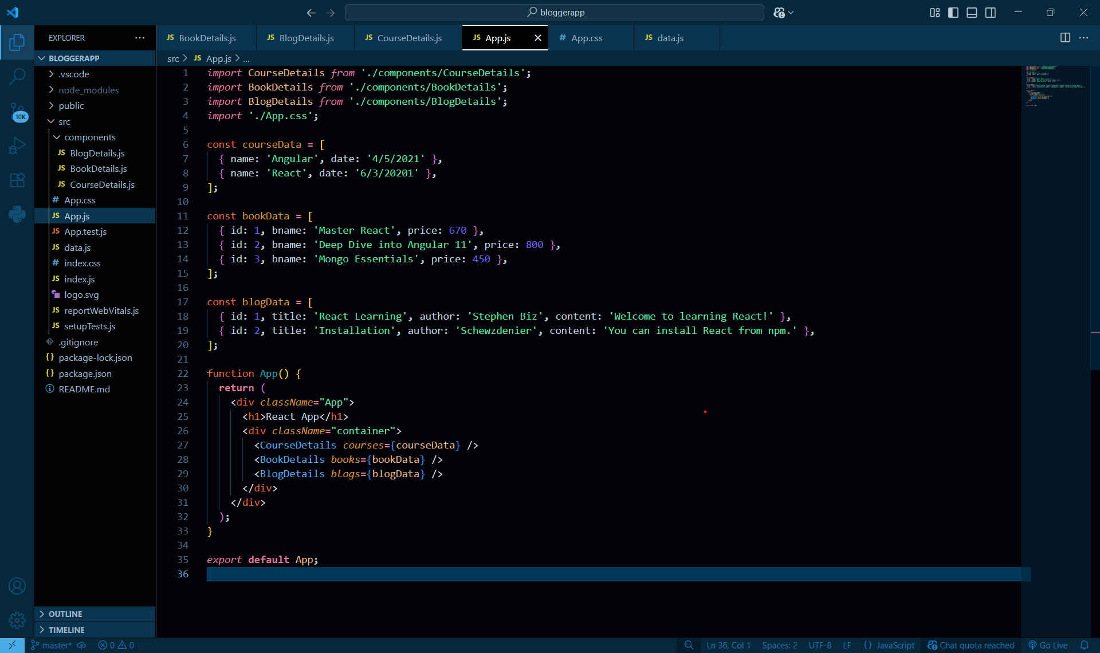

**Output:  
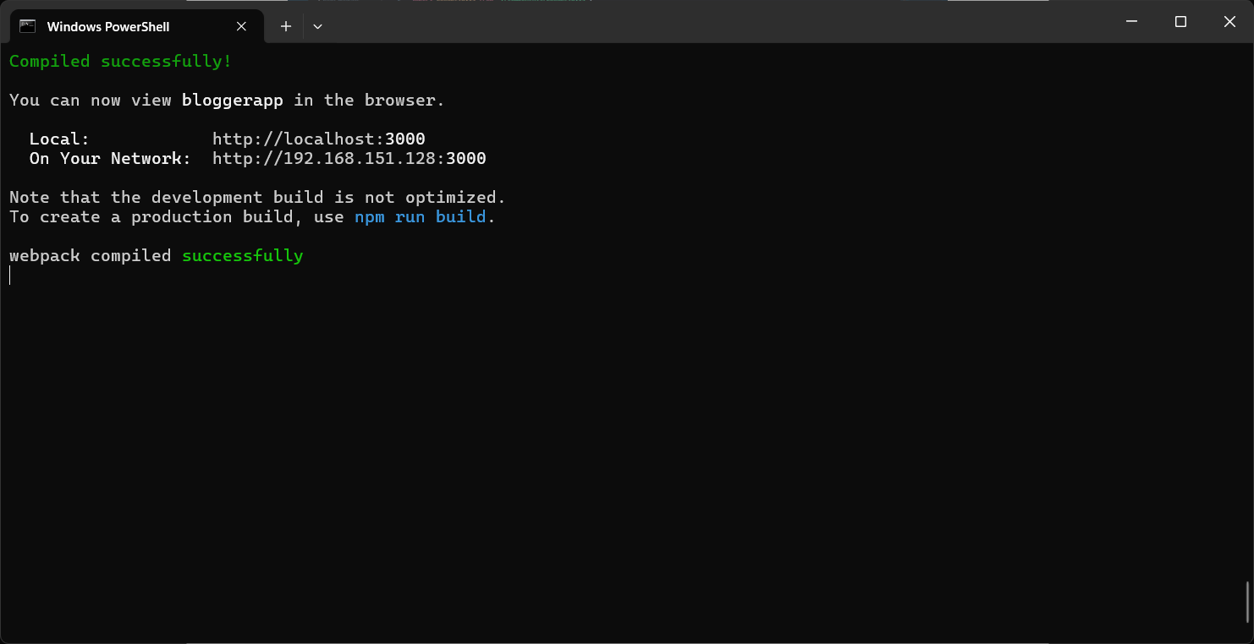**

**Browser output:  
