**Week 6 :**

**Step 1:**

* **Setting up a react environment :**installing the required libraries React app, Install Nodejs and Npm.

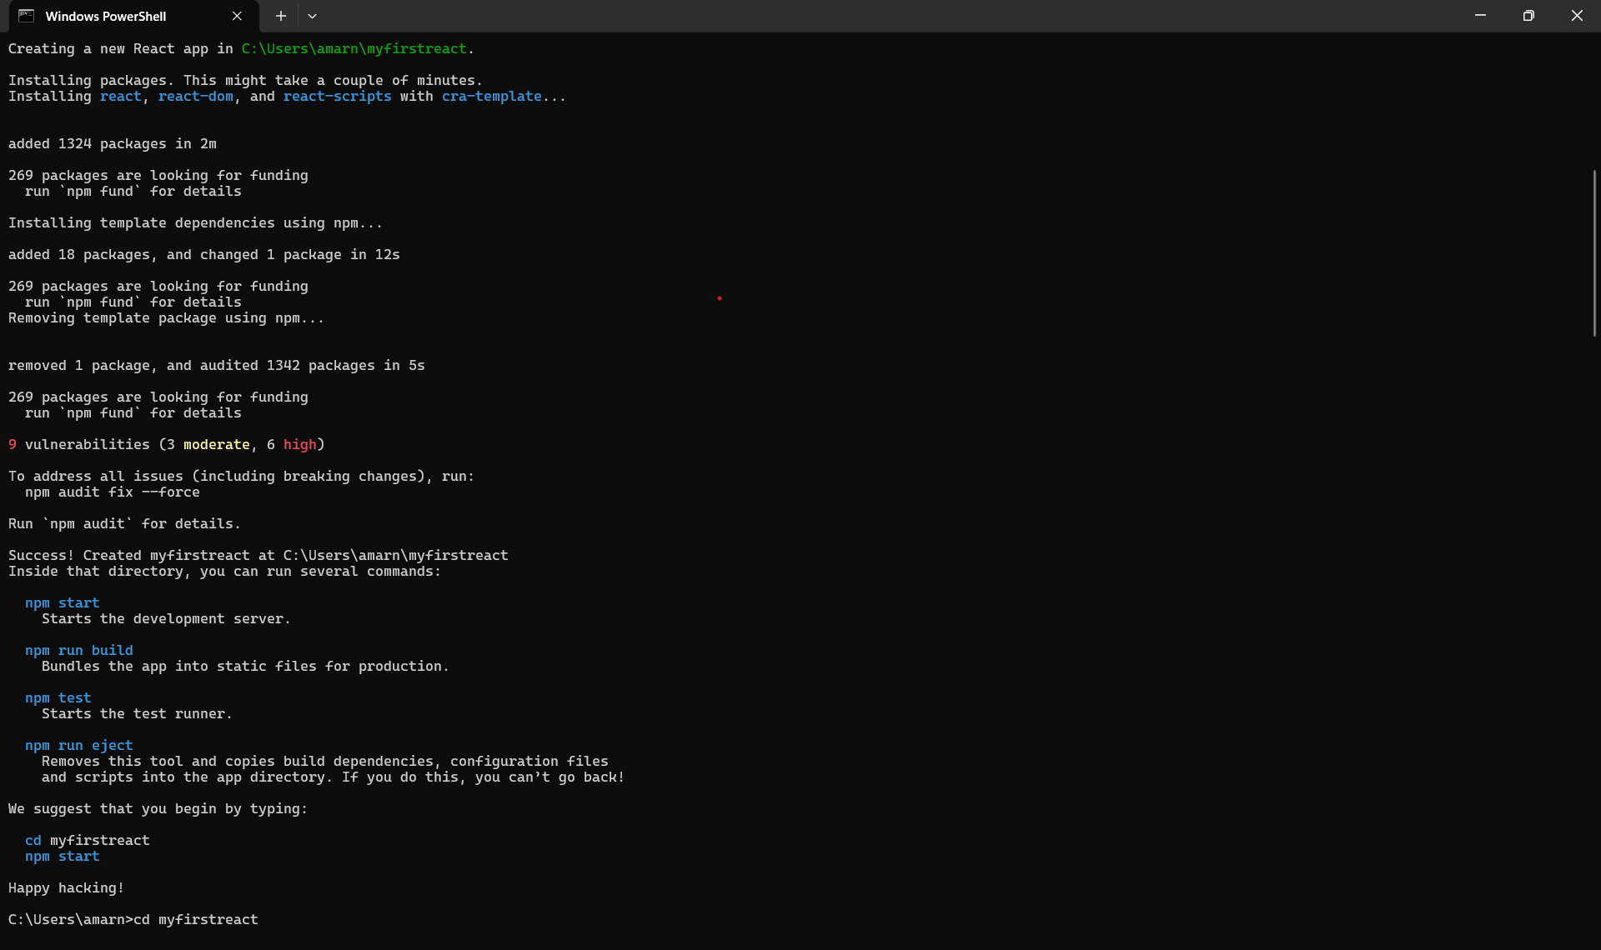

**installing the packages successfully .**

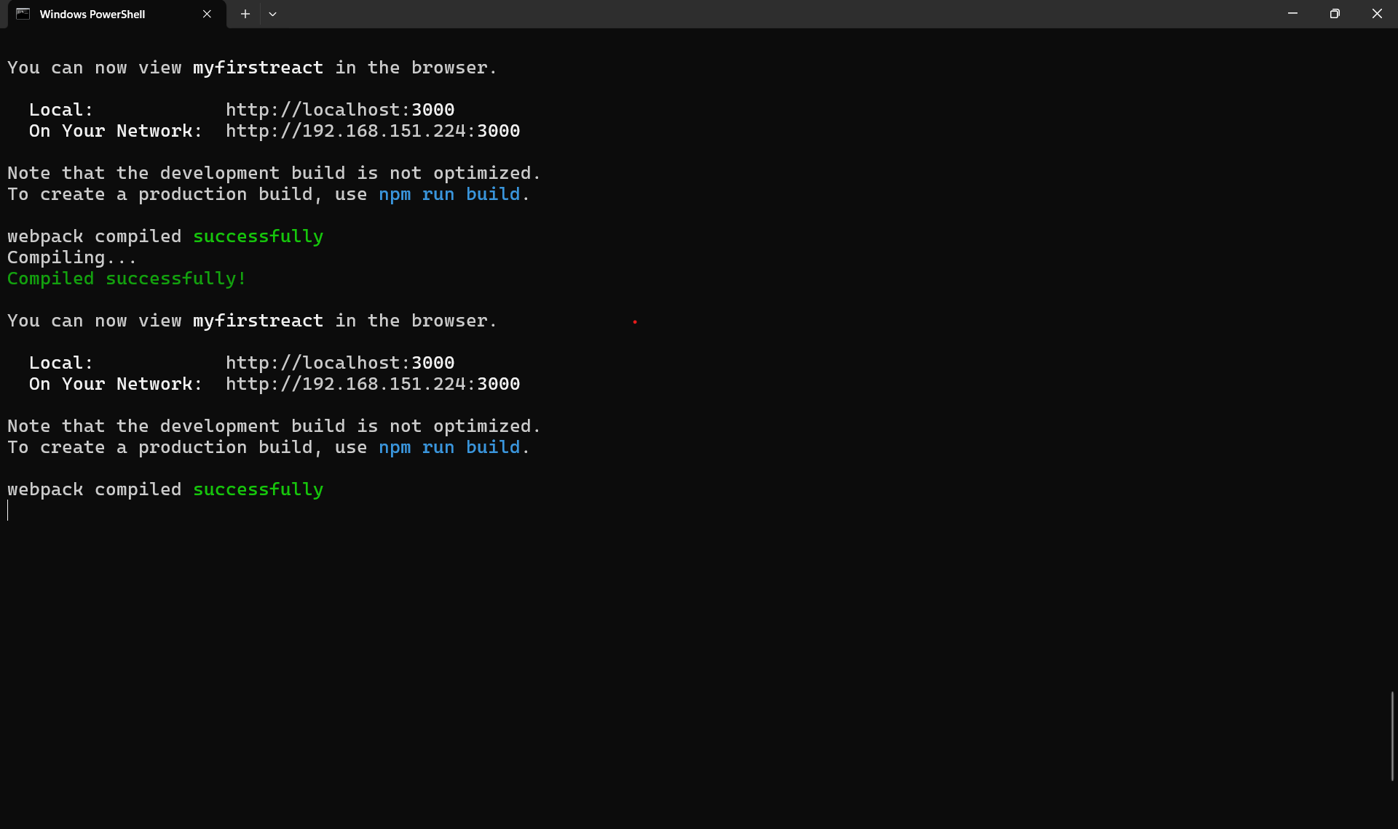

**Step 2:**

Creating and Using create-react-app.

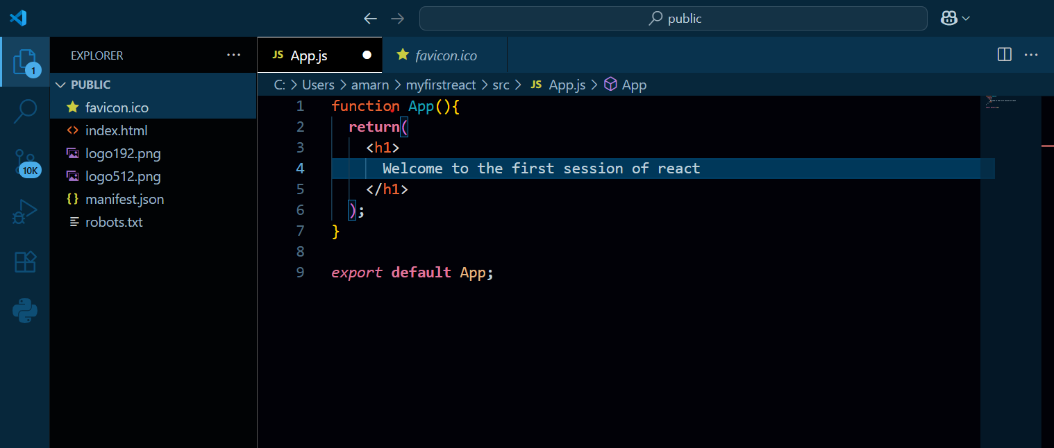

**Step 3:**

**Running the app (Output):**

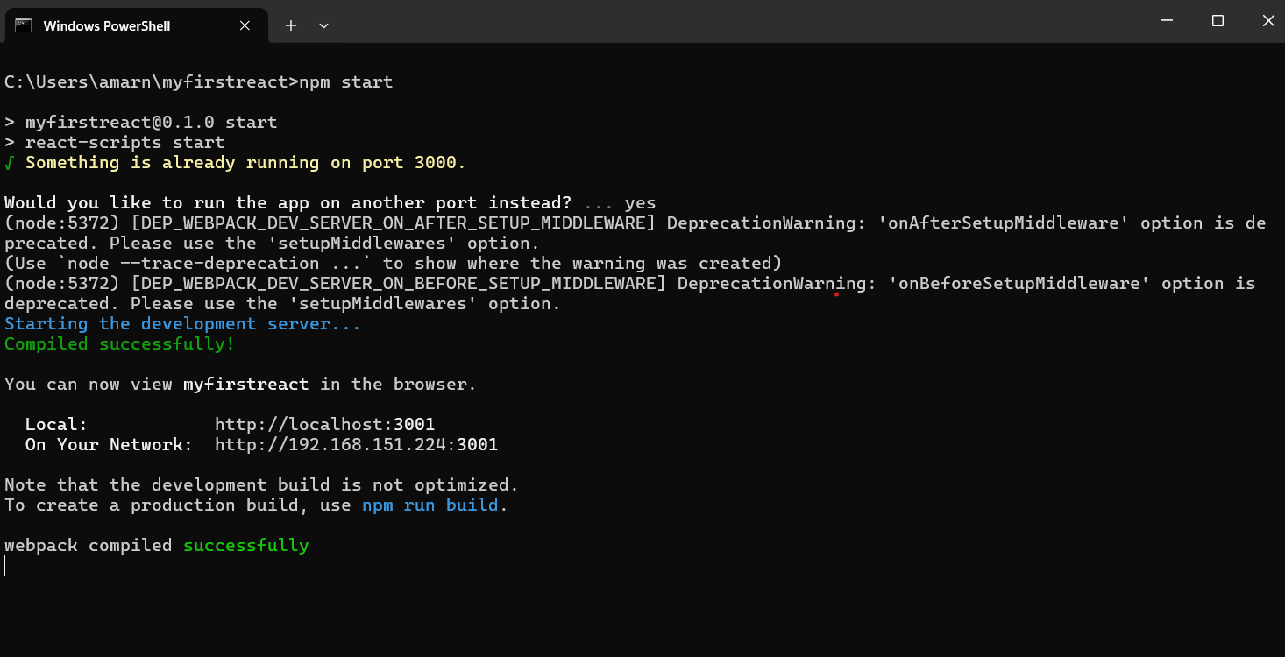

**Output:**

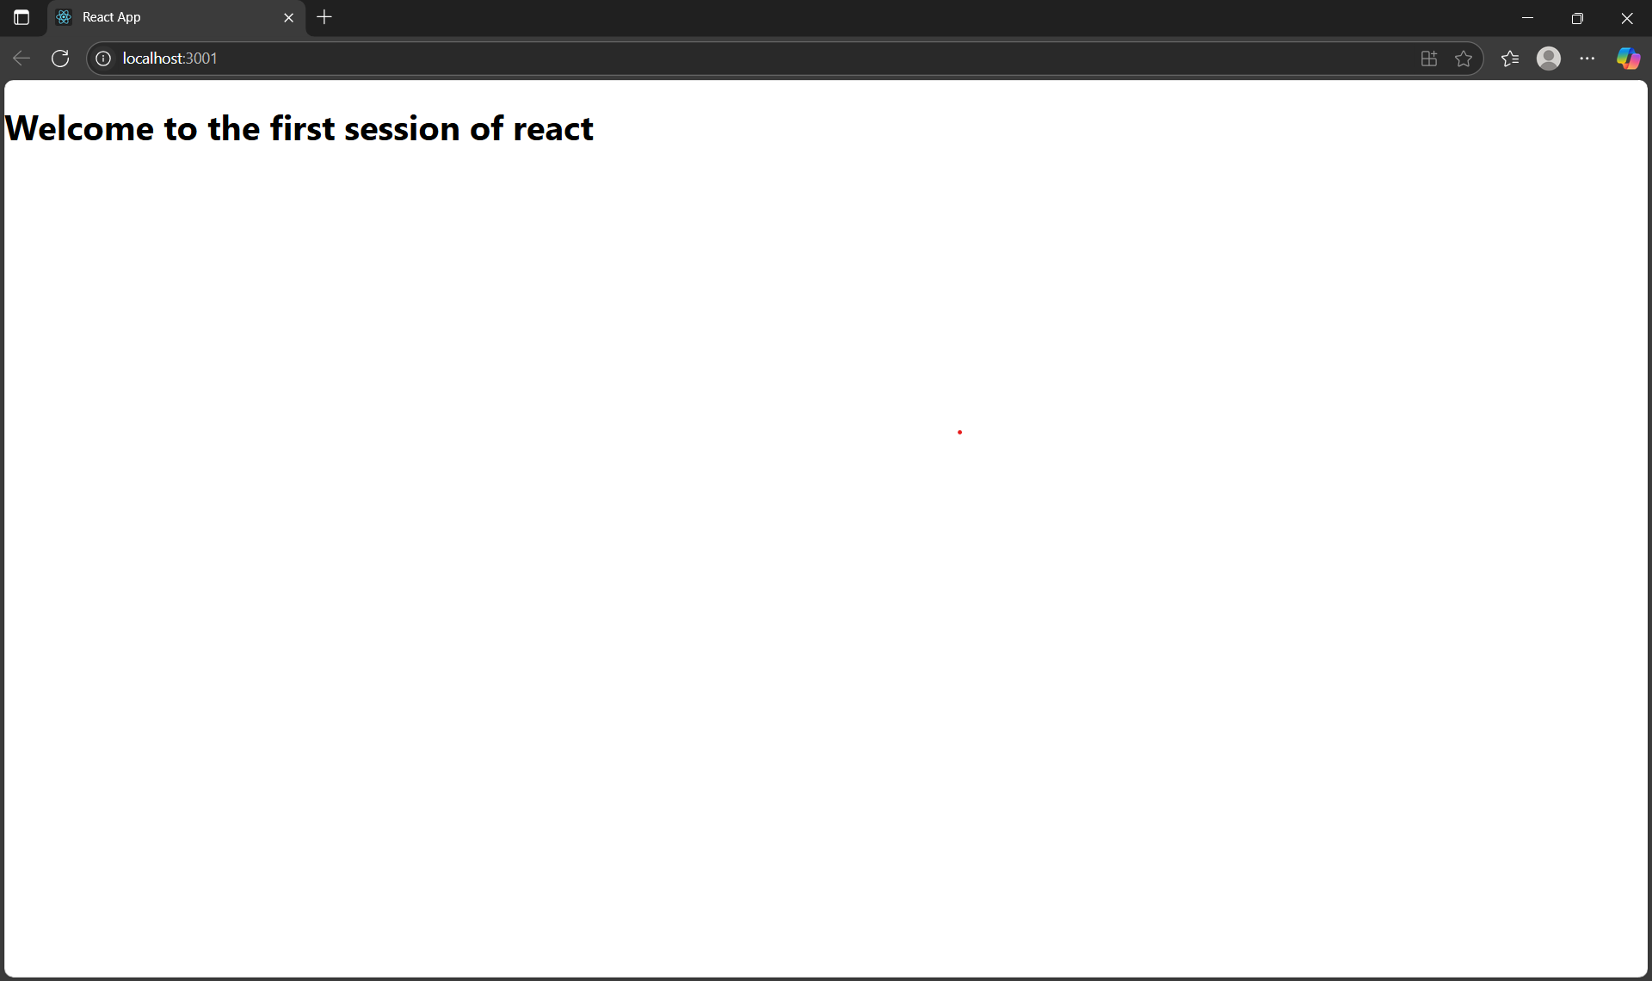

**2 : Student App**

**Creating student app using react :  
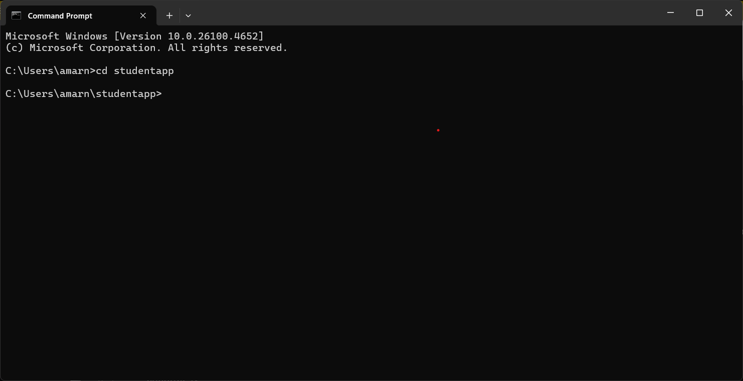**

**Adding the component classes:  
Home,About,Contact :**

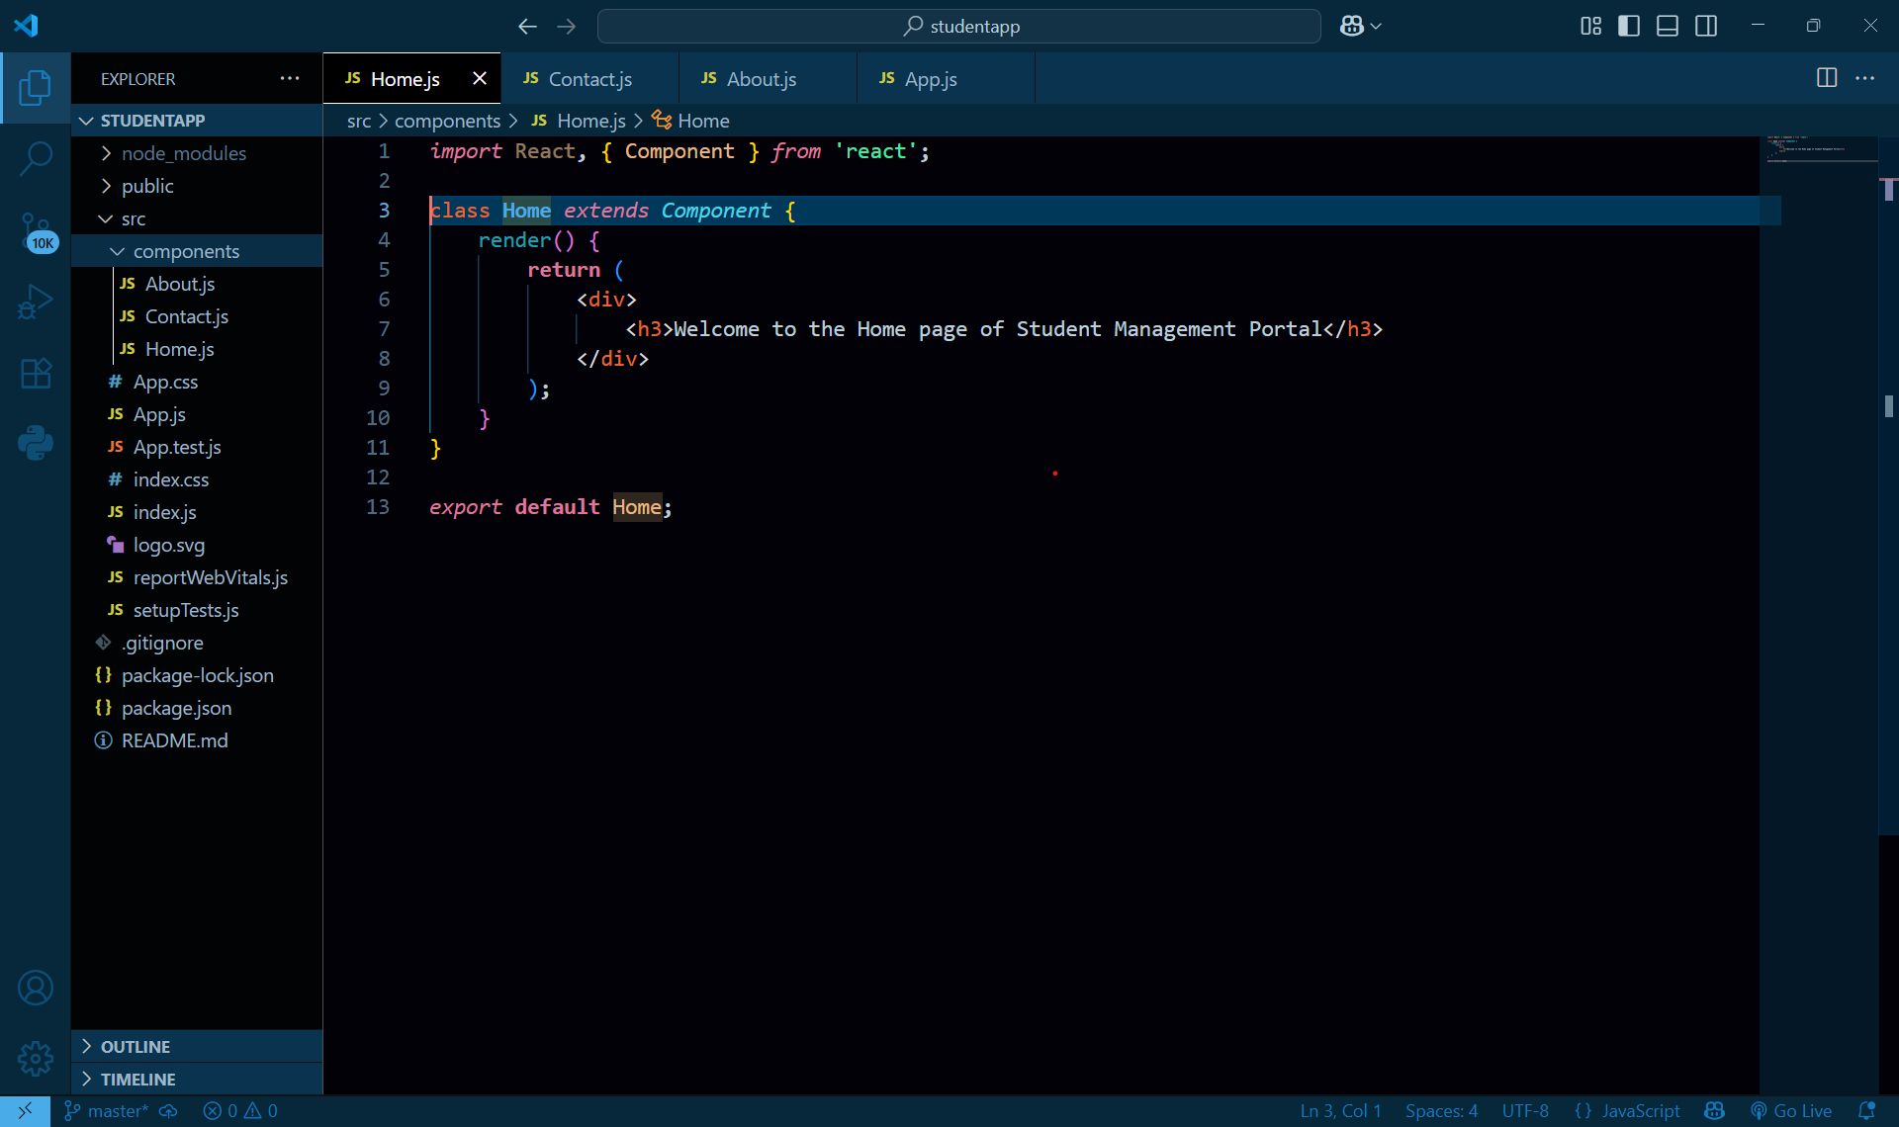

**App.js:  
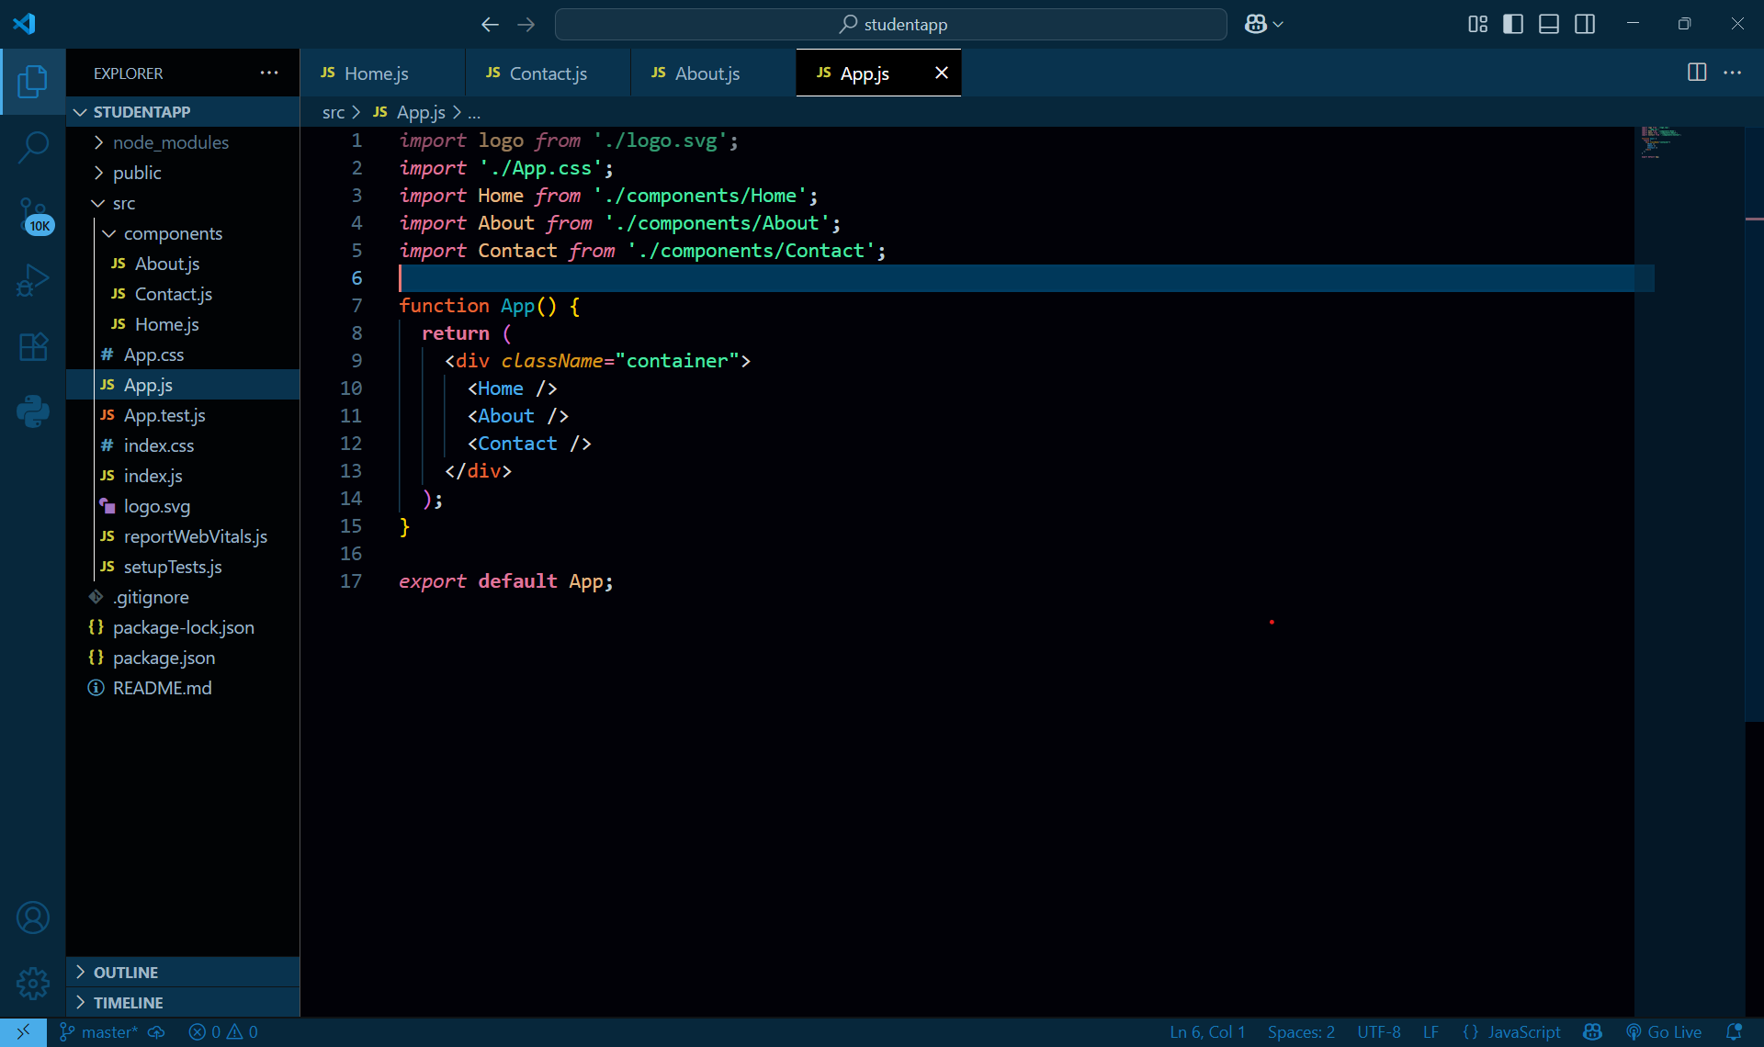**

**Running the app :**

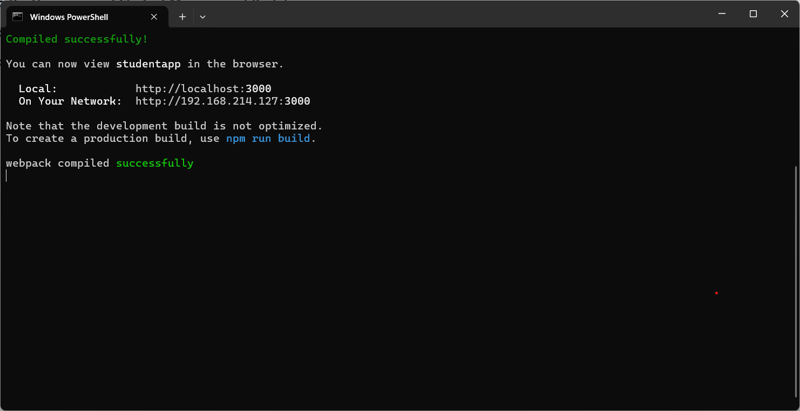

**Execution in Browser :**

**Localhost : 3000**

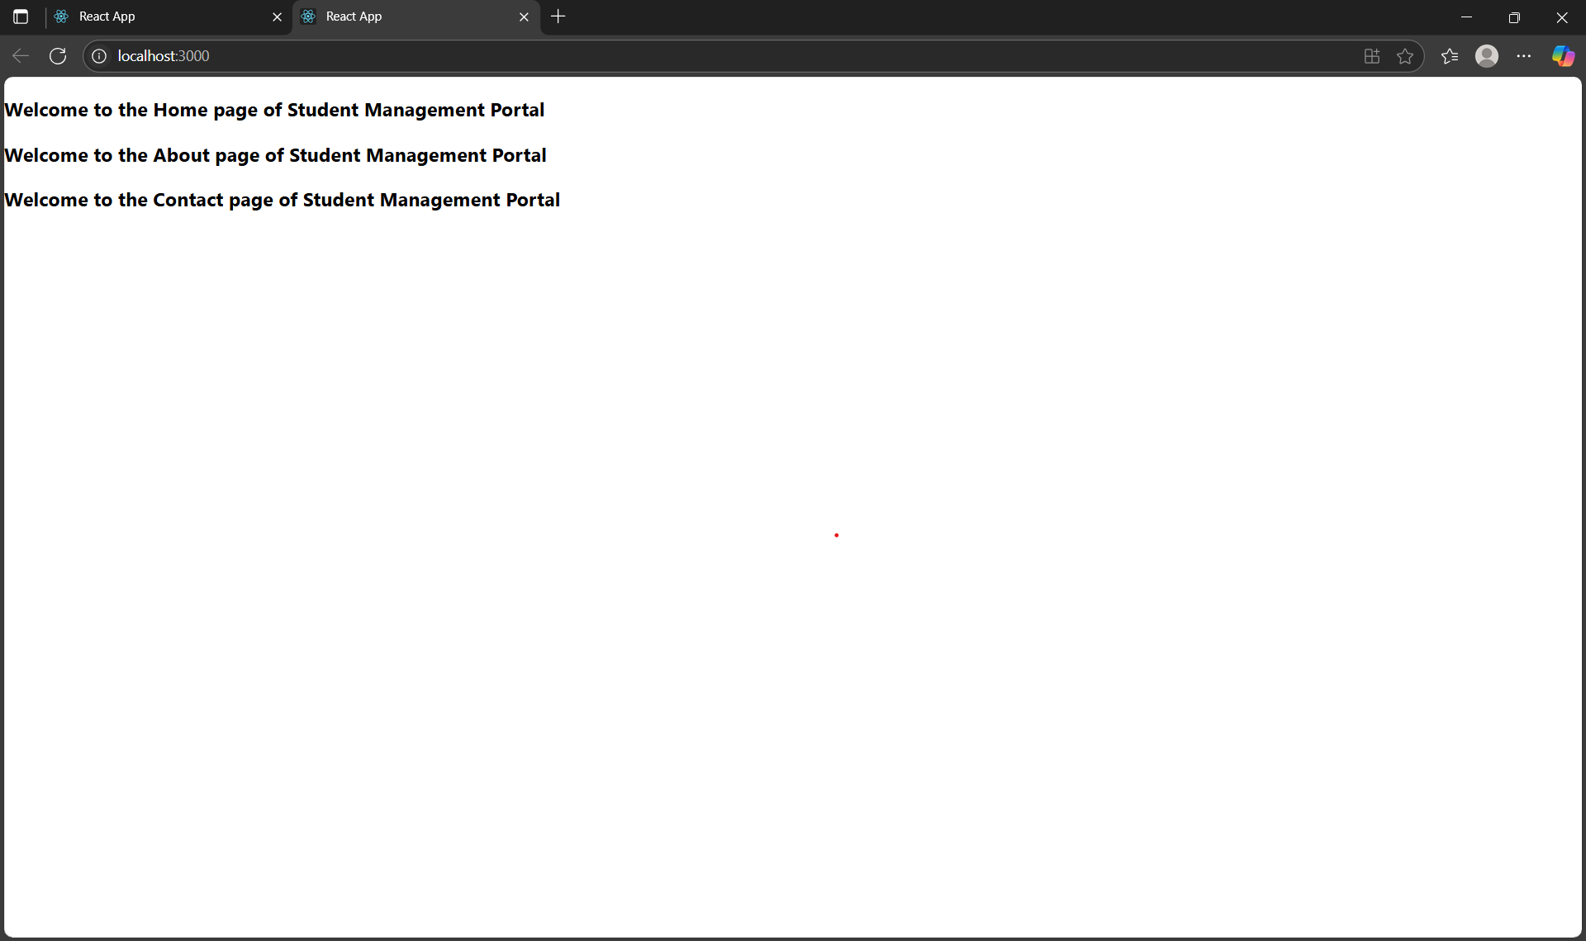

**3 : score calculator App**

**Creating a score calculator app using reactjs :**

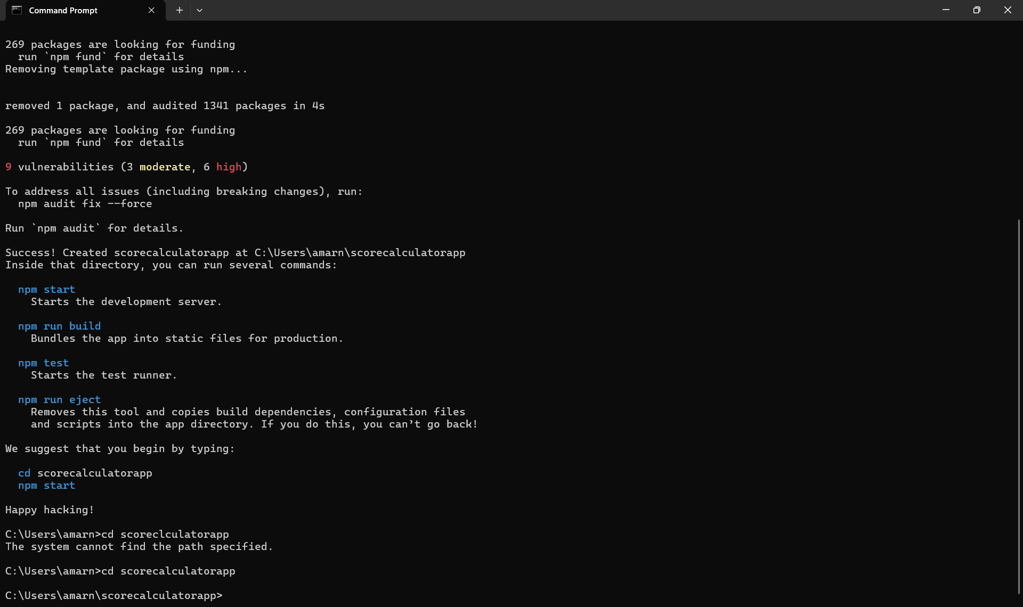

**Creating the components :**

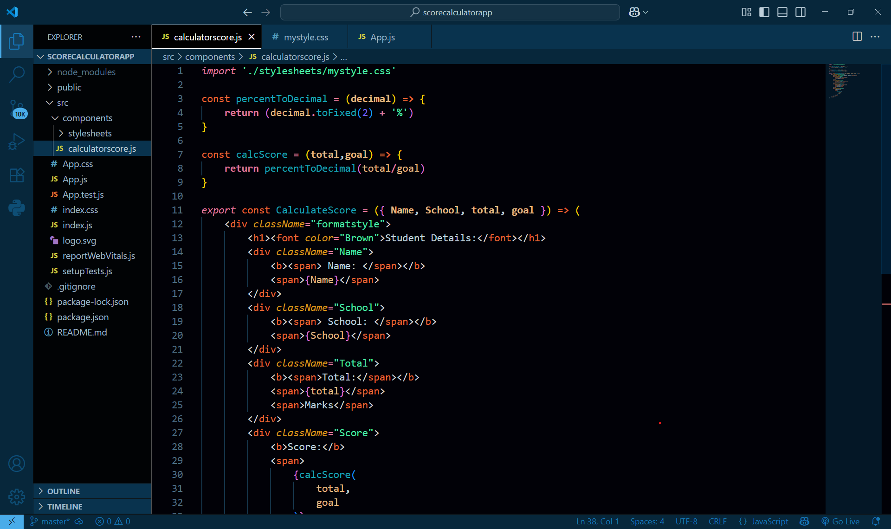

**Styling the app :  
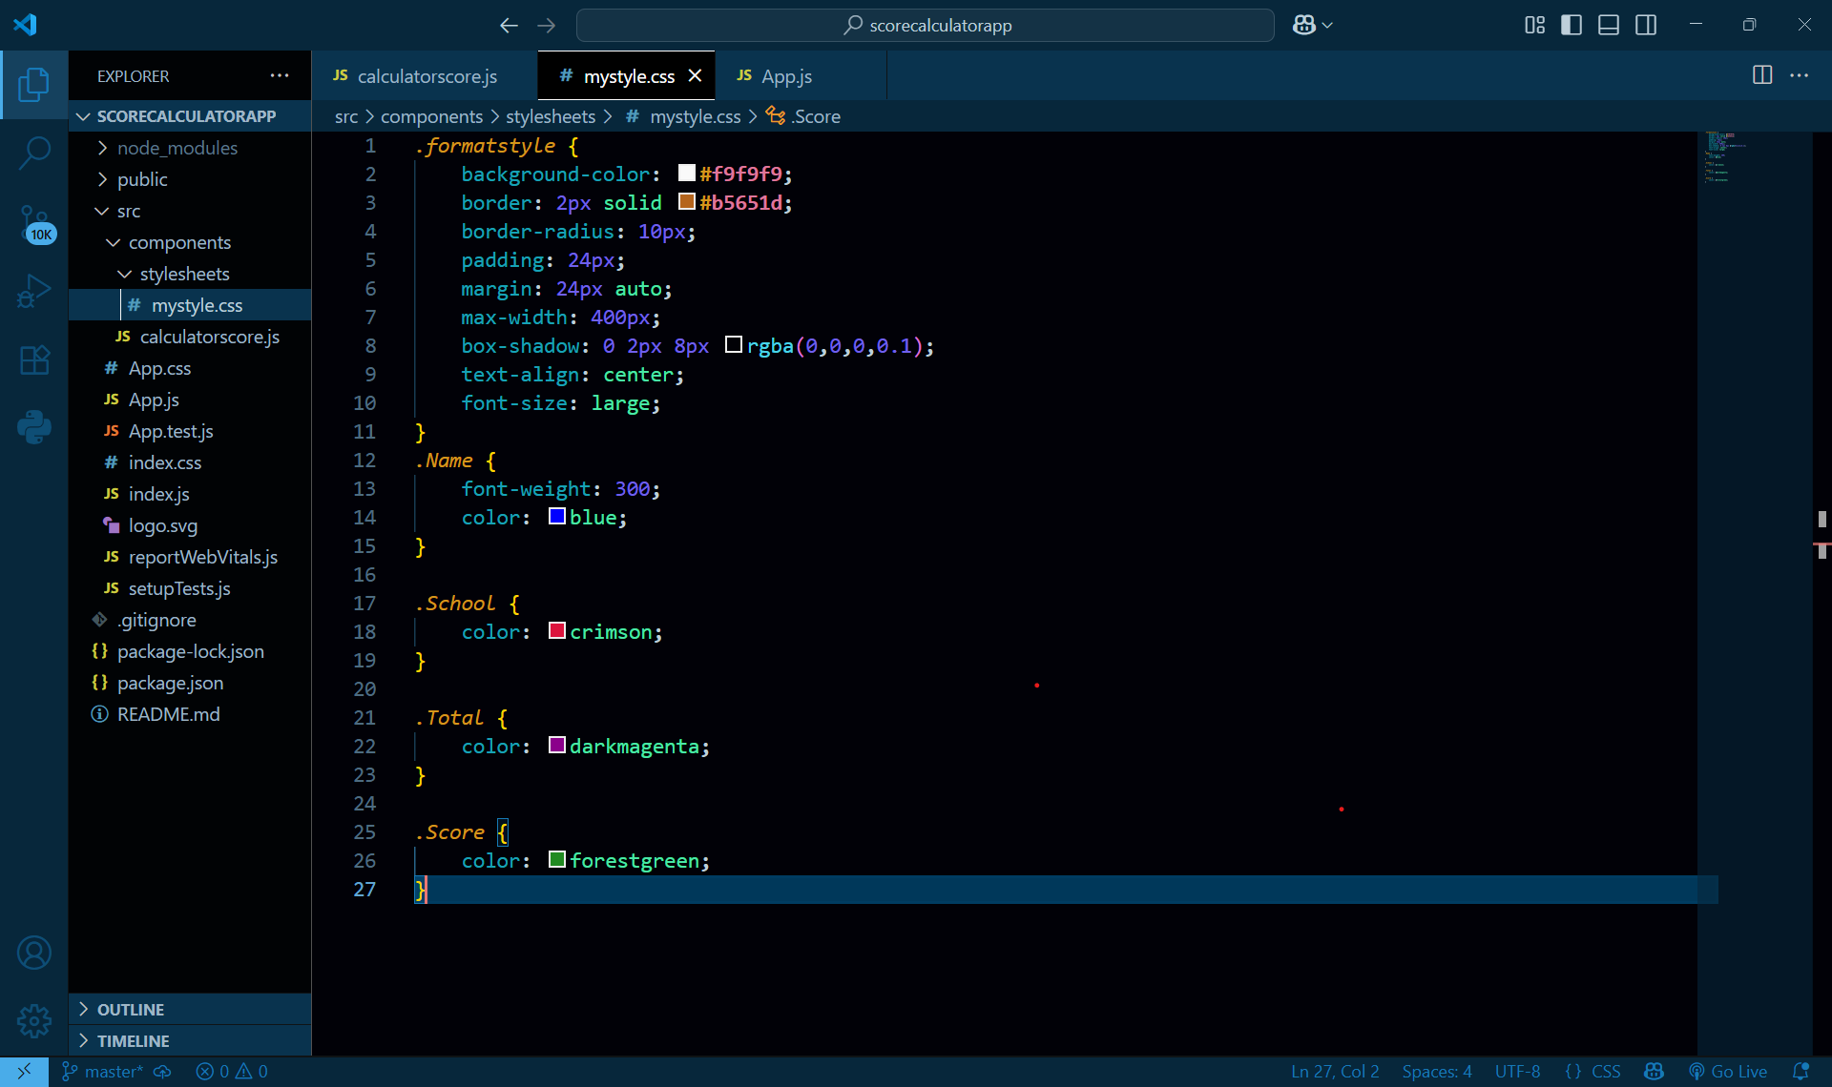**

**App.js :**

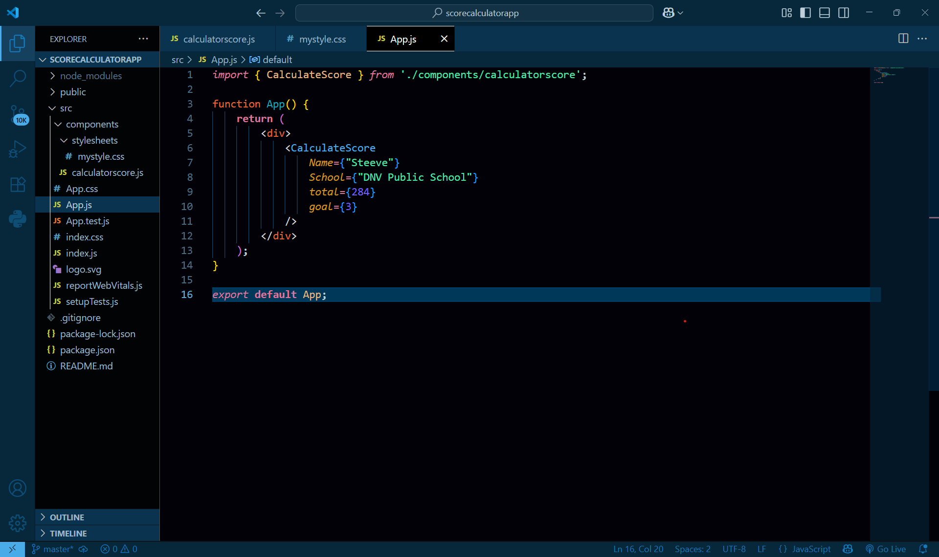

**output :**

Executing scorecalculator.js

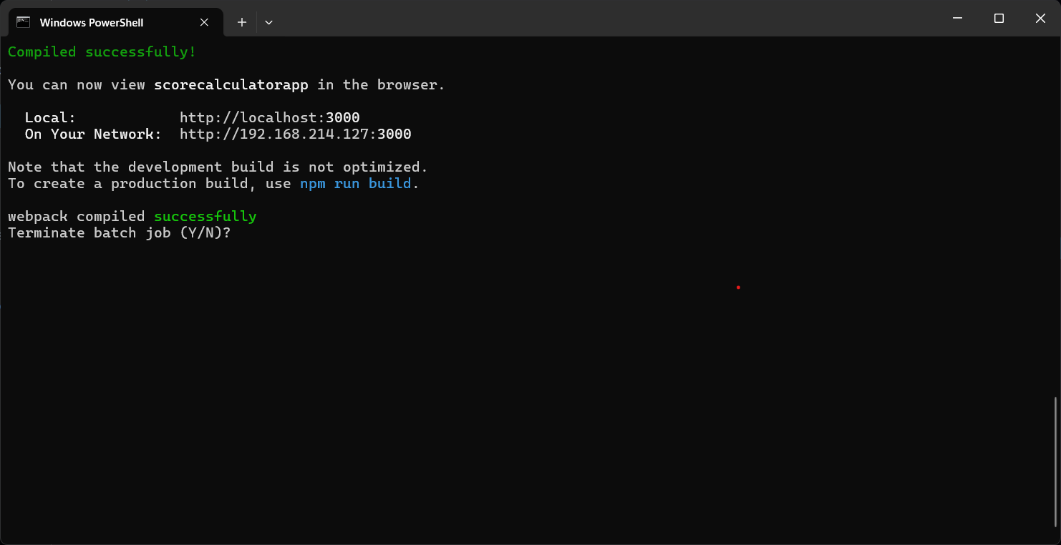

**Browser output :**

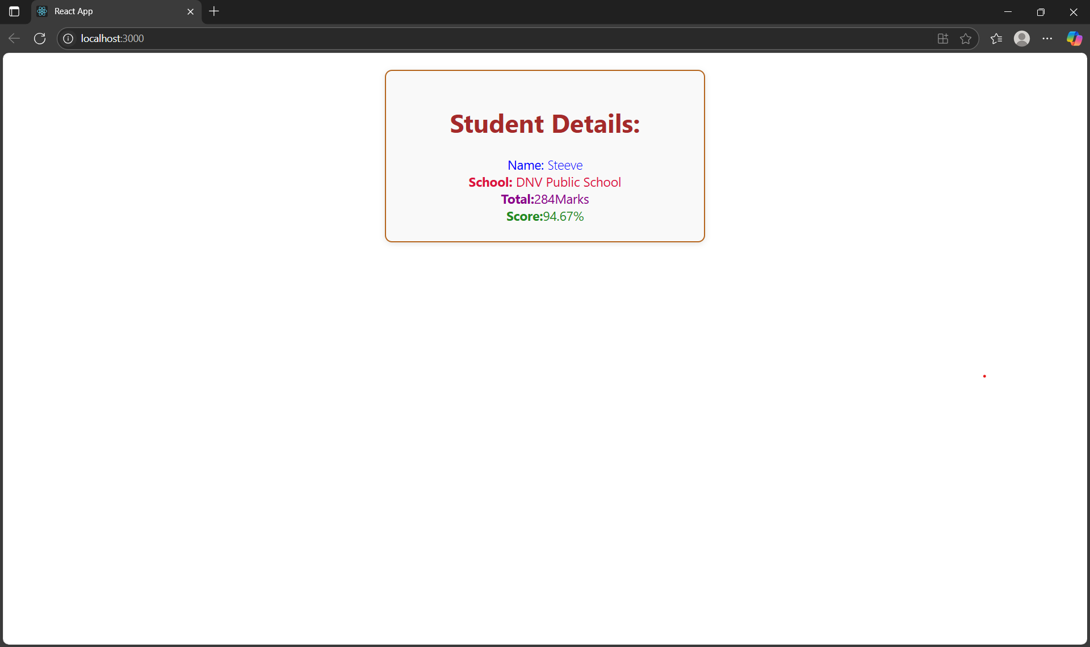

**4 : Blogapp**

**Step1 :**

Creating a blogapp using react . 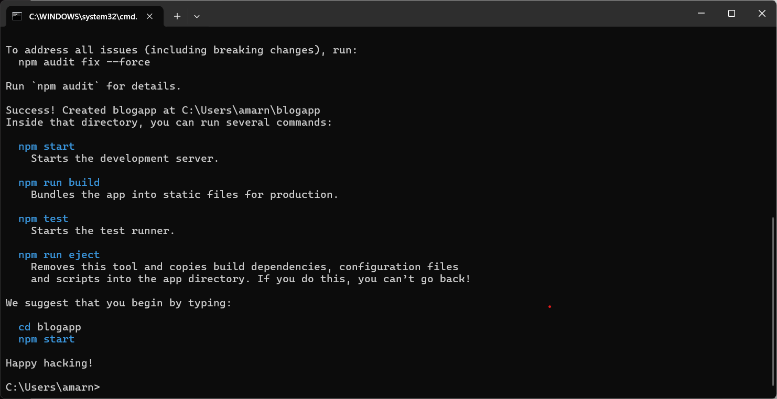

**Step2:**

Creating post.js

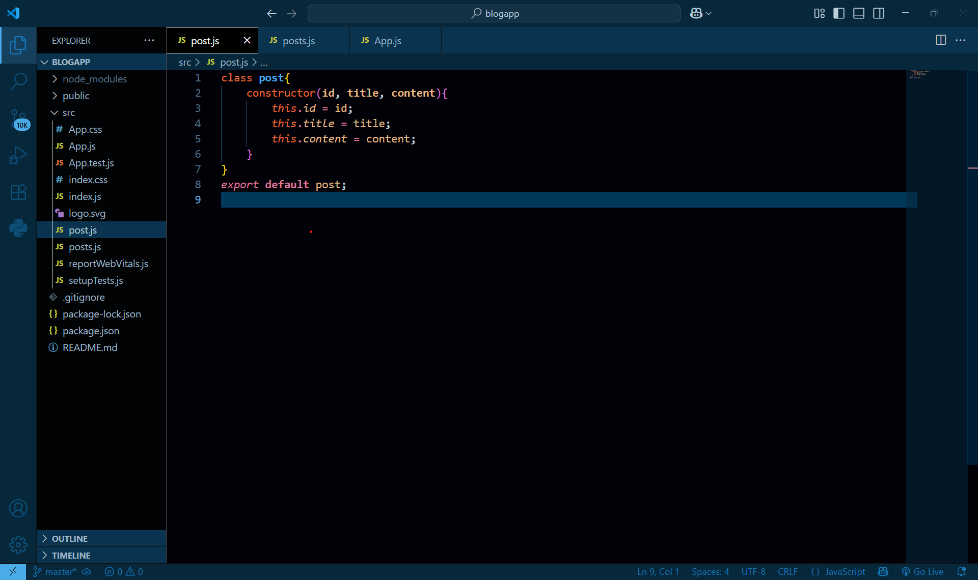

**Step 3:**

Creating a new class based component named as Posts inside Posts.js file

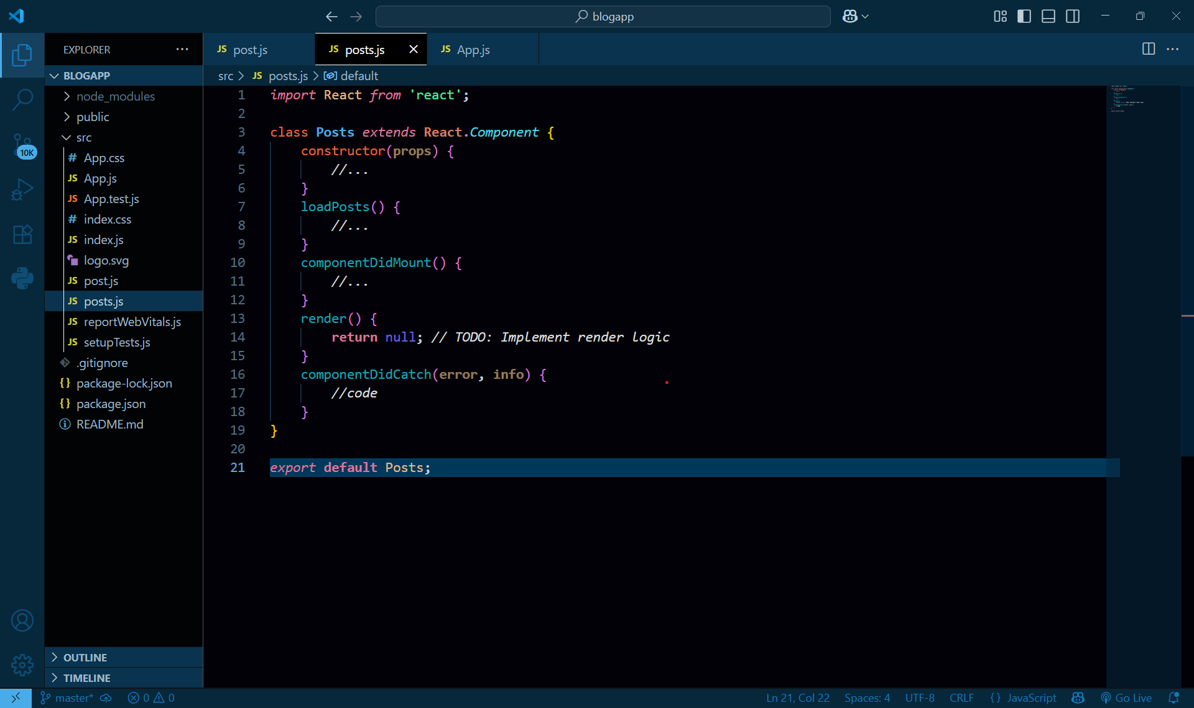

Initializing the components and Implementing the componentDidMount() hook to make calls to loadPosts() , Define a **componentDidCatch() .**

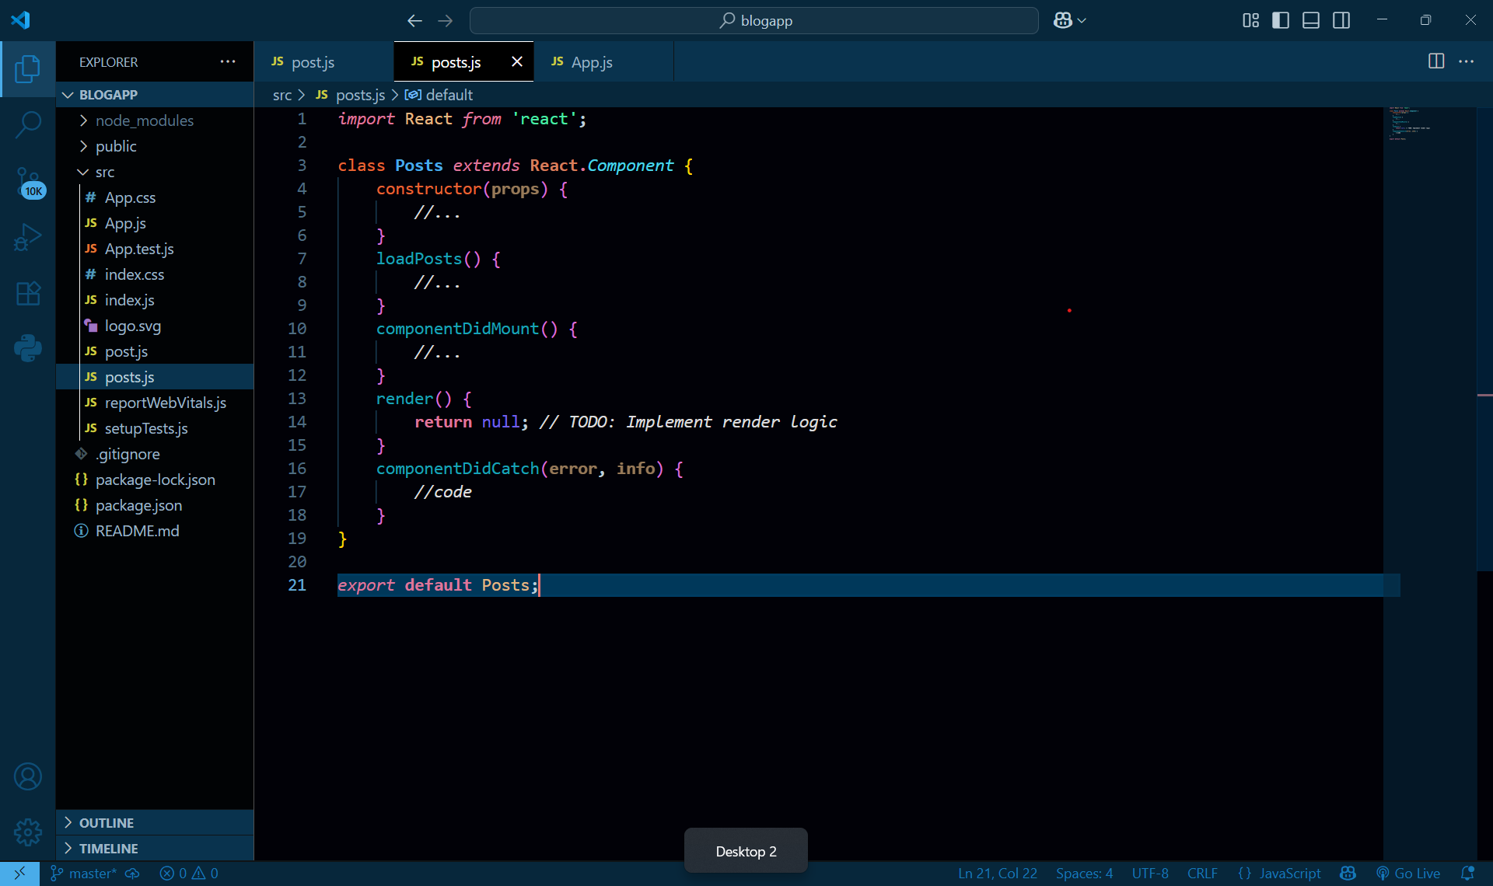

**Output:**

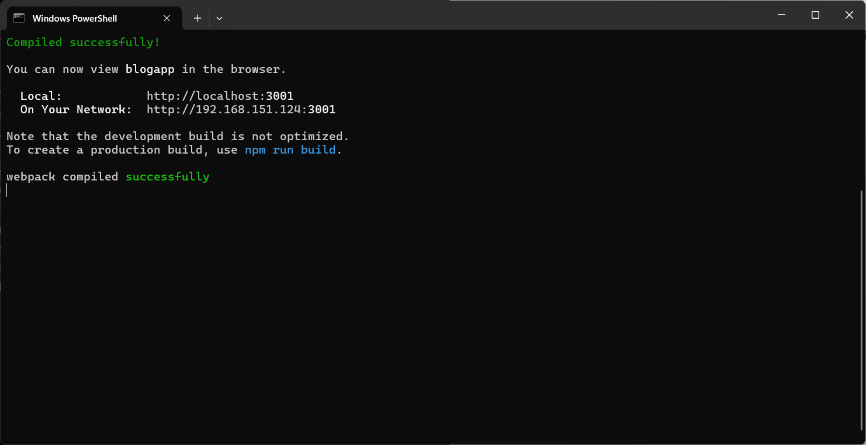

**Browser output :**

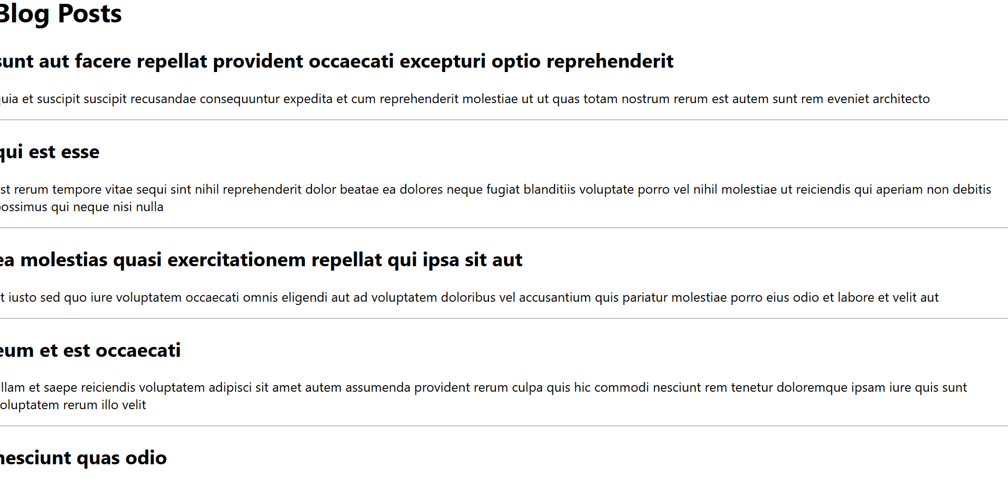

**5. styling the react components :**

Unzipping the application into react folder:

Installing the required packages

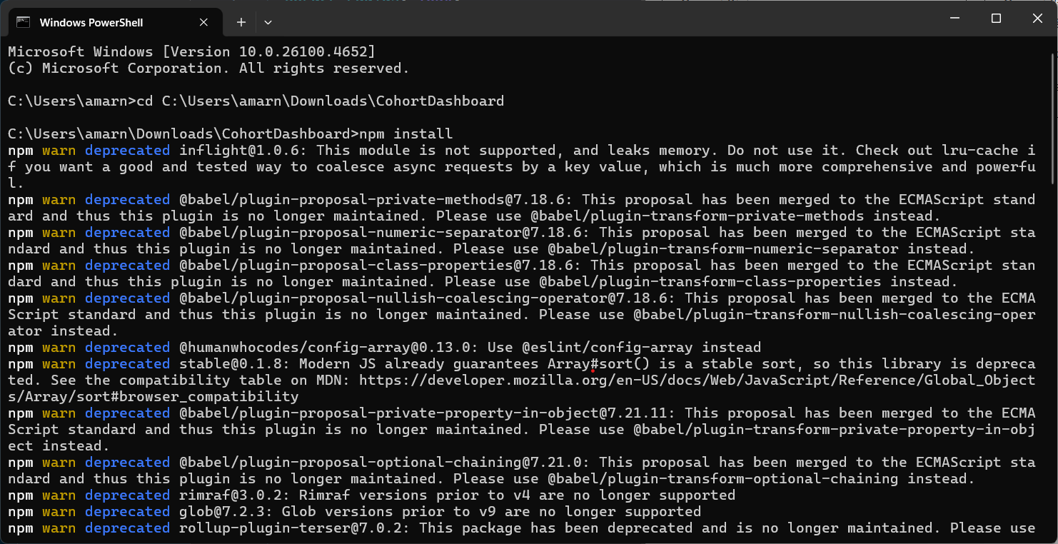

Creating a new CSS Module in a file called “CohortDetails.module.css”

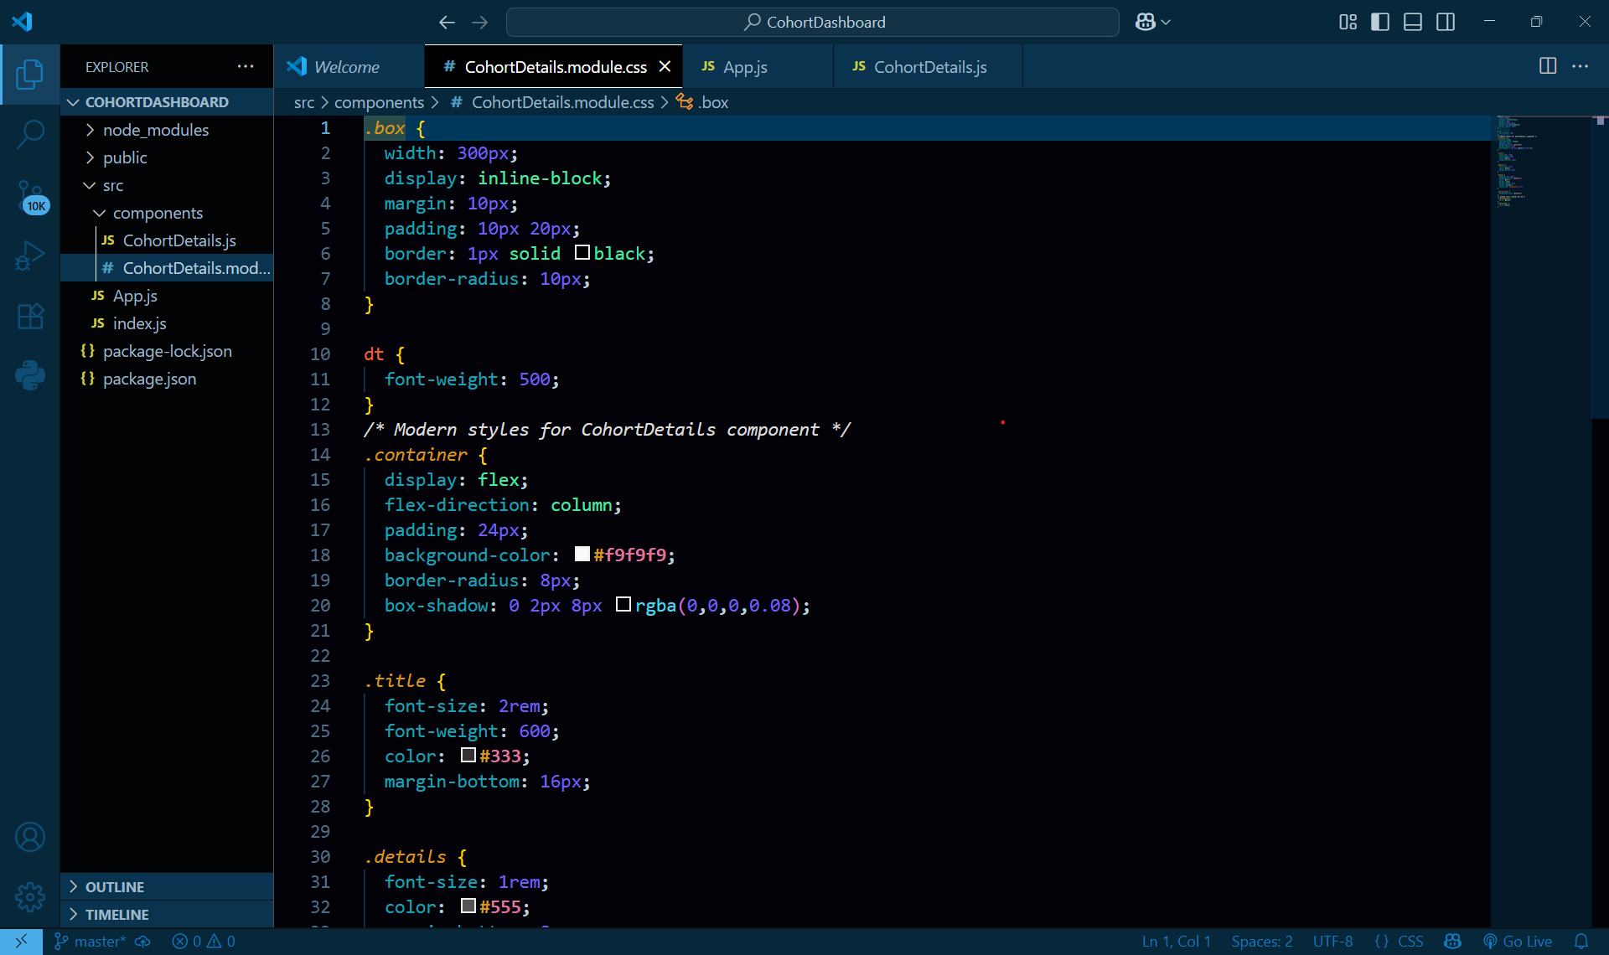

**Output:  
