**VISVESVARAYA TECHNOLOGICAL UNIVERSITY**

**“JnanaSangama”, Belgaum -590014, Karnataka.**



**LAB REPORT**

**on**

**Analysis and Design of Algorithms**

***Submitted by***

**VISHNU VP (1BM20CS191)**

***in partial fulfillment for the award of the degree of***

**BACHELOR OF ENGINEERING**

***in***

**COMPUTER SCIENCE AND ENGINEERING**



**B.M.S. COLLEGE OF ENGINEERING**

**(Autonomous Institution under VTU)**

**BENGALURU-560019**

**May-2022 to July-2022**

**B. M. S. College of Engineering,**

**Bull Temple Road, Bangalore 560019**

(Affiliated To Visvesvaraya Technological University, Belgaum)

**Department of Computer Science and Engineering**



**CERTIFICATE**

This is to certify that the Lab work entitled “**Analysis and Design of Algorithms**” carried out by **VISHNU VP(1BM20CS191),** who is bonafide student of **B. M. S. College of Engineering.** It is in partial fulfillment for the award of **Bachelor of Engineering in Computer Science and Engineering** of the Visvesvaraya Technological University, Belgaum during the year 2022. The Lab report has been approved as it satisfies the academic requirements in respect of **Analysis and Design of Algorithms - (19CS4PCADA)** work prescribed for the said degree.

Name of the Lab-In charge:

Vikranth BM            **Dr. Jyothi S Nayak**

Designation Professor and Head

Department of CSE Department of CSE

BMSCE, Bengaluru BMSCE, Bengaluru

**Index Sheet**

|  |  |  |
| --- | --- | --- |
| **Sl. No.** | **Experiment Title** | **Page No.** |
| **1** | Write a recursive program to Solve  **a)** Towers-of-Hanoi problem **b)** To find GCD | **5** |
| **2** | Implement Recursive Binary search and Linear search and determine the time required to search an element. Repeat the experiment for different values of N and plot a graph of the time taken versus N. | **7** |
| **3** | Sort a given set of N integer elements using Selection Sort technique and compute its time taken. Run the program for different values of N and record the time taken to sort. | **13** |
| **4** | Write program to do the following:  **a)** Print all the nodes reachable from a given starting node in a digraph usingBFS method.  **b)** Check whether a given graph is connected or not using DFS method. | **16** |
| **5** | Sort a given set of N integer elements using Insertion Sort technique and compute its time taken. | **20** |
| **6** | Write program to obtain the Topological ordering of vertices in a given digraph. | **22** |
| **7** | Implement Johnson Trotter algorithm to generate permutations. | **24** |
| **8** | Sort a given set of N integer elements using Merge Sort technique and compute its time taken. Run the program for different values of N and record the time taken to sort. | **29** |
| **9** | Sort a given set of N integer elements using Quick Sort technique and compute its time taken. | **32** |
| **10** | Sort a given set of N integer elements using Heap Sort technique and compute its time taken. |  |
| **11** | Implement Warshall’s algorithm using dynamic programming |  |
| **12** | Implement 0/1 Knapsack problem using dynamic programming. |  |
| **13** | Implement All Pair Shortest paths problem using Floyd’s algorithm. |  |
| **14** | Find Minimum Cost Spanning Tree of a given undirected graph using Prim’s algorithm. |  |
| **15** | Find Minimum Cost Spanning Tree of a given undirected graph using Kruskals algorithm. |  |
| **16** | From a given vertex in a weighted connected graph, find shortest paths to other vertices using Dijkstra’s algorithm. |  |
| **17** | 1. Implement “Sum of Subsets” using Backtracking. “Sum of Subsets” problem: Find a subset of a given set S = {s1,s2,……,sn} of n positive integers whose sum is equal to a given positive integer d. For example, if S = {1,2,5,6,8} and d = 9 there are two solutions {1,2,6} and {1,8}. A suitable message is to be displayed if the given problem instance doesn’t have a solution. |  |
| **18** | Implement “N-Queens Problem” using Backtracking. |  |

**Course Outcome**

|  |  |
| --- | --- |
| **CO1** | Ability to **analyze** time complexity of Recursive and Non-Recursive algorithms using asymptotic notations. |
| **CO2** | Ability to **design** efficient algorithms using various design techniques. |
| **CO3** | Ability to **apply** the knowledge of complexity classes P, NP, and NP-Complete and prove certain problems are NP-Complete |
| **CO4** | Ability to **conduct** practical experiments to solve problems using an appropriate designing method and find time efficiency. |

**Write a recursive program to Solve**

1. **Towers-of-Hanoi problem b) To find GCD**
2. **TOWER OF HANOI**

#include <stdio.h>

void toh(int n,char a,char b,char c)

{

if(n>0)

{

toh(n-1,a,c,b);

printf("move the disk from %c to %c\n",a,c);

toh(n-1,b,a,c);

}

}

int main()

{

int n;

char a,b,c;

printf("Enter the number of disks: ");

scanf("%d",&n);

toh(n,'a','b','c');

return 0;

}

**OUTPUT:**

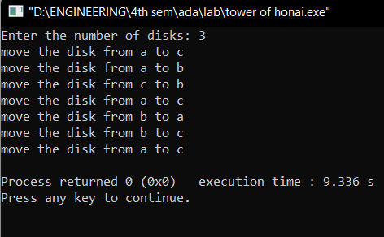

1. **GREATEST COMMON DIVISOR**

#include <stdio.h>

int gcd(int a,int b) {

if(b!=0)

return gcd(b,a%b);

else

return a;

}

void main()

{

int a,b,c;

printf("Enter two numbers: ");

scanf("%d%d",&a,&b);

c=gcd(a,b);

printf("The gcd of two numbers is %d\n",c);

}

**OUTPUT:**

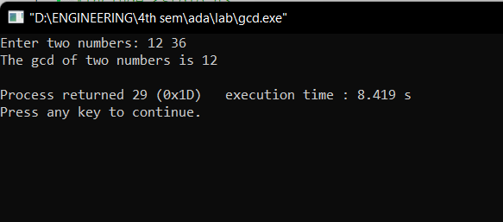

**2.Implement Recursive Binary search and Linear search and determine the time required to search an element. Repeat the experiment for different values of N and plot a graph of the time taken versus N.**

**CODE:**

#include<stdio.h>;

#include<time.h>;

#include<stdlib.h>;

int bin_srch(int [],int,int,int);

int lin_srch(int [],int,int,int);

int n,a[1000000];

int main() {

int ch,key,search_status,temp;

clock_t end,start;

unsigned long int i, j;

while(1) {

printf("\n1: Binary search\t 2: Linear search\t 3: Exit\n");

printf("\nEnter your choice:\t");

scanf("%d",&ch);

switch(ch) {

case 1:

n=1000;

while(n<=7000){

for(i=0;i<n;i++)

a[i]=i;

key=a[n-1];

start=clock();

search_status=bin_srch(a,0,n-1,key);

end=clock();

if(search_status==-1)

printf("\nKey Not Found");

else

printf("\n Key found at position %d",search_status);

printf("\nTime for n=%d is %f Secs",n,(double)(end-

start)/CLOCKS_PER_SEC);

n=n+1000;

}

break;

case 2:

n=1000;

while(n<=7000) {

for(i=0;i<n;i++)

a[i]=i;

key=a[n-1];

start=clock();

search_status=lin_srch(a,0,n-1,key);

end=clock();

if(search_status==-1)

printf("\nKey Not Found");

else

printf("\n Key found at position %d",search_status);

printf("\nTime for n=%d is %f Secs",n,(double)(end-

start)/CLOCKS_PER_SEC);

n=n+1000;

}

break;

default:

exit(0);

}

getchar();

}

}

int bin_srch(int a[],int low,int high,int key) {

for(int j=0;j<1000000;j++);

int mid;

if(low>high)

return -1;

mid=(low+high)/2;

if(key==a[mid])

return mid;

if(key<a[mid])

return bin_srch(a,low,mid-1,key);

else

return bin_srch(a,mid+1,high,key);

}

int lin_srch(int a[],int i,int high,int key) {

for(int j=0;j<10000;j++){ int temp=38/600;}

if(i>high)

return -1;

if(key==a[i])

return i;

else

return lin_srch(a,i+1,high,key);

}

**OUTPUT:**

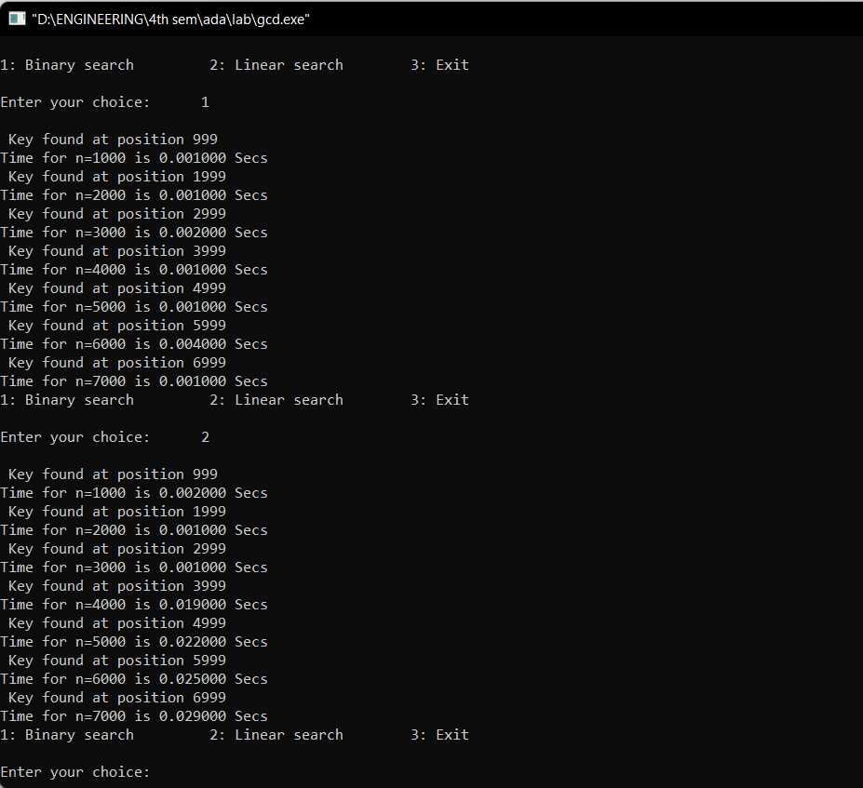

**GRAPH:**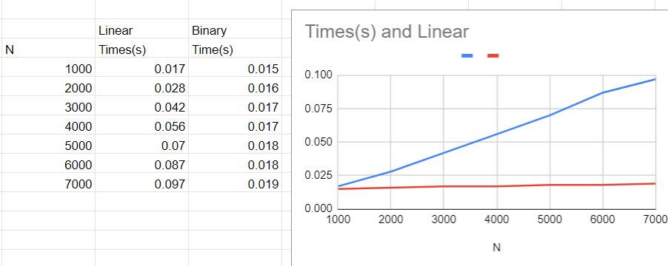

**3.Sort a given set of N integer elements using Selection Sort technique and compute its time taken. Run the program for different values of N and record the time taken to sort.**

**CODE:**

#include<stdio.h>

#include<time.h>

void sort(int x){

int n=x;

int a[n],max,i,j,k;

for(i=0;i<n;i++)

a[i]=i+1;

double start,end;

start = clock();

for(i=0;i<(n-1);i++){

max=a[i];

for(j=(i+1);j<n;j++){

if(max<a[j]){

max=a[j];

k=j;

}

}

if(a[i]!=max){

int temp=a[i];

a[i]=a[k];

a[k]=temp;

}

}

end = clock();

printf("Time taken to sort %d numbers is %f seconds \n",n,(end-start)/CLOCKS_PER_SEC);

n=n+1000;

}

void main(){

for(int x=1000;x<=10000;x+=1000){

sort(x);}

}

**OUTPUT:**

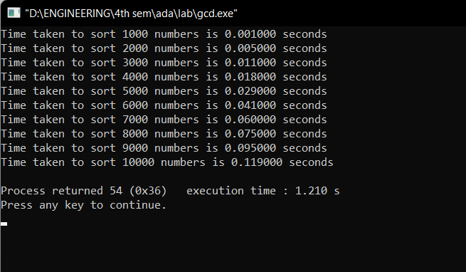

**GRAPH:**

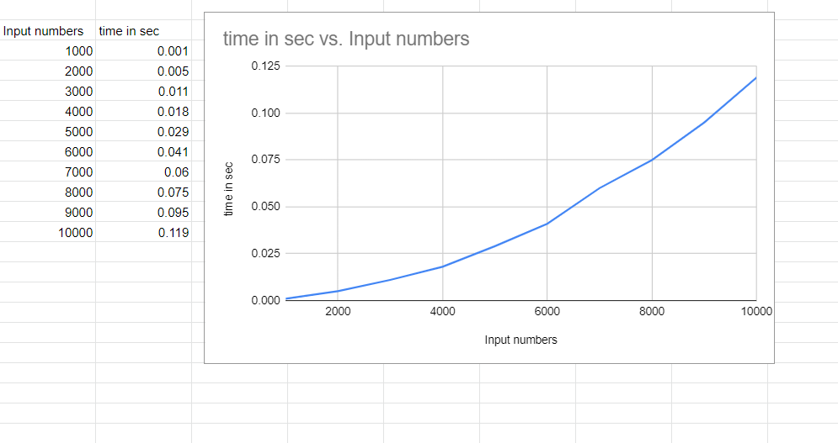

**4.Write program to do the following:**

**a) Print all the nodes reachable from a given starting node in a digraph usingBFS method.**

**b) Check whether a given graph is connected or not using DFS method.**

1. **BREADTH FIRST SEARCH**

**CODE:**

#include<stdio.h>

#include<conio.h>

int a[15][15],n;

void bfs(int);

void main() {

int i,j,src;

printf("\nEnter the no of nodes:\t");

scanf("%d",&n);

printf("\nEnter the adjacency matrix:\n");

for(i=1;i<=n;i++)

for(j=1;j<=n;j++)

scanf("%d",&a[i][j]);

printf("\nEnter the source node:\t");

scanf("%d",&src);

bfs(src);

}

void bfs(int src) {

int q[15],f=0,r=-1,vis[15],i,j;

for(j=1;j<=n;j++)

vis[j]=0;

vis[src]=1;

r=r+1;

q[r]=src;

while(f<=r) {

i=q[f];

f=f+1;

for(j=1;j<=n;j++)

{

if(a[i][j]==1&&vis[j]!=1) {

vis[j]=1;

r=r+1;

q[r]=j;

}

}

}

for(j=1;j<=n;j++) {

if(vis[j]!=1)

printf("\nNode %d is not reachable",j);

else

printf("\nNode %d is reachable",j);

}

}

**OUTPUT:**

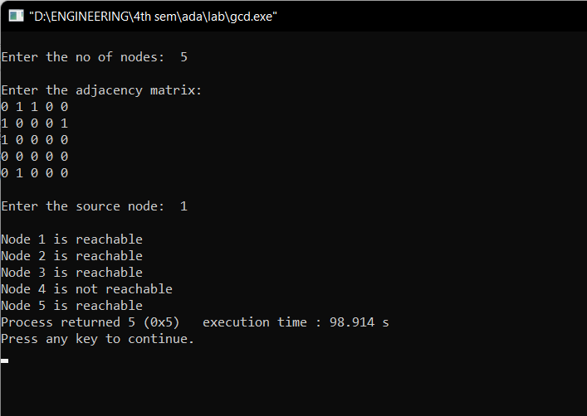

**b)DEPTH FIRST SEARCH**

**CODE:**

#include<stdio.h>

#include<conio.h>

int a[10][10],n,vis[10];

int dfs(int);

void main()

{

int i,j,src,ans;

for(j=1;j<=n;j++)

vis[j]=0;

printf("\nEnter the no of nodes:\t");

scanf("%d",&n);

printf("\nEnter the adjacency matrix:\n");

for(i=1;i<=n;i++)

for(j=1;j<=n;j++)

scanf("%d",&a[i][j]);

printf("\nEnter the source node:\t");

scanf("%d",&src);

ans=dfs(src);

if(ans==1)

printf("\nGraph is connected\n");

else

printf("\nGragh is not connected\n");

getch();

}

int dfs(int src)

{

int j;

vis[src]=1;

for(j=1;j<=n;j++)

if(a[src][j]==1&&vis[j]!=1)

dfs(j);

for(j=1;j<=n;j++) {

if(vis[j]!=1)

return 0;

}

return 1;

}

**OUTPUT:**

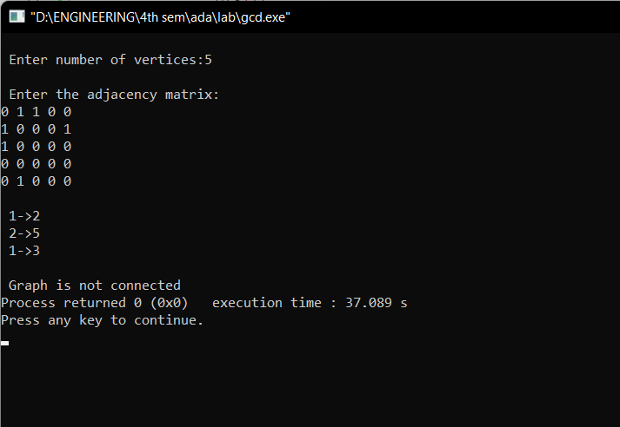

**5.Sort a given set of N integer elements using Insertion Sort technique and compute its time taken.**

**CODE:**

#include <math.h>

#include <stdio.h>

#include<stdlib.h>

#include<time.h>

void insertionSort(int arr[], int n)

{

int i, key, j;

for (i = 1; i < n; i++)

{

key = arr[i];

j = i - 1;

while (j >= 0 && arr[j] > key)

{

for(int k=0;k<100000;k++);

arr[j + 1] = arr[j];

j = j - -;

}

arr[j + 1] = key;

}

}

void main() {

int i, n;

clock_t start, end;

printf("ENTER ARRAY SIZE =");

scanf("%d", &n);

int arr[150000];

for (int j = 0; j < n; j++)

arr[j] = rand()%10000;

for (i = 0; i < n; i++)

printf(" %d", arr[i]);

printf("\n");

start = clock();

insertionSort(arr, n);

end = clock();

printf("\nSorted elements = ");

for (i = 0; i < n; i++)

printf(" %d", arr[i]);

printf("\n Time taken to sort %d Numbersis %f secs", n, (((double)(end - start)) / CLOCKS_PER_SEC));

}

**OUTPUT:**

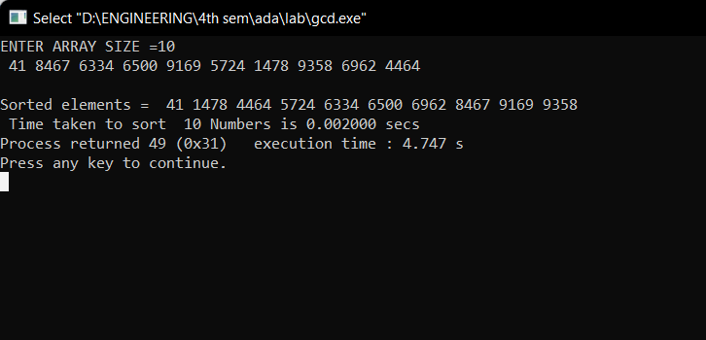

**GRAPH:**

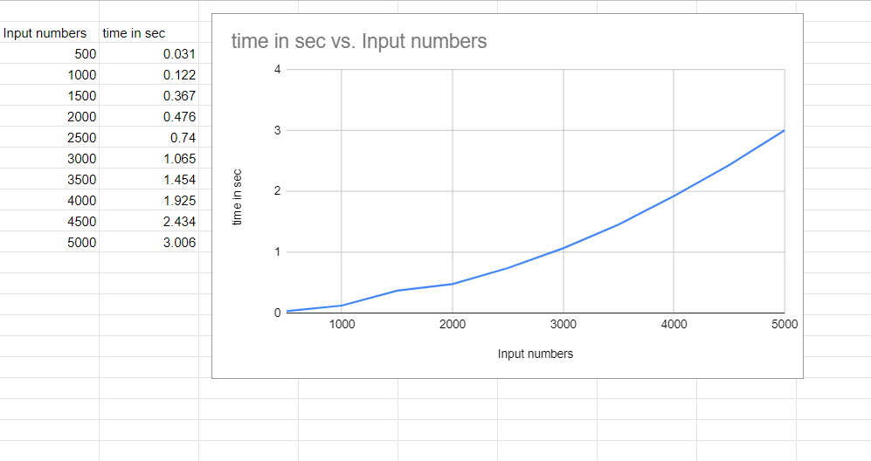

1. **Write program to obtain the Topological ordering of vertices in a given digraph.**

**CODE:**

#include<stdio.h>

#include<conio.h>

void source_removal(int n, int a[10][10]) {

int i,j,k,u,v,top,s[10],t[10],indeg[10],sum;

for(i=0;i<n;i++) {

sum=0;

for(j=0;j<n;j++)

sum+=a[j][i];

indeg[i]=sum;

}

top=-1;

for(i=0;i<n;i++) {

if(indeg[i]==0)

s[++top]=i;

}

k=0;

while(top!=-1) {

u=s[top--];

t[k++]=u;

for(v=0;v<n;v++) {

if(a[u][v]==1) {

indeg[v]=indeg[v]-1;

if(indeg[v]==0)

s[++top]=v;

}

}

}

printf("Topological order :");

for(i=0;i<n;i++)

printf(" %d", t[i]);

}

void main() {

int i,j,a[10][10],n;

printf("Enter number of nodes\n");

scanf("%d", &n);

printf("Enter the adjacency matrix\n");

for(i=0;i<n;i++)

for(j=0;j<n;j++)

scanf("%d", &a[i][j]);

source_removal(n,a);

getch();

}

**OUTPUT:**

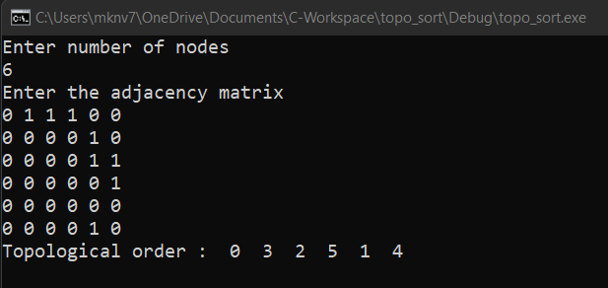

1. **Implement Johnson Trotter algorithm to generate permutations.**

**CODE:**

#include <stdio.h>

#include <stdlib.h>

int flag = 0;

int swap(int *a,int *b) {

int t = *a;

*a = *b;

*b = t;

}

int search(int arr[],int num,int mobile)

{

int g;

for(g=0;g<num;g++) {

if(arr[g] == mobile)

return g+1;

else

flag++;

}

return -1;

}

int find_Moblie(int arr[],int d[],int num)

{

int mobile = 0;

int mobile_p = 0;

int i;

for(i=0;i<num;i++)

{

if((d[arr[i]-1] == 0) && i != 0)

{

if(arr[i]>arr[i-1] && arr[i]>mobile_p)

{

mobile = arr[i];

mobile_p = mobile;

}

else

flag++;

}

else if((d[arr[i]-1] == 1) & i != num-1)

{

if(arr[i]>arr[i+1] && arr[i]>mobile_p)

{

mobile = arr[i];

mobile_p = mobile;

}

else

flag++;

}

else

flag++;

}

if((mobile_p == 0) && (mobile == 0))

return 0;

else

return mobile;

}

void permutations(int arr[],int d[],int num)

{

int i;

int mobile = find_Moblie(arr,d,num);

int pos = search(arr,num,mobile);

if(d[arr[pos-1]-1]==0)

swap(&arr[pos-1],&arr[pos-2]);

else

swap(&arr[pos-1],&arr[pos]);

for(int i=0;i<num;i++)

{

if(arr[i] > mobile)

{

if(d[arr[i]-1]==0)

d[arr[i]-1] = 1;

else

d[arr[i]-1] = 0;

}

}

for(i=0;i<num;i++)

{

printf(" %d ",arr[i]);

} }

int factorial(int k)

{

int f = 1;

int i = 0;

for(i=1;i<k+1;i++)

f = f*i;

return f;

}

int main()

{

int num = 0;

int i;

int j;

int z = 0;

printf("Johnson trotter algorithm to find all permutations of given numbers \n");

printf("Enter the number\n");

scanf("%d",&num);

int arr[num],d[num];

z = factorial(num);

printf("total permutations = %d",z);

printf("\nAll possible permutations are: \n");

for(i=0;i<num;i++)

{

d[i] = 0;

arr[i] = i+1;

printf(" %d ",arr[i]);

}

printf("\n");

for(j=1;j<z;j++) {

permutations(arr,d,num);

printf("\n");

}

return 0;

}

**OUTPUT:**

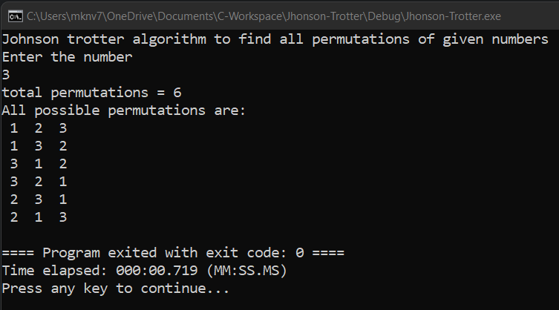

1. **Sort a given set of N integer elements using Merge Sort technique and compute its time taken. Run the program for different values of N and record the time taken to sort.**

**CODE:**

#include<stdio.h>

#include<stdlib.h>

#include<time.h>

void mergesort(int a[],int i,int j);

void merge(int a[],int i1,int j1,int i2,int j2);

int main()

{

clock_t start,end;

int a[30000],n=500,i;

while(n<=5000){

for(i=0;i<n;i++)

{

a[i] = rand()%1000;

}

start = clock();

mergesort(a,0,n-1);

end = clock();

printf("\n To Sort array of %d numbers ",n);

printf("required time is %lf secs",(double)(end-start)/CLOCKS_PER_SEC);

printf(“\n”);

n+=500;

}

}

void mergesort(int a[],int i,int j)

{

int mid;

if(i<j)

{

mid=(i+j)/2;

mergesort(a,i,mid);

mergesort(a,mid+1,j);

merge(a,i,mid,mid+1,j);

}

}

void merge(int a[],int i1,int j1,int i2,int j2)

{

int temp[30000];

int i,j,k;

i=i1;

j=i2;

k=0;

while(i<=j1 && j<=j2)

{

for(int j=0;j<100000;j++);

if(a[i]<a[j])

temp[k++]=a[i++];

else

temp[k++]=a[j++];

}

while(i<=j1)

temp[k++]=a[i++];

while(j<=j2)

temp[k++]=a[j++];

for(i=i1,j=0;i<=j2;i++,j++){

a[i]=temp[j];

}

}

**OUTPUT:**

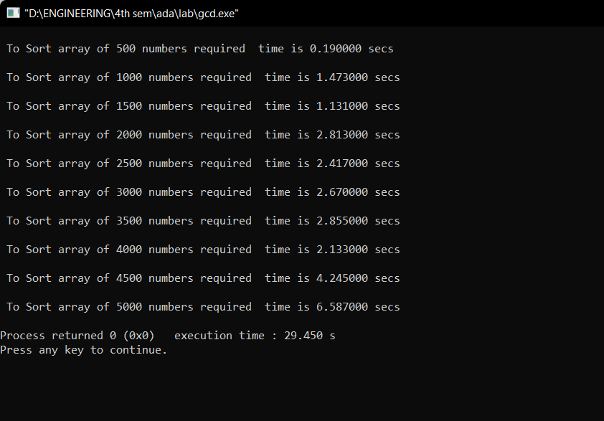

**GRAPH:**

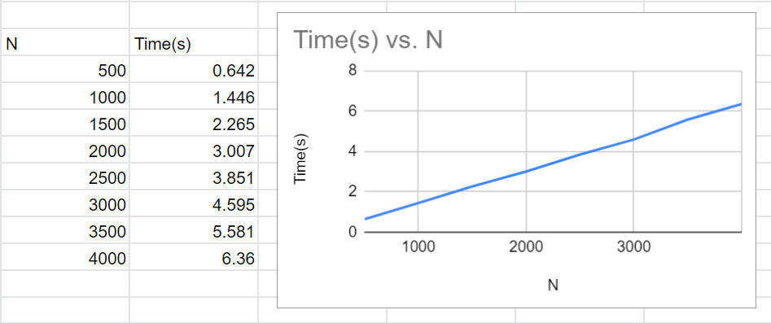

1. **Sort a given set of N integer elements using Quick Sort technique and compute its time taken.**

**CODE:**

#include<stdio.h>

#include<time.h>

#include<math.h>

#include<stdlib.h>

void quicksort(int number[5000],int first,int last)

{

int i, j, pivot, temp;

if(first<last)

{

pivot=first;

i=first;

j=last;

while(i<j)

{

for(int x=0;x<10000000;x++);

while(number[i]<=number[pivot]&&i<last)

i++;

while(number[j]>number[pivot])

j--;

if(i<j)

{

temp=number[i];

number[i]=number[j];

number[j]=temp;

}

}

temp=number[pivot];

number[pivot]=number[j];

number[j]=temp;

quicksort(number,first,j-1);

quicksort(number,j+1,last);

}

}

int main()

{

clock_t start,end;

int i, count, number[5000];

printf("No. of elements: ");

scanf("%d",&count);

printf("Enter %d elements: ", count);

for(i=0;i<count;i++)

{

number[i]=rand()%5000;

}

start = clock();

quicksort(number,0,count-1);

end = clock();

printf("Order of Sorted elements: ");

for(i=0;i<count;i++)

{

printf(" %d",number[i]);

}

printf("\nSeconds taken %lf",(double)(end-start)/CLOCKS_PER_SEC);

return 0;

}

**OUTPUT:**

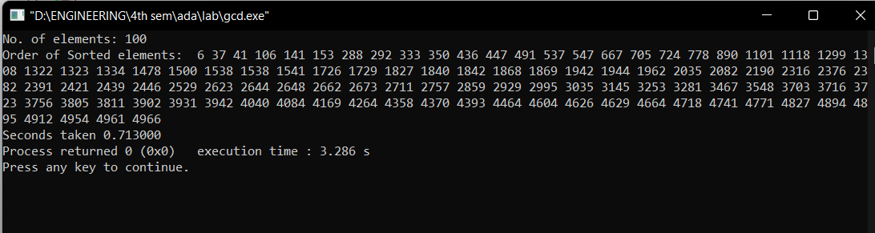

**GRAPH:**

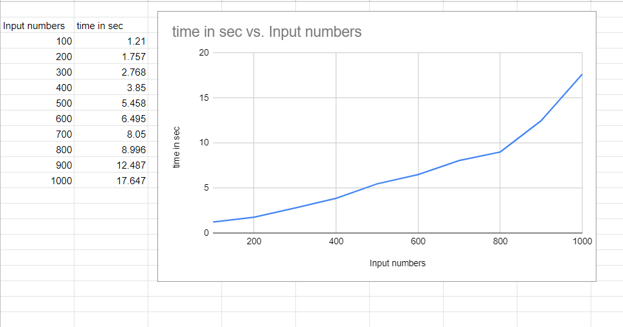

**11. Implement Warshall’s algorithm using dynamic programming**

}

printf("\nSeconds taken %lf",(double)(end-start)/CLOCKS_PER_SEC);

return 0;

}

|  |
| --- |
| #include<stdio.h> |
|  | #include<math.h> |
|  | int max(int,int); |
|  | void warshall(int A[10][10],int n) { |
|  | int i,j,k; |
|  | for ( k=0;k<n;k++) |
|  | for ( i=0;i<n;i++) |
|  | for ( j=0;j<n;j++) |
|  | A[i][j]=max(A[i][j],A[i][k]&&A[k][j]); |
|  | } |
|  | int max(int a,int b) { |
|  | return a>b?a:b; |
|  | } |
|  | void main() { |
|  | int p[10][10]; |
|  | int n; |
|  | int i,j; |
|  |  |
|  | printf("\n Enter the Number of Vertices : "); |
|  | scanf("%d",&n); |
|  | printf("\n Enter the adjacency matrix:\n"); |
|  | for( i=0;i<n;i++) |
|  | { |
|  | for( j=0;j<n;j++) |
|  | scanf("%d",&p[i][j]); |
|  | } |
|  |  |
|  | printf("\n Matrix of input data: \n"); |
|  | for ( i=0;i<n;i++) { |
|  | for ( j=0;j<n;j++) |
|  | printf(" %d\t",p[i][j]); |
|  | printf("\n"); |
|  | } |
|  | warshall(p,n); |
|  | printf("\n Transitive closure: \n"); |
|  | for ( i=0;i<n;i++) { |
|  | for ( j=0;j<n;j++) |
|  | printf(" %d\t",p[i][j]); |
|  | printf("\n"); |
|  | } |
|  |  |
|  | } |

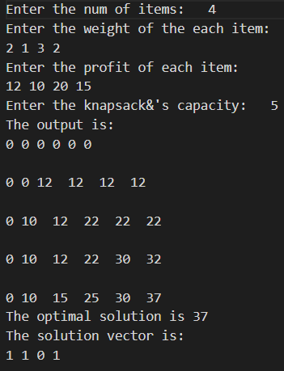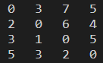

**12. Implement 0/1 Knapsack algorithm using dynamic programming**

|  |
| --- |
| #include<stdio.h> |
|  | #include<conio.h> |
|  | void knapsack(); |
|  | int max(int,int); |
|  | int i,j,n,m,p[10],w[10],v[10][10]; |
|  | void main() |
|  | { |
|  |  |
|  | printf("\nenter the no. of items:\t"); |
|  | scanf("%d",&n); |
|  | printf("\nenter the weight of the each item:\n"); |
|  | for(i=1;i<=n;i++) |
|  | { |
|  | scanf("%d",&w[i]); |
|  | } |
|  | printf("\nenter the profit of each item:\n"); |
|  | for(i=1;i<=n;i++) |
|  | { |
|  | scanf("%d",&p[i]); |
|  | } |
|  | printf("\nenter the knapsack's capacity:\t"); |
|  | scanf("%d",&m); |
|  | knapsack(); |
|  | getch(); |
|  | } |
|  | void knapsack() |
|  | { |
|  | int x[10]; |
|  | for(i=0;i<=n;i++) |
|  | { |
|  | for(j=0;j<=m;j++) |
|  | { |
|  | if(i==0||j==0) |
|  | { |
|  | v[i][j]=0; |
|  | } |
|  | else if(j-w[i]<0) |
|  | { |
|  | v[i][j]=v[i-1][j]; |
|  | } |
|  | else |
|  | { |
|  | v[i][j]=max(v[i-1][j],v[i-1][j-w[i]]+p[i]); |
|  | } |
|  | } |
|  | } |
|  | printf("\nthe output is:\n"); |
|  | for(i=0;i<=n;i++) |
|  | { |
|  | for(j=0;j<=m;j++) |
|  | { |
|  | printf("%d\t",v[i][j]); |
|  | } |
|  | printf("\n\n"); |
|  | } |
|  | printf("\nthe optimal solution is %d",v[n][m]); |
|  | printf("\nthe solution vector is:\n"); |
|  | for(i=n;i>=1;i--) |
|  | { |
|  | if(v[i][m]!=v[i-1][m]) |
|  | { |
|  | x[i]=1; |
|  | m=m-w[i]; |
|  | } |
|  | else |
|  | { |
|  | x[i]=0; |
|  | } |
|  | } |
|  | for(i=1;i<=n;i++) |
|  | { |
|  | printf("%d\t",x[i]); |
|  | } |
|  | } |
|  | int max(int x,int y) |
|  | { |
|  | if(x>y) |
|  | { |
|  | return x; |
|  | } |
|  | else |
|  | { |
|  | return y; |
|  | } |
|  | } |

**13. Implement All Pair Shortest Paths Problem using Floyd’s Algorithm**

|  |
| --- |
| #include<stdio.h> |
|  | #include<conio.h> |
|  | int a[10][10],n; |
|  | void floyds(); |
|  | int min(int,int); |
|  | void main() |
|  | { |
|  | int i,j; |
|  | printf("\nenter the no. of vertices:\t"); |
|  | scanf("%d",&n); |
|  | printf("\nenter the cost matrix:\n"); |
|  | for(i=1;i<=n;i++) |
|  | { |
|  | for(j=1;j<=n;j++) |
|  | { |
|  | scanf("%d",&a[i][j]); |
|  | } |
|  | } |
|  | floyds(); |
|  | getch(); |
|  | } |
|  | void floyds() |
|  | { |
|  | int i,j,k; |
|  | for(k=1;k<=n;k++) |
|  | { |
|  | for(i=1;i<=n;i++) |
|  | { |
|  | for(j=1;j<=n;j++) |
|  | { |
|  | a[i][j]=min(a[i][j],a[i][k]+a[k][j]); |
|  | } |
|  | } |
|  | } |
|  | printf("\nall pair shortest path matrix is:\n"); |
|  | for(i=1;i<=n;i++) |
|  | { |
|  | for(j=1;j<=n;j++) |
|  | { |
|  | printf("%d\t",a[i][j]); |
|  | } |
|  | printf("\n\n"); |
|  | } |
|  | } |
|  | int min(int x,int y) |
|  | { |
|  | if(x<y) |
|  | { |
|  | return x; |
|  | } |
|  | else |
|  | { |
|  | return y; |
|  | } |
|  | } |

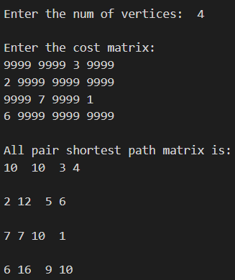

**14. Find Minimum Cost Spanning tree of a given undirected graph using Prim’s Algorithm.**

|  |
| --- |
| #include<stdio.h> |
|  | int main() |
|  | { |
|  | int cost[10][10],visited[10]={0},i,j,n,no_e=1,min,a,b,min_cost=0; |
|  | printf("Enter number of nodes "); |
|  | scanf("%d",&n); |
|  | printf("Enter cost in form of adjacency matrix\n"); |
|  |  |
|  | for(i=1;i<=n;i++) |
|  | { |
|  | for(j=1;j<=n;j++) |
|  | { |
|  | scanf("%d",&cost[i][j]); |
|  |  |
|  | if(cost[i][j]==0) |
|  | cost[i][j]=1000; |
|  | } |
|  | } |
|  |  |
|  |  |
|  | visited[1]=1; |
|  | while(no_e<n) |
|  | { |
|  | min=1000; |
|  |  |
|  | for(i=1;i<=n;i++) |
|  | { |
|  | for(j=1;j<=n;j++) |
|  | { |
|  | if(cost[i][j]<min) |
|  | { |
|  | if(visited[i]!=0) |
|  | { |
|  | min=cost[i][j]; |
|  | a=i; |
|  | b=j; |
|  | } |
|  | } |
|  | } |
|  | } |
|  |  |
|  | if(visited[b]==0) |
|  | { |
|  | printf("\n%d to %d cost=%d",a,b,min); |
|  | min_cost=min_cost+min; |
|  | no_e++; |
|  | } |
|  | visited[b]=1; |
|  |  |
|  | cost[a][b]=cost[b][a]=1000; |
|  | } |
|  | printf("\nminimum weight is %d",min_cost); |
|  | return 0; |
|  | } |

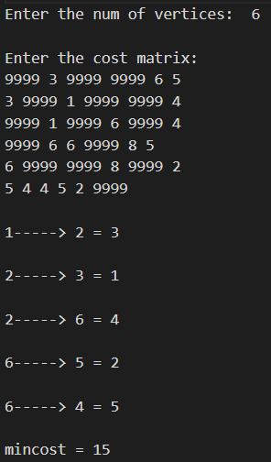

**15. Find Minimum Cost Spanning tree of a given undirected graph using Kruskal’s algorithm.**

#include <stdio.h>

#include <conio.h>

#include <stdlib.h>

int i,j,k,a,b,u,v,n,ne=1;

int min,mincost=0,cost[9][9],parent[9];

int find(int);

int uni(int,int);

void main()

{

printf("\n\tImplementation of Kruskal's Algorithm\n");

printf("\nEnter the no. of vertices:");

scanf("%d",&n);

printf("\nEnter the cost adjacency matrix:\n");

for(i=1;i<=n;i++)

{

for(j=1;j<=n;j++)

{

scanf("%d",&cost[i][j]);

if(cost[i][j]==0)

cost[i][j]=999;

}

}

printf("The edges of Minimum Cost Spanning Tree are\n");

while(ne < n)

{

for(i=1,min=999;i<=n;i++)

{

for(j=1;j <= n;j++)

{

if(cost[i][j] < min)

{

min=cost[i][j];

a=u=i;

b=v=j;

}

}

}

u=find(u);

v=find(v);

if(uni(u,v))

{

printf("%d edge (%d,%d) =%d\n",ne++,a,b,min);

mincost +=min;

}

cost[a][b]=cost[b][a]=999;

}

printf("\n\tMinimum cost = %d\n",mincost);

getch();

}

int find(int i)

{

while(parent[i])

i=parent[i];

return i;

}

int uni(int i,int j)

{

if(i!=j)

{

parent[j]=i;

return 1;

}

return 0;

}

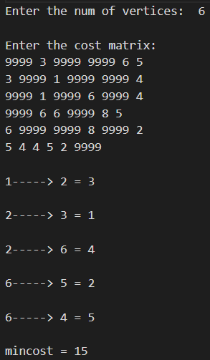

**16. Find Minimum Cost Spanning tree of a given undirected graph using Dijikstra’s algorithm.**

#include<stdio.h>

#include<conio.h>

#define INFINITY 9999

#define MAX 10

void dijkstra(int G[MAX][MAX],int n,int startnode);

int main()

{

int G[MAX][MAX],i,j,n,u;

printf("Enter no. of vertices:");

scanf("%d",&n);

printf("\nEnter the adjacency matrix:\n");

for(i=0;i<n;i++)

for(j=0;j<n;j++)

scanf("%d",&G[i][j]);

printf("\nEnter the starting node:");

scanf("%d",&u);

dijkstra(G,n,u);

return 0;

}

void dijkstra(int G[MAX][MAX],int n,int startnode)

{

int cost[MAX][MAX],distance[MAX],pred[MAX];

int visited[MAX],count,mindistance,nextnode,i,j;

//pred[] stores the predecessor of each node

//count gives the number of nodes seen so far

//create the cost matrix

for(i=0;i<n;i++)

for(j=0;j<n;j++)

if(G[i][j]==0)

cost[i][j]=INFINITY;

else

cost[i][j]=G[i][j];

//initialize pred[],distance[] and visited[]

for(i=0;i<n;i++)

{

distance[i]=cost[startnode][i];

pred[i]=startnode;

visited[i]=0;

}

distance[startnode]=0;

visited[startnode]=1;

count=1;

while(count<n-1)

{

mindistance=INFINITY;

//nextnode gives the node at minimum distance

for(i=0;i<n;i++)

if(distance[i]<mindistance&&!visited[i])

{

mindistance=distance[i];

nextnode=i;

}

//check if a better path exists through nextnode

visited[nextnode]=1;

for(i=0;i<n;i++)

if(!visited[i])

if(mindistance+cost[nextnode][i]<distance[i])

{

distance[i]=mindistance+cost[nextnode][i];

pred[i]=nextnode;

}

count++;

}

//print the path and distance of each node

for(i=0;i<n;i++)

if(i!=startnode)

{

printf("\nDistance of node%d=%d",i,distance[i]);

printf("\nPath=%d",i);

j=i;

do

{

j=pred[j];

printf("<-%d",j);

}while(j!=startnode);

}

}

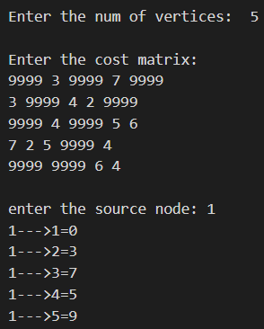

**17. Implement “Sum of Subsets” using backtracking.**

**“Sum of Subsets” problem:Find a subset of a given set S={s1,s2,….,sn}**

**Of n positive integers whose sum is equal to a given positive integer d.**

**For example,if S={1,2,5,6,8} and d=9 there are two solutions {126} and**

**{1,8}.**

#include<stdio.h>

#include<conio.h>

intcount,w[10],d,x[10];

void subset(int cs, int k, int r)

{

int i;

x[k]=1;

if(cs+w[k]==d)

{

printf("\nSubset solution = %d\n", ++count);

for(i=0;i<=k;i++)

{

if(x[i]==1)

printf("%d", w[i]);

}

}

else

if(cs+w[k]+w[k+1]<=d)

subset(cs+w[k], k+1, r-w[k]);

if((cs+r-w[k]>=d) && (cs+w[k+1])<=d)

{

x[k]=0;

subset(cs,k+1,r-w[k]);

}

}

void main()

{

int sum=0,i,n;

printf("Enter the number of elements\n");

scanf("%d", &n);

printf("Enter the elements in ascending order\n");

for(i=0;i<n;i++)

scanf("%d", &w[i]);

printf("Enter the required sum\n");

scanf("%d", &d);

for(i=0;i<n;i++)

sum+=w[i];

if(sum<d)

{

printf("No solution exists\n");

return;

}

printf("The solution is\n");

count=0;

subset(0,0,sum);

getch();

}

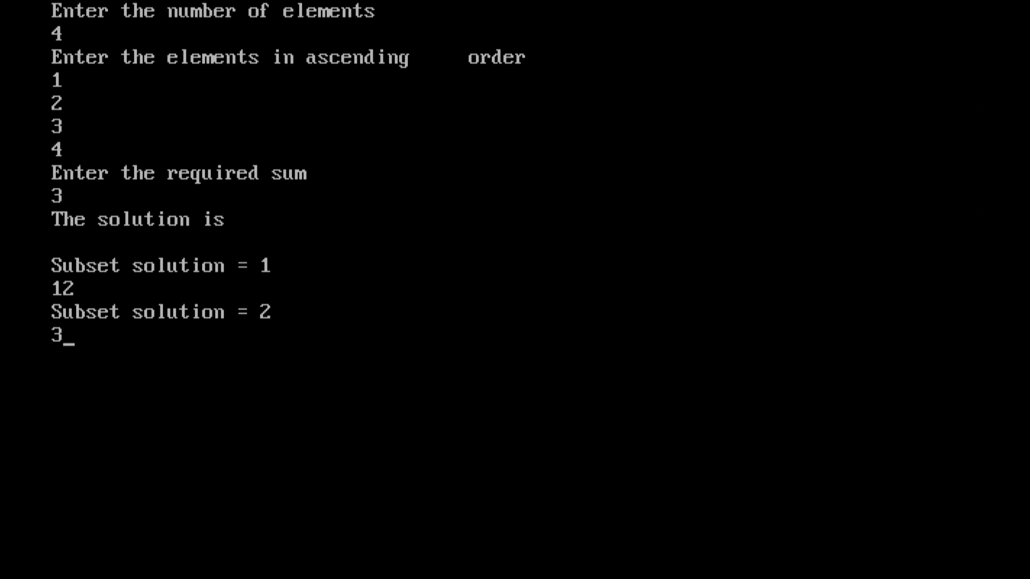

**18.Implement “N-Queens Problem” using Backtracking.**

**CODE:**

#include<stdio.h>

#include<conio.h>

void nqueens(int n)

{

Int k,x[20],count=0;

k=1;

x[k]=0;

while(k!=0)

{

x[k]++;

while(place(x,k)!=1 && x[k]<=n)

x[k]++;

if(x[k]<=n)

{

if(k==n)

{

printf("\nSolution is %d\n", ++count);

printf("Queen\t\tPosition\n");

for(k=1;k<=n;k++)

printf("%d\t\t%d\n", k,x[k]);

}

else

{

k++;

x[k]=0;

}

}

else

k--;

}

}

int place(int x[], int k)

{

int i;

for(i=1;i<=k-1;i++)

{

if(i+x[i]==k+x[k]||i-x[i]==k-x[k]||x[i]==x[k])

return 0;

}

return 1;

}

void main()

{

int n;

clrscr();

printf("Enter the number of Queens\n");

scanf("%d", &n);

nqueens(n);

getch();

}

**OUTPUT:**

