Experiment-1:

Write SQL queries to CREATE TABLES for various databases using DDL commands (i.e. CREATE, ALTER, DROP, TRUNCATE).

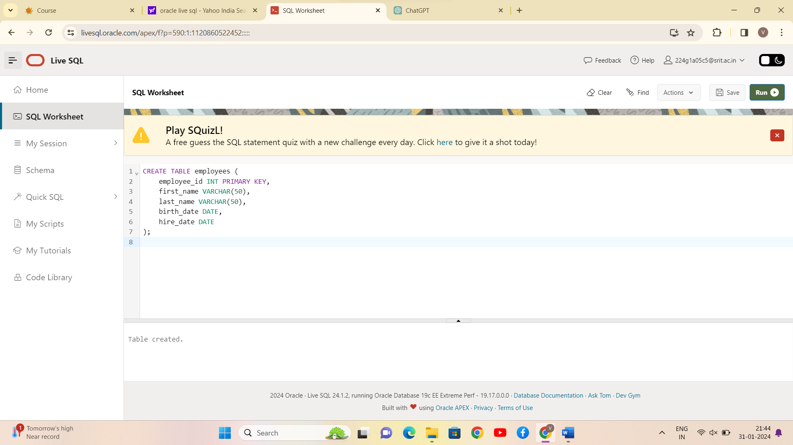

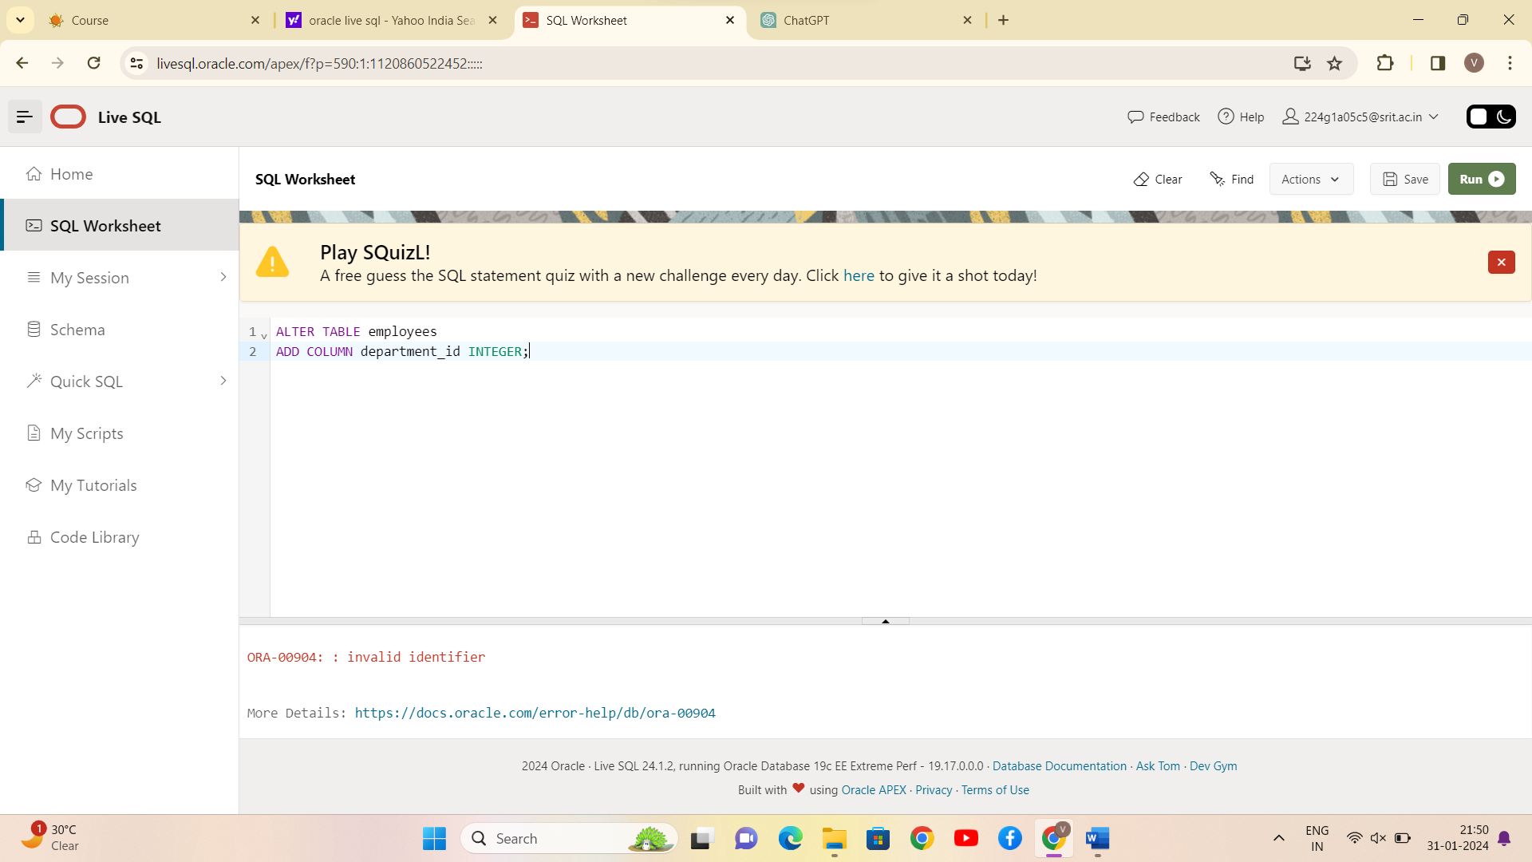

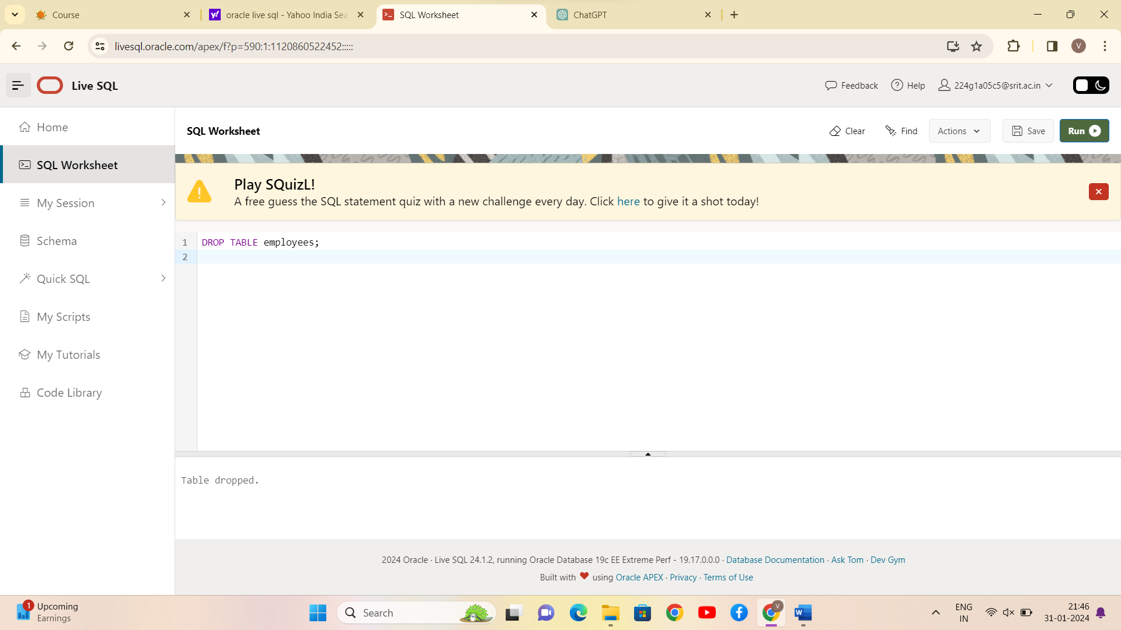

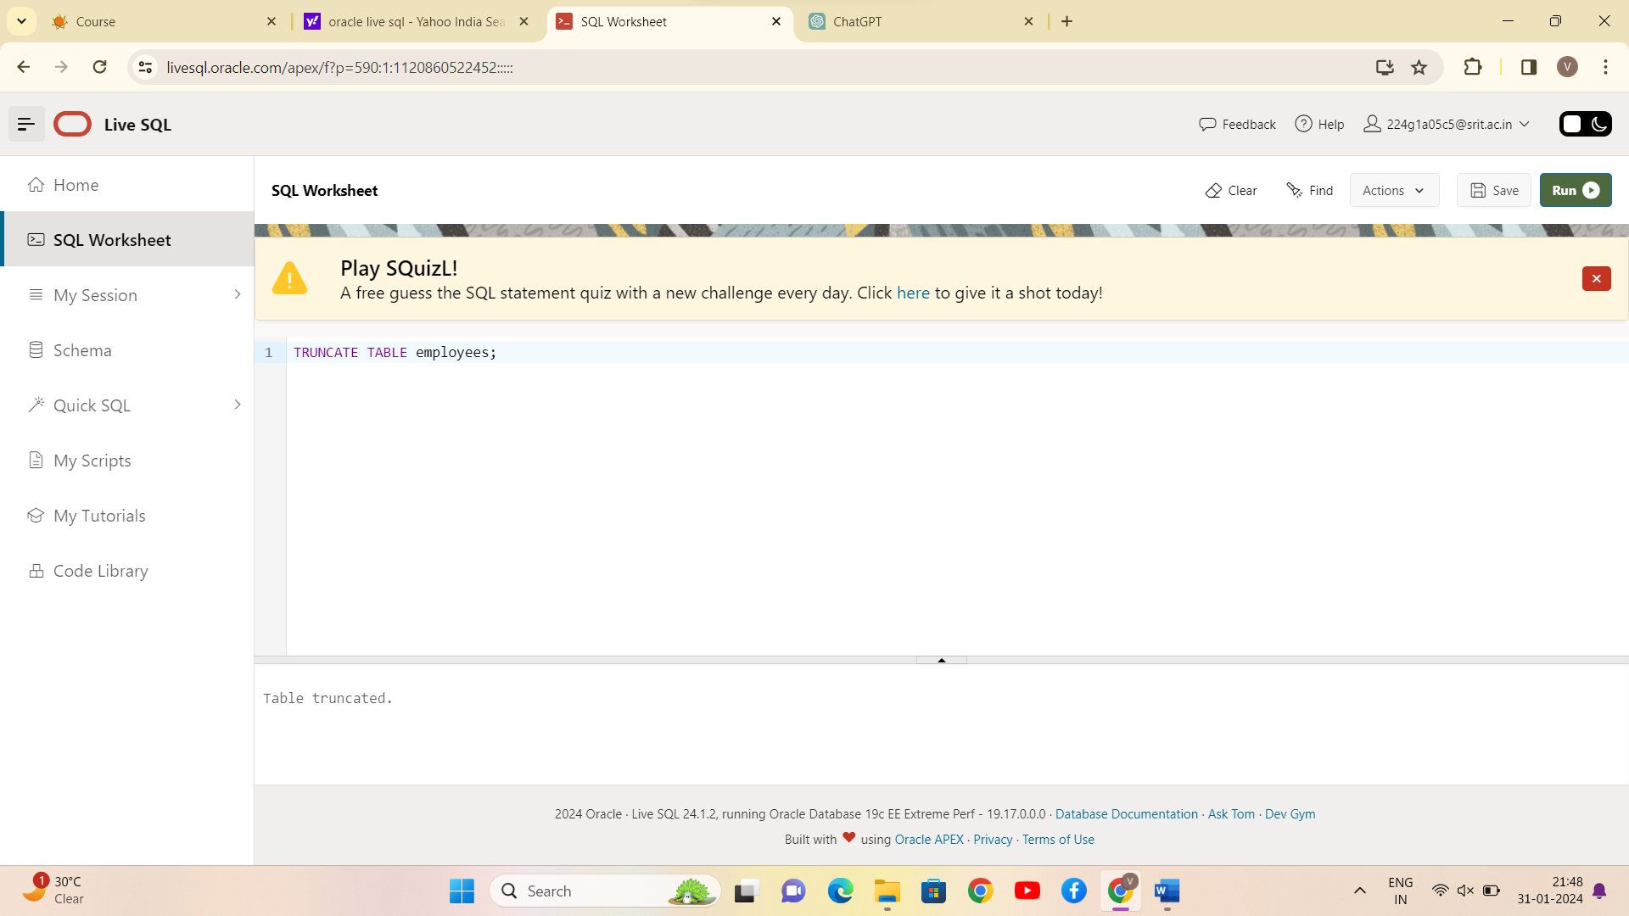

CONCLUSION:

SQL queries to CREATE TABLES for various databases using DDL commands (i.e., CREATE, ALTER, DROP, TRUNCATE) is successfully completed.