Experiment-6:

Write SQL queries to perform JOIN OPERATIONS (i.e. CONDITIONAL JOIN, EQUI JOIN,

LEFT OUTER JOIN, RIGHT OUTER JOIN, FULL OUTER JOIN)

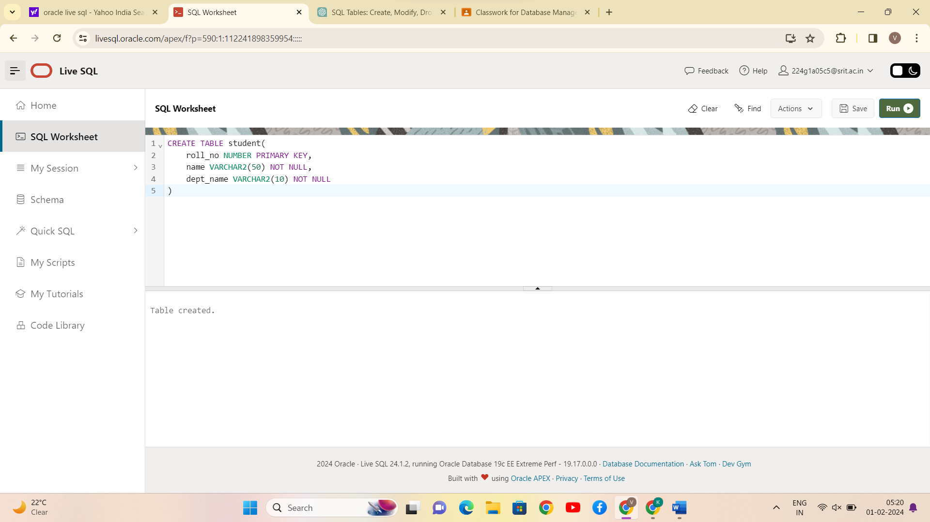

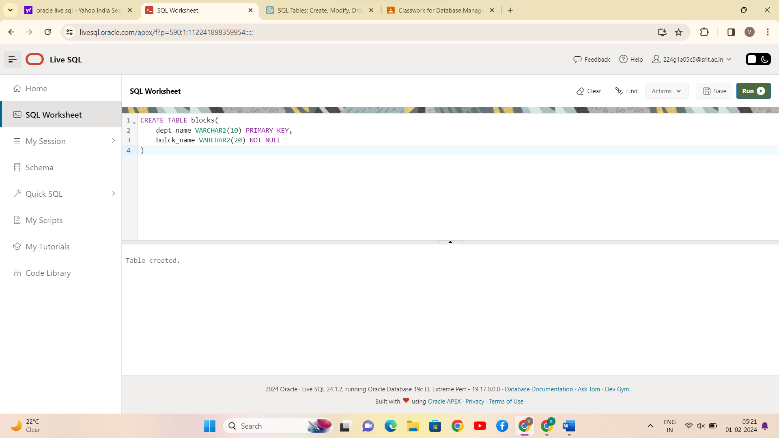

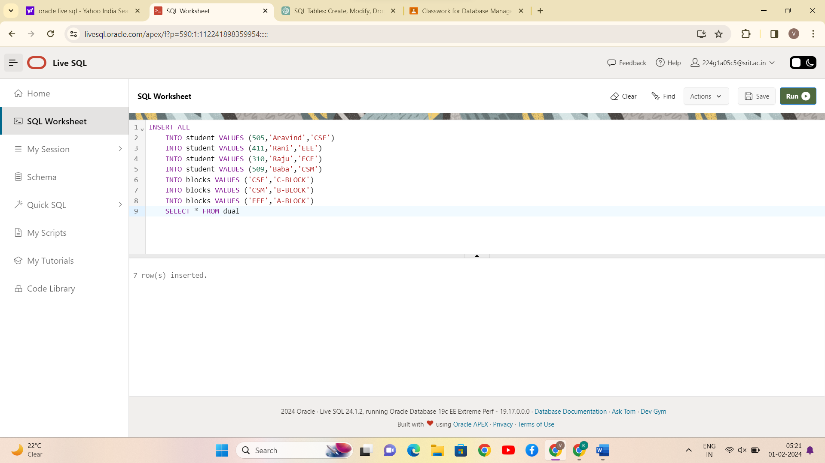

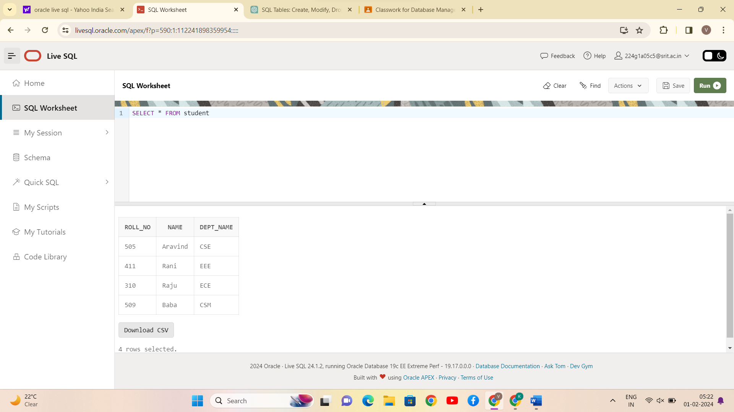

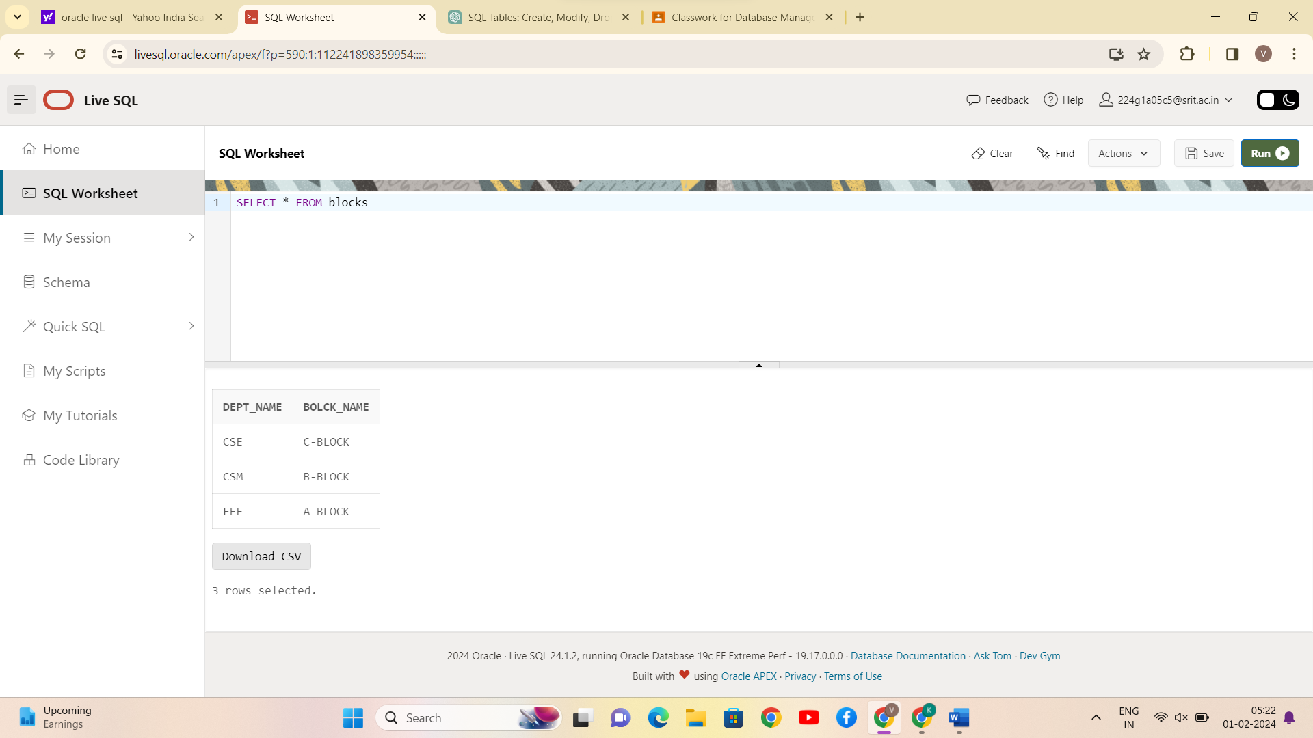

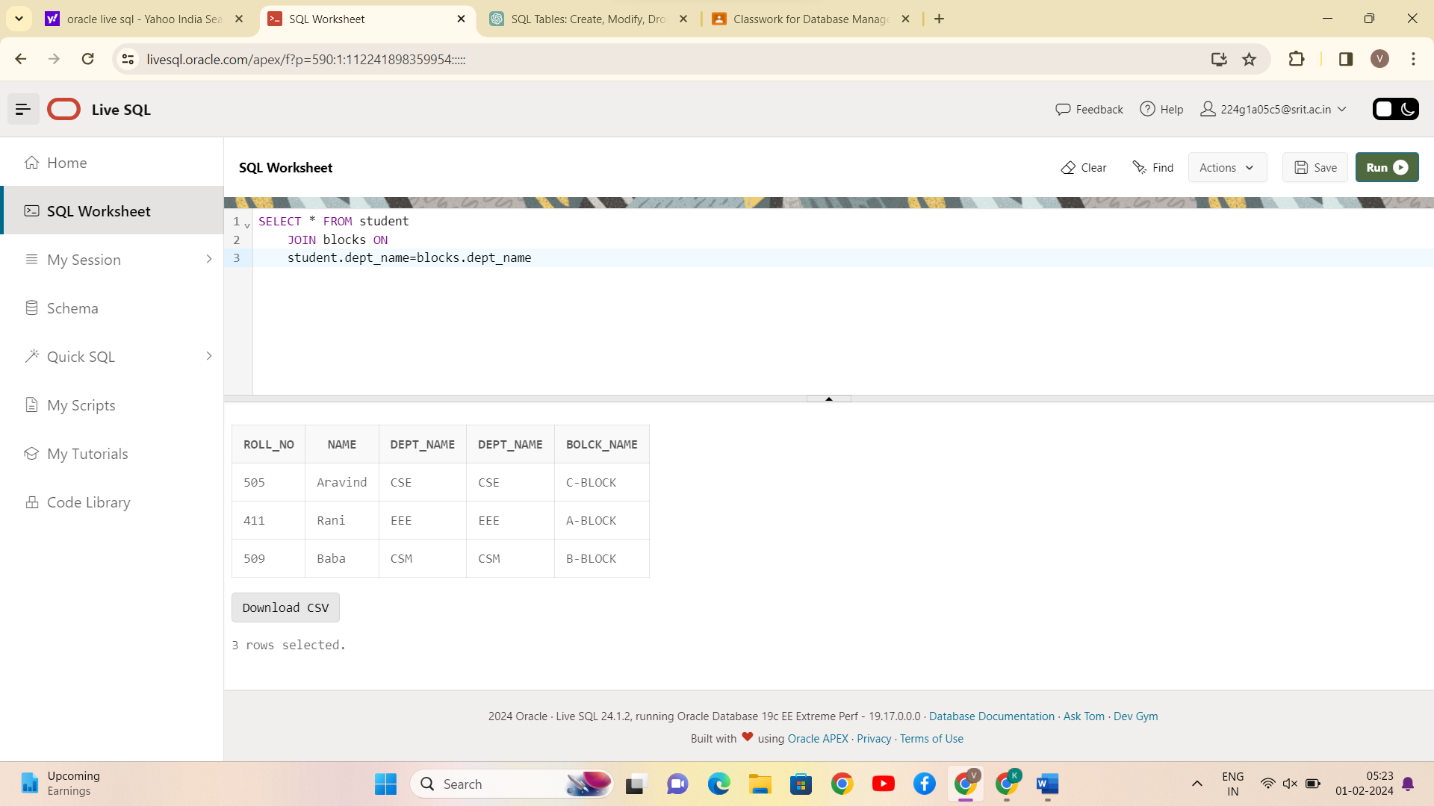

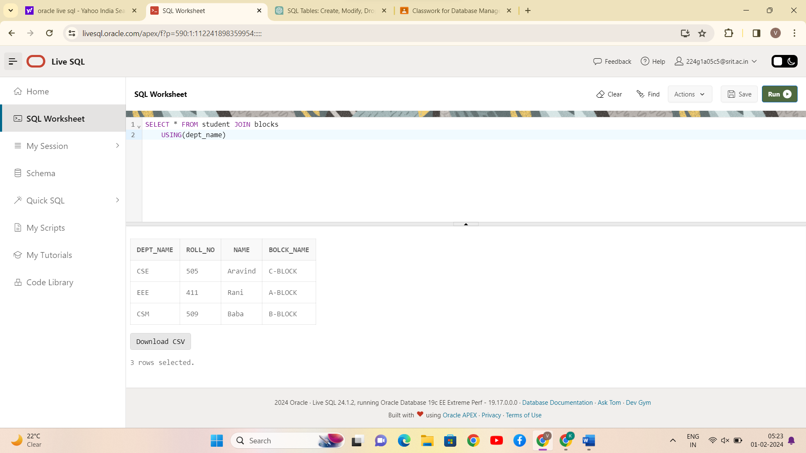

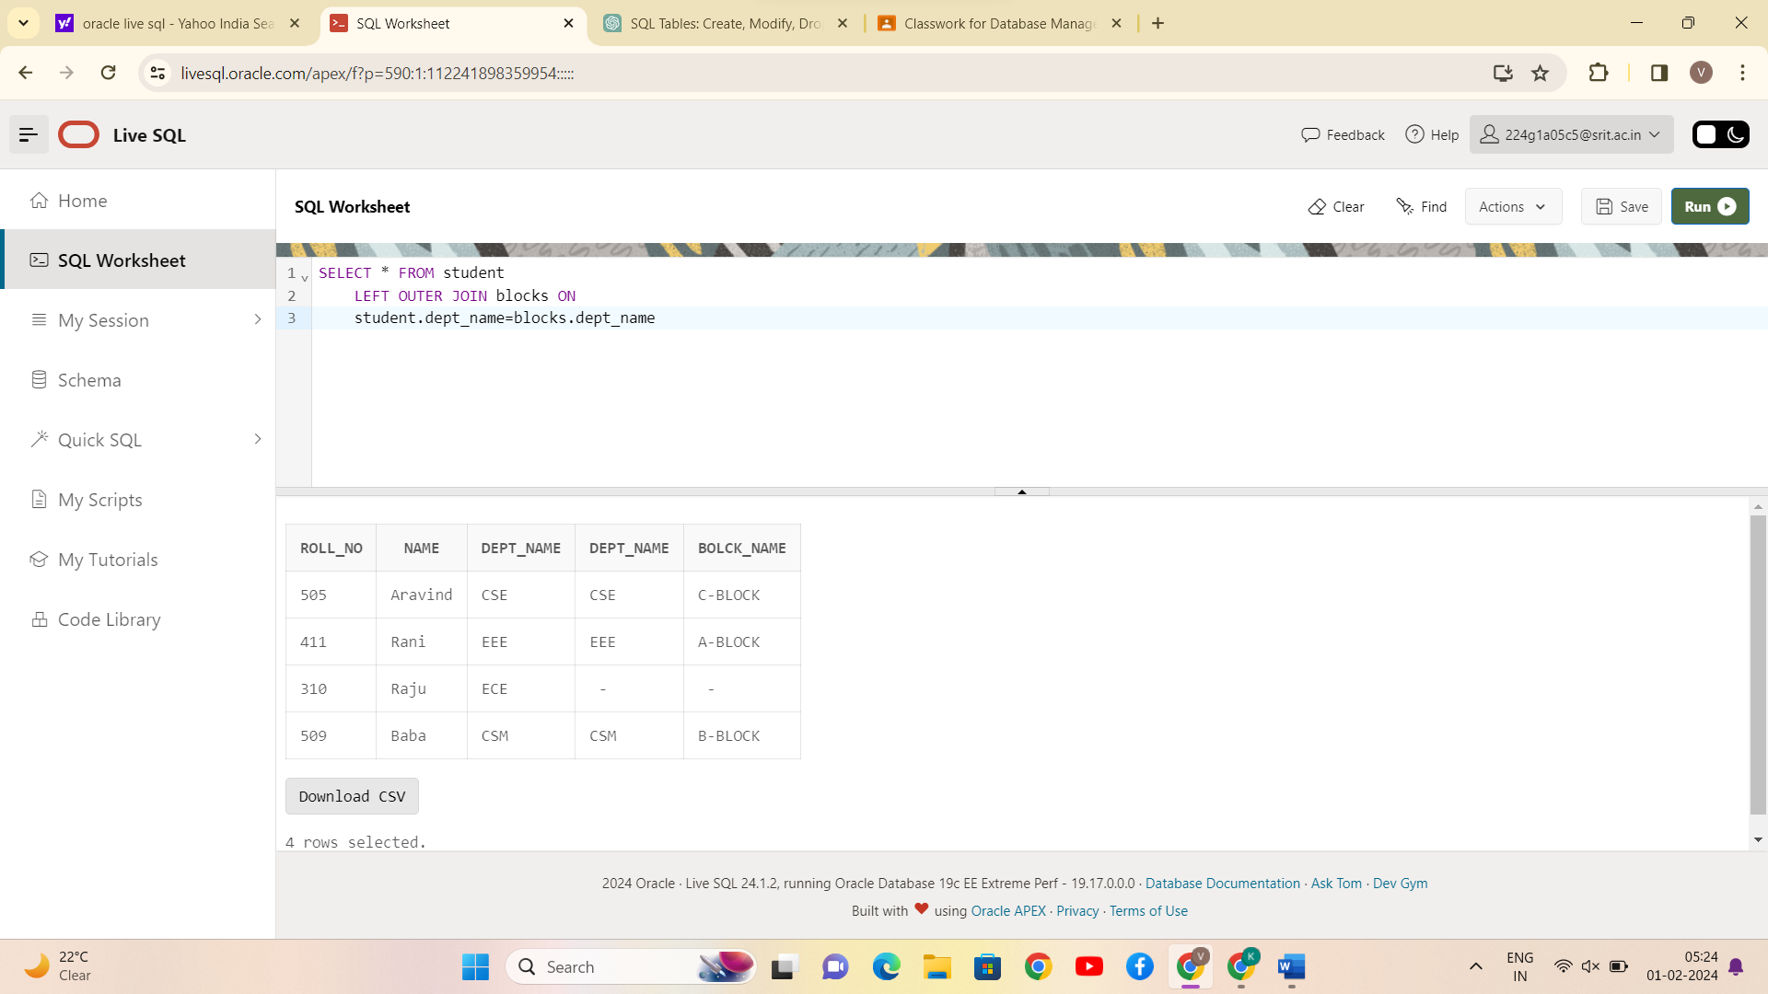

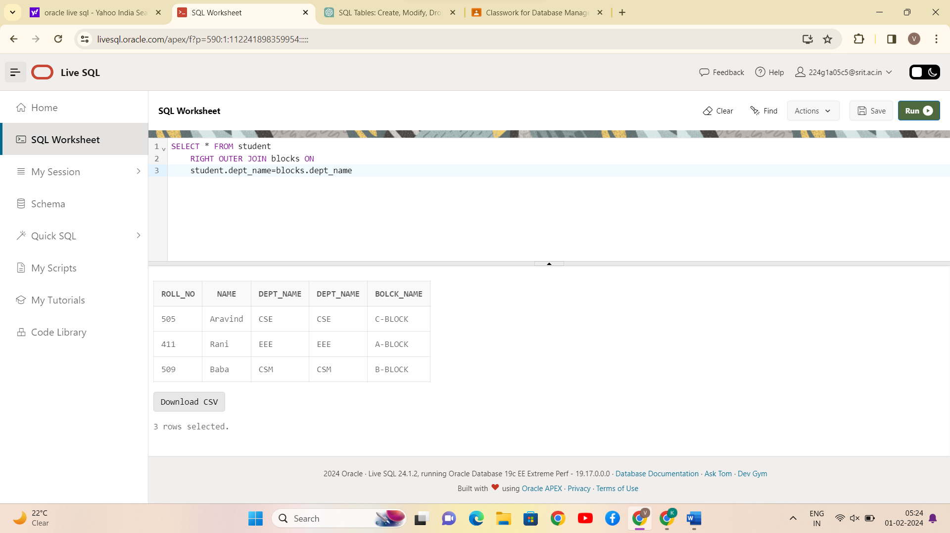

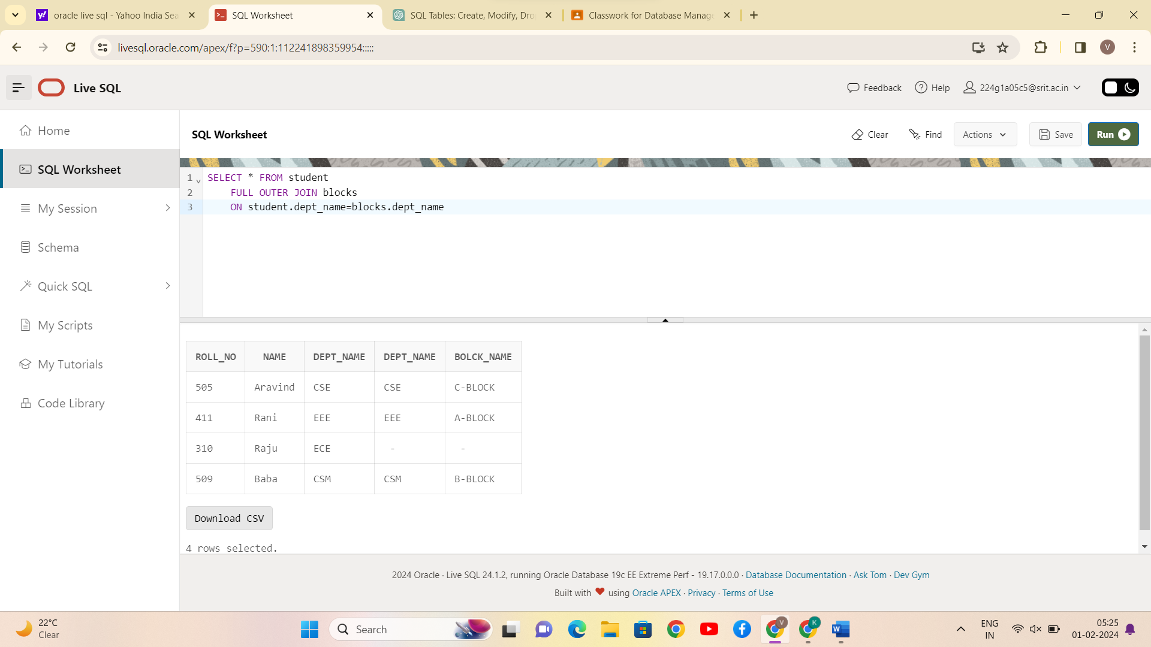

CONCLUSION:

SQL queries to perform JOIN OPERATIONS (i.e., CONDITIONAL JOIN, EQUI JOIN, LEFT OUTER JOIN, RIGHT OUTER JOIN, FULL OUTER JOIN) is successfully completed.