Experiment-7:

Write SQL queries to perform AGGREGATE OPERATIONS (i.e. SUM, COUNT, AVG, MIN,

MAX).

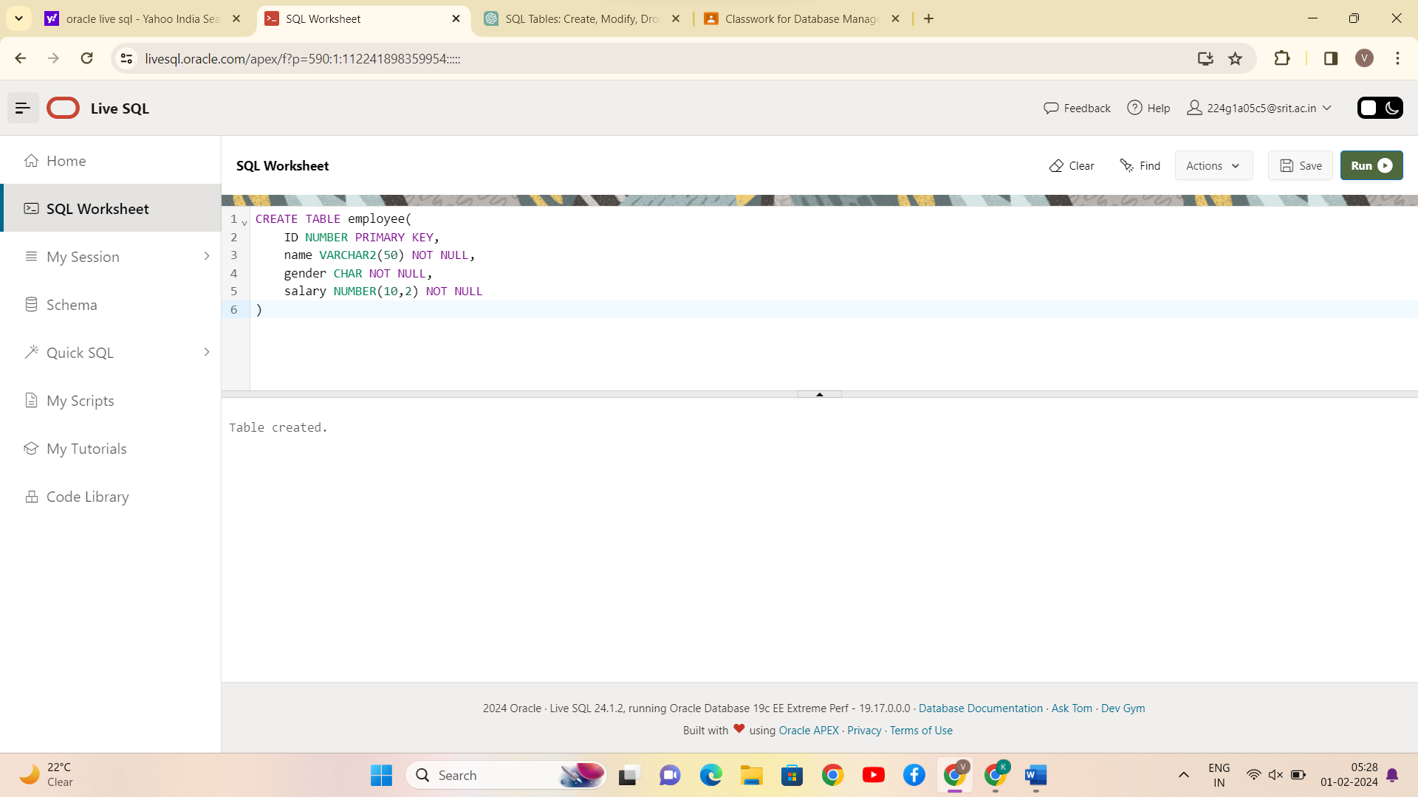

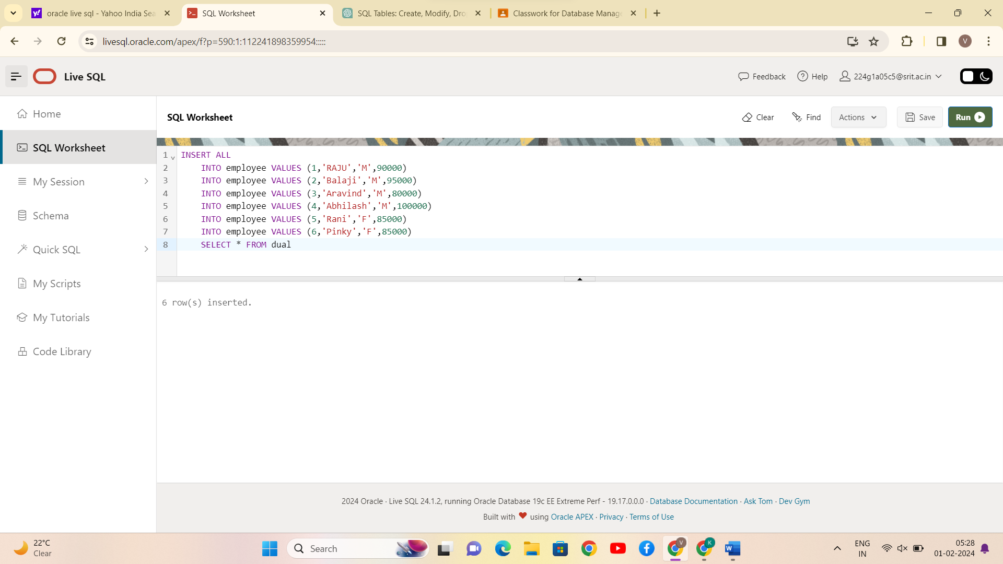













CONCLUSION:

SQL queries to perform AGGREGATE OPERATIONS (i.e., SUM, COUNT, AVG, MIN, MAX) is successfully completed.