Experiment-8:

Write SQL queries to perform ORACLE BUILT-IN FUNCTIONS (i.e. DATE, TIME).

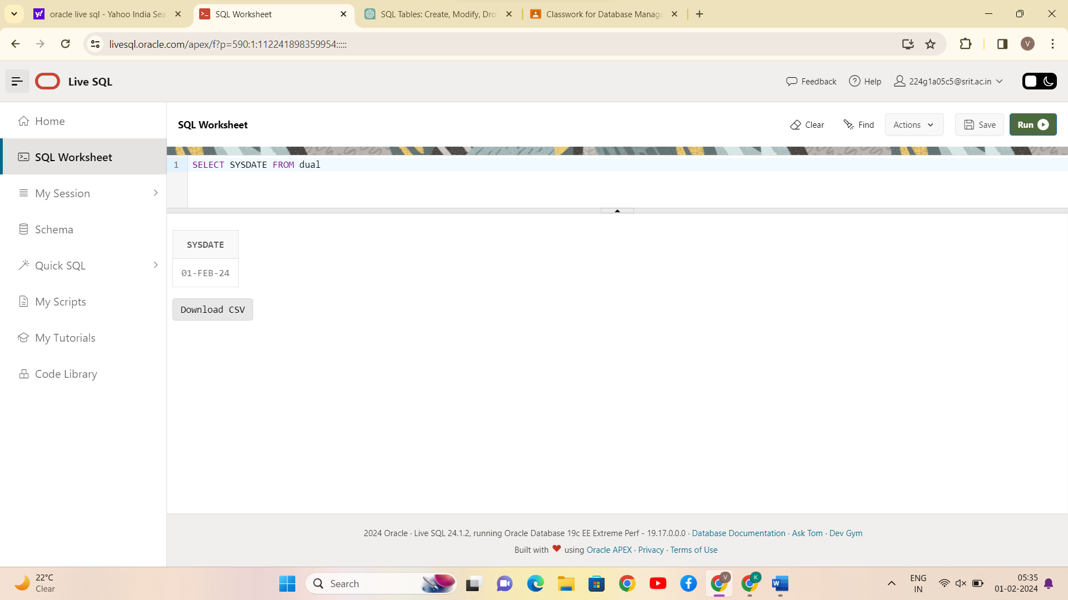

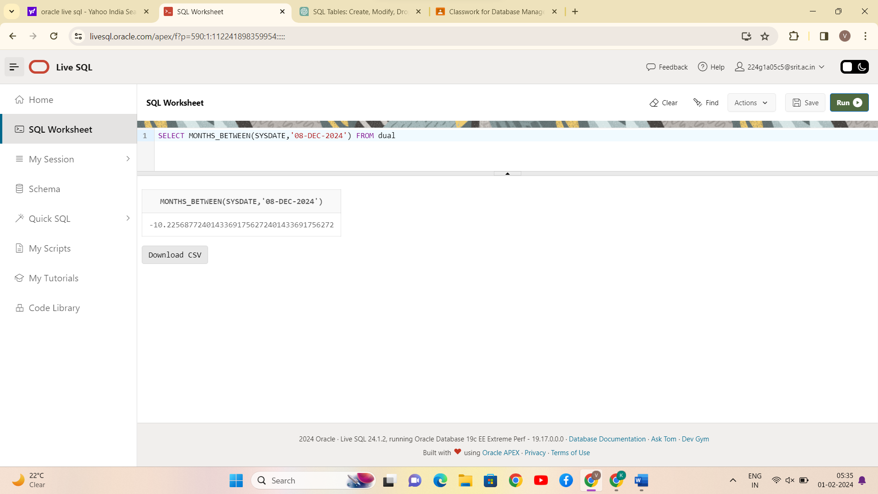

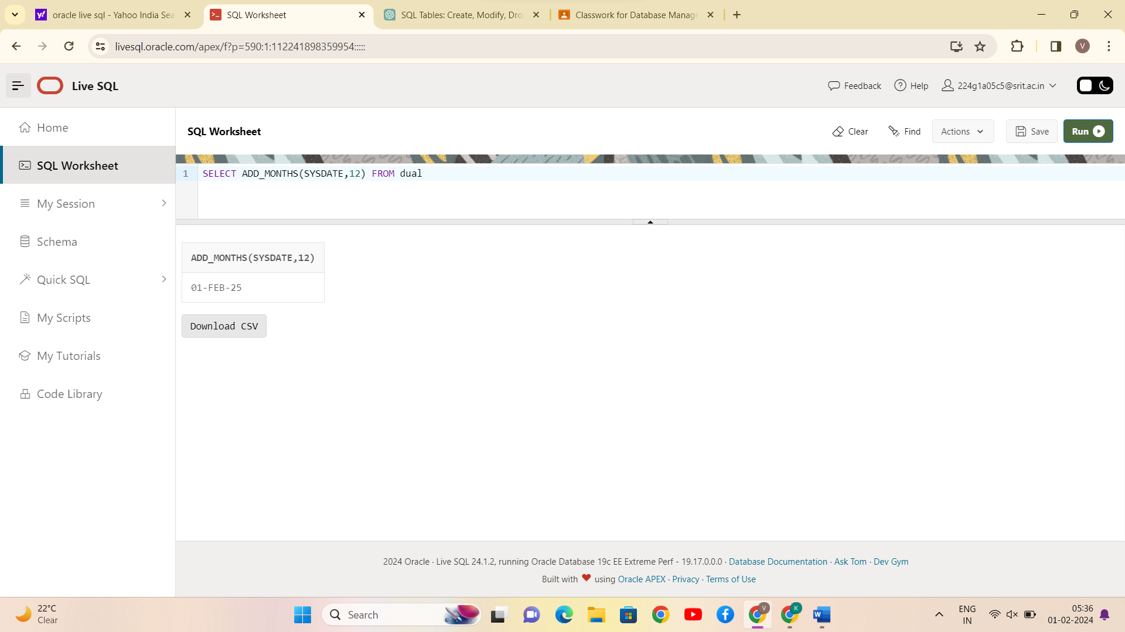

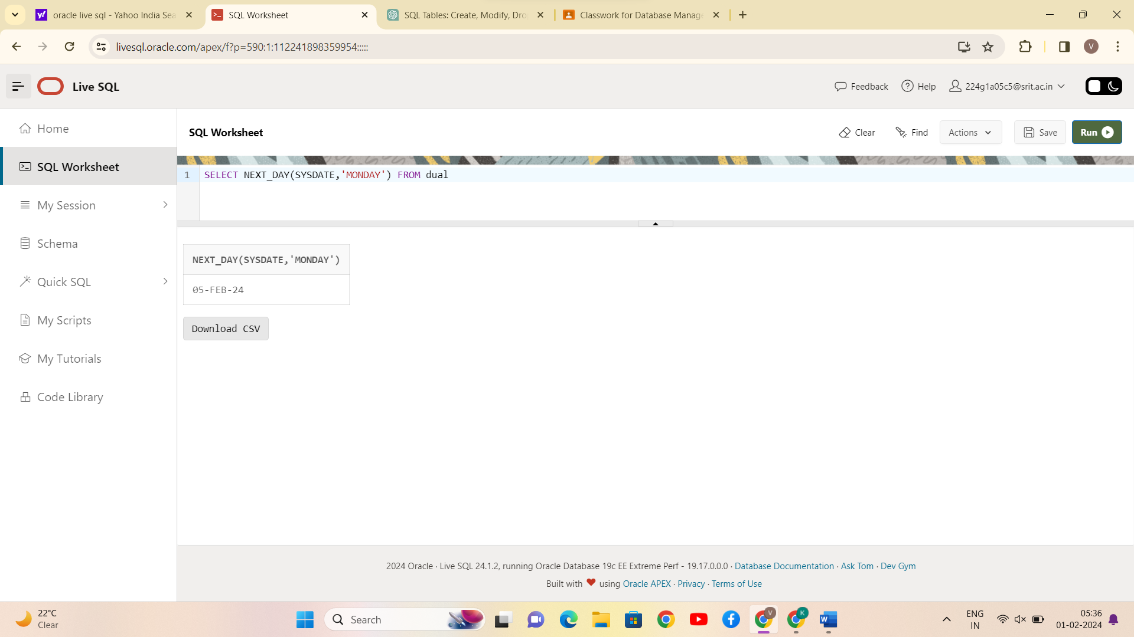

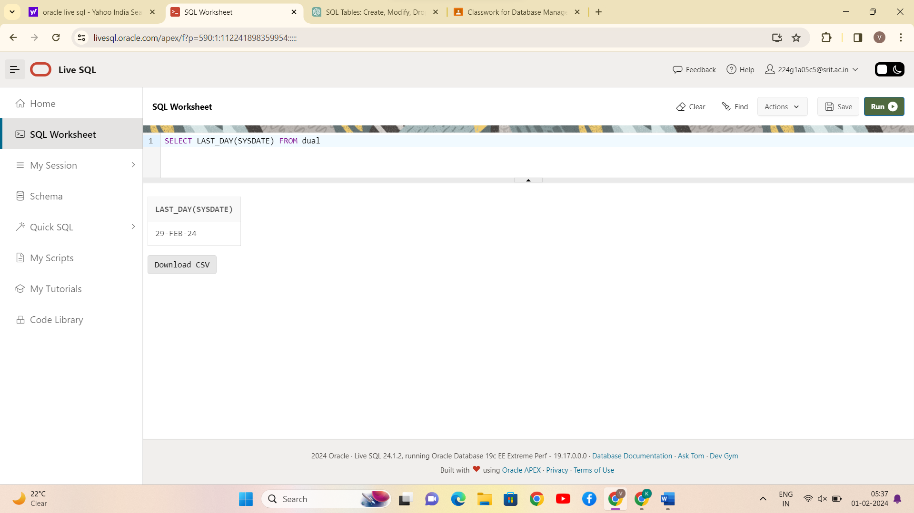

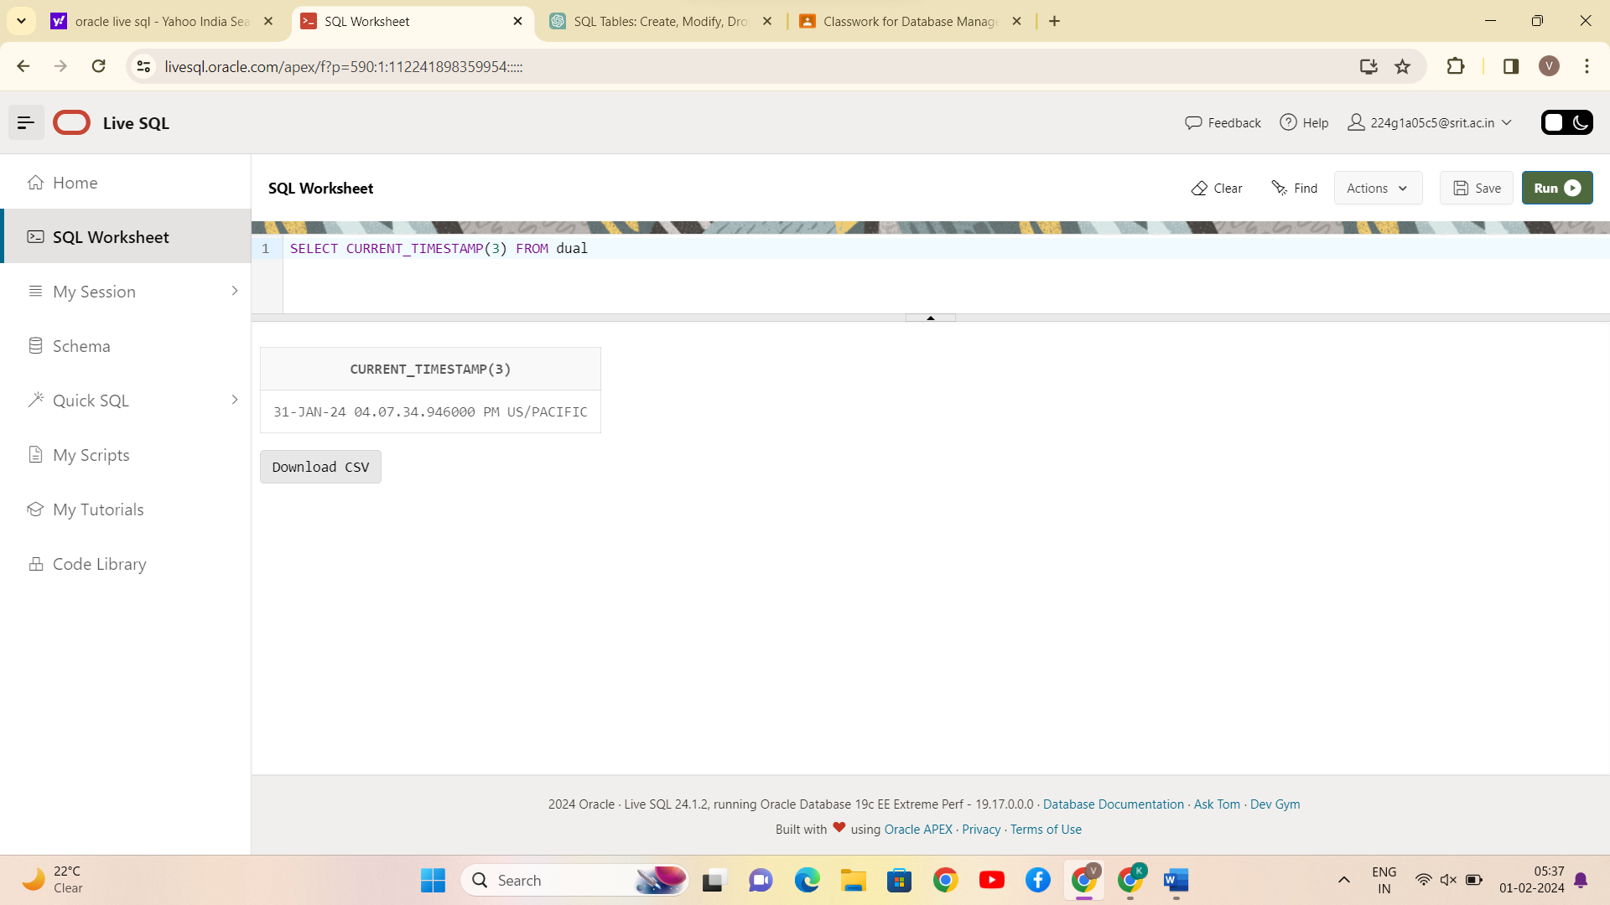

CONCLUSION:

SQL queries to perform ORACLE BUILT-IN FUNCTIONS (i.e., DATE, TIME) is successfully completed.