Experiment-9:

Write SQL queries to perform KEY CONSTRAINTS (i.e. PRIMARY KEY, FOREIGN KEY,

UNIQUE NOT NULL, CHECK, DEFAULT).

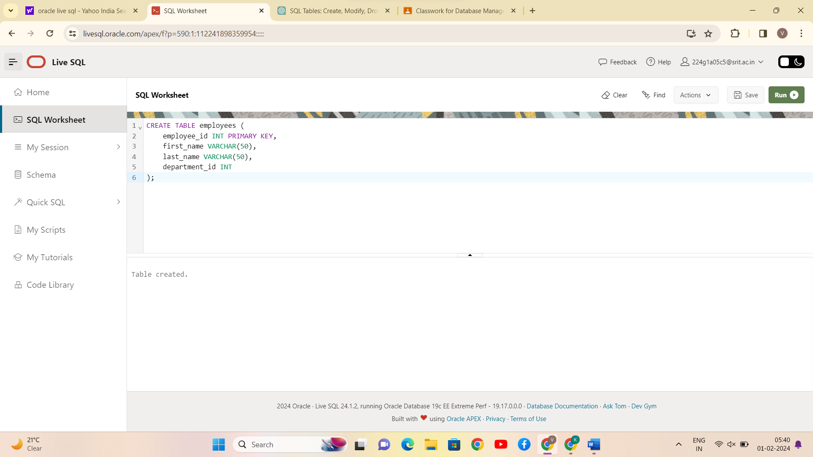

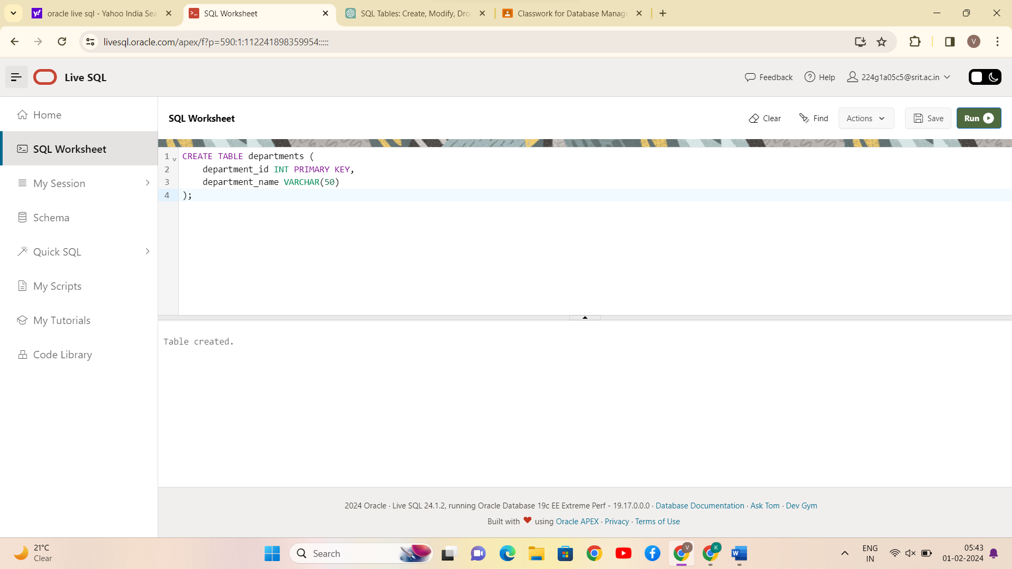

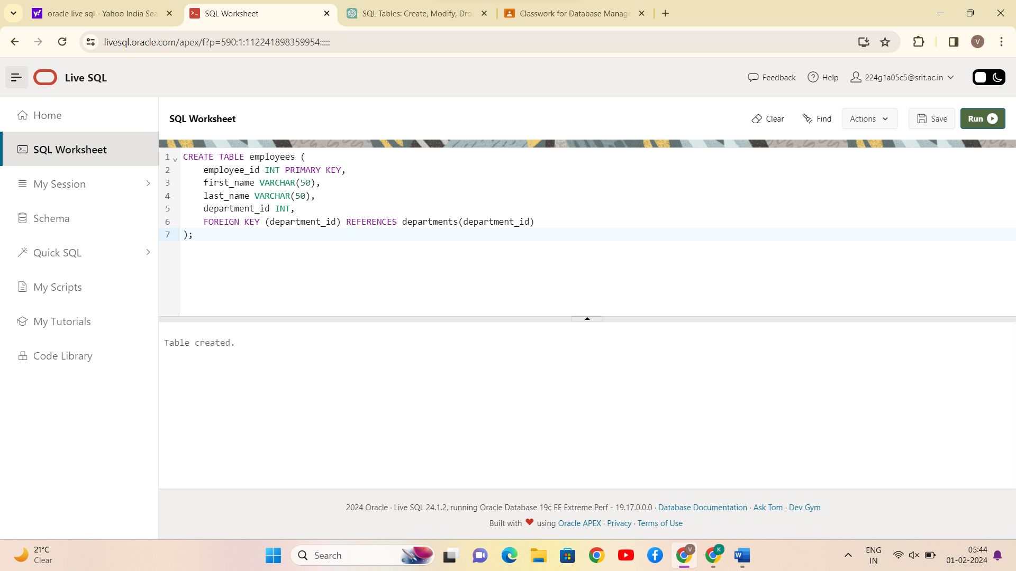

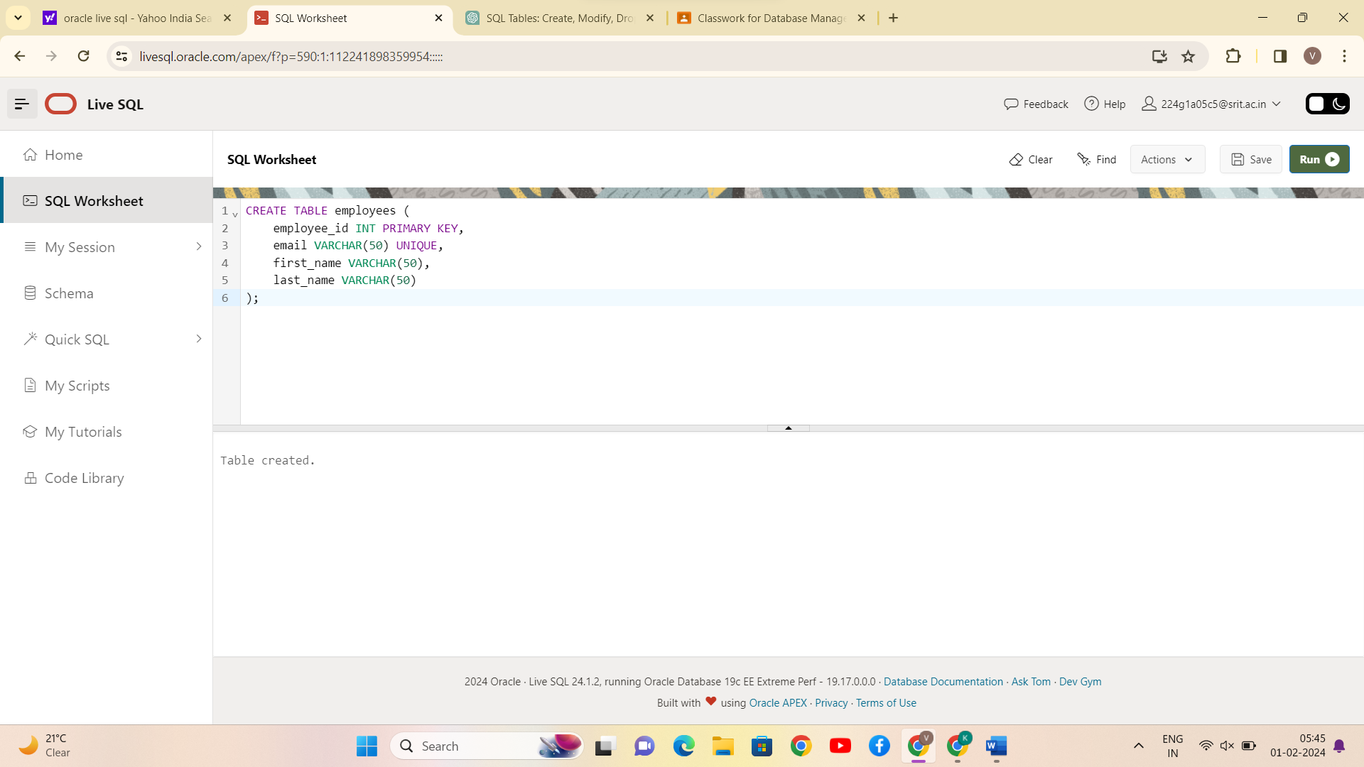

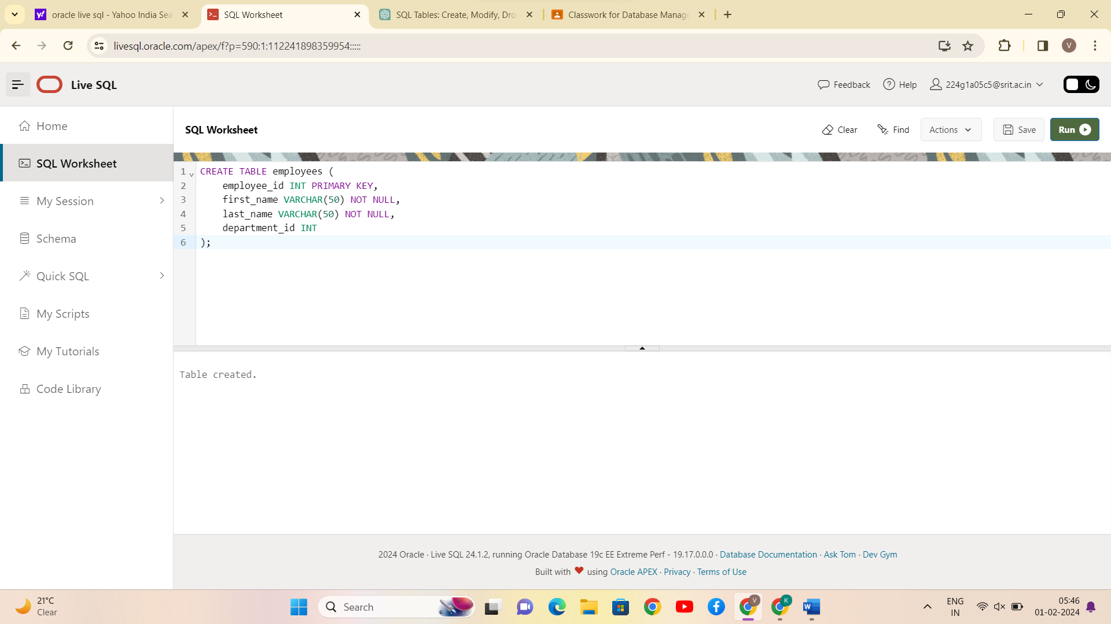

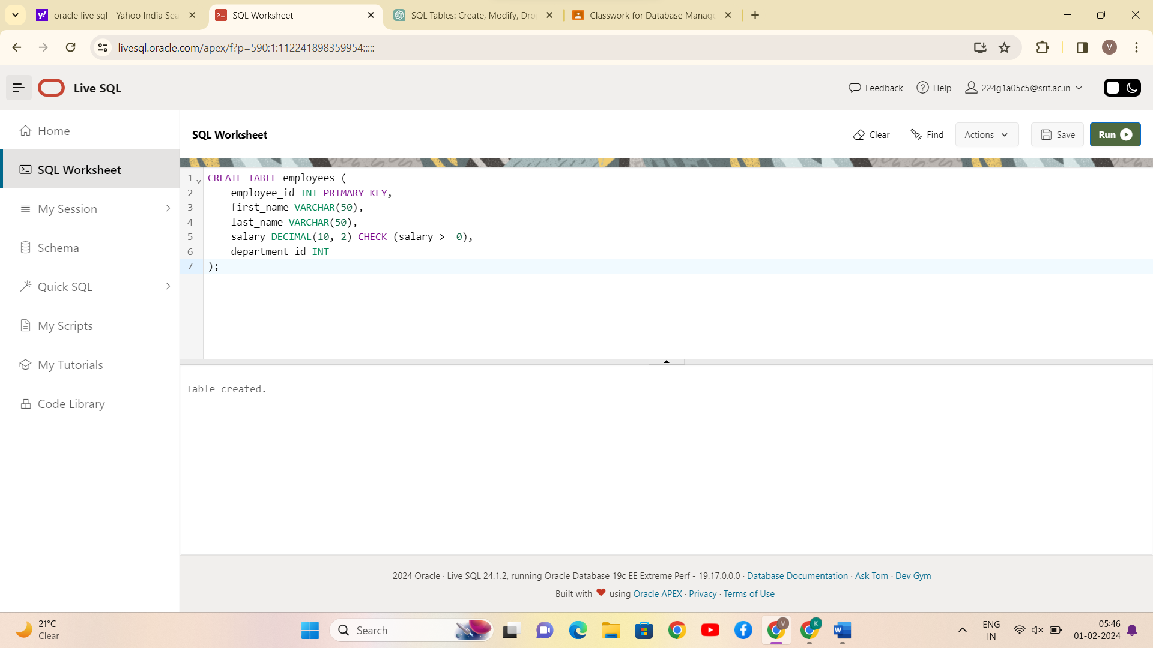

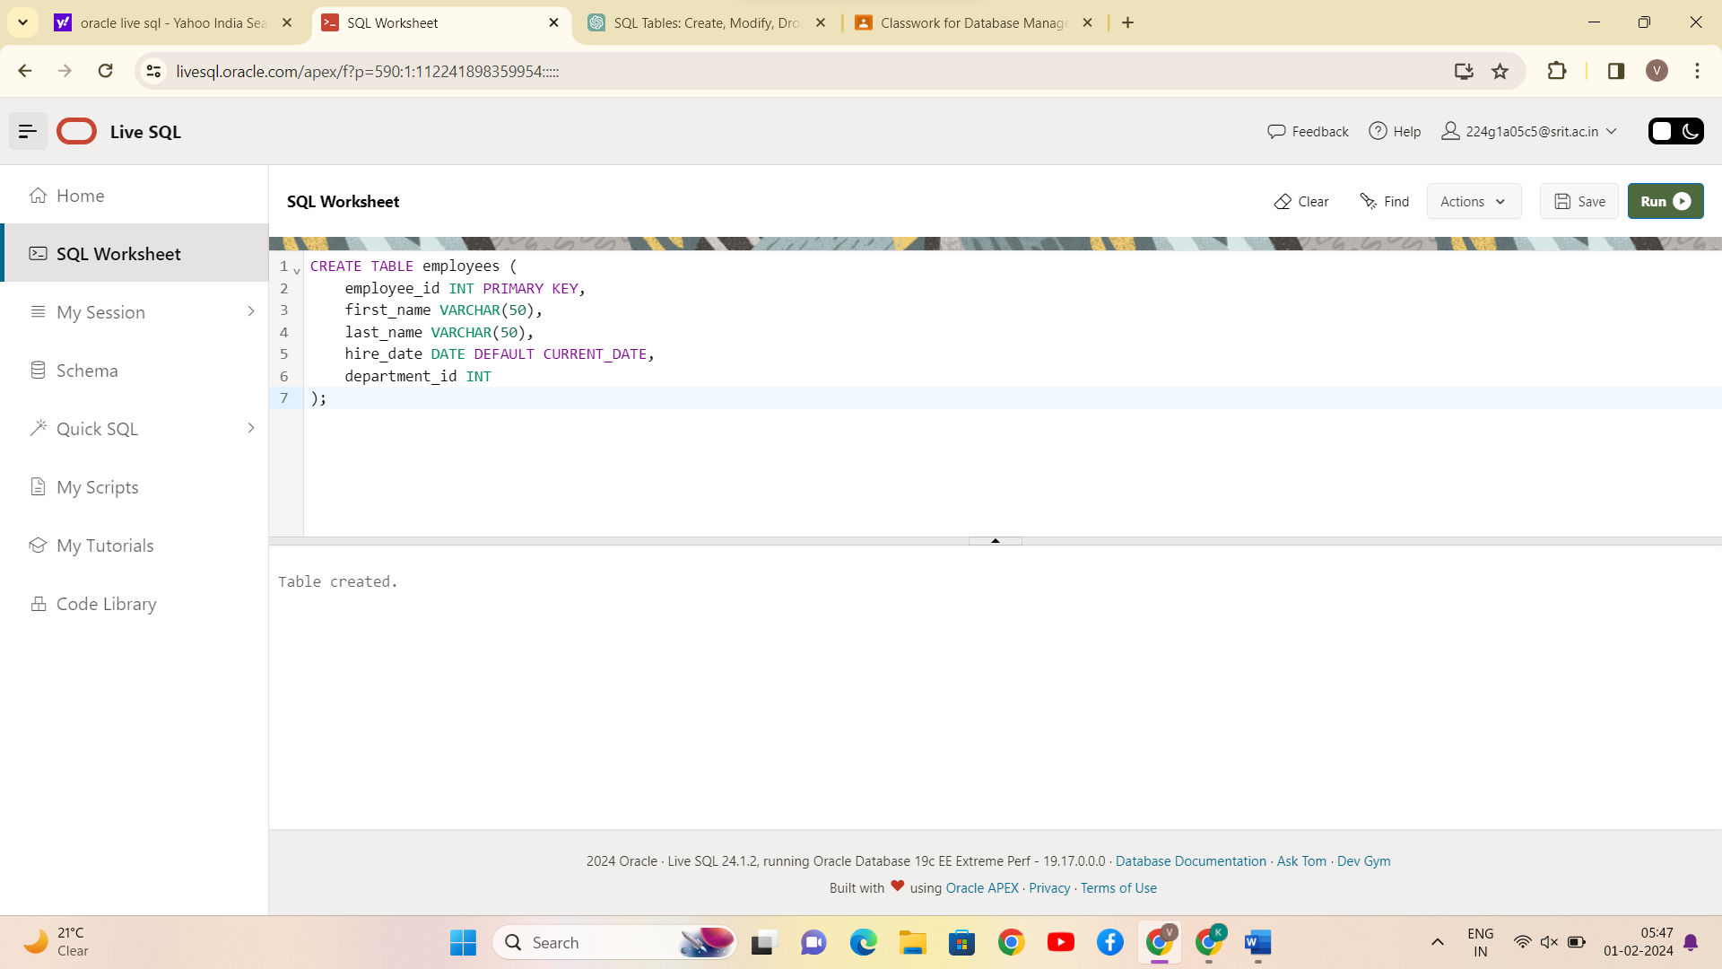

CONCLUSION:

SQL queries to perform KEY CONSTRAINTS (i.e., PRIMARY KEY, FOREIGN KEY, UNIQUE NOT NULL, CHECK, DEFAULT) is successfully completed.