**Prediction of Seismic Exertion in the Subduction Zones Using Artificial Neural Networks**

*1st Narendran Sobanapuram Muruganandam  
 smnarenv@gmail.com  
 6380204574  
 Amrita Vishwa Vidyapeetham, Mysuru*

*2st Vishnu N  
 vishnuramguru@gmail.com  
 6381764440  
 Amrita Vishwa Vidyapeetham, Mysuru*

1. **OVERVIEW**

The exploration composition explores the expectation of aquatic earthquakes, which is pivotal for disaster preparation. It does this by studying the unique traits and difficulties of seismic exertion in the ocean. Using a neural network model, the study aims to facilitate the delicacy of prognostications by taking advantage of its capability to handle complex patterns in data. This system offers substantial advancements in earthquake monitoring and the development of better strategies for reducing pitfalls in aquatic settings. It ensures lesser adaptability to seismic events and strengthens overall preparedness for responding to disasters.

1. **INTRODUCTION**

Coastal communities and coastal areas face serious problems from marine earthquakes that can be devastating and cause catastrophic damage. Predicting and mitigating these seismic events is difficult due to their variability; This highlights the critical need for accurate forecasts in disaster planning. This research paper investigates the unique characteristics of underwater accidents and proposes ways to improve the prediction method and the overall assessment model and process model to improve coastal safety and protection of life and infrastructure.

The earthquake and tsunami that occurred in Japan in 2011 was the 9th largest natural disaster, resulting in damage and economic losses of approximately $360 billion. The most dangerous of these, the 2004 Sumatra-Andaman earthquake of magnitude 9.1 to 9.3 [1][2][4], which led to the first estimate of damage of $125 to $150 billion, highlighted the difficulty of accurately measuring the economic costs of disasters. The epicenter is off the northwestern coast of Sumatra, Indonesia. December 26, 2004, at Indian Ocean earthquake[3]

Advances in earthquake prediction include the integration of advanced technologies, multivariate modeling, real-time data transmission, forecasting, and prediction services. These innovations aim to improve forecast accuracy and raise awareness of hazard mitigation strategies in coastal areas.

**III. ARCHITECTURE DIAGRAM**

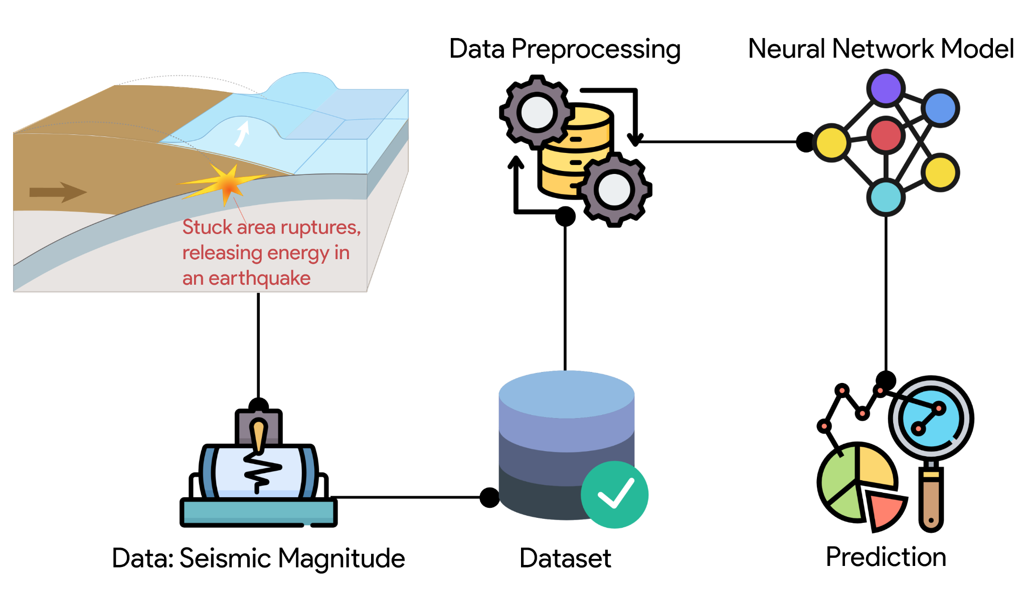

**IV. METHODOLOGY**

1. **Data Collection and Preprocessing**

Underwater sensors and monitoring stations carefully gather seismic data. To improve its quality, a thorough preparation process is undertaken to eliminate any unwanted noise or outliers. This includes using different techniques like filtering and normalization to ensure the data is suitable for analysis.

1. **Neural Network Model Development**

A specialized neural network model is carefully crafted and built to predict underwater earthquakes. This involves deciding on the structure of the neural network, such as the arrangement of layers, allocation of neurons, and choosing the right activation functions and optimization algorithms[5].

1. **Training and Validation**

The neural network model that has been developed goes through a thorough training process using the preprocessed dataset. Throughout this iterative process, the model adjusts its parameters dynamically to minimize any errors in its predictions. Various validation techniques, such as cross-validation, are thoughtfully utilized to assess the model's performance on unseen data and prevent overfitting.

1. **Forecasting of Seismic Movement**

The prediction process of neural network models involves data collection, careful planning, and training by tuning parameters. Forward propagation calculates the prediction product based on input data and evaluates it using performance indicators to evaluate the performance of the model in underwater earthquake prediction.

**V. TECHNICAL INNOVATIONS**

* ***Seismic Data Fusion:*** Integrating multiple data sources to improve the accuracy of underwater earthquake prediction.
* ***Deep Learning Architectures:*** Using advanced neural network models to accurately identify underwater earthquake patterns.
* ***Transfer Learning:*** Using pre-trained models to improve underwater earthquake prediction with recorded data.
* ***Hybrid Models:*** Integrating multiple machine learning technologies to improve the robustness of underwater earthquake prediction models.
* ***Edge Computing:*** Using deep neural network models for real-time underwater earthquake prediction on edge devices.

**VI. PROOF OF CONCEPT**

The research provides practical evidence that neural network models effectively predict underwater earthquakes. Thorough data collection and preparation from underwater sensors ensure accuracy. The extensively trained and validated neural network model demonstrates impressive precision in forecasting, validated by strong performance evaluation measures and sensitivity analysis, confirming its adaptability.

**VII. CONCLUSION**

The research findings suggest that the utilization of neural network models can improve the ability to predict underwater earthquakes. By combining different sources of data, the accuracy of forecasting can be enhanced. Transfer learning is particularly useful when there is a shortage of labeled data, while hybrid models contribute to more robust predictions. The reliability of these earthquake prediction methods in underwater settings is confirmed through the evaluation of performance metrics and sensitivity analysis.

**VII. REFERENCE**

[1] Biswas, S., KUMAR, D., & Bera, U. K. (2023). Prediction of earthquake magnitude and seismic vulnerability mapping using artificial intelligence techniques: a case study of Turkey.

[2] Hughes, A., Escartín, J., Billant, J., Leclerc, F., Andreani, M., Olive, J. A., ... & Quidelleur, X. (2023). Seafloor earthquake ruptures and mass wasting from the 2004 Mw 6.3 Les Saintes submarine earthquake. Communications Earth & Environment, 4(1), 270.

[3] Jena, R., Pradhan, B., Al-Amri, A., Lee, C. W., & Park, H. J. (2020). Earthquake probability assessment for the Indian subcontinent using deep learning. Sensors, 20(16), 4369.

[4] Zhou, W. Z., Kan, J. S., & Sun, S. (2017, July). Study on seismic magnitude prediction based on combination algorithm. In 2017 9th International Conference on Modelling, Identification and Control (ICMIC) (pp. 539-544). IEEE.

[5] Ridzwan, N. S. M., & Yusoff, S. H. M. (2023). Machine learning for earthquake prediction: a review (2017–2021). Earth Science Informatics, 16(2), 1133-1149.