**Architecture Diagram**

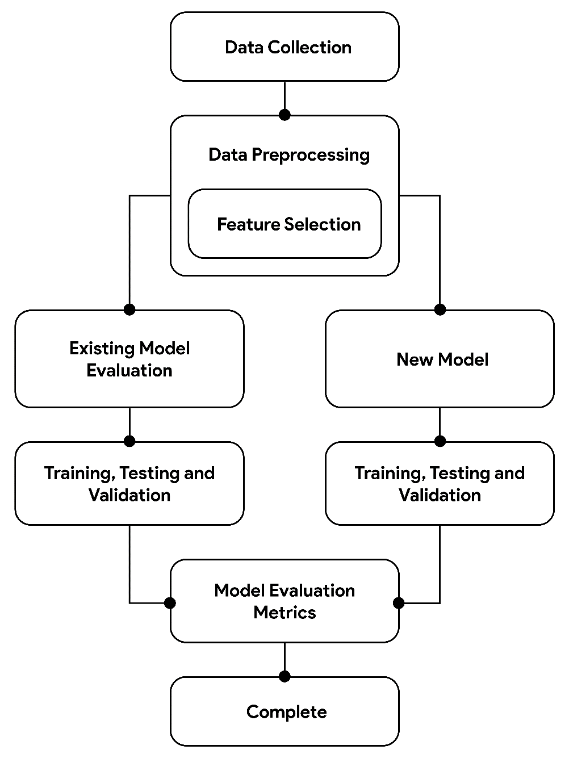

Fig. Model Architecture

Architectural diagram of our research process showing the process of developing and evaluating new tsunami prediction models based on artificial neural networks (ANN). Starting with data collection, we collected important information on seismic activity and tsunami history from online databases. These data were carefully preprocessed, focusing on specific selection to identify important variables amenable to treatment control, including steps to remove missing values ​​and normalize the format. We will then carefully evaluate the performance of existing models using metrics such as mean square error (MSE) and root mean square error (RMSE) for comparison with our ANN model. Our new method then undergoes rigorous evaluation against existing methods, including training, testing, and validation phases to ensure robustness and generalizability. Finally, both models were evaluated using metrics such as MSE, RMSE, and mean error (MAE) to determine their accuracy and reliability in predicting tsunami events. Through this integrated approach, we focus on disaster preparedness and mitigation by providing more accurate and reliable predictions of tsunami occurrence.

**Methodology**

1. **Feature Selection**

Feature selection and architecture play an important role in developing accurate and efficient tsunami prediction models, especially when ANN is used. In this process, researchers used pre-tsunami events as input data for the ANN model. These events are comprehensive and cover a wide range of earthquake sizes and locations, providing rich material and a variety of environments for education. By integrating these different events, neural network models can better understand the relationship between seismic events and tsunamis and ultimately improve their prediction capabilities.

One of the important steps of the selection and design process is to carefully consider the variables that constitute input to the ANN model. This selection process is based on experience, drawing on the expertise of scientists who understand the dynamics of seismicity and tsunami generation. In addition, statistical analysis techniques were used to identify and prioritize the differences in the model. These changes may include factors such as large earthquakes at sea, depth, location and geological features.

Correlation analysis is a statistical technique commonly used in private selection to measure the strength and direction of relationships between variables. By examining correlation coefficients, researchers can identify variables associated with different targets (e.g., tsunami occurrence and characteristics) and thus have an impact on tsunami forecasting. It is often important to include correlated variables in ANN models because they provide important information for accurate prediction.

In addition to relationship analysis, automatic selection methods are often used to simplify the process of analyzing data points. Original seismic data. This process uses algorithms to evaluate the importance of each feature based on a set of predefined criteria, such as predictive power or support of a functional model. The most common methods include iterative elimination (repeatedly eliminating the most important until the best subset is identified) and Lasso regression (penalizing the inclusion of non-monotonic factor characteristics in the sample).

By combining their experience with techniques such as statistical analysis and automatic selection, researchers have ensured that the ANN model is equipped with important and relevant data regarding tsunami forecasting. This approach improves the model's ability to capture the relationship between seismic data and accurately predict tsunami events. In addition, by selecting features that cover multiple earthquake scenarios, the model becomes more robust and can adapt to different environments, ultimately improving capability predictions in practical use.

1. **Existing Models**

* **Existing Models**
* **Algorithms**

1. **New Hybrid Model**

* **New Model Architecture**
* **New Model Algorithm**

1. **Model Evaluation**

The evaluation model plays an important role in evaluating the performance of ANN as a tsunami prediction model. These metrics provide a quantitative measure of a model's predictive accuracy and performance, allowing researchers to evaluate the model's reliability and suitability for real-world use. Among the various measurement methods used, mean square error (MSE), root mean square error (RMSE), and mean error (MAE) are frequently used to measure the accuracy of altitude and arrival time.

*Mean Square Error* (MSE) is a simple metric that measures the mean square difference between the prediction and the actual value. MSE penalizes larger deviations more heavily by squaring the error, thus providing a measure of the overall size of the forecast error. A lower MSE indicates better performance because it means there is no difference between the predicted and actual values. MSE is particularly important for assessing the overall accuracy of model predictions across the entire data set.

*Root Mean Square Error* (RMSE) is derived from MSE by taking the square root of the mean square difference between predicted and actual values. RMSE makes it easier to understand and compare different data by providing a well-defined measurement in the same unit as the target variable. Similar to MSE, a lower RMSE indicates better model performance; It indicates that the difference between predicted and actual values ​​is smaller. RMSE is especially useful when the magnitude of the forecast error is significant (such as a tsunami height forecast).

*Mean Absolute Error* (MAE) gives the measurement accuracy by measuring the measurement difference between the prediction and the actual value. Unlike MSE and RMSE, which penalize more serious errors, MAE treats all errors equally. This makes the MAE less sensitive to outsiders and more suitable for accurate measurement of values. A lower MAE indicates that the model is better as it shows the difference between the predicted and actual values. MAE is particularly useful when the goal is to reduce the magnitude of the forecast error without considering the direction of the forecast error.

Researchers can evaluate the performance of ANN-based tsunami prediction models using these measurements. These measurements give a good idea of ​​the accuracy and reliability of the prediction model, allowing researchers to identify areas for improvement and improve the measurement model accordingly. Additionally, by comparing the model's performance with previous tests or benchmarks, researchers can determine whether the model meets appropriate criteria for practical use.

In general, MSE, RMSE and MAE are important indicators to evaluate the accuracy and efficiency of ANN-based tsunami prediction model. These measurements provide a quantitative measure of prediction accuracy, allowing researchers to evaluate the model's reliability and suitability for real-world use. Using these measurements, researchers can make informed decisions about improving and optimizing the model, ultimately improving the model's ability and confidence in predicting the tsunami layer in nature.

1. **Comparison with Baseline Models**

Comparing the performance of ANN based forecasting models with underlying models or statistical models is an important step in evaluating the performance, quality and reliability of tsunami forecasting techniques. This comparison provides insight into the strengths and weaknesses of different models, helping researchers decide which method is best for accurate prediction.

Basic models are benchmarks used to evaluate the performance of more advanced forecasting models such as ANN. The following models often include simple methods such as linear regression, which provide simple predictions based on the relationship between input variables and target variables (e.g., tsunami occurrence and characteristics). Linear regression models assume a positive relationship between the predictor and the target variable, making them easier to interpret and use. However, their simplicity may limit their ability to capture complex patterns and relationships within objects.

Traditional statistical methods such as regression analysis or autoregressive models provide an alternative to tsunami modelling. Time series analysis involves the analysis of consecutive points collected over time to identify patterns and trends that make them suitable for modeling the time dependence, testing and characteristics of tsunami generation. Autoregressive models, on the other hand, use past results of the target variable to predict future results, taking into account the period of autocorrelation present in the data.

By comparing the performance of the ANN model with the following models, researchers can evaluate the quality of prediction accuracy and robustness. By measuring metrics such as mean square error (MSE), root mean square error (RMSE), and mean error (MAE), researchers can measure the accuracy of the predictions made by each model. Lower values ​​for these parameters indicate better performance, indicating smaller differences between predicted and actual values.

Comparative analysis will also help inform new data-driven approaches used in tsunami forecasting. Unlike basic models and statistical models, which can be based on simple assumptions or relationships, ANN models can capture non-linear relationships and patterns in records. This change allows the ANN model to adapt to different data and capture the complex dynamics that occur in tsunami events, ultimately allowing for more accurate predictions.

Also, comparing the computational complexity and optimization capabilities of ANN models with baseline models and statistical models can provide further insight into their feasibility, nice and efficient. Although ANN models are more expensive to train and deploy, they are more flexible and adaptable, making them suitable for processing different types of data and documents.

1. **Sensitive Analysis**

As we delve deeper into the development of tsunami forecasting methods, sensitivity analysis becomes an important tool. It gives a good idea of ​​the power and reliability of our ANN models by allowing us to better understand changes in parameters or features that affect our predictions. We aim to evaluate the model's sensitivity to change and its performance in various scenarios by adjusting the parameters in predefined ranges.

The main purpose of sensitivity analysis is to identify non-significant factors or factors that have a significant impact on forecast accuracy. By varying these parameters and observing changes in the prediction, we can determine the significant performance of the model. This information helps us prioritize optimization by focusing on areas most likely to improve forecast accuracy.

In addition, sensitivity analysis allows us to evaluate the strength of the model in different seismic environments. By examining how changes affect predictions under different conditions, we gain insight into the model's ability to expand and adapt to different situations. Given the variability of tsunami events, this analysis is important to ensure model reliability across different regions and seismic contexts.

Information gained from analysis of needs informs our optimization strategy and leads us to fine-tune benchmarks to improve overall performance. By improving the parameters that have the greatest impact on prediction accuracy, we can improve the model to perform well in many situations. This iterative optimization process ensures that our ANN model is optimized to provide reliable predictions in global tsunami forecast scenarios.

In addition, sensitivity analysis allows us to understand the changes in the ANN model more deeply. By examining how changes in context affect predictions, we reveal interactions and dependencies that may not be immediately apparent. This better understanding allows us to make informed decisions about better treatment models and better strategies, ultimately making them more accurate and reliable.

1. **Uncertainty Estimation**

Forecast uncertainties should be taken into account when developing tsunami forecasting methods. Uncertainty forecasts allow us to make informed decisions about disaster preparedness, allowing stakeholders to take critical steps to reduce risks. To analyze the uncertainty in the forecast, we use the hypothesis model and Bayesian inference method, which provides the basis for evaluating the reliability and reliability of the forecast.

Probabilistic modeling allows us to capture the uncertainty inherent in tsunami forecasts by combining randomness and stochasticity. Variability of our sample. By considering various possible outcomes and their likelihood of occurring, we gain a better understanding of the events that occur. This approach allows us to create uncertain times or possibilities that provide insight into different possible outcomes.

Bayesian inference is a powerful tool for changing our beliefs about tsunami predictions based on new evidence or data. Bayesian inference combines prior information with observed data, allowing us to improve our predictions and quantify uncertainty more precisely. This iterative process helps us continually improve the reliability of our forecasts and adapt to the changing environment.

Identifying periods of uncertainty or probabilities allows us to evaluate the reliability and reliability of tsunami forecasts. These sections present a range of possible outcomes and their corresponding consequences, allowing participants to understand the uncertainty of our predictions. By communicating effectively about the level of uncertainty, we enable stakeholders to make decisions and take appropriate measures to reduce risks.

Understanding and communicating levels of uncertainty is critical to disaster planning and effective response. We create a culture of transparency and accountability by recognizing the limitations and uncertainties inherent in our forecasts. This encourages stakeholders to take preventive measures, such as providing timely warnings and using evacuation methods, to protect lives and property.

1. **Discussing**

* **Comparing Existing Model and New Model**
* **Discussing its Results**

1. **Limitations of New Hybrid Model**

**Paper Conclusion**

**Feature Selection**

**Existing models (existing models, algorithms)**

**New Model (new model architecture, algorithms)**

**Model Evaluation (accuracy, error rate of existing and new model)**

**Comparison with Baseline Models (which is best)**

**Sensitive Analysis**

**Uncertainty Estimation**

**Discussion**

**Conclusion**