**Web Module Handson**

**Exercise 1:**

Create a Gallery for the Royal Challengers Bangalore Team to display all the players available in the team. Arrange all the images in a grid view using table with 3 column and 3 rows. Inside each cell create <div> element to hold both the image and the player name with appropiate id attribute. The images are displayed using <img> tag.  
  
Create 6 different html page for each player with their image and description as shown in the below screenshot.  
Provide hyperlinks to both the image and player name to the corresponding player page from your image gallery.  
  
  
**UI Constraints:**  
    Each div element with the specified id should contain a <img>.  
    Anchor tag should be used for each div,which on clicking displays a new page with details of the particular player.  
    font-style: italic  
    font-size-adjust: 0.50  
  
**Screenshot1:**   
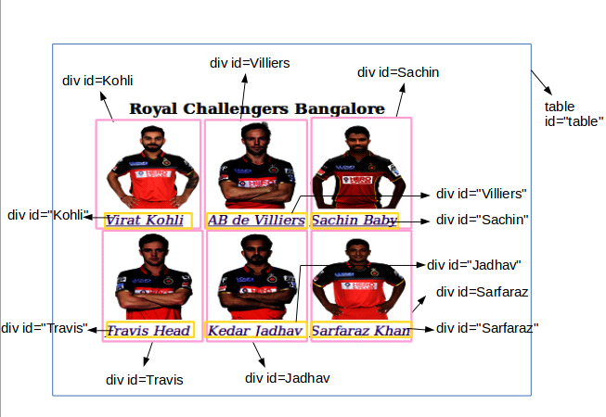   
**Screenshot2:**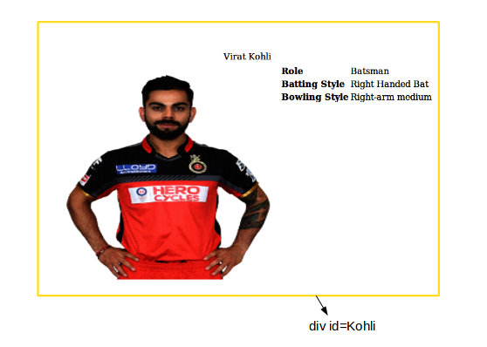   
**Screenshot3: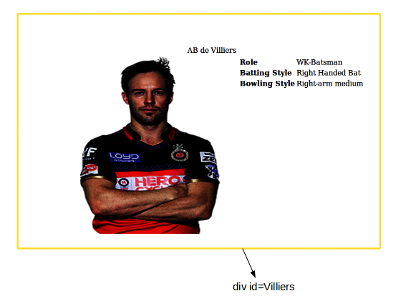 Screenshot4: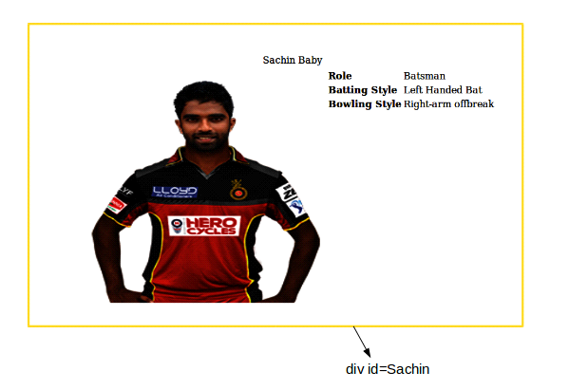 Screenshot5:**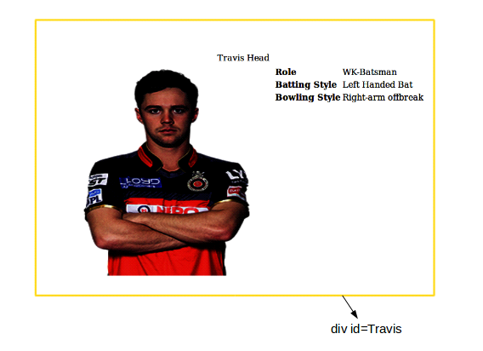

**Exercise 2:**  
  
The start of the tenth edition of IPL is already announced and no doubt we can witness cricket going to the whole new level. The IPL Selection Committee members have arranged for the Player Auctions in the near months and are in full swing working towards it. You are given a task to create an application form for the players to apply for the auctions to contest in the IPL, as shown in the given screenshot. Have the content and look and feel of the page as shown in the screenshot, use html table for better formatting.  
  
Have the HTML file name as "index.html".  
  
  
**Screenshot 1:**   
  
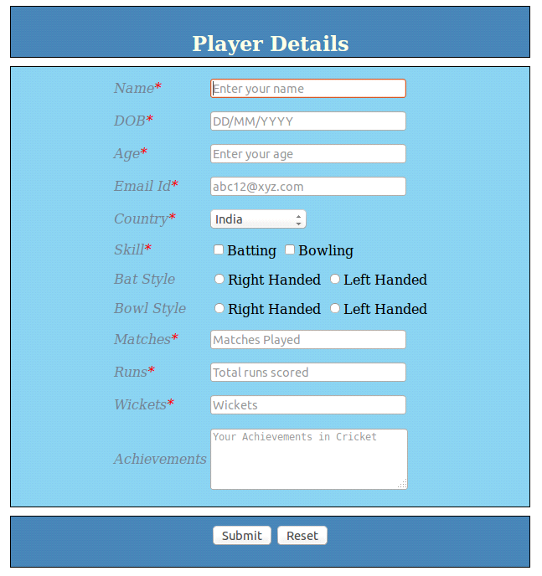   
  
  
 **3) Create favorite list of websites into links and unordered list as shown in the screen below. When we click on the**

**favorite link the respective page should open in a new tab.**

**. Google**

**. Facebook**

**. w3schools**

**Add logos for the sites**

**4) Implement the page in below two different ways:**

**Show the links one line after the other using DIV**

**Show the links adjacent to each other using SPAN**

**logo logo logo**

**Google Facebook w3schools**

**5) Create a page student.html showing the regno, name, college,stream and department in the table format. Give table header and footer.**