**CSS & Bootstrap**

**Exercise 1:**

IPL Committee wants to display the match summary of a league match in a webpage. Help them by creating a webpage to display the match summary. Build the web page with the details metioned in the below screenshot. Have the content and look and feel of the page as shown in the screenshot.  
  
  
**UI Constraints:**  
    For class "heading"  have the font-style as "**italic**" and color  **#C71585**.  
    Have the color **#FFFF00** for hr tag  
    For all headings except "Indian Premier League" use heading class.   
  
**Screenshot 1:**   
  
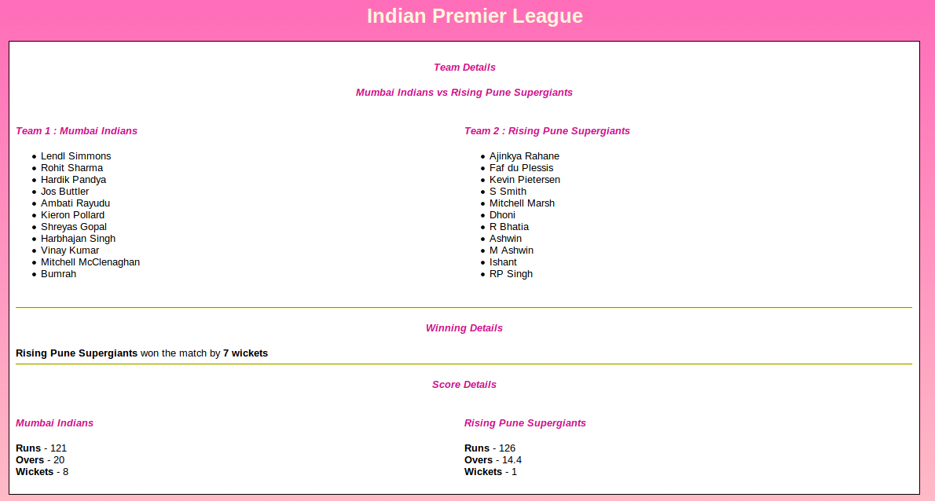   
  
  
**Screenshot 2:**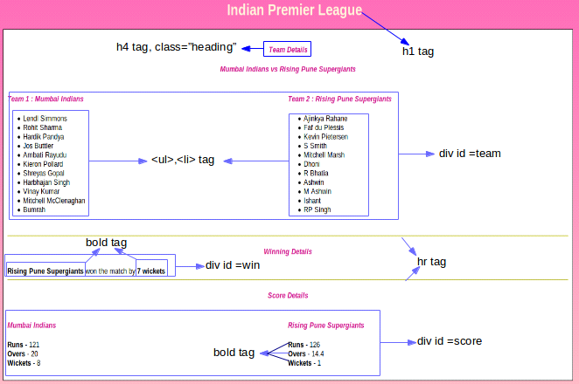

**Exercise 2:**

IPL Commitee wants to display the team details and differentiate the teams based on their points as Low, Average and High. Help them by creating a HTML table to display IPL team details, as shown in the below screenshot.  
  
Teams are classified based on their Points as below:  
Less then 50  and equal to 50    -  Low  
Greater than 50 and less than 80     -  Average  
Greater than 80 and equal  to 80  -  High  
  
Use CSS class for these three classification and have the appropiate background color as mentioned below.  
  
UI constraints should be followed for the element id and name as shown in the screenshot below,  
  
The file name should be index.html.  
  
**UI Constraints:**  
    For class "high" background-color is #FFB6C1.  
    For class "average" background-color is #FFFF00.  
    For class "low" background-color is #98FB98.  
    For Thead background-color is #00BFFF.  
    Font-style: oblique  
    Font-size-adjust: 0.50  
    " IPL Team Details" should be declared under colspan.  
**Screenshot1:**   
  
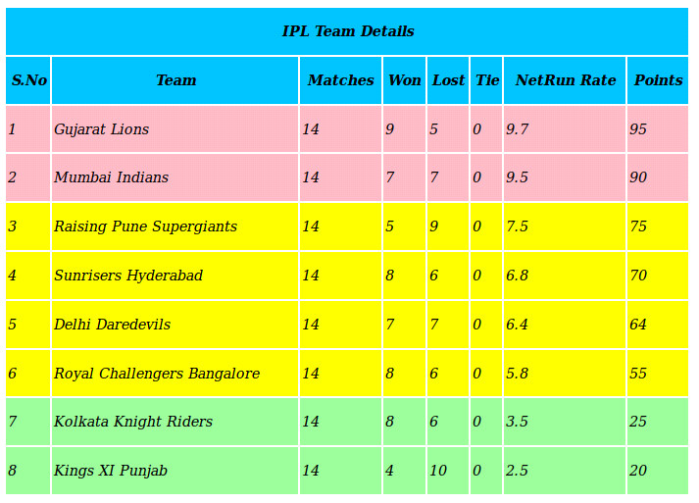   
  
**Screenshot2:**  
  
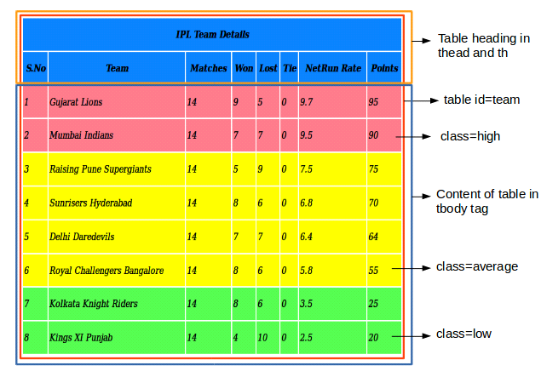

**Exercise 3:**

**Create a home page layout for an ecommerce website using html, css and bootstrap. Create header with bootstrap navbar , footer .and main body content.**

**Sample layout:**

