**1.Simple Calculator**

|  |  |  |
| --- | --- | --- |
| Label Name | Element Name | Constraints |
| Input1 | input1 | This element is to get the first input. Type should be 'number' |
| Input2 | input2 | This element is to get the second input. Type should be 'number' |
| Select Operation | Operation | A drop down list contains the following values: **Select..**, **ADD, SUBTRACT, MULTIPLY and DIVIDE.**  **Set these values as its option tag text and option tag's 'value' attributes** |
|  | Submit | An image for submit must be included using img tag |
|  | Reset | An image for reset must be included using img tag |

**2. Player Application Form Validation**

In the player application form created, do the following validation using JavaScript.

1. All fields are mandatory
2. Matches played, runs scored, wickets and age should be numbers
3. Player name should contain alphabets only
4. Email should be in the correct format

If all validation rules are satisfied, success page should be displayed.

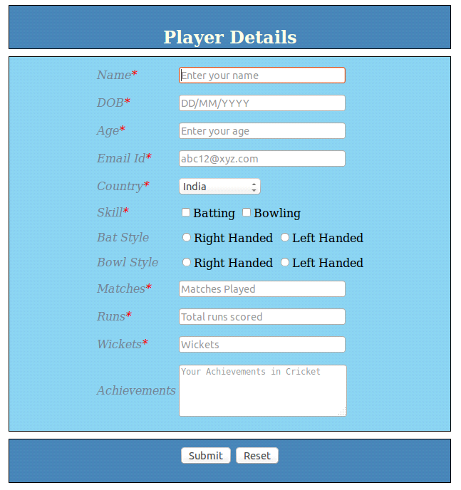

3. Create a html page with radio buttons to select colors. Selected color should be applied as the background colour of the page.