HOSTEL MANAGEMENT SYSTEM

A Course Project Report
Submitted in partial fulfilment of the completion of the course
23CS002PC304 AI Assisted Coding
In III Year II Semester B.Tech – CSE

Submitted by
M. Vishnu
(2303A510J2)

Under the supervision of
Sallauddin Md
Assistant Professor, SOCS & AI

Academic Year 2025–2026


Department of Computer Science & Engineering
SR University
Warangal, Telangana, India

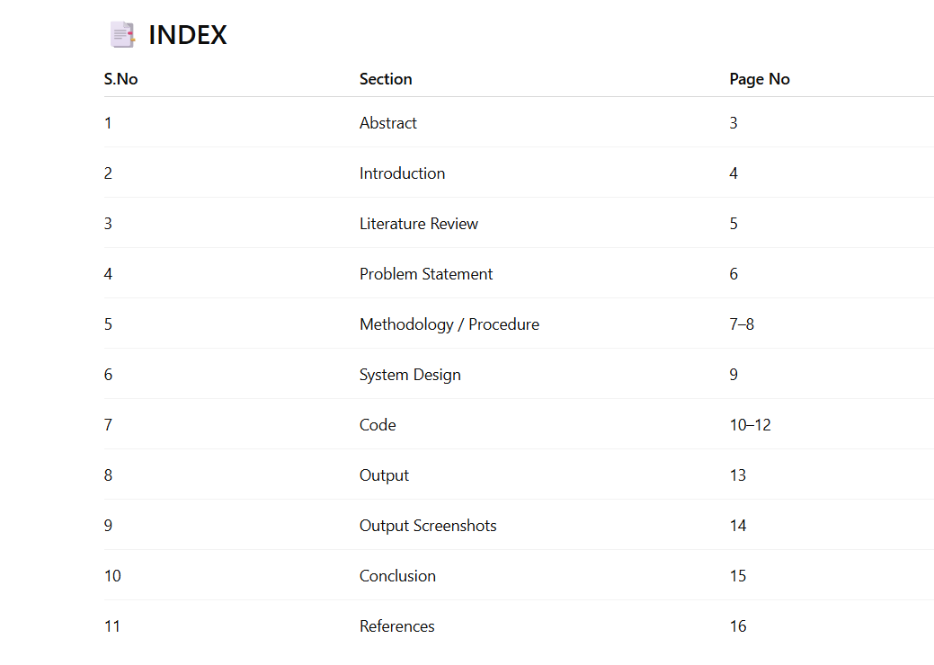

1. ABSTRACT

The Hostel Management System is a full-stack web application developed using Node.js, Express.js, and MongoDB. The system is designed to automate and streamline hostel operations such as room management, student registration, booking allocation, complaint handling, and fee management.
The application provides two types of users: Administrator and Resident (Student). It includes secure authentication using session-based login, role-based access control, and complete CRUD operations. The admin can manage rooms, users, bookings, complaints, and payments, while residents can book rooms, raise complaints, and track their payments.
The system integrates modern technologies like MongoDB for data storage, Express.js for backend logic, and EJS for rendering dynamic pages. It ensures security through password hashing and session management.
By digitizing hostel operations, the system reduces manual work, improves efficiency, enhances transparency, and provides a user-friendly experience.

2. INTRODUCTION

Hostel management in educational institutions is often handled manually, leading to inefficiencies such as poor record keeping, lack of transparency, and difficulty in managing large volumes of data.
The Hostel Management System is developed to overcome these challenges by providing a centralized web-based platform.
Objectives of the System
- Automate hostel operations
- Manage rooms and bookings efficiently
- Provide secure authentication
- Improve transparency and tracking
- Reduce manual workload
Scope of the Project
The system is designed for:
- Colleges and universities
- Private hostels
- Residential facilities
It supports both administrators and residents, making it scalable and flexible.

Objectives:

- Automate operations
- Improve transparency
- Reduce manual work

3. LITERATURE REVIEW

3.1 Traditional Systems
Manual hostel systems rely on registers and paperwork.
Limitations:
- Time-consuming
- Error-prone
- No real-time tracking
3.2 Digital Systems
Basic computer-based systems improved record keeping but lacked:
- Remote access
- Security
- User-friendly interface
3.3 Modern Web-Based Systems
Modern systems use technologies like Node.js and MongoDB.
Advantages:
- Real-time data access
- Secure authentication
- Scalability
- Cloud integration
- 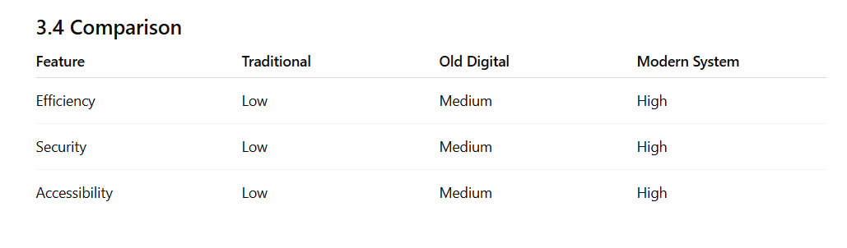
4. PROBLEM STATEMENT
- 4.1 Key Problems
- Manual room allocation
- Difficulty in tracking bookings
- No centralized system
- Poor complaint management
- Lack of transparency

- 4.2 Need for Solution
- A system is required that:
- Automates hostel operations
- Provides secure access
- Enables real-time tracking
- Improves user experience

5 . METHODOLOGY / PROCEDURE

5.1 Development Approach
The system follows a full-stack development approach using:
- Frontend: EJS + Bootstrap
- Backend: Node.js + Express
- Database: MongoDB
5.2 Modules Implemented
Authentication System
- Login/Signup using email & password
- Password hashing using bcryptjs
- Session handling using express-session
Role-Based Access
- Admin → Full access
- Resident → Limited access
Core Modules
- Room Management
- Booking System
- Complaint System
- Payment System
- User Management

5.3 AI Prompt Engineering Approach
The development process relied on carefully structured prompts, each targeting a specific module of the Hostel Management System:
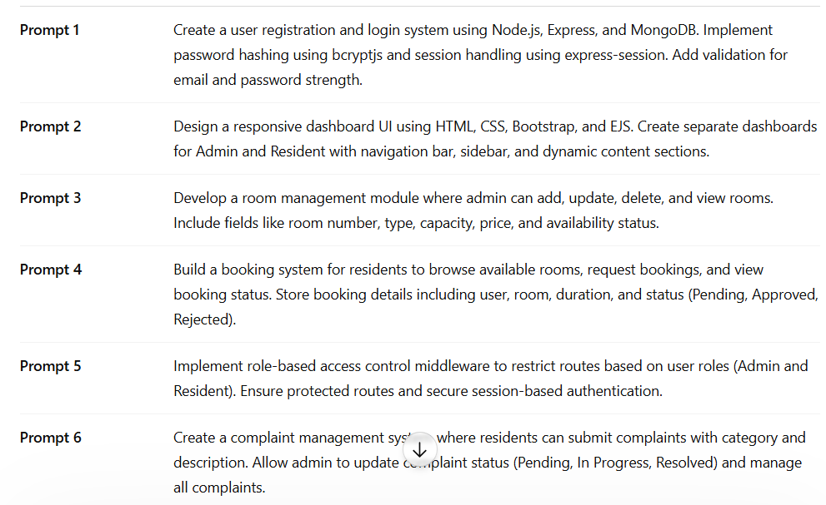
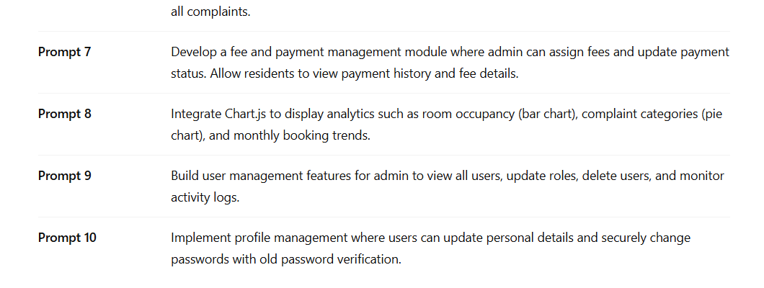

6. SYSTEM DESIGN
6.1 Architecture
The system follows MVC Architecture:
Layers:
- Model → MongoDB schemas
- View → EJS templates
- Controller → Business logic
- Routes → API endpoints
- Middleware → Authentication & authorization
6.2 Workflow
- User logs in
- Session is created
- Redirect based on role
- Admin/Resident dashboard loads
- Actions performed via routes → controllers → database

CODE :
The complete project consists of 44 files generated through AI prompting. Key source files are presented below:
7.1 admin.html— Main Application Entry Point

require('dotenv').config();
const express = require('express');
const mongoose = require('mongoose');
const session = require('express-session');
const MongoStore = require('connect-mongo');

const app = express();

mongoose.connect(process.env.MONGO_URI)
.then(()=>console.log("MongoDB Connected"))
.catch(err=>console.log(err));

app.use(express.urlencoded({extended:true}));

app.use(session({
secret: 'secretkey',
resave: false,
saveUninitialized: false,
store: MongoStore.create({
mongoUrl: process.env.MONGO_URI
})
}));

app.get('/', (req,res)=>{
res.send("Hostel Management System Running");
});

app.listen(3000, ()=>console.log("Server running"));

7.2 User Model

const mongoose = require('mongoose');

const userSchema = new mongoose.Schema({
name:String,
email:String,
password:String,
role:{type:String, enum:['admin','resident']}
});

module.exports = mongoose.model('User', userSchema);

7.3 Room Model

const mongoose = require('mongoose');

const roomSchema = new mongoose.Schema({
number:Number,
type:String,
capacity:Number,
price:Number,
status:String
});

module.exports = mongoose.model('Room', roomSchema);

7.4 Booking Model

const mongoose = require('mongoose');

const bookingSchema = new mongoose.Schema({
userId:String,
roomId:String,
status:String,
date:Date
});

module.exports = mongoose.model('Booking', bookingSchema);

OUTPUTS :
9. SCREENSHOTS
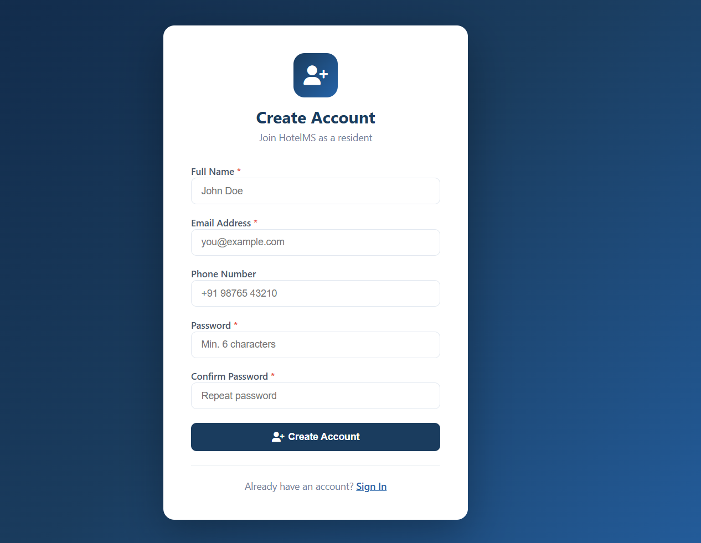
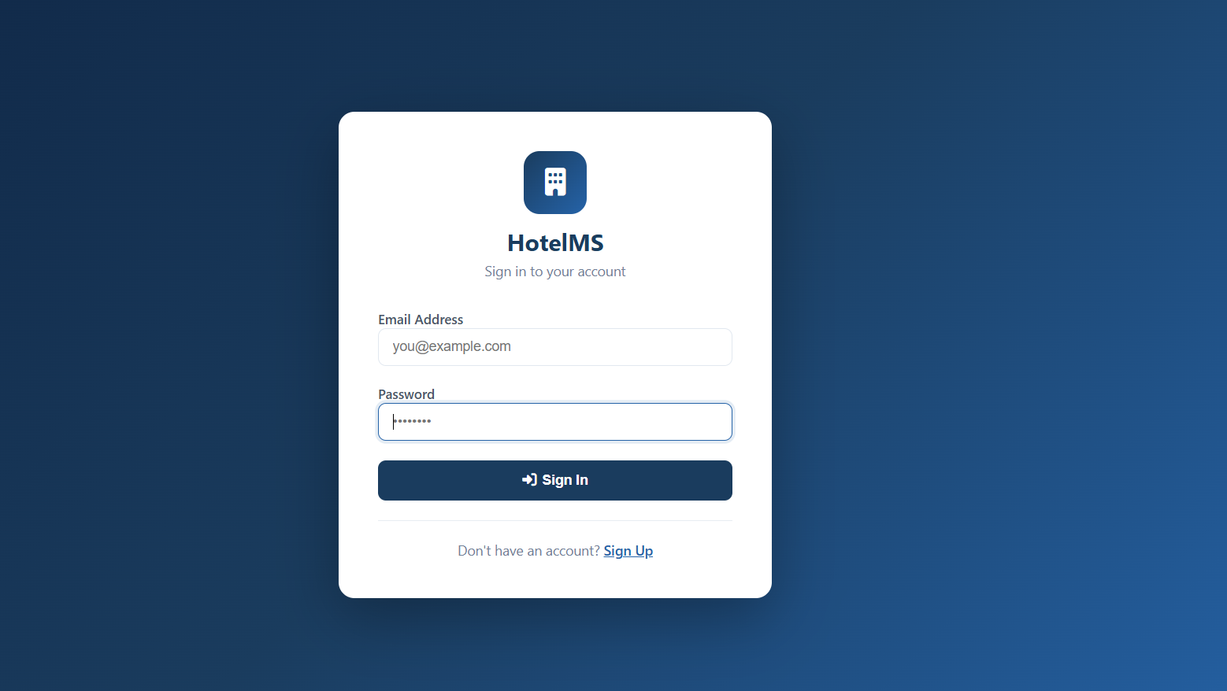
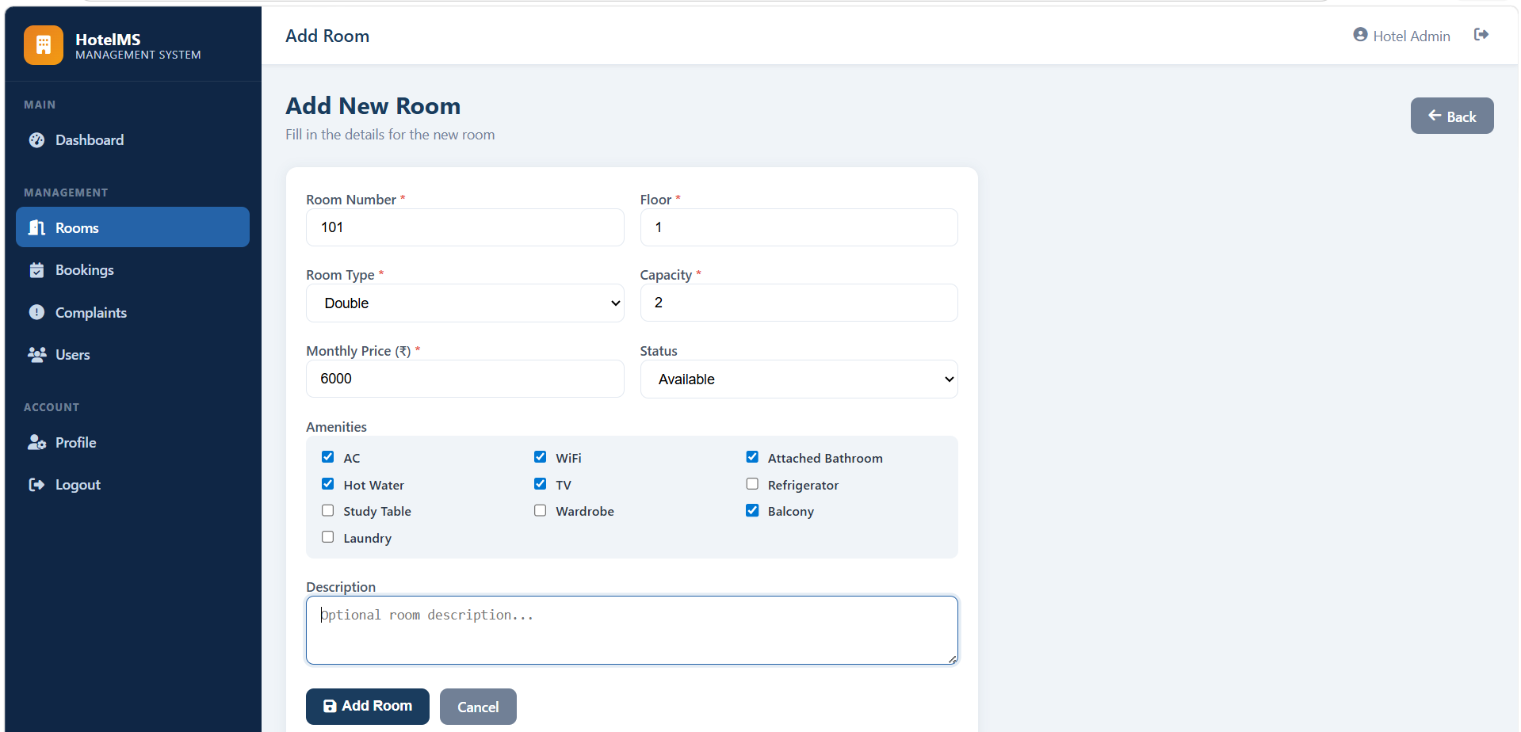
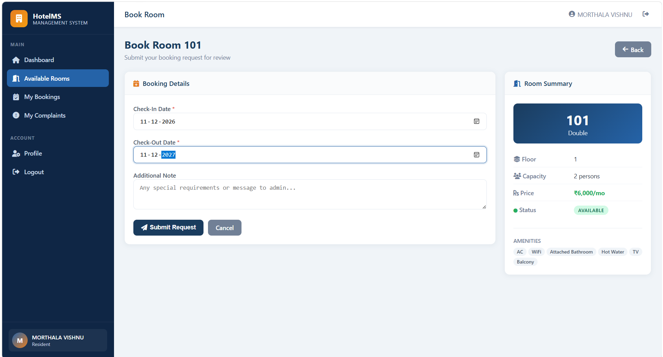

10. CONCLUSION
The Hostel Management System successfully demonstrates the use of modern web technologies to automate hostel operations. It improves efficiency, reduces manual workload, and enhances user experience.
The system is secure, scalable, and user-friendly. Features like role-based access, session management, and CRUD operations make it suitable for real-world deployment.
The system improves hostel management efficiency and provides a scalable solution.

Future Enhancements
- Mobile app integration
- Online payment gateway
- Notification system
- AI-based room allocation

11. REFERENCES

- MongoDB Documentation: https://www.mongodb.com/docs/
- Node.js Documentation: https://nodejs.org
- Express.js Guide: https://expressjs.com
- MDN Web Docs: https://developer.mozilla.org
- Bootstrap Documentation: https://getbootstrap.com

