3. Describe the best project you have worked on, including links if any.

Answer: Project name: Contact Management System

It is a case study on contact management system build to improve my font-end and back-end skills. It is a website to manage user’s contact details and can modify it as per modules created inside UI. Here I have used react js to create components and design the concept of single page application. For styling the page elements, I have used basic bootstrap css library. In the back-end perspective I have used express and node js to create online API(REST) to perform CRUD operation. For working with dataset, I have used mongoDB database

Here default home page is the login page where user need to logged to perform CURD operation. Any modification, can only be done after being logged in or else user need to register to perform the same. User can add, delete, modify or update there own details or can manage their contact details.

Tech stack: HTML, CSS, JavaScript, React js, Node js, express framework, Bootstrap css, mongoDb.

Login page: user is required to enter valid input for log in. User authentication is done checked for validation and verification of input.

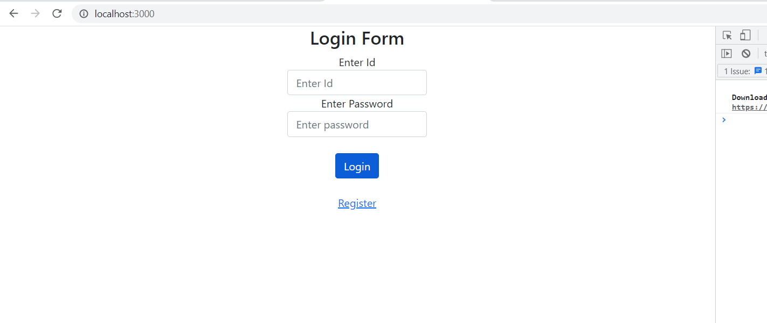

Registration page: Before logging in user need to register in this registration page. Here also validation of input takes place and data is been stored in the database using post request.

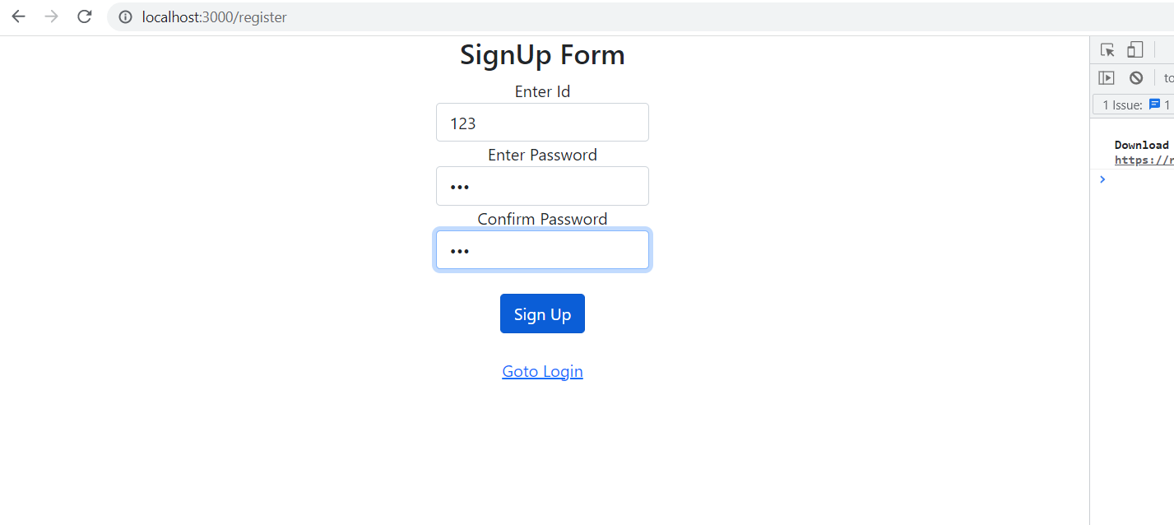

User Dashboard: If log in successful then redirects to user dashboard where user can perform CRUD operations.

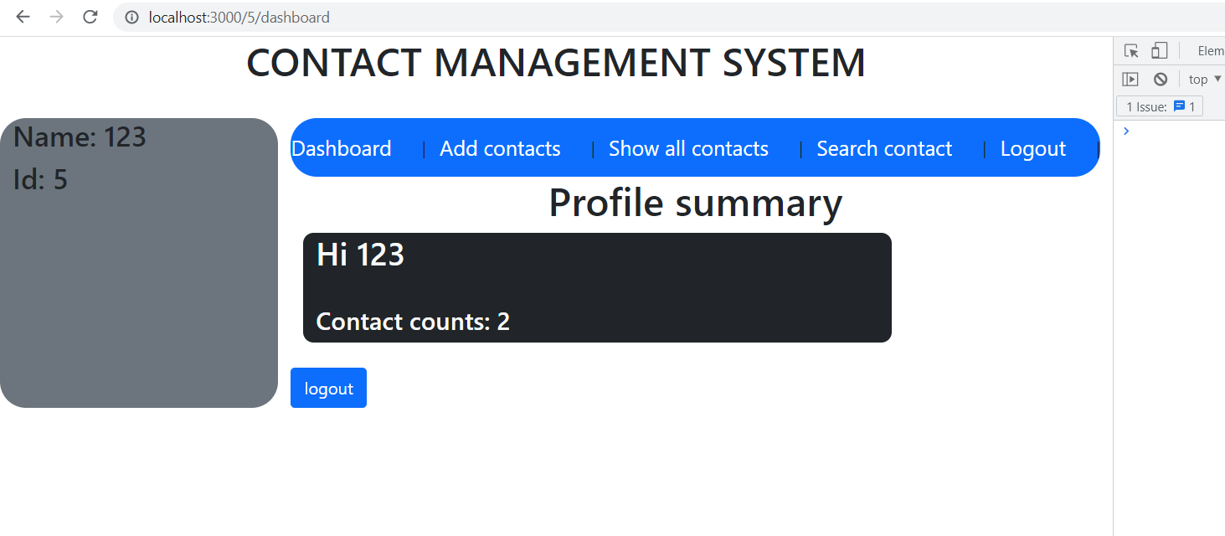

Add contacts component: User can manage their contact list by providing input as shown below and can save data in the database.

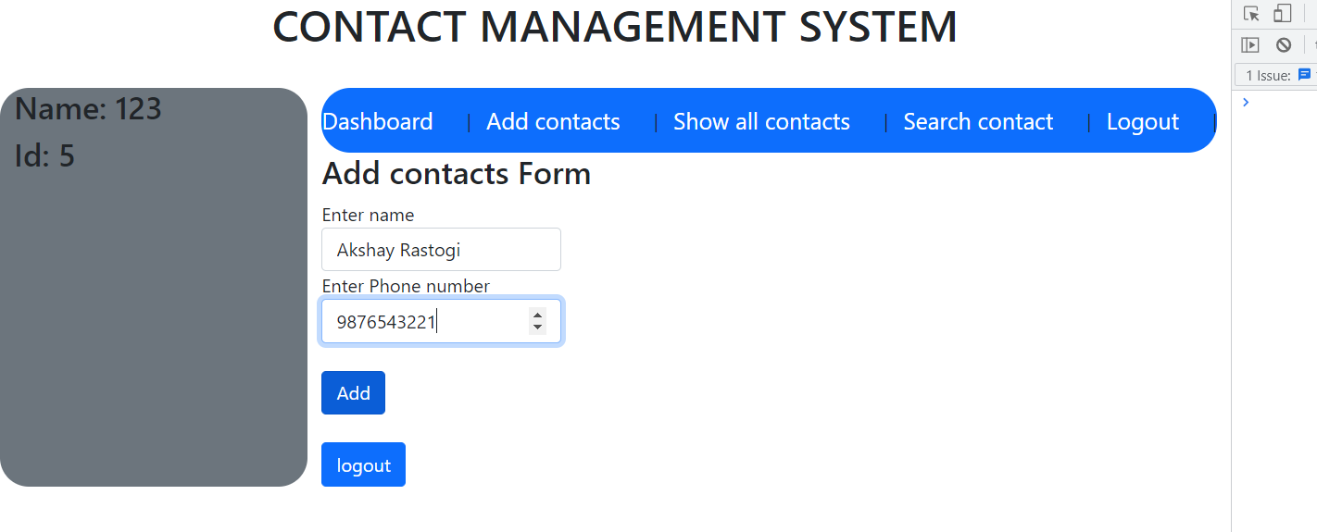

Show all contacts and delete option: This component show all the contacts saved in this current profile and can also delete the same.

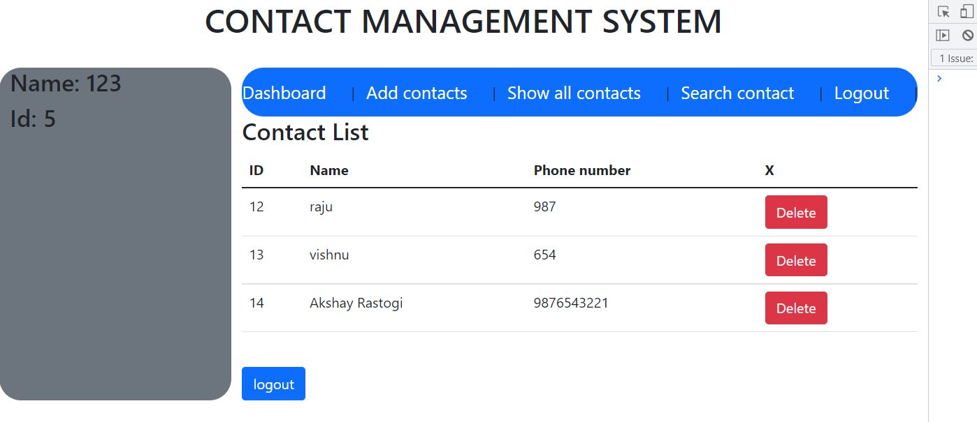

Logout button is created to log out from this current user dashboard.

Github link: https://github.com/vishnu11006271/contact_management_system

4. if you are to start a software company, name 2 people from your batch whom you

will choose as your partner and why?

Answer: I will