1.shell program to convert binary to decimal

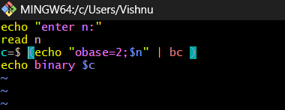

OUTPUT:

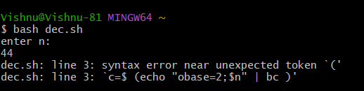

2.Concatenating two strind=gs and finding the length of the concatenated string

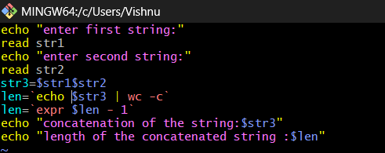

OUTPUT:

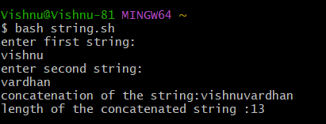

3.Shell programming to swap two numbers

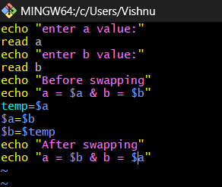

OUTPUT:

