Ethical RPA for Financial Auditing

1. How the solution works
Process 1 (EthicalAuditFlow) tests the data and creates review forms. A person decides each form in Action Center. Process 2 (EthicalAuditFinalize) reads the decisions and recalculates the outstanding amounts.
Workflow screenshot:
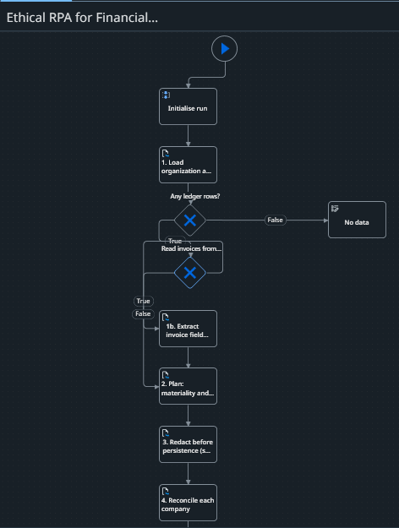
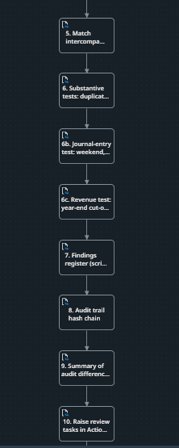
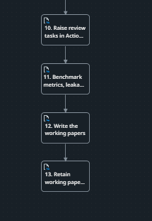

2. Result of a run
Output of the EthicalAuditFlow job. The run folder name identifies the folder in the storage bucket that holds the result files.
Output | Value
out_RunFolder | 20261019-134051_data_2ea5_Ethical
Payments tested (Rows) | 500
Committed (matched) / Routed (sent to a person) | 382 / 118
Decision accuracy / false commits / false routes | 100% / 0 / 0
Findings / review forms created | 284 / 40
Orphan invoices found | 6 of 6
Journal: tested / flagged / exact matches / false flags | 240 / 116 / 116 / 0
Revenue: tested / flagged / exact matches / false flags | 92 / 44 / 44 / 0
Sensitive data leaks found in stored files | 0
Audit-trail hash chain intact | True
Invoices read / unreadable | 441 / 20
Conclusion | Further audit procedures required before a conclusion

3. Output Screenshot

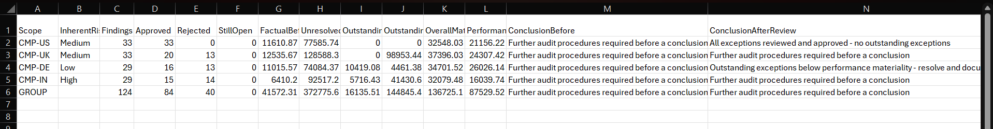
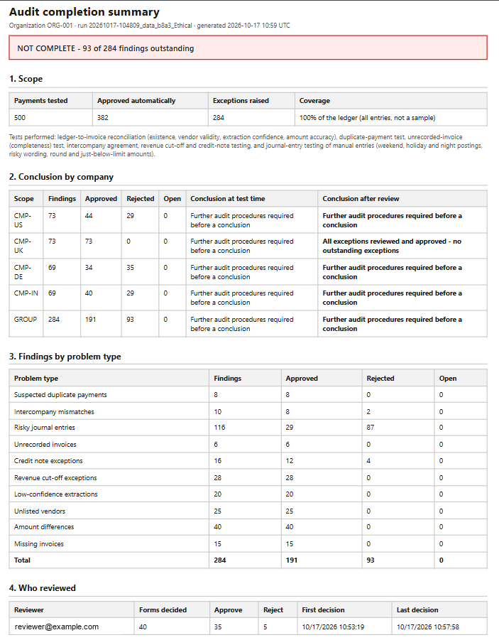

4. Action center Screenshot
The human auditor reviews the flagged errors

1)Review amount differences
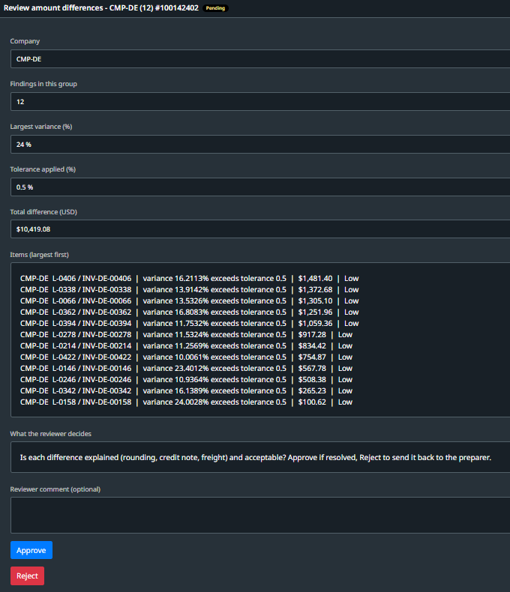

2)Review unlisted vendors
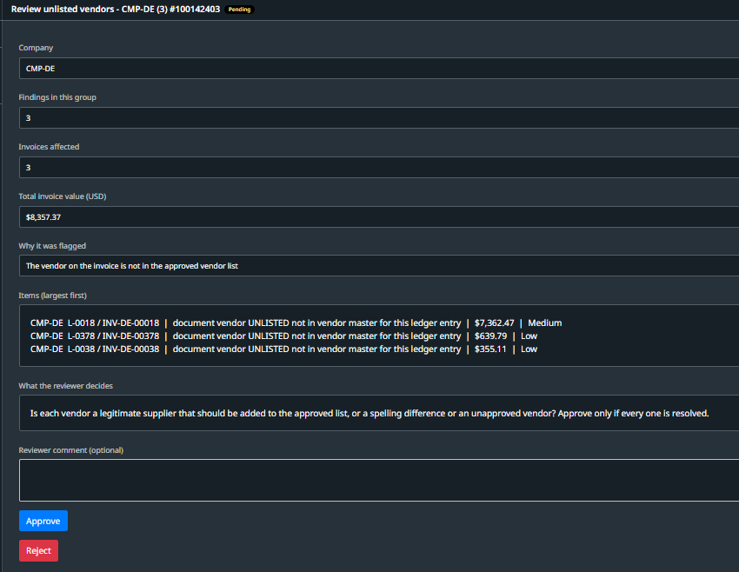

3)Review intercompany mismatches
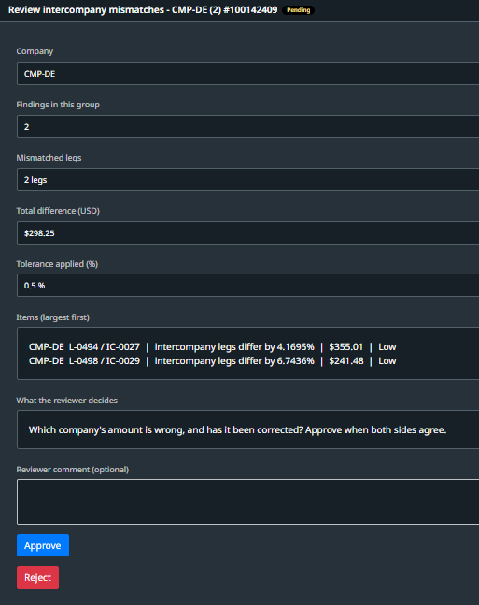

4)Review risky journal entries
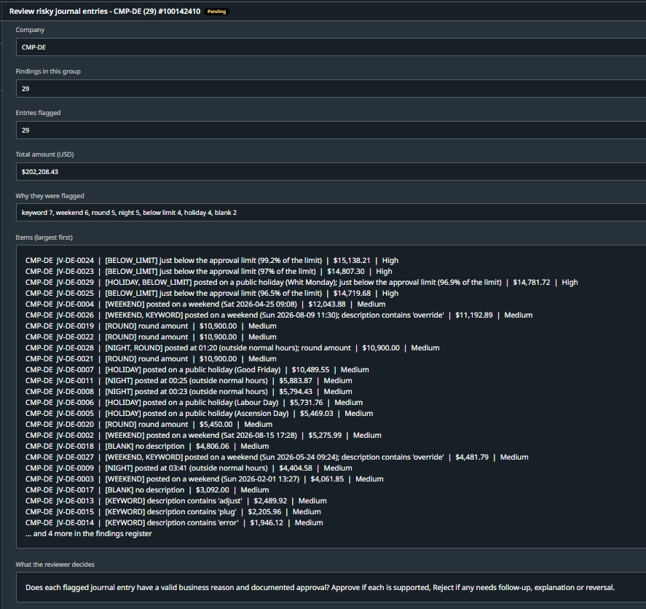

5)Review credit note exception
