
INDEX

EX.NO. | DATE | NAME OF THE EXPERIMENTS | MARKS | SIGNATURE
COMMUNICATION EXPERIMENTS
1. |  | Amplitude modulation(AM)
2. |  | Frequency modulation(FM)
3. |  | Pulse Amplitude Modulation (PAM)
4. |  | Pulse Width Modulation(PWM)
5. |  | Pulse Position Modulation(PPM)
6. |  | Amplitude Shift Keying (ASK)
7. |  | Frequency Shift keying (FSK)
NETWORK EXPERIMENTS
1. |  | Finding the IP address
2. |  | Bit stuffing
3. |  | Character stuffing
4. |  | Error Detection using Hamming Code
5 |  | Error Correction using Cyclic Redundancy Check (CRC)
6. |  | Remote Method Invocation(RMI)
7. |  | Encryption And Decryption
8. |  | Transmission Control Protocol(TCP
9. |  | User Datagram Protocol(UDP)
10. |  | Distance Vector Routing
11. |  | Study Of SASTRA Intranet

AM MODULATION

AIM:

To generate the amplitude modulated waveform using an emitter modulator circuit

APPARATUS REQUIRED:

Transistor BF 495

Resistors 5.6K, 100 ohm,220 ohm,

Capacitors 0.02µF,10µF(2 nos),0.1µF

Function Generator 2 nos

CRO 1 no

Decade Inductance Box 1no

Regulated power supply 0 – 30 V

Breadboard and connecting wires

THEORY:

Modulation is defined as the process by which some characteristics of a carrier signal is varied in accordance with a modulating signal. The base band signal is referred to as the modulating signal and the output of the modulation process is called as the modulation signal.
Amplitude modulation is defined as the process in which is the amplitude of the carrier wave is varied about a means values linearly with the base band signal. The envelope of the modulating wave has the same shape as the base band signal provided the following two requirements are satisfied
I). the carrier frequency fc must be much greater then the highest frequency components fm of the message signal m (t) i.e. fc >> fm
II)The modulation index must be less than unity. if the modulation index is greater than unity, the carrier wave becomes over modulated.

AMPLITUDE MODULATION CIRCUIT DIAGRAM:

PROCEDURE:
- Circuit connections are given as shown in the circuit diagram.
- The power supply is connected to the collector of the transistor.
- Using Function Generator the carrier signal(10V,12.5KHZ) is given to the base of the transistor.
- The modulating (message or base band) signal(2V,625HZ) is given to the emitter of the transistor.
- From the collector of the transistor, the modulated wave is noted down using CRO.
- By varying the amplitude of the modulating signal the values of E_{max} and E_{min} are noted down to find the modulation index.

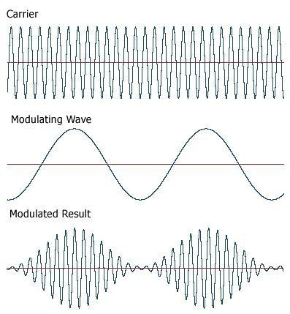
MODEL GRAPH:

RESULT:

Thus, the amplitude modulation circuit was designed and the modulation index for various modulating voltage were calculated.

FREQUENCY MODULATION

AIM:
To generate a frequency modulated wave-using IC 566.

APPARATUS REQUIRED:
Function Generator
IC NE566
Resistors 39K, 5.6K and 2.7K
Capacitor 0.001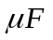(2 Nos) and 0.01(1 No.)
CRO
Bread board and connecting Wires
RPS 0 – 30 Volts

THEORY:

Frequency modulation is a process of changing the frequency of a carrier wave in accordance with the slowly varying base band signal. The main advantage of this modulation is that it can provide better discrimination against noise.

FREQUENCY MODULATION USING IC 566:

A VCO is a circuit that provides an oscillating signal whose frequency can be adjusted over a control by Dc voltage. VCO can generate both square and triangular Wave signal whose frequency is set by an external capacitor and resistor and then varied by an applied DC voltage. IC 566 contains a current source to charge and discharge an external capacitor C1 at a rate set by an external resistor. R1 and a modulating DC output voltage.
The Schmitt trigger circuit present in the IC is used to switch the current source between charge and discharge capacitor and triangular voltage developed across the capacitor and the square wave from the Schmitt trigger are provide as the output of the buffer amplifier.

RESULT:
Thus, the FM modulated wave was obtained using ICXR2206

PULSE AMPLITUDE MODULATION – PAM

AIM:
To generate pulse amplitude modulated signal.

APPARATUS REQUIRED:
Apparatus | Range | Quantity
Transistor | BC107 | 1
Resistor | 10Kohm | 2
CRO | - | 1
FG | - | 2
Bread board | - | 1

THEORY:
Pulse amplitude modulation is a scheme, which alters the amplitude of regularly spaced rectangular pulses in accordance with the instantaneous values of continuous message signal. Then amplitude of the modulated pulses represents the amplitude of the intelligence.
A train of very short pulses of constant amplitude and fast repetition rate is chosen the amplitude of these pulse is made to vary in accordance with that of a slower modulating signal the result is that of multiplying the train by the modulating signal the envelope of the pulse height corresponds to the modulating wave .PAM is not employed in practical circuits
In pulse amplitude modulation, the amplitudes of regularly spaced rectangular pulses vary with the instantaneous sample values of a continuous message signal in a one to one fashion. The pulse in PAM can be of rectangular or the type that we have arrival in natural sampling. The carrier undergoes amplitude modulation in PAM. The width of the pulse remains fixed. Natural sample method is used here to generate the PAM signal. The diodes are used as a switching element. If the closing time t of the diode approaches zero, the output gives only the instantaneous value. Since the width of the pulse approaches zero. The instantaneous sampling gives train of impulses. The area of each sampled section is equal to the instantaneous value of the signal input. This signal is modulated with the message signal to get the PAM output.

PAM MODULATION CIRCUIT:

PROCEDURE:
- Make connections as shown in the diagram.
- Set the message signal(sine wave) of 3V,50HZ and carrier signal (pulse wave) of 5V,898HZ.
- Obtain PAM signal at emitter terminal.

MODEL GRAPH:

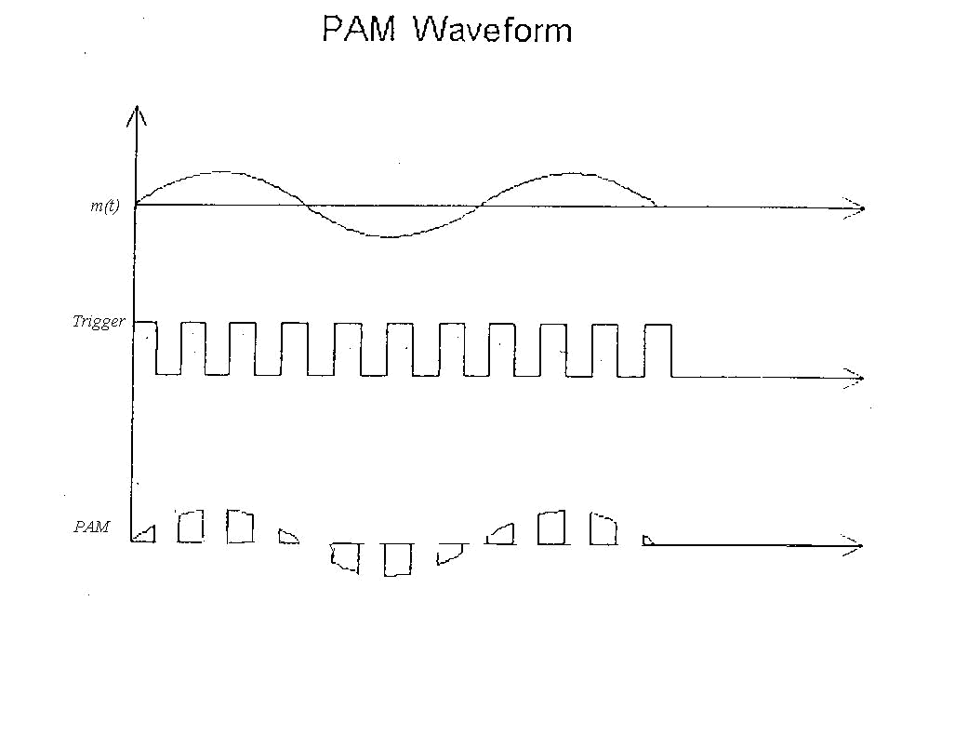

RESULT:

Thus, the PAM signal was obtained.

PULSE WIDTH MODULATION – PWM

AIM:
To generate pulse width modulated signals

APPARATUS REQUIRED:
Apparatus | Range | Quantity
IC | 555 | 1
Resistor | 47Kohm | 1
 | 10Kohm | 1
Capacitor | 0.01µF | 1
RPS | 0-30v | 1
CRO |  | 1
FG |  | 1
Bread board |  | 1

THEORY:
The PWM is also known as pulse duration modulation. It modulates the time parameter of the pulses. The width of PWM pulses varies. The amplitude is constant; width of the pulse is proportional to the amplitude of the modulating signal. Bandwidth on transmission channel depends on rise time of the pulse.

PROCEDURE:
1. Connect the circuit as per circuit diagram .
2. Apply carrier signal (square wave) of frequency 4 KHz with amplitude of
2.5V (p-p).
3. Apply message signal (sine wave) of frequency 500Hz with amplitude of
8V (p-p)
4. Observe the sample signal at the pin3.

MODEL GRAPH:

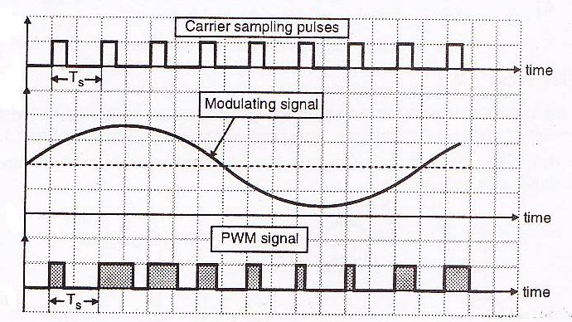

RESULT:
Thus, the PWM waveform was obtained.
PULSE POSITION MODULATION
AIM: To generate pulse position modulation signals
COMPONENTS REQUIRED:  Sl.No. | Components | Type/ Range / Value | Quantity
1. | Resistors | 3.9k, 3k, 10k, 680k | Each one
2. | Capacitors | 0.01μF, 60μF | 2,1
3. | Function Generator | 1MHz | 1
4. | RPS | 0-30v,1A | 1
5. | CRO | 0-30MHz | 1
6. | IC 555 | Operating tem :SE 555 -55degC to 125deg C  NE 555 0deg to 70degC  Supply voltage :+5V to +18V  Timing :μSec to Hours  Sink current :200mA  Temperature stability :50 PPM/deg C change in temp or 0-005% /deg C. | 1
7. | CRO Probes | ----- | 1

CIRCUIT DIAGRAM:

PROCEDURE:
1. Connect the circuit as per circuit diagram as shown in the fig.
2. Observe the sample output at pin 3 and observe the position of the pulses on CRO and adjust the amplitude by slightly increasing the power supply. Also observe the frequency of pulse output.
3. Apply the modulating signal, sinusoidal signal of 2V (p-p) (ac signal) 2v (p-p) to the control pin 5 using function generator.
4. Now by varying the amplitude of the modulating signal, note down the position of the pulses.
5. Observe the o/p on CRO.

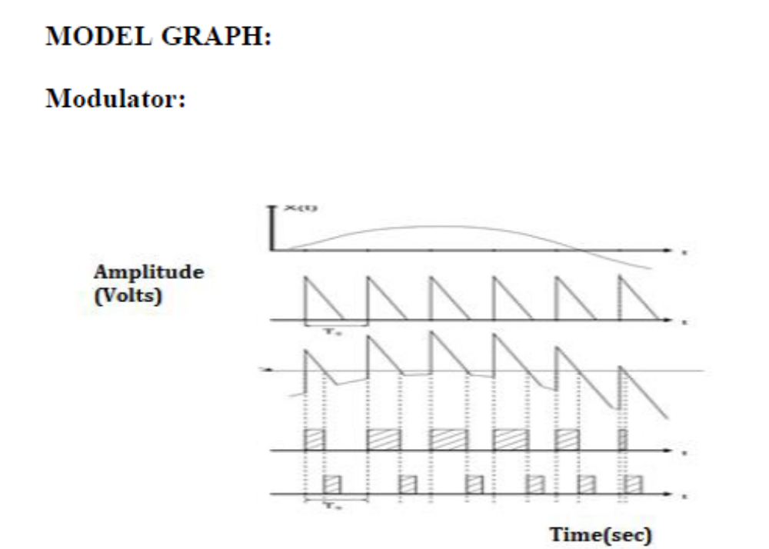

RESULT:
Thus PPM wave can be generated using IC555

AMPLITUDE SHIFT KEYING

AIM:

To generate ASK modulated signal.

APPARATUS REQUIRED:
1.)Transistor – SL100(1 NO)
2.)Resistors -39k,1.8k
3.)Function Generator –(1 NO)
4.)CRO –(1 NO)

THEORY:
ASK or ON-OFF key is the simplest digital modulation technique. In this method there is only one unit energy carrier it is switched ON/OFF depending upon the input binary sequence to transmit symbol 0 & 1. No pulse is transmitted output contains some complete no of cycle of carrier frequency.

The disadvantage of ASK is the modulated carrier signal is not continuously transmitted. The peak power requirement is also high. The bit error probability rate is also not required in this technique.

ASK CIRCUIT DIAGRAM:

PROCEDURE:
- Set up the modulator circuit as show in the figure.
- Set the message signal (square wave) of amplitude 6V(P-P) and
frequency 300Hz.
- Set the carrier signal (Sine wave) of amplitude 4V(P-P) and frequency
3KHz.
- Observe the ASK waveform at the collector of transistor using CRO.
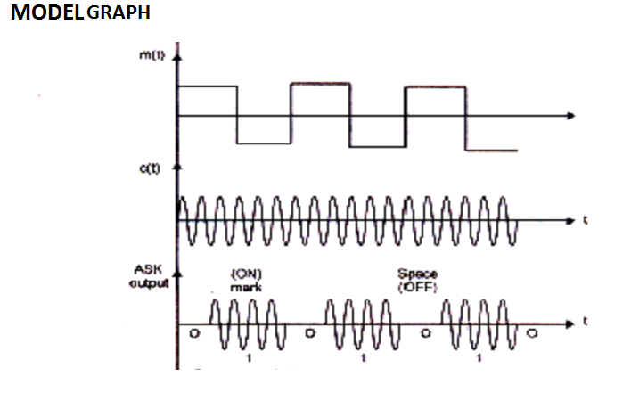

RESULT:
Thus ASK output waveform was obtained.
FREQUENCY SHIFT KEYING

AIM:
To obtain the modulated output waveforms by using the circuit diagram for Frequency
Shift Keying technique.

APPARATUS REQUIRED:

Apparatus | Range | Quantity
IC | 741 | 1
Transistor | SL100  SK100 | 1  1
Resistor | 1Kohm | 2
 | 10Kohm | 3
 | 2.2Kohm | 2
Bread board & connecting wires
FG | ----- | 3
RPS | ----- | 1
CRO | ----- | 1

THEORY:
Digital data communication, binary code is transmitted by shifting a carrier frequency between two preset frequencies. This type of transmission is called frequency shift keying technique. FSK is one of the digital modulation technique. Here frequency of the carrier is switched between two values. A sinusoidal of amplitude' A' and frequency fc1 is used to represent a binary '1' and frequency fc2 is used to represent binary '0' .

CIRCUIT DIAGRAM:

PROCEDURE:
1. Connect the modulator circuit as shown in the figure.
2. Apply upper carrier (sine) of amplitude 1.4V(P-P) and frequency 1KHz.
3. Apply lower carrier (sine) of amplitude 1.4V(P-P) and frequency 3KHz.
4. Apply message signal(square) of amplitude 5V(P-P) and frequency of 150 Hz. .
5. Observe ASK outputs at each collector of transistor, and also observe the FSK output
at pin 6 of op-amp.

MODEL GRAPH:

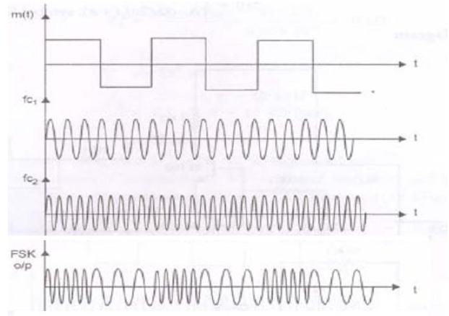

RESULT:
Thus, the FSK waveform was obtained from the binary input signal.
EXNO:1 FINDING THE IP ADDRESS

Aim:-

– To find the IP address of the local host
– To find the IP address of the remote systems in the current network
– To get the name of the specified IP address

Procedure:-

– Import the java.net package to utilize the built-in classes
– Use InetAddressclass for invoking the following methods.
• isReachable () - to check the availability
• getHostAddress() – getting address
Source code:-

import java.net.*;
public class IPAddress
{
public static void main(String args[]) throws Exception
{
System.out.println(InetAddress.getLocalHost());
}
}

Output:- 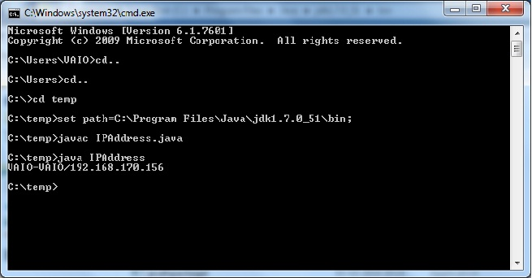

EXP NO:2 BIT STUFFING
AIM:
- To Learn the importance of bit stuffing in communication and network protocols.
- To Learn to synchronize sender and receiver – Learn to create communication protocols having fixed frame size
PROCEDURE:
- Creating two file pointers, one is read and another in write mode for input and output files .
- -Access the given input binary file in read mode .
- -If there is any consecutive five 1’s, ad a stuff bit 0
- Open the output file and write the stuffed string
- At receiver end the additional stuffed bits are rejected at the Data Link layer
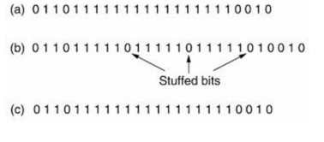

SOURCE CODE:
import java.io.*;
public class BitStuff {
public static void main(String[] args) throws IOException {
// TODO code application logic here
System.out.print("Enter the binary message: ");
BufferedReader br = new BufferedReader (new InputStreamReader(System.in));
String data = br.readLine();
String res = new String();
int counter = 0;
for(int i=0;i<data.length();i++)
{ System.out.println(data.charAt(i));
if (data.charAt(i)!='1' &&data.charAt(i)!='0')
{ System.out.println("invalid data");
return; }
if(data.charAt(i) == '1')
{ counter++;
res = res + data.charAt(i); }
else
{ res = res + data.charAt(i);
counter = 0; }
if(counter == 5)
{ res = res + '0';
counter = 0; }
}
System.out.println("The encrypted string is: " +res);
} }
OUTPUT:
Enter the binary message: 11111111110000000
The encrypted string is: 1111101111100000000

EXP NO:3 BYTE / CHARACTER STUFFING
AIM:-
- To Learn the importance of character stuffing in communication and network protocols.
- To Learn to synchronize sender and receiver – Learn to create communication protocols having fixed frame size.
PROCEDURE:
- In byte stuffing (or character stuffing), a special byte is added to the data section of the frame when there is a character with the same pattern as the flag.
- The data section is stuffed with an extra byte. This byte is usually called the escape character (ESC), which has a predefined bit pattern.
- Whenever the receiver encounters the ESC character, it removes it from the data section and treats the next character as data, not a delimiting flag.
SOURCE CODE:
import java.io.*;
public class CharStuff
{
public static void main(String[] args) throws IOException
{
// TODO code application logic here
System.out.print("Enter the input: ");
BufferedReader br = new BufferedReader (new InputStreamReader(System.in));
String data = br.readLine();
String res = "DLESTX";
int i;
for(i=0;i<data.length()-2;i++)
{
if ((data.charAt(i) == 'd' || data.charAt(i) == 'D') && (data.charAt(i+1) == 'l' ||
data.charAt(i+1) == 'L') && (data.charAt(i+2) == 'e' || data.charAt(i+2) == 'E'))
{
res = res + "DLE";
}
res = res + data.charAt(i);
}
res = res + data.charAt(i) + data.charAt(i+1) + "DLEETX";
System.out.println("Output is: " +res);
}
}
OUTPUT:
Enter the input: dlefdhgddieDLEjvdvhDle
Output is:DLESTXDLEdlefdhgddieDLEDLEjvdvhDLEDleDLEETX

EXNO:4 HAMMING CODE
AIM:
Learn Error detection and correction Mechanisms.
PROCEDURE:
• calculate the redundancy bit r1,r2,r4 and r8
• Calculate the parity for each parity bit (a ? represents the bit position being set):
• Position 1 checks bits 1,3,5,7,9,1:
? _ 1 _ 001 _ 1 0 1 0. Even parity so set position 1 to a 0: 0 _ 1 _ 001 _ 1 0 1 0
• Position 2 checks bits 2,3,6,7,10,1:
0 ?1 _ 0 0 1 _ 1 0 1 0.Odd parity so set position 2 to a 1: 0 1 1 _ 0 0 1 _ 1 0 1 0
• Position 4 checks bits 4,5,6,7,12:
0 1 1?0 0 1 _ 1 0 1 0.Odd parity so set position 4 to a 1: 0 1 11 0 0 1 _ 1 0 1 0
• Position 8 checks bits 8,9,10,1,12:
0 1 1 0 01 ?1 0 1 0. Even parity so set position 8 to a 0: 0 1 1 0 0 1 0 1 0 1 0
• Code word: 0110101010.
Error Detection and correction
Calculate r1,r2,r4 and r8.
if r1,r2,r4 and r8 are zero, No single bit erroroccurred.
By using these check bit values we can detect he error bit position.

Source code
import java.util.*;
class Hamming
{
public static void main(String args[])
{
Scanner read=new Scanner(System.in);
int i,dec_value;
int codeword[]=new int[12];
int redunt[]=new int[12];
int v[]=new int[4];
System.out.println("_________SENDER SIDE_______");
System.out.println("Enter the data in bits");
for(i=11;i>=1;i--)
if(i!=8 && i!=4 && i!=2 && i!=1)
codeword[i]=read.nextInt();
codeword[1]=codeword[1]^codeword[3]^codeword[5]^codeword[7]^codeword[9]^codeword[11];
codeword[2]=codeword[2]^codeword[3]^codeword[6]^codeword[7]^codeword[10]^codeword[11];
codeword[4]=codeword[4]^codeword[5]^codeword[6]^codeword[7];
codeword[8]=codeword[8]^codeword[9]^codeword[10]^codeword[11];
System.out.println("The codeword to be transmitted is ");
for(i=11;i>=1;i--)
System.out.print(codeword[i]);
System.out.println();
System.out.println("_________RECEIVER SIDE_______");
System.out.println("Enter the codeword in bits");
for(i=11;i>=1;i--)
codeword[i]=read.nextInt();

redunt[1]=codeword[1]^codeword[3]^codeword[5]^codeword[7]^codeword[9]^codeword[11];
redunt[2]=codeword[2]^codeword[3]^codeword[6]^codeword[7]^codeword[10]^codeword[11];
redunt[3]=codeword[4]^codeword[5]^codeword[6]^codeword[7];
redunt[4]=codeword[8]^codeword[9]^codeword[10]^codeword[11];
System.out.println("The redundancy bits at receiver side are ");
for(i=4;i>=1;i--)
System.out.print(redunt[i]);
System.out.println();
dec_value=(redunt[1]*1)+(redunt[2]*2)+(redunt[3]*4)+(redunt[4]*8);
if(dec_value==0)
System.out.println("No Bit is corrupted ");
else
{
System.out.println("Bit "+dec_value+" is corrupted ");
if(codeword[dec_value]==0)
codeword[dec_value]=1;
else
codeword[dec_value]=0;
}
System.out.println("The Correct data with redundancy bits : ");
for(i=11;i>=1;i--)
System.out.print(codeword[i]);
System.out.println();
System.out.println("The data after removing redundancy bits : ");
for(i=11;i>=1;i--)
if(i!=8 && i!=4 && i!=2 && i!=1)
System.out.print(codeword[i]);

}
}

OUTPUT:
Enter the 7-bit data code
1
0
0
1
0
0
1
Complete code word is
1 1 1 1 0 0 1 1 0 0 1
Enter the received codeword
1 1 1 1 0 0 1 1 0 0 1
No error
Corrected code word is:1 1 1 1 0 0 1 1 0 0 1

EXNO:5 CRC

AIM:
- Learn error detection concepts .
- Learn how to chose Pattern P (divisor for CRC algorithms
- Learn to generate Frame Check Sequence (FCS which is to be added at end ofthe message bits)
PROCEDURE:
- Choose n and k(number of msg bits) value
- Where (n-k) is the frame check sequence(FCS) size.
- Chose pattern P where as it should be at least one bit greater than the FCS.
- LSB and MSB in P should be 1.
- Divide the msg bit by P .Add the remainder with the msg bit.
- At the receiver end the transmitted data is divided by the same pattern P.
- If the remainder is zero ,No Error in the code Otherwise Error is Detected.
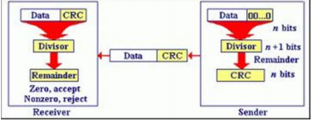

SOURCE CODE:
import java.io.*;
class crc_gen
{
public static void main(String args[]) throws IOException
{
BufferedReader br=new BufferedReader(new InputStreamReader(System.in));
int[] data;
int[] div;
int[] divisor;
int[] rem;
int[] crc;
int data_bits, divisor_bits, tot_length;
System.out.println("Enter number of data bits : ");
data_bits=Integer.parseInt(br.readLine());
data=new int[data_bits];
System.out.println("Enter data bits : ");
for(int i=0; i<data_bits; i++)
data[i]=Integer.parseInt(br.readLine());

System.out.println("Enter number of bits in divisor : ");
divisor_bits=Integer.parseInt(br.readLine());
divisor=new int[divisor_bits];

System.out.println("Enter Divisor bits : ");
for(int i=0; i<divisor_bits; i++)
divisor[i]=Integer.parseInt(br.readLine());
tot_length=data_bits+divisor_bits-1;
div=new int[tot_length];
rem=new int[tot_length];
crc=new int[tot_length];
/*------------------ CRC GENERATION-----------------------*/
for(int i=0;i<data.length;i++)
div[i]=data[i];

System.out.print("Dividend (after appending 0's) are : ");
for(int i=0; i< div.length; i++)
System.out.print(div[i]);
System.out.println();

for(int j=0; j<div.length; j++){
rem[j] = div[j];
}

rem=divide(div, divisor, rem);
for(int i=0;i<div.length;i++) //append dividend and ramainder
{
crc[i]=(div[i]^rem[i]);
}

System.out.println();
System.out.println("CRC code : ");
for(int i=0;i<crc.length;i++)
System.out.print(crc[i]);

/*-------------------ERROR DETECTION---------------------*/
System.out.println();
System.out.println("Enter CRC code of "+tot_length+" bits : ");
for(int i=0; i<crc.length; i++)
crc[i]=Integer.parseInt(br.readLine());
for(int j=0; j<crc.length; j++){
rem[j] = crc[j];
}
rem=divide(crc, divisor, rem);

for(int i=0; i< rem.length; i++)
{
if(rem[i]!=0)
{
System.out.println("Error");
break;
}
if(i==rem.length-1)
System.out.println("No Error");
}

}

static int[] divide(int div[],int divisor[], int rem[])
{
int cur=0;
while(true)
{
for(int i=0;i<divisor.length;i++)
rem[cur+i]=(rem[cur+i]^divisor[i]);

while(rem[cur]==0 && cur!=rem.length-1)
cur++;

if((rem.length-cur)<divisor.length)
break;
}
return rem;
}
}
OUTPUT
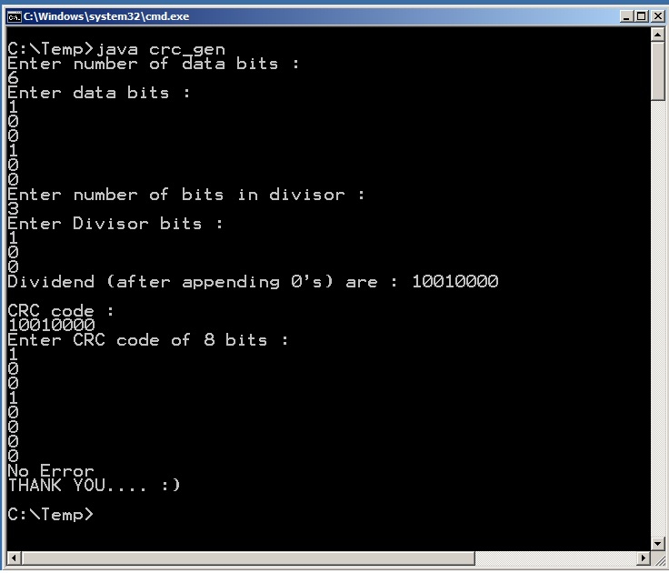
EXNO:6 REMOTE PROCEDURE CALL(RMI)
AIM:-
• To learn the concepts of Remote Procedure Call and Remote Method Invocation
• To learn to develop applications which uses Distributed Objects
• To learn the working and significance of stub object (Client side )and Skeleton
objects (Server side).
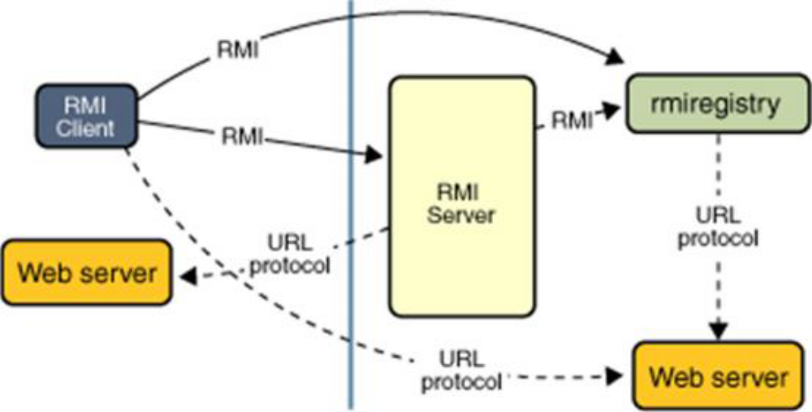

PROCEDURE:-
• Creating the RMI server
• Contains both class and interface
• Creating an interface
• Both client and server have to agree
• Implementing the interface
• Binding with RMI registry
• Should contain the operational code
• Creating the RMI client
• Call Registry to obtain reference to remote object
• Compiling and starting the server
CALCULATOR PROGRAM:-
import java.rmi.Remote;
import java.rmi.RemoteException;

public interface Calculator extends Remote
{
public long add(long a,long b) throws RemoteException;
}
CALCULATOR IMPL:-
import java.rmi.RemoteException;
import java.rmi.server.UnicastRemoteObject;

public class CalculatorImpl extends UnicastRemoteObject implements Calculator
{
protected CalculatorImpl() throws RemoteException
{
super();
}
public long add(long a, long b) throws RemoteException
{
return a+b;
}
}
CALCULATOR SERVER:-
import java.rmi.Naming;
public class CalculatorServer
{
CalculatorServer()
{
try
{
Calculator c = new CalculatorImpl(); Naming.rebind("rmi://127.0.0.1:1099/CalculatorService", c);
}
catch (Exception e)
{
e.printStackTrace();
}
}
public static void main(String[] args)
{
new CalculatorServer();
}
}
CALCULATOR CLIENT:-
import java.rmi.Naming;

public class CalculatorClient
{
public static void main(String[] args)
{
try
{
Calculator c = (Calculator) Naming.lookup("//127.0.0.1:1099/CalculatorService");
System.out.println("addition : "+c.add(10, 15));
}
catch (Exception e)
{
System.out.println(e);
}
}
}

OUTPUT:-
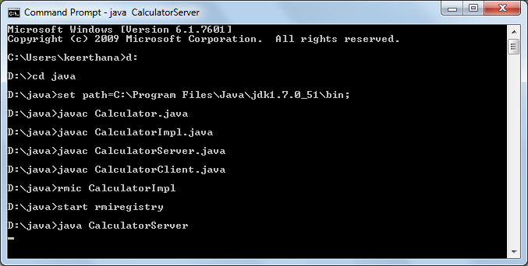
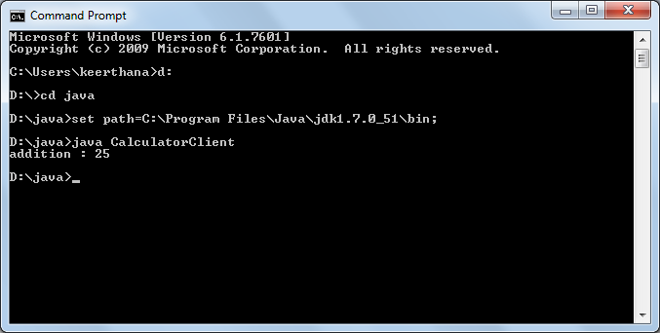

EXNO:7 ENCRYPTION AND DECRYPTION

AIM:
To encrypt a plain text using a key and transmit he cipher text; decrypt the cipher text at the
receiver side to get back the original message (Hint: Use Ceaser Cipher)
PROCEDURE:
- Get he “key”.
- Replace each character with the character, which is, “key” positons ahead.
- Send the encrypted mesage.
- Decrypt he mesage received by replacing each character with the character, which is
- key positons behind.
- For data transfer, use either TCP or UDP.
SOURCE CODE:
import java.io.BufferedReader;
import java.io.IOException;
import java.io.InputStreamReader;
import java.util.Scanner;
public class CeaserCipher {
static Scanner sc=new Scanner(System.in);
static BufferedReader br = new BufferedReader(new InputStreamReader(System.in));
public static void main(String[] args) throws IOException {
// TODO code application logic here
System.out.print("Enter any String: ");
String str = br.readLine();
System.out.print("\nEnter the Key: ");
int key = sc.nextInt();
String encrypted = encrypt(str, key);
System.out.println("\nEncrypted String is: " +encrypted);
String decrypted = decrypt(encrypted, key);
System.out.println("\nDecrypted String is: " +decrypted);
System.out.println("\n");
}
public static String encrypt(String str, int key) {
String encrypted = "";
for(int i = 0; i < str.length(); i++) {
int c = str.charAt(i);
if (Character.isUpperCase(c)) {
c = c + (key % 26);
if (c > 'Z')
c = c - 26;
}
else if (Character.isLowerCase(c)) {
c = c + (key % 26);
if (c > 'z')
c = c - 26;
}
encrypted += (char) c;
}
return encrypted;
}
public static String decrypt(String str, int key) {
String decrypted = "";
for(int i = 0; i < str.length(); i++) {
int c = str.charAt(i);
if (Character.isUpperCase(c)) {
c = c - (key % 26);
if (c < 'A')
c = c + 26;
}
else if (Character.isLowerCase(c)) {
c = c - (key % 26);
if (c < 'a')
c = c + 26;
}
decrypted += (char) c;
}
return decrypted;
}
}

OUTPUT:
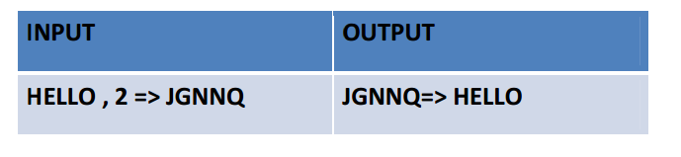

EXNO:8 TCP

Aim:-
To perform one to one chat within a system.
Procedure:-
- One-to-one communication is the act of an individual communicating with another.
- In Internet terms, this can be done by e-mail but the most typical one-to-one communication in the Internet is instant messaging as it does not consider many-to-many communication such as a chat room as an essential part of its scope.
- The program displays what is written by one party another by opening a socket connection.
- The Application contains two classes:
1.Chat client
2.Chat server
- The chat server class creates a server socket object which listens on port 9999.
- The server socket accepts client socket and reads whatever is written by client and sends the message to the client thus allowing One-one communication .
- The Chat client class creates a socket object using which it sends message to the server on port 9999.
- The communication ends when the client send server says ?bye?.
Source code
SERVER PROGRAM:-
import java.io.*;
import java.net.*;
import java.lang.*;
public class server1
{
public static void main(String args[]) throws IOException
{
ServerSocket ssoc=null;
try
{
ssoc=new ServerSocket(7);
}
catch(IOException e)
{
System.err.println("No connection established");
System.exit(1);
}
Socket csoc=null;

try
{
csoc=ssoc.accept();
}
catch(IOException e)
{
System.err.println("Not accepted");
System.exit(1);
}
PrintWriter pw=new PrintWriter(csoc.getOutputStream(),true);
BufferedReader br=new BufferedReader(new InputStreamReader(csoc.getInputStream()));
String inline;
String outline;
try
{
DataInputStream din=new DataInputStream(System.in);
while(true)
{
inline=br.readLine();
System.out.println("Server :"+inline);
outline=din.readLine();
pw.println(outline);
if(outline.equals("bye"))
break;
}
}
catch(Exception e)
{
System.err.println(e);
}
pw.close();
br.close();
csoc.close();
ssoc.close();
}
}

CLIENT PROGRAM:-
import java.io.*;
import java.net.*;
import java.lang.*;
public class client1
{
public static void main(String args[]) throws IOException
{
Socket csoc=null;
String host;
if(args.length>0)
host=args[0];
else
host="localhost";
PrintWriter pout=null;
BufferedReader bin=null;
try
{
csoc=new Socket(host,7);
pout=new PrintWriter(csoc.getOutputStream(),true);
bin=new BufferedReader(new InputStreamReader(csoc.getInputStream()));
}
catch(UnknownHostException e)
{
System.err.println("Unknownhost");
System.exit(1);
}
catch(IOException e)
{}
BufferedReader in=new BufferedReader(new InputStreamReader(System.in));
String input;
while(true)
{
input=in.readLine();
pout.println(input);
String msg=bin.readLine();
System.out.println("client :"+msg);
if(msg.equals("bye"))
break;
}
in.close();
pout.close();
bin.close();
csoc.close();
}}
OUTPUT:
SERVER :
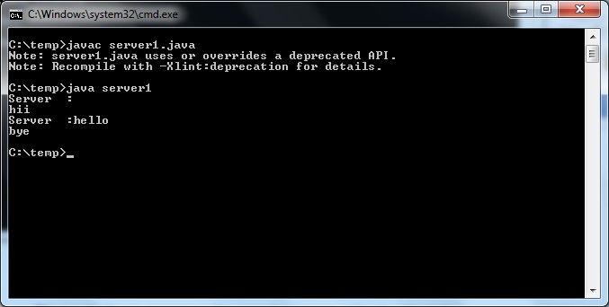
CLIENT:-
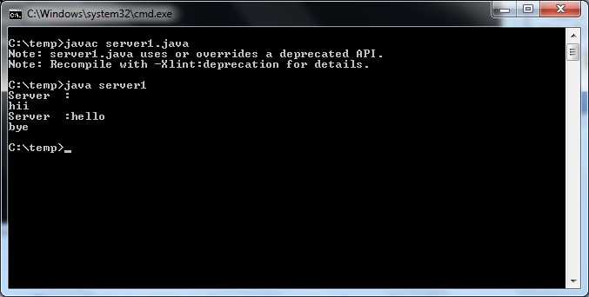

EXNO:9 UDP

AIM:
To transfer a text file from one machine to other using UDP.
PROCEDURE:
- -Import java. io and java.net packages to utilize the built-in classes
- DatagramSocketClass for generating UDP socket
- DatagramPacketClass for form the data container .
- send() – to send the packet o the destination.
- receive() – to receive the packet from the client/server –
- Using FileWriter Class, the received text is written in the new file.

SOURCE CODE:
Client program
import java.io.*;
import java.net.*;

class UDPChatClient
{
public static void main(String args[]) throws Exception
{

DatagramSocket ds = new DatagramSocket(991);

String str1 = new String();
String str2 = new String();
byte[] b1 = new byte[200];
byte[] b2 = new byte[200];
BufferedReader br = new BufferedReader(new InputStreamReader(System.in));

DatagramPacket dp1,dp2;

while(true)
{
dp2 = new DatagramPacket(b2,b2.length);
ds.receive(dp2);
str2 = new String(dp2.getData(),0,dp2.getLength());
System.out.println("Received Data:"+str2);
if(str2.equalsIgnoreCase("bye"))
break;

System.out.println("\nEnter data to send:");
str1 = br.readLine();
b1 = str1.getBytes();
dp1 = new DatagramPacket(b1,b1.length,InetAddress.getLocalHost(),990);
ds.send(dp1);

}

}
}
Server Program
import java.io.*;
import java.net.*;

class UDPChatServer
{
public static void main(String args[]) throws Exception
{

DatagramSocket ds = new DatagramSocket(990);

String str1 = new String();
String str2 = new String();
byte[] b1 = new byte[200];
byte[] b2 = new byte[200];
BufferedReader br = new BufferedReader(new InputStreamReader(System.in));

DatagramPacket dp1,dp2;

while(true)
{
System.out.println("\nEnter data to send:");
str1 = br.readLine();
b1 = str1.getBytes();
dp1 = new DatagramPacket(b1,b1.length,InetAddress.getLocalHost(),991);
ds.send(dp1);

dp2 = new DatagramPacket(b2,b2.length);
ds.receive(dp2);
str2 = new String(dp2.getData(),0,dp2.getLength());
System.out.println("Received Data:"+str2);
if(str2.equalsIgnoreCase("bye"))
break;
}

}
}
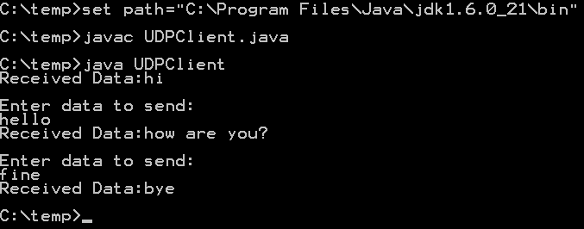

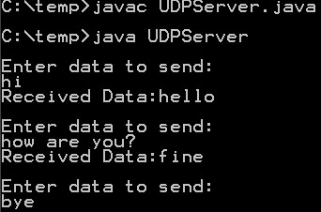

EXNO:10 DISTANCE VECTOR ROUTING
AIM:
Routers using distance-vector protocol do not have knowledge of the entire path to a destination. Instead they use two methods:
- Direction in which router or exit interface a packet should be forwarded.
- Distance from its destination

PROCEDURE:
- Each node constructs a one-dimensional array containing the "distances"(costs) to all other nodes and distributes that vector to its immediate neighbours.
- The starting assumption for distance-vector routing is that each node knows the cost of the link to each of its directly connected neighbours.
- A link that is down is assigned an infinite cost.
Example.
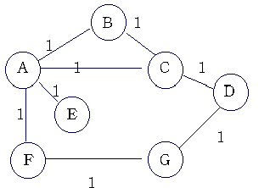

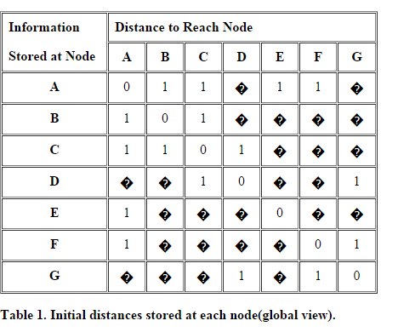
We can represent each node's knowledge about the distances to all other nodes as a table like the one given in Table 1.
Note that each node only knows the information in one row of the table.
- Every node sends a message to its directly connected neighbours containing its personal list of distance. ( for example, A sends its information to its neighbours B,C,E, and F. )
- If any of the recipients of the information from A find that A is advertising a path shorter than the one they currently know about, they update their list to give the new path length and note that they should send packets for that destination through A. ( node Blearns from A that node E can be reached at a cost of 1; B also knows it can reach A at a cost of 1, so it adds these to get the cost of reaching E by means of A. B records that it can reach E at a cost of 2 by going through A.)
- After every node has exchanged a few updates with its directly connected neighbors, all nodes will know the least-cost path to all the other nodes.
- In addition to updating their list of distances when they receive updates, the nodes need to keep track of which node told them about the path that they used to calculate the cost, so that they can create their forwarding table. ( for example, B knows that it was A who said " I can reach E in one hop" and so B puts an entry in its table that says " To reach E, use the link to A.)

SOURCE CODE:
import java.util.*;
import java.io.*;
class Exp9_Routing
{
public static void main(String args[])
{
Scanner in=new Scanner(System.in);
int n,source,dest,inter,k,i;
int[] [] cost=new int [10][10];
int[] [] nextnode=new int [10][10];
System.out.println("Enter the number of nodes");
n=in.nextInt();
System.out.println("Enter the distance (If no direct path enter 1000) :");
for(source=1;source<=n;source++)
{
for(dest=source;dest<=n;dest++)
{
System.out.print("between "+source+" and "+dest+" :");
cost[source][dest]=in.nextInt();
nextnode[source][dest]=dest;
cost[dest][source]=cost[source][dest];
nextnode[dest][source]=source;
}
}
for(i=1;i<=n;i++) // For self node distance is 0
{
cost[i][i]=0;
}
System.out.println("The cost matrix for the given network is :");
for(source=1;source<=n;source++)
{
for(dest=1;dest<=n;dest++)
{
System.out.print(cost[source][dest]+"\t");
}
System.out.println("");
}
for(source=1;source<=n;source++) // Calculate the shortest distance
{
for(dest=1;dest<=n;dest++)
{
for(inter=1;inter<=n;inter++)
{
if(cost[source][dest] > cost[source][inter]+cost[inter][dest])
{
cost[source][dest]=cost[source][inter]+cost[inter][dest];
nextnode[source][dest]=inter;
}
}
}
}
System.out.println("Enter the node to print the routing information");
int src=in.nextInt();
for(int des=1;des<=n;des++)
{
{
System.out.println("The shortest distance between "+src+" and "+des+" is "+cost[src][des]+" via "+nextnode[src][des]);
}
}
}

}
OUTPUT:

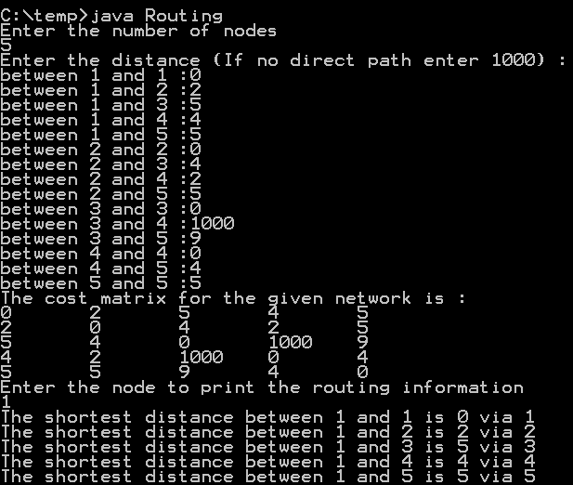

EXNO:11 STUDY OF SASTRA INTRANET
AIM:
To study about SASTRA Intranet, the networking devices, topology used, etc.
DESCRIPTION:-
The campus internet connectivity is provided using a 1Gbps (BSNL NKN) wired connection and 20Mbps (Reliance Connection). The routers used in the Campus are made by IBM.
The IBM Ethernet Switch J48E was designed for high-performance server access deployments. A single switch can be deployed initially; as requirements grow, Virtual Chassis technology allows up to nine additional switches to be interconnected over a 128 gigabit-per-second (Gbps) backplane and managed as a single device, with a single configuration file and OS image. Modular Gigabit Ethernet (GbE) and 10-Gigabit Ethernet (10 GbE) uplink module options enable Virtual Chassis technology to be extended to switches in different racks or even in different data centers.

Host ports 48 10/100/1000BASE-T ports.
Rear-panel Virtual Chassis ports support 128 Gigabit per second (Gbps) backplane connections to other IBM J48E switches in a Virtual Chassis configuration. There are Optional GbE (four) and 10 GbE (two) front-panel uplink ports.

Link Speeds10 Mbps, 100 Mbps, 1 Gbps (fixed ports and optional uplink module), 128 Gbps (Virtual Chassis backplane), 10Gbps (optional uplink module)

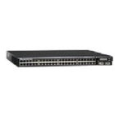

Siemens Access Points have been installed across the Campus. Siemens has established its access points all over the campus for providing Wi-Fi to SASTRA inmates. The TIFAC-Core @ SASTRA uses 250Mbps connection.
o Siemens hi-path Wi-Fi controller 'c1000' with two fiber ports and redundant power supply to support up to 200ap's.
o Siemens hi-path '2620' provides 180 access point with 4dbi external antenna and 9dbi Omni-directional antenna 182nos.
o Windows 2003 based radius auth server for user authentication.
o Registered users 6000 (includes staff, student and guest) with Mac authentication.
o Total area covered 165 acres.
- Aruba Wi-Fi controller '6000' with high powered fiber ports and can support up to 2048ap's
- Aruba 105, 93 and 61 access point with foldable external antenna and bi directional wave propagation which has a high range.
- Windows 2003 based radius auth server for user and Mac authentication.
- Registered users of 8000 (including staff, student and guest) with Mac authentication.
- Installed all over the Campus.
- WPA - Enterprise authentication which gives a high security towards anonymous user’s entry.
The Topologies used are:
  - Star Topology
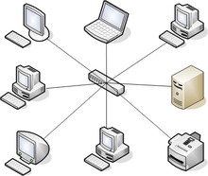
In its simplest form, a star network consists of one central switch, hub or computer, which act as a conduit to transmit messages. This consists of a central node, to which all other nodes are connected; this central node provides a common connection point for all nodes through a hub. In star topology, every node (computer workstation or any other peripheral) is connected to a central node called a hub or switch. The switch is the server and the peripherals are the clients. Thus, the hub and leaf nodes, and the transmission lines between them, form a graph with the topology of a star.

  - Bus Topology:
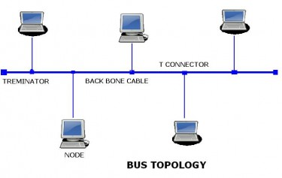
The bus is the data link in a bus network. The bus can only transmit data in one direction, and if any network segment is severed, all network transmission ceases.
A host on a bus network is called a station or workstation. In a bus network, every station receives all network traffic, and the traffic generated by each station has equal transmission priority.^{[1]} Each network segment is, therefore, a collision domain. In order for nodes to transmit on the same cable simultaneously, they use a media access control technology such as carrier sense multiple access (CSMA) or a bus master.

The Server available:
- Blade Server:

The HP Pro-Liant BL460c server blade provides enterprise-class features for high performance and reliability without compromising energy efficiency or density populated in c7000 enclosure supports up to 16 BL460c server blades. Features with Integrated Lights Out 2 (iLO 2) Management for unprecedented, high-speed remote management which includes virtual KVM and graphical remote console. The BL460c provides a performance system ideal for the full range of scale out applications. The BL460c Blades includes more features to ensure high-availability such as hot-plug hard drives, mirrored-memory, online spare memory, memory interleaving, embedded RAID capability.
- Supercomputer: HP rp8400

Specifications:

Peak Performance | 17 GFLOP/s
Processors | 16 PA-8700 @750 MHz
Architecture | SMP with 4 cell boards
Memory | 8 GB (2 GB per cell board)
Disk | 360 GB (Expandable up to 1 TB)
Backup Storage | i) Ultirium Tape Library (2 X 20 Tapes), 200 GB.  ii) DAT drive 40 GB.
PCI Slots | 15 numbers
NIC | One GB fiber optic Ethernet Card.  One 10/100 MB Ethernet card for remote mgt.

