Department of Computer Science and Engineering
(AI & ML)
B. Tech. CSE - 5th Semester
Aug – Dec 2026

UE23CS351A
DATABASE MANAGEMENT SYSTEMS (DBMS)

PROJECT REPORT on

Campus Lost & Found

Submitted by:
PES1UG24AM187 | Vishnu Patruni | AIML-D
PES1UG24AM202 | Pravith Mohandas | AIML-D

Class of Prof. Raghu B.A
Devna Sumesh

Abstract

Students lose things on campus every day: ID cards, earphones, water bottles, chargers and calculators. At present the only way to get them back is to post in WhatsApp groups or ask at the security office, where messages get buried and each collection point only knows about the items handed in to it. Campus Lost & Found is a web application that gives the campus one place to report lost and found items, suggests which reports are probably the same item, and lets staff verify ownership before anything is handed back.
The core data (users, items, claims, matches and handovers) is stored in PostgreSQL in 11 tables. Constraints, triggers, stored procedures, views and indexes keep that data correct and fast to search. Activity logs, search logs and notifications are stored in MongoDB, because they change shape from one event to another, are written often and never need joins. Each report is also converted into a 384-number sentence embedding by a small language model that runs locally, and a SQL function compares these embeddings, so that reports describing the same item in different words can still be matched.
The application is built with Next.js. It supports three roles (student, staff and admin), and every change goes through a backend API that checks the user's role, validates the input and runs inside a database transaction. The project covers the main database topics of the course: ER modelling, a normalised relational design, DDL and DML, joins, nested, correlated and recursive queries, transactions, stored procedures, triggers, views, indexing, full-text search, NoSQL aggregation and vector similarity search.
Table of Contents
Sl. No | Topic | Page No.
 | Introduction  - Problem Statement | 4
 | User Requirements Specification- Tech Stack | 6
 | E-R Model  - List of Entities [labeling Weak ones]  - List non-simple Attributes  - ER Diagram Snapshot  - ERD from tool like draw.io | 9
 | Relational Model  - List of Relations that are not Entities in ER Model  - Schema Diagram [ensure light background image] | 12
 | SQL DDL Statements | 14
 | SQL DML Statements | 25
 | NoSQL/ Vector Database Commands | 31
8. | Results  - Resulting Tables’ Screenshots | 35
9. | Next.js-Project Tree Structure | 39
10. | Few sample Screenshots of application code and demo | 40
11. | Evaluation Rubrics- Completion Status | 46

Introduction

Problem Statement
Lost property on campus is handled informally. Someone who loses an item posts in a class or hostel WhatsApp group, and someone who finds an item either posts a photo or hands it in at the nearest office. This causes four problems:
- Reports are scattered. An ID card handed in at the library help desk is invisible to a student asking at the main gate.
- Messages are not searchable. Within a day a post is buried under other messages, and there is no way to search past reports.
- Descriptions do not match word for word. The owner writes "AirPods case" while the finder writes "white earbuds box", so even a keyword search would miss the match.
- Ownership is hard to verify. Anyone can say an item is theirs. Staff have no structured way to check proof or to notice people who repeatedly make false claims.
The project therefore needs a database that keeps lost reports, found reports, claims and handovers consistent, and that can match reports by meaning rather than by exact words.

Short Description
Campus Lost & Found is a web application with three kinds of users: students, staff (the security office and the library desk) and an admin. A typical item goes through these steps:
- A student who loses something files a lost report with a title, description, category, place, date, colour, brand and an optional photo.
- Someone who finds an item files a found report and hands the item in at a collection point. The finder can add a secret question that only the real owner could answer, for example "What initials are engraved on the case?".
- A staff member approves each new report before it becomes public.
- On approval, the database compares the report with open reports of the opposite type in the same category and date range. Pairs that score 0.50 or higher are saved as suggested matches, and the owner of the lost item gets a notification.
- The owner claims the found item with proof and the answer to the secret question. A database trigger scores the answer against the finder's answer.
- A staff member reviews the claim, seeing the answer score and the claimant's history of rejected claims, and approves or rejects it. Approving one claim automatically rejects the other claims on the same item.
- When the owner collects the item, staff record the handover. Both reports become "returned" and the finder earns 10 reputation points.
Staff and admins also get a Reports page with charts built from SQL views and MongoDB aggregations, for example the recovery rate per category, the places where items are lost most often, and searches that returned nothing. Admins can manage users and read an audit log that database triggers fill automatically.

Objectives
- Give the campus one searchable place for lost and found reports, with collection points.
- Match lost and found reports automatically, using both wording and meaning.
- Make claiming safer through ownership questions, answer scoring and staff approval.
- Keep the data consistent by enforcing the rules inside the database.
- Provide reports that help the administration see where and how often items are lost and recovered.

User Requirements Specification

Users and roles
Role | Who | What they can do
Student | Any registered student (signs up with SRN and department) | Report lost and found items, search, see suggested matches, claim found items, track their claims, read notifications
Staff | Security office and library desk | Everything a student can do, plus approve or reject reports, review claims, record handovers, run housekeeping and view reports
Admin | Admin office | Everything staff can do, plus promote users to staff, deactivate accounts and view the audit log

Functional requirements
# | Requirement | Who
F1 | Register with SRN and department; sign in and out | Student
F2 | Report a lost item with title, description, category, place, date, colour, brand and photo | Student, staff
F3 | Report a found item, choose the collection point and optionally set an ownership question | Student, staff
F4 | Approve or reject new reports | Staff, admin
F5 | Browse and filter reports; search by meaning or by exact words | Everyone
F6 | See suggested matches for my lost items and hide wrong ones | Student
F7 | Claim a found item with proof and an answer to the ownership question | Student
F8 | Review claims with the answer score and the claimant's history; approve or reject | Staff, admin
F9 | Record the handover; the finder earns reputation points | Staff, admin
F10 | Receive notifications for matches, claim decisions and handovers | Everyone
F11 | View reports with charts and download them as CSV | Staff, admin
F12 | Manage users and view the audit log | Admin
F13 | Close reports older than their category's retention period | Staff, admin

Non-functional requirements
- Integrity: the rules are enforced by constraints, triggers and transactions in the database, not only by the app.
- Security: passwords are hashed with bcrypt, sessions use signed tokens in httpOnly cookies, all queries are parameterised, and credentials are kept in environment variables.
- Performance: searches and filters are backed by B-tree, GIN (full-text) and trigram indexes.
- Availability: if MongoDB is unavailable, the site keeps working and only skips logging and notifications, because PostgreSQL holds the core data.
- Usability: the interface works on phones and desktops and has a light and a dark theme.

Tech stack and why we chose it
Layer | Technology | Why it suits this problem
Web application | Next.js 16 with React 19 and Tailwind CSS | Required by the project guidelines. Pages and the backend API live in one project, and pages can read data on the server so the browser never connects to a database directly.
Backend / API | Next.js Route Handlers (app/api), Node.js | Every change (report, approve, claim, handover) goes through an API route that checks the role, validates input and runs a transaction.
Relational database | PostgreSQL 18 | Users, items, claims and handovers are closely linked and must stay consistent, for example "only one approved claim per item". PostgreSQL gives foreign keys, CHECK constraints, triggers, stored procedures, partial indexes, generated columns, full-text search and the pg_trgm extension for fuzzy matching.
NoSQL database | MongoDB 8 | Stores activity logs, search logs and notifications, whose fields vary by event type and which are written very often (see below).
Semantic search | all-MiniLM-L6-v2 sentence embeddings via transformers.js | Owners and finders describe the same item differently. The model turns text into 384 numbers so that similar meanings get similar vectors. It runs locally, so it is free and needs no API key.
Validation | zod | Checks every request on the server before it reaches the database.
Authentication | bcrypt and JWT (jose) in an httpOnly cookie | Passwords are never stored in plain text, and the signed token carries the user id and role.
Charts | Recharts | Draws the charts on the Reports page.

Why MongoDB for the NoSQL part
We use MongoDB for three collections: search_logs, activity_logs and notifications. This data suits a document store better than more relational tables, for four reasons:
- The shape changes from one event to another. A search log has a query, a mode and filters; a page view has an item id; a login has neither. In SQL this would mean a wide table full of NULLs or many small tables. In MongoDB each document simply has the fields it needs.
- It is written far more often than it is read. Every page view and search adds a document. Keeping this traffic out of PostgreSQL keeps the core tables small and fast.
- It never needs joins or transactions. Logs are only appended and then summarised.
- MongoDB has the right built-in tools. A TTL index deletes search logs after a year automatically, and aggregation pipelines ($match, $group, $sort, $limit) produce the search and activity reports, such as "what do students search for that nobody has handed in?".
Each collection still has a $jsonSchema validator, so MongoDB rejects documents that are missing required fields or have wrong types.

Why the embeddings are stored in PostgreSQL
The guidelines also allow a vector database. Our dataset is small (hundreds of items, not millions), so we keep each item's 384-number embedding in a REAL[] column next to the item and compare vectors with the SQL function cosine_similarity. This lets a single query filter by category, date window and status and rank by meaning at the same time. If the number of items grew to many thousands, the column can be moved to the pgvector extension with an approximate-nearest-neighbour index without changing the application.

E-R Model

List of Entities {highlight Weak ones}
The design has 11 entities. Every entity has its own primary key, so there are no weak entities. Three entities depend on another for their existence and are deleted with it (ON DELETE CASCADE): ITEM_IMAGES and VERIFICATION_QUESTIONS depend on ITEMS, and HANDOVERS depends on CLAIMS. We gave them their own surrogate keys (image_id, question_id, handover_id), so they are modelled as strong entities.
Entity | Primary key | What it represents | Type
DEPARTMENTS | dept_id | An academic department (CSE, AIML, ECE, ...) | Strong
USERS | user_id | A student, staff member or admin | Strong
CATEGORIES | category_id | Item category, with how long reports stay open | Strong
LOCATIONS | location_id | A place on campus; some are collection points | Strong
ITEMS | item_id | One lost or found report | Strong
ITEM_IMAGES | image_id | A photo of an item | Strong (existence-dependent on ITEMS)
VERIFICATION_QUESTIONS | question_id | The finder's secret ownership question for a found item | Strong (existence-dependent on ITEMS)
CLAIMS | claim_id | A user's claim that a found item is theirs | Strong
MATCHES | match_id | A suggested pair of a lost report and a found report | Strong
HANDOVERS | handover_id | The physical return of an item after an approved claim | Strong (existence-dependent on CLAIMS)
AUDIT_LOG | log_id | A record of a change to items, claims or users, written by triggers | Strong (no relationships)

List of non-simple attributes
Attribute | Entity | Kind | Notes
search_doc | ITEMS | Derived | Generated by PostgreSQL from title, description, brand and colour; used for full-text search
verification_score | CLAIMS | Derived | Computed by the claims_validate trigger by comparing the claimant's answer with the expected answer
reputation | USERS | Derived (stored) | Increased by 10 by sp_record_handover each time an item the user found is returned
embedding | ITEMS | Multivalued | 384 numbers describing the meaning of the report, stored as an array (REAL[])
photos | ITEMS | Multivalued (modelled as an entity) | An item can have several photos, so they are stored in ITEM_IMAGES rather than as an attribute
place (building, area) | LOCATIONS | Composite | A place is identified by building and area together; (building, area) is unique
old_data, new_data | AUDIT_LOG | Composite (JSONB) | A copy of the whole row before and after the change

In the ER diagram below, primary keys are underlined, foreign keys are shown as relationships rather than as attributes, and dashed ovals mark attributes that are unique (for example email and srn).

ERD from a tool like draw.io, lucidchart
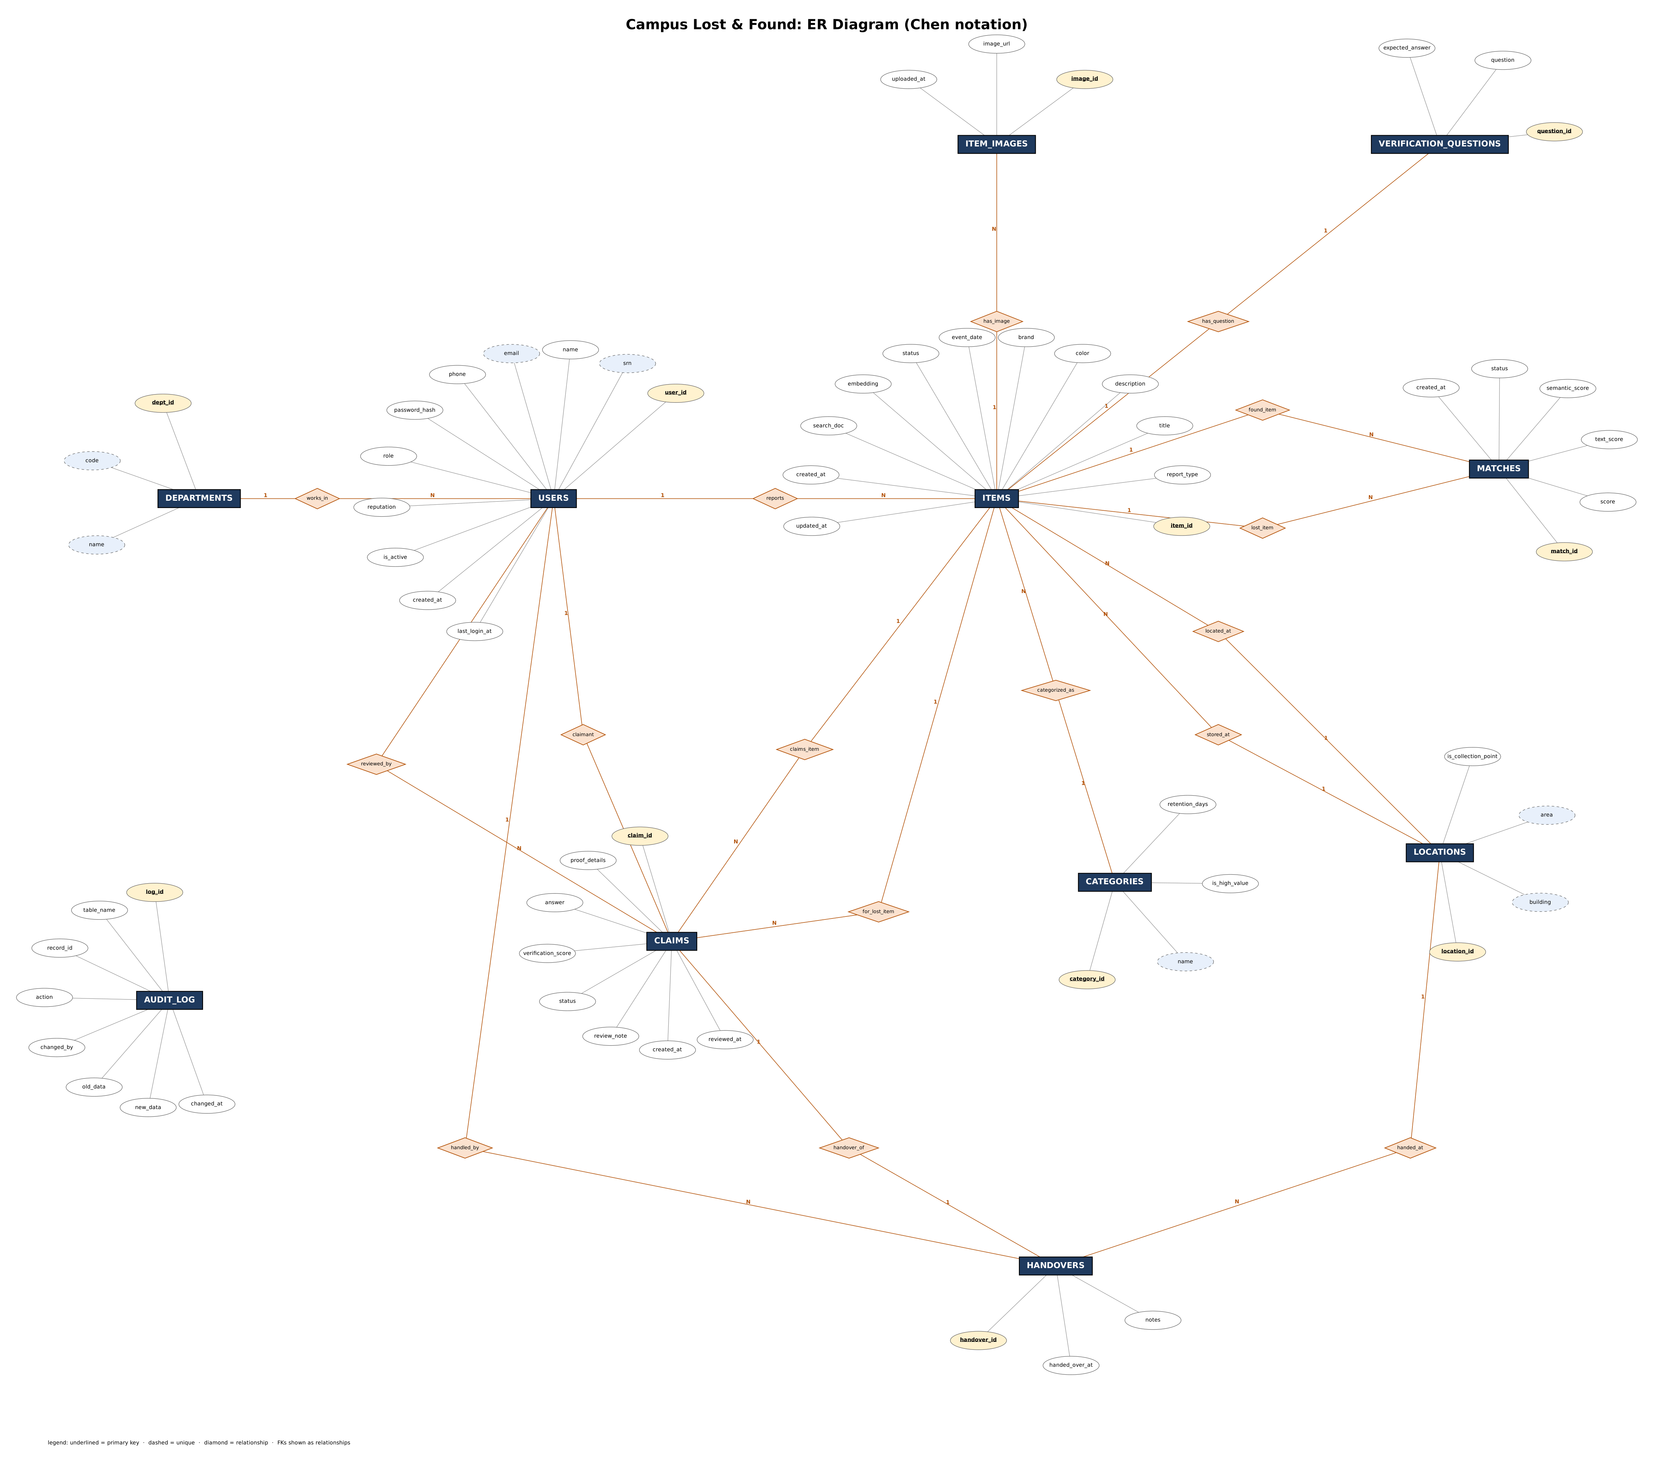
Figure 3.1: ER diagram of Campus Lost & Found (Chen notation)
Relationships and cardinality (16 relationships):
Relationship | Between | Cardinality
works_in | DEPARTMENTS - USERS | 1 : N
reports | USERS - ITEMS | 1 : N
categorized_as | CATEGORIES - ITEMS | 1 : N
located_at | LOCATIONS - ITEMS (where it was lost or found) | 1 : N
stored_at | LOCATIONS - ITEMS (collection point holding a found item) | 1 : N
has_image | ITEMS - ITEM_IMAGES | 1 : N
has_question | ITEMS - VERIFICATION_QUESTIONS | 1 : 1
lost_item | ITEMS - MATCHES (lost side) | 1 : N
found_item | ITEMS - MATCHES (found side) | 1 : N
claims_item | ITEMS - CLAIMS (the found item claimed) | 1 : N
for_lost_item | ITEMS - CLAIMS (the claimant's own lost report) | 1 : N
claimant | USERS - CLAIMS (who filed it) | 1 : N
reviewed_by | USERS - CLAIMS (staff who decided it) | 1 : N
handover_of | CLAIMS - HANDOVERS | 1 : 1
handled_by | USERS - HANDOVERS (staff) | 1 : N
handed_at | LOCATIONS - HANDOVERS | 1 : N

Relational Model
- List of Relations {label those that are not Entities in ER Model}
The ER model maps to 11 relations, one for each entity. Every relationship is 1:N or 1:1, so each one became a foreign key on the N side (or a foreign key with UNIQUE for 1:1). No extra relation was needed for an M:N relationship, so there are no relations that are not entities in the ER model. CLAIMS and MATCHES act as associative entities: they connect users and items, or two items, and have their own attributes.
Relation | Primary key | Foreign keys | Other keys
departments | dept_id | - | code, name unique
users | user_id | dept_id → departments | email, srn unique
categories | category_id | - | name unique
locations | location_id | - | (building, area) unique
items | item_id | reporter_id → users  category_id → categories  location_id → locations  storage_location_id → locations | -
item_images | image_id | item_id → items | -
verification_questions | question_id | item_id → items | item_id unique (1:1)
claims | claim_id | item_id → items  claimant_id → users  lost_item_id → items  reviewed_by → users | (item_id, claimant_id) unique; one approved claim per item
matches | match_id | lost_item_id → items  found_item_id → items | (lost_item_id, found_item_id) unique
handovers | handover_id | claim_id → claims  handled_by → users  location_id → locations | claim_id unique (1:1)
audit_log | log_id | none (keeps history after rows are deleted) | -

All relations are in third normal form: every non-key attribute depends only on the primary key. For example, a location's building and area are stored once in locations, and items only hold location_id.

Schema Diagram
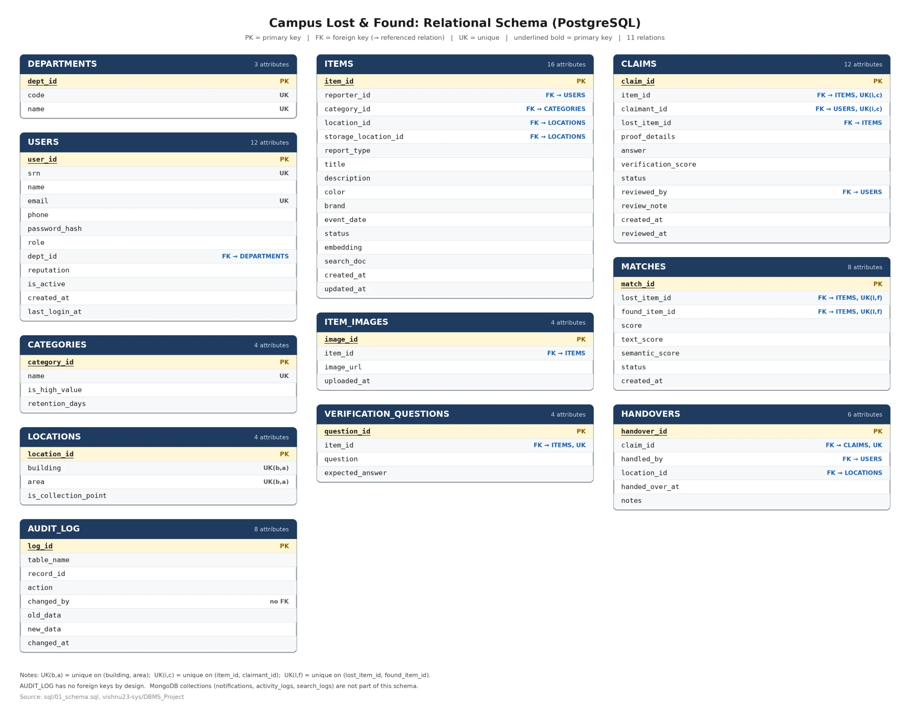
Figure 4.1: Relational schema with primary keys, foreign keys and unique constraints

SQL DDL Statements
The schema is created by four SQL files, run in order by npm run db:setup. The full source of the DDL files is given below, followed by the execution logs.
- sql/01_schema.sql: DROP, CREATE TABLE for all 11 tables with primary keys, foreign keys (with ON DELETE rules), NOT NULL, UNIQUE, CHECK and DEFAULT constraints, 12 indexes (B-tree, GIN full-text, GIN trigram and a partial unique index) and two ALTER statements.
- sql/02_functions.sql: 5 functions, 4 stored procedures and 6 triggers.
- sql/03_views.sql: 5 views and 1 materialised view.
Execution log (npm run db:setup, 9 Nov 2026). It runs the DDL, loads the sample data, computes the embeddings and runs every report query once as a check:
Running sql/01_schema.sql ... ok
Running sql/02_functions.sql ... ok
Running sql/03_views.sql ... ok
Running sql/04_seed.sql ... ok
Embedded 44/44 items
report category_recovery: 9 rows
report department_summary: 6 rows
report location_hotspots: 10 rows
report monthly_trend: 5 rows
report claim_turnaround: 7 rows
report top_finders: 7 rows
report unclaimed_high_value: 1 rows
report suspicious_claimants: 1 rows
report match_quality: 2 rows
Postgres ready: { users: '19', items: '44', claims: '16', matches: '14' }
MongoDB ready: 320 search logs, 600 activity logs, 4 notifications
List of tables (\dt in psql):
List of tables
Schema | Name | Type | Owner
--------+------------------------+-------+-----------
public | audit_log | table | lostfound
public | categories | table | lostfound
public | claims | table | lostfound
public | departments | table | lostfound
public | handovers | table | lostfound
public | item_images | table | lostfound
public | items | table | lostfound
public | locations | table | lostfound
public | matches | table | lostfound
public | users | table | lostfound
public | verification_questions | table | lostfound
(11 rows)
Structure of one table (\d claims), showing the keys, constraints, indexes and triggers created by the DDL:
Table "public.claims"
Column | Type | Collation | Nullable | Default
--------------------+--------------------------+-----------+----------+------------------------------------------
claim_id | integer | | not null | nextval('claims_claim_id_seq'::regclass)
item_id | integer | | not null |
claimant_id | integer | | not null |
lost_item_id | integer | | |
proof_details | text | | not null |
answer | character varying(200) | | |
verification_score | numeric(4,3) | | |
status | character varying(10) | | not null | 'pending'::character varying
reviewed_by | integer | | |
review_note | text | | |
created_at | timestamp with time zone | | not null | now()
reviewed_at | timestamp with time zone | | |
Indexes:
"claims_pkey" PRIMARY KEY, btree (claim_id)
"idx_claims_claimant" btree (claimant_id)
"idx_claims_item_status" btree (item_id, status)
"uq_claim_once" UNIQUE CONSTRAINT, btree (item_id, claimant_id)
"ux_one_approved_claim" UNIQUE, btree (item_id) WHERE status::text = 'approved'::text
Check constraints:
"chk_claim_proof" CHECK (length(TRIM(BOTH FROM proof_details)) >= 10)
"chk_claim_review" CHECK ((status::text <> ALL (ARRAY['approved'::character varying, 'rejected'::character varying]::text[])) OR reviewed_by IS NOT NULL AND reviewed_at IS NOT NULL)
"chk_claim_score" CHECK (verification_score >= 0::numeric AND verification_score <= 1::numeric)
"chk_claim_status" CHECK (status::text = ANY (ARRAY['pending'::character varying, 'approved'::character varying, 'rejected'::character varying, 'withdrawn'::character varying]::text[]))
Foreign-key constraints:
"claims_claimant_id_fkey" FOREIGN KEY (claimant_id) REFERENCES users(user_id) ON DELETE CASCADE
"claims_item_id_fkey" FOREIGN KEY (item_id) REFERENCES items(item_id) ON DELETE CASCADE
"claims_lost_item_id_fkey" FOREIGN KEY (lost_item_id) REFERENCES items(item_id) ON DELETE SET NULL
"claims_reviewed_by_fkey" FOREIGN KEY (reviewed_by) REFERENCES users(user_id) ON DELETE SET NULL
Referenced by:
TABLE "handovers" CONSTRAINT "handovers_claim_id_fkey" FOREIGN KEY (claim_id) REFERENCES claims(claim_id) ON DELETE CASCADE
Triggers:
claims_audit AFTER INSERT OR DELETE OR UPDATE ON claims FOR EACH ROW EXECUTE FUNCTION trg_audit('claim_id')
claims_validate BEFORE INSERT ON claims FOR EACH ROW EXECUTE FUNCTION trg_validate_claim()
sql/01_schema.sql (tables, keys, constraints, indexes, ALTER):
-- =====================================================================
-- Campus Lost & Found | 01_schema.sql (DDL)
-- Tables, keys, constraints and indexes.
-- Re-runnable: drops everything first.
-- =====================================================================

CREATE EXTENSION IF NOT EXISTS pg_trgm; -- trigram similarity (fuzzy matching)

DROP VIEW IF EXISTS v_item_details, v_category_stats, v_location_hotspots,
v_department_stats, v_claim_turnaround CASCADE;
DROP MATERIALIZED VIEW IF EXISTS mv_monthly_trends CASCADE;
DROP TABLE IF EXISTS audit_log, handovers, matches, claims, verification_questions,
item_images, items, locations, categories, users, departments CASCADE;

-- ---------------------------------------------------------------------
-- 1. departments
-- ---------------------------------------------------------------------
CREATE TABLE departments (
dept_id SERIAL PRIMARY KEY,
code VARCHAR(10) NOT NULL UNIQUE,
name VARCHAR(80) NOT NULL UNIQUE
);

-- ---------------------------------------------------------------------
-- 2. users (roles: student | staff | admin)
-- ---------------------------------------------------------------------
CREATE TABLE users (
user_id SERIAL PRIMARY KEY,
srn VARCHAR(20) UNIQUE,
name VARCHAR(100) NOT NULL,
email VARCHAR(120) NOT NULL UNIQUE,
phone VARCHAR(15),
password_hash TEXT NOT NULL,
role VARCHAR(10) NOT NULL DEFAULT 'student',
dept_id INT REFERENCES departments(dept_id) ON DELETE SET NULL,
reputation INT NOT NULL DEFAULT 0,
is_active BOOLEAN NOT NULL DEFAULT TRUE,
created_at TIMESTAMPTZ NOT NULL DEFAULT now(),

CONSTRAINT chk_user_name CHECK (length(trim(name)) >= 2),
CONSTRAINT chk_user_email CHECK (email ~* '^[^@\s]+@[^@\s]+\.[^@\s]+$'),
CONSTRAINT chk_user_phone CHECK (phone IS NULL OR phone ~ '^[0-9+ -]{7,15}$'),
CONSTRAINT chk_user_role CHECK (role IN ('student', 'staff', 'admin')),
CONSTRAINT chk_reputation CHECK (reputation >= 0),
-- every student must have an SRN
CONSTRAINT chk_student_srn CHECK (role <> 'student' OR srn IS NOT NULL)
);

-- ---------------------------------------------------------------------
-- 3. categories (retention_days = how long an unclaimed report stays open)
-- ---------------------------------------------------------------------
CREATE TABLE categories (
category_id SERIAL PRIMARY KEY,
name VARCHAR(50) NOT NULL UNIQUE,
is_high_value BOOLEAN NOT NULL DEFAULT FALSE,
retention_days INT NOT NULL DEFAULT 30,
CONSTRAINT chk_retention CHECK (retention_days BETWEEN 7 AND 365)
);

-- ---------------------------------------------------------------------
-- 4. locations (collection points = where found items are stored)
-- ---------------------------------------------------------------------
CREATE TABLE locations (
location_id SERIAL PRIMARY KEY,
building VARCHAR(60) NOT NULL,
area VARCHAR(60) NOT NULL,
is_collection_point BOOLEAN NOT NULL DEFAULT FALSE,
CONSTRAINT uq_location UNIQUE (building, area)
);

-- ---------------------------------------------------------------------
-- 5. items (one row per lost OR found report)
-- status flow: pending -> open -> matched -> claimed -> returned
-- (or rejected by moderator / closed after retention)
-- ---------------------------------------------------------------------
CREATE TABLE items (
item_id SERIAL PRIMARY KEY,
reporter_id INT NOT NULL REFERENCES users(user_id) ON DELETE CASCADE,
category_id INT NOT NULL REFERENCES categories(category_id),
location_id INT NOT NULL REFERENCES locations(location_id),
storage_location_id INT REFERENCES locations(location_id),
report_type VARCHAR(5) NOT NULL,
title VARCHAR(120) NOT NULL,
description TEXT NOT NULL,
color VARCHAR(30),
brand VARCHAR(50),
event_date DATE NOT NULL,
status VARCHAR(10) NOT NULL DEFAULT 'pending',
embedding REAL[], -- 384-d sentence embedding
created_at TIMESTAMPTZ NOT NULL DEFAULT now(),
updated_at TIMESTAMPTZ NOT NULL DEFAULT now(),

-- full-text search document, maintained by Postgres itself
search_doc TSVECTOR GENERATED ALWAYS AS (
setweight(to_tsvector('english', coalesce(title, '')), 'A') ||
setweight(to_tsvector('english', coalesce(description, '') || ' ' ||
coalesce(brand, '') || ' ' ||
coalesce(color, '')), 'B')
) STORED,

CONSTRAINT chk_item_type CHECK (report_type IN ('lost', 'found')),
CONSTRAINT chk_item_title CHECK (length(trim(title)) >= 3),
CONSTRAINT chk_item_desc CHECK (length(trim(description)) >= 10),
CONSTRAINT chk_item_status CHECK (status IN ('pending', 'open', 'matched', 'claimed',
'returned', 'closed', 'rejected')),
CONSTRAINT chk_item_storage CHECK (report_type = 'found' OR storage_location_id IS NULL),
CONSTRAINT chk_embedding CHECK (embedding IS NULL OR array_length(embedding, 1) = 384)
);

-- ---------------------------------------------------------------------
-- 6. item_images
-- ---------------------------------------------------------------------
CREATE TABLE item_images (
image_id SERIAL PRIMARY KEY,
item_id INT NOT NULL REFERENCES items(item_id) ON DELETE CASCADE,
image_url TEXT NOT NULL,
uploaded_at TIMESTAMPTZ NOT NULL DEFAULT now(),
CONSTRAINT chk_image_url CHECK (image_url ~ '^(https?://|/)')
);

-- ---------------------------------------------------------------------
-- 7. verification_questions (finder sets a secret question about a found item;
-- only the true owner should know the answer)
-- ---------------------------------------------------------------------
CREATE TABLE verification_questions (
question_id SERIAL PRIMARY KEY,
item_id INT NOT NULL UNIQUE REFERENCES items(item_id) ON DELETE CASCADE,
question VARCHAR(200) NOT NULL,
expected_answer VARCHAR(200) NOT NULL,
CONSTRAINT chk_question CHECK (length(trim(question)) >= 5)
);

-- ---------------------------------------------------------------------
-- 8. claims (a user claims a FOUND item as theirs)
-- ---------------------------------------------------------------------
CREATE TABLE claims (
claim_id SERIAL PRIMARY KEY,
item_id INT NOT NULL REFERENCES items(item_id) ON DELETE CASCADE,
claimant_id INT NOT NULL REFERENCES users(user_id) ON DELETE CASCADE,
lost_item_id INT REFERENCES items(item_id) ON DELETE SET NULL,
proof_details TEXT NOT NULL,
answer VARCHAR(200),
verification_score NUMERIC(4, 3), -- auto-computed by trigger
status VARCHAR(10) NOT NULL DEFAULT 'pending',
reviewed_by INT REFERENCES users(user_id) ON DELETE SET NULL,
review_note TEXT,
created_at TIMESTAMPTZ NOT NULL DEFAULT now(),
reviewed_at TIMESTAMPTZ,

CONSTRAINT uq_claim_once UNIQUE (item_id, claimant_id),
CONSTRAINT chk_claim_status CHECK (status IN ('pending', 'approved', 'rejected', 'withdrawn')),
CONSTRAINT chk_claim_proof CHECK (length(trim(proof_details)) >= 10),
CONSTRAINT chk_claim_score CHECK (verification_score BETWEEN 0 AND 1),
CONSTRAINT chk_claim_review CHECK (status NOT IN ('approved', 'rejected')
OR (reviewed_by IS NOT NULL AND reviewed_at IS NOT NULL))
);

-- ---------------------------------------------------------------------
-- 9. matches (system-suggested lost <-> found pairs)
-- ---------------------------------------------------------------------
CREATE TABLE matches (
match_id SERIAL PRIMARY KEY,
lost_item_id INT NOT NULL REFERENCES items(item_id) ON DELETE CASCADE,
found_item_id INT NOT NULL REFERENCES items(item_id) ON DELETE CASCADE,
score NUMERIC(5, 4) NOT NULL,
text_score NUMERIC(5, 4) NOT NULL,
semantic_score NUMERIC(5, 4),
status VARCHAR(10) NOT NULL DEFAULT 'suggested',
created_at TIMESTAMPTZ NOT NULL DEFAULT now(),

CONSTRAINT uq_match UNIQUE (lost_item_id, found_item_id),
CONSTRAINT chk_match_pair CHECK (lost_item_id <> found_item_id),
CONSTRAINT chk_match_score CHECK (score BETWEEN 0 AND 1),
CONSTRAINT chk_match_status CHECK (status IN ('suggested', 'confirmed', 'dismissed'))
);

-- ---------------------------------------------------------------------
-- 10. handovers (physical return of an item after an approved claim)
-- ---------------------------------------------------------------------
CREATE TABLE handovers (
handover_id SERIAL PRIMARY KEY,
claim_id INT NOT NULL UNIQUE REFERENCES claims(claim_id) ON DELETE CASCADE,
handled_by INT NOT NULL REFERENCES users(user_id),
location_id INT NOT NULL REFERENCES locations(location_id),
handed_over_at TIMESTAMPTZ NOT NULL DEFAULT now(),
notes TEXT
);

-- ---------------------------------------------------------------------
-- 11. audit_log (filled automatically by triggers)
-- ---------------------------------------------------------------------
CREATE TABLE audit_log (
log_id BIGSERIAL PRIMARY KEY,
table_name VARCHAR(40) NOT NULL,
record_id INT NOT NULL,
action VARCHAR(6) NOT NULL,
changed_by INT, -- app user, from SET LOCAL app.user_id
old_data JSONB,
new_data JSONB,
changed_at TIMESTAMPTZ NOT NULL DEFAULT now(),
CONSTRAINT chk_audit_action CHECK (action IN ('INSERT', 'UPDATE', 'DELETE'))
);

-- ---------------------------------------------------------------------
-- Indexes
-- ---------------------------------------------------------------------
CREATE INDEX idx_items_status_type ON items (status, report_type);
CREATE INDEX idx_items_category ON items (category_id);
CREATE INDEX idx_items_location ON items (location_id);
CREATE INDEX idx_items_reporter ON items (reporter_id);
CREATE INDEX idx_items_event_date ON items (event_date DESC);
CREATE INDEX idx_items_search_doc ON items USING GIN (search_doc); -- full-text
CREATE INDEX idx_items_title_trgm ON items USING GIN (title gin_trgm_ops); -- fuzzy
CREATE INDEX idx_claims_item_status ON claims (item_id, status);
CREATE INDEX idx_claims_claimant ON claims (claimant_id);
CREATE INDEX idx_matches_found ON matches (found_item_id);
CREATE INDEX idx_audit_record ON audit_log (table_name, record_id);

-- at most ONE approved claim per item (partial unique index)
CREATE UNIQUE INDEX ux_one_approved_claim ON claims (item_id) WHERE status = 'approved';

-- ---------------------------------------------------------------------
-- ALTER demo: columns added after initial design
-- ---------------------------------------------------------------------
ALTER TABLE users ADD COLUMN last_login_at TIMESTAMPTZ;
ALTER TABLE items ADD CONSTRAINT chk_item_color CHECK (color IS NULL OR length(color) <= 30);
sql/02_functions.sql (functions, stored procedures, triggers):
-- =====================================================================
-- Campus Lost & Found | 02_functions.sql
-- Functions, stored procedures and triggers.
-- =====================================================================

-- ---------------------------------------------------------------------
-- cosine_similarity(a, b): similarity of two embedding vectors (-1 .. 1)
-- ---------------------------------------------------------------------
CREATE OR REPLACE FUNCTION cosine_similarity(a REAL[], b REAL[])
RETURNS DOUBLE PRECISION
LANGUAGE sql IMMUTABLE STRICT PARALLEL SAFE AS $$
SELECT CASE WHEN sqrt(sum(x * x)) * sqrt(sum(y * y)) = 0 THEN 0
ELSE sum(x * y) / (sqrt(sum(x * x)) * sqrt(sum(y * y))) END
FROM unnest(a::FLOAT8[], b::FLOAT8[]) AS t(x, y); -- float8 avoids REAL underflow
$$;

-- ---------------------------------------------------------------------
-- fn_find_matches(item): hybrid matching of a lost item against found
-- items (or the other way round).
-- text_score = trigram similarity + full-text rank
-- semantic_score = cosine similarity of AI embeddings (when present)
-- score = weighted mix + small bonuses for same place/colour/brand
-- Candidates must be the opposite report type, same category, still open,
-- and within the category's retention window.
-- ---------------------------------------------------------------------
CREATE OR REPLACE FUNCTION fn_find_matches(p_item_id INT, p_limit INT DEFAULT 5)
RETURNS TABLE (candidate_id INT, title VARCHAR, text_score NUMERIC,
semantic_score NUMERIC, score NUMERIC)
LANGUAGE sql STABLE AS $$
WITH src AS (
SELECT i.*,
lower(i.title || ' ' || coalesce(i.brand, '') || ' ' || coalesce(i.color, '')) AS label,
replace(plainto_tsquery('english', i.title || ' ' || coalesce(i.brand, ''))::text,
'&', '|') AS q_text,
c.retention_days
FROM items i JOIN categories c USING (category_id)
WHERE i.item_id = p_item_id
),
cand AS (
SELECT c.item_id, c.title,
similarity(s.label, lower(c.title || ' ' || coalesce(c.brand, '') || ' ' ||
coalesce(c.color, ''))) AS trigram,
CASE WHEN s.q_text = '' THEN 0
ELSE ts_rank(c.search_doc, s.q_text::tsquery, 32) END AS fts,
CASE WHEN s.embedding IS NOT NULL AND c.embedding IS NOT NULL
THEN cosine_similarity(s.embedding, c.embedding) END AS semantic,
(CASE WHEN c.location_id = s.location_id THEN 0.08 ELSE 0 END
+ CASE WHEN lower(c.color) = lower(s.color) THEN 0.04 ELSE 0 END
+ CASE WHEN lower(c.brand) = lower(s.brand) THEN 0.08 ELSE 0 END) AS bonus
FROM src s
JOIN items c
ON c.report_type <> s.report_type
AND c.category_id = s.category_id
AND c.status IN ('open', 'matched')
AND c.item_id <> s.item_id
AND abs(c.event_date - s.event_date) <= s.retention_days
-- an item cannot be found more than 2 days before it was lost
AND (CASE WHEN s.report_type = 'lost' THEN c.event_date - s.event_date
ELSE s.event_date - c.event_date END) >= -2
),
scored AS (
SELECT item_id, title,
LEAST(1, 0.6 * trigram + 0.4 * LEAST(1, fts * 3)) AS t_score,
semantic, bonus
FROM cand
)
SELECT item_id, title,
round(t_score::numeric, 4),
round(semantic::numeric, 4),
round(LEAST(1, GREATEST(0,
CASE WHEN semantic IS NULL THEN t_score
ELSE 0.65 * semantic + 0.35 * t_score END + bonus))::numeric, 4) AS score
FROM scored
ORDER BY score DESC
LIMIT p_limit;
$$;

-- ---------------------------------------------------------------------
-- sp_refresh_matches(item): store suggestions above a threshold and
-- mark both sides as 'matched'.
-- ---------------------------------------------------------------------
CREATE OR REPLACE PROCEDURE sp_refresh_matches(p_item_id INT, p_threshold NUMERIC DEFAULT 0.50)
LANGUAGE plpgsql AS $$
DECLARE
v_type VARCHAR(5);
BEGIN
SELECT report_type INTO v_type FROM items WHERE item_id = p_item_id;
IF NOT FOUND THEN
RAISE EXCEPTION 'Item % does not exist', p_item_id;
END IF;

INSERT INTO matches (lost_item_id, found_item_id, score, text_score, semantic_score)
SELECT CASE WHEN v_type = 'lost' THEN p_item_id ELSE m.candidate_id END,
CASE WHEN v_type = 'lost' THEN m.candidate_id ELSE p_item_id END,
m.score, m.text_score, m.semantic_score
FROM fn_find_matches(p_item_id, 10) m
WHERE m.score >= p_threshold
ON CONFLICT (lost_item_id, found_item_id) DO UPDATE
SET score = EXCLUDED.score,
text_score = EXCLUDED.text_score,
semantic_score = EXCLUDED.semantic_score
WHERE matches.status = 'suggested';

UPDATE items SET status = 'matched'
WHERE status = 'open'
AND item_id IN (SELECT lost_item_id FROM matches
WHERE status = 'suggested' AND p_item_id IN (lost_item_id, found_item_id)
UNION
SELECT found_item_id FROM matches
WHERE status = 'suggested' AND p_item_id IN (lost_item_id, found_item_id));
END;
$$;

-- ---------------------------------------------------------------------
-- sp_approve_claim: one atomic unit of work
-- approve claim -> reject competing claims -> mark items claimed
-- -> confirm/dismiss matches. Any error rolls everything back.
-- ---------------------------------------------------------------------
CREATE OR REPLACE PROCEDURE sp_approve_claim(p_claim_id INT, p_reviewer_id INT, p_note TEXT DEFAULT NULL)
LANGUAGE plpgsql AS $$
DECLARE
v_claim claims%ROWTYPE;
v_role VARCHAR(10);
BEGIN
SELECT role INTO v_role FROM users WHERE user_id = p_reviewer_id AND is_active;
IF v_role IS NULL OR v_role NOT IN ('staff', 'admin') THEN
RAISE EXCEPTION 'User % is not allowed to review claims', p_reviewer_id;
END IF;

SELECT * INTO v_claim FROM claims WHERE claim_id = p_claim_id FOR UPDATE;
IF NOT FOUND THEN
RAISE EXCEPTION 'Claim % does not exist', p_claim_id;
END IF;
IF v_claim.status <> 'pending' THEN
RAISE EXCEPTION 'Claim % is already %', p_claim_id, v_claim.status;
END IF;

PERFORM 1 FROM items WHERE item_id = v_claim.item_id FOR UPDATE; -- lock the item

UPDATE claims
SET status = 'approved', reviewed_by = p_reviewer_id, reviewed_at = now(), review_note = p_note
WHERE claim_id = p_claim_id;

UPDATE claims
SET status = 'rejected', reviewed_by = p_reviewer_id, reviewed_at = now(),
review_note = 'Another claim for this item was approved'
WHERE item_id = v_claim.item_id AND claim_id <> p_claim_id AND status = 'pending';

UPDATE items SET status = 'claimed'
WHERE item_id IN (v_claim.item_id, v_claim.lost_item_id)
AND status IN ('open', 'matched');

UPDATE matches SET status = 'confirmed'
WHERE found_item_id = v_claim.item_id AND lost_item_id = v_claim.lost_item_id;

UPDATE matches SET status = 'dismissed'
WHERE found_item_id = v_claim.item_id AND status = 'suggested';
END;
$$;

CREATE OR REPLACE PROCEDURE sp_reject_claim(p_claim_id INT, p_reviewer_id INT, p_note TEXT DEFAULT NULL)
LANGUAGE plpgsql AS $$
BEGIN
IF NOT EXISTS (SELECT 1 FROM users WHERE user_id = p_reviewer_id AND is_active
AND role IN ('staff', 'admin')) THEN
RAISE EXCEPTION 'User % is not allowed to review claims', p_reviewer_id;
END IF;

UPDATE claims
SET status = 'rejected', reviewed_by = p_reviewer_id, reviewed_at = now(), review_note = p_note
WHERE claim_id = p_claim_id AND status = 'pending';
IF NOT FOUND THEN
RAISE EXCEPTION 'Claim % is not pending', p_claim_id;
END IF;
END;
$$;

-- ---------------------------------------------------------------------
-- sp_record_handover: item physically returned to its owner.
-- Finder earns +10 reputation (honesty points).
-- ---------------------------------------------------------------------
CREATE OR REPLACE PROCEDURE sp_record_handover(p_claim_id INT, p_staff_id INT,
p_location_id INT, p_notes TEXT DEFAULT NULL)
LANGUAGE plpgsql AS $$
DECLARE
v_claim claims%ROWTYPE;
BEGIN
SELECT * INTO v_claim FROM claims WHERE claim_id = p_claim_id FOR UPDATE;
IF NOT FOUND OR v_claim.status <> 'approved' THEN
RAISE EXCEPTION 'Claim % is not approved', p_claim_id;
END IF;
IF NOT EXISTS (SELECT 1 FROM users WHERE user_id = p_staff_id AND role IN ('staff', 'admin')) THEN
RAISE EXCEPTION 'User % cannot record handovers', p_staff_id;
END IF;

INSERT INTO handovers (claim_id, handled_by, location_id, notes)
VALUES (p_claim_id, p_staff_id, p_location_id, p_notes);

UPDATE items SET status = 'returned'
WHERE item_id IN (v_claim.item_id, v_claim.lost_item_id) AND status = 'claimed';

UPDATE users SET reputation = reputation + 10
WHERE user_id = (SELECT reporter_id FROM items WHERE item_id = v_claim.item_id);
END;
$$;

-- ---------------------------------------------------------------------
-- fn_expire_stale_items(): close reports older than their category's
-- retention period. Returns how many were closed.
-- ---------------------------------------------------------------------
CREATE OR REPLACE FUNCTION fn_expire_stale_items()
RETURNS INT LANGUAGE plpgsql AS $$
DECLARE
v_count INT;
BEGIN
UPDATE items i SET status = 'closed'
FROM categories c
WHERE c.category_id = i.category_id
AND i.status IN ('open', 'matched')
AND i.event_date < CURRENT_DATE - c.retention_days;
GET DIAGNOSTICS v_count = ROW_COUNT;
RETURN v_count;
END;
$$;

-- =====================================================================
-- TRIGGERS
-- =====================================================================

-- keep items.updated_at current
CREATE OR REPLACE FUNCTION trg_set_updated_at()
RETURNS TRIGGER LANGUAGE plpgsql AS $$
BEGIN
NEW.updated_at := now();
RETURN NEW;
END;
$$;

CREATE TRIGGER items_set_updated_at
BEFORE UPDATE ON items
FOR EACH ROW EXECUTE FUNCTION trg_set_updated_at();

-- validate items: no future dates, storage must be a collection point,
-- and only legal status transitions are allowed
CREATE OR REPLACE FUNCTION trg_validate_item()
RETURNS TRIGGER LANGUAGE plpgsql AS $$
BEGIN
IF NEW.event_date > CURRENT_DATE THEN
RAISE EXCEPTION 'event_date (%) cannot be in the future', NEW.event_date;
END IF;

IF NEW.storage_location_id IS NOT NULL AND NOT EXISTS (
SELECT 1 FROM locations WHERE location_id = NEW.storage_location_id AND is_collection_point) THEN
RAISE EXCEPTION 'Location % is not a collection point', NEW.storage_location_id;
END IF;

IF TG_OP = 'UPDATE' AND NEW.status <> OLD.status AND NOT (
(OLD.status = 'pending' AND NEW.status IN ('open', 'rejected'))
OR (OLD.status = 'open' AND NEW.status IN ('matched', 'claimed', 'closed', 'rejected'))
OR (OLD.status = 'matched' AND NEW.status IN ('open', 'claimed', 'closed'))
OR (OLD.status = 'claimed' AND NEW.status IN ('returned', 'open'))
OR (OLD.status = 'closed' AND NEW.status = 'open')) THEN
RAISE EXCEPTION 'Illegal status change % -> % for item %', OLD.status, NEW.status, OLD.item_id;
END IF;

RETURN NEW;
END;
$$;

CREATE TRIGGER items_validate
BEFORE INSERT OR UPDATE ON items
FOR EACH ROW EXECUTE FUNCTION trg_validate_item();

-- validate claims + auto-compute the verification score
CREATE OR REPLACE FUNCTION trg_validate_claim()
RETURNS TRIGGER LANGUAGE plpgsql AS $$
DECLARE
v_item items%ROWTYPE;
v_expected VARCHAR(200);
BEGIN
SELECT * INTO v_item FROM items WHERE item_id = NEW.item_id;

IF v_item.report_type <> 'found' THEN
RAISE EXCEPTION 'Only found items can be claimed';
END IF;
IF v_item.status NOT IN ('open', 'matched') THEN
RAISE EXCEPTION 'Item % is % and cannot be claimed', NEW.item_id, v_item.status;
END IF;
IF v_item.reporter_id = NEW.claimant_id THEN
RAISE EXCEPTION 'You cannot claim an item you reported as found';
END IF;
IF NEW.lost_item_id IS NOT NULL AND NOT EXISTS (
SELECT 1 FROM items WHERE item_id = NEW.lost_item_id
AND report_type = 'lost' AND reporter_id = NEW.claimant_id) THEN
RAISE EXCEPTION 'Linked lost report must be your own lost report';
END IF;

SELECT expected_answer INTO v_expected FROM verification_questions WHERE item_id = NEW.item_id;
IF v_expected IS NOT NULL AND NEW.answer IS NOT NULL THEN
NEW.verification_score := round(GREATEST(
similarity(lower(NEW.answer), lower(v_expected)),
word_similarity(lower(v_expected), lower(NEW.answer)))::numeric, 3);
END IF;

RETURN NEW;
END;
$$;

CREATE TRIGGER claims_validate
BEFORE INSERT ON claims
FOR EACH ROW EXECUTE FUNCTION trg_validate_claim();

-- generic audit trigger: TG_ARGV[0] = primary key column
CREATE OR REPLACE FUNCTION trg_audit()
RETURNS TRIGGER LANGUAGE plpgsql AS $$
DECLARE
v_old JSONB := CASE WHEN TG_OP <> 'INSERT' THEN to_jsonb(OLD) END;
v_new JSONB := CASE WHEN TG_OP <> 'DELETE' THEN to_jsonb(NEW) END;
BEGIN
-- never copy secrets or large columns into the log
v_old := v_old - 'password_hash' - 'embedding' - 'search_doc';
v_new := v_new - 'password_hash' - 'embedding' - 'search_doc';

-- skip updates that only touched ignored columns
IF TG_OP = 'UPDATE' AND v_old - 'updated_at' = v_new - 'updated_at' THEN
RETURN NULL;
END IF;

INSERT INTO audit_log (table_name, record_id, action, changed_by, old_data, new_data)
VALUES (TG_TABLE_NAME,
(COALESCE(v_new, v_old) ->> TG_ARGV[0])::INT,
TG_OP,
NULLIF(current_setting('app.user_id', TRUE), '')::INT,
v_old, v_new);
RETURN NULL;
END;
$$;

CREATE TRIGGER items_audit AFTER INSERT OR UPDATE OR DELETE ON items
FOR EACH ROW EXECUTE FUNCTION trg_audit('item_id');
CREATE TRIGGER claims_audit AFTER INSERT OR UPDATE OR DELETE ON claims
FOR EACH ROW EXECUTE FUNCTION trg_audit('claim_id');
CREATE TRIGGER users_audit AFTER UPDATE OR DELETE ON users
FOR EACH ROW EXECUTE FUNCTION trg_audit('user_id');
sql/03_views.sql (views and materialised view):
-- =====================================================================
-- Campus Lost & Found | 03_views.sql
-- Views used by the app and by the report pages.
-- =====================================================================

-- one denormalised row per item, for listing pages
CREATE OR REPLACE VIEW v_item_details AS
SELECT i.item_id, i.report_type, i.title, i.description, i.color, i.brand,
i.event_date, i.status, i.created_at, i.updated_at,
i.reporter_id, u.name AS reporter_name, u.role AS reporter_role,
c.category_id, c.name AS category, c.is_high_value,
l.location_id, l.building, l.area,
s.building || ' - ' || s.area AS stored_at,
(SELECT image_url FROM item_images im
WHERE im.item_id = i.item_id ORDER BY image_id LIMIT 1) AS cover_image,
(i.embedding IS NOT NULL) AS has_embedding
FROM items i
JOIN users u ON u.user_id = i.reporter_id
JOIN categories c ON c.category_id = i.category_id
JOIN locations l ON l.location_id = i.location_id
LEFT JOIN locations s ON s.location_id = i.storage_location_id;

-- recovery rate per category
CREATE OR REPLACE VIEW v_category_stats AS
SELECT c.category_id, c.name AS category,
COUNT(i.item_id) FILTER (WHERE i.report_type = 'lost') AS lost_reports,
COUNT(i.item_id) FILTER (WHERE i.report_type = 'found') AS found_reports,
COUNT(i.item_id) FILTER (WHERE i.report_type = 'lost' AND i.status = 'returned') AS recovered,
ROUND(100.0 * COUNT(i.item_id) FILTER (WHERE i.report_type = 'lost' AND i.status = 'returned')
/ NULLIF(COUNT(i.item_id) FILTER (WHERE i.report_type = 'lost'), 0), 1) AS recovery_rate_pct
FROM categories c
LEFT JOIN items i ON i.category_id = c.category_id AND i.status NOT IN ('pending', 'rejected')
GROUP BY c.category_id, c.name;

-- where things get lost / found most
CREATE OR REPLACE VIEW v_location_hotspots AS
SELECT l.location_id, l.building, l.area,
COUNT(*) FILTER (WHERE i.report_type = 'lost') AS lost_count,
COUNT(*) FILTER (WHERE i.report_type = 'found') AS found_count,
COUNT(*) AS total_reports
FROM locations l
JOIN items i ON i.location_id = l.location_id AND i.status NOT IN ('pending', 'rejected')
GROUP BY l.location_id, l.building, l.area;

-- per department: how many students lose things, how fast they get them back
CREATE OR REPLACE VIEW v_department_stats AS
SELECT d.dept_id, d.code, d.name AS department,
COUNT(DISTINCT u.user_id) AS students,
COUNT(i.item_id) AS lost_reports,
COUNT(h.handover_id) AS recovered,
ROUND(AVG(EXTRACT(EPOCH FROM (h.handed_over_at - i.created_at)) / 86400)::numeric, 1)
AS avg_days_to_recover
FROM departments d
LEFT JOIN users u ON u.dept_id = d.dept_id AND u.role = 'student'
LEFT JOIN items i ON i.reporter_id = u.user_id AND i.report_type = 'lost'
AND i.status NOT IN ('pending', 'rejected')
LEFT JOIN claims cl ON cl.lost_item_id = i.item_id AND cl.status = 'approved'
LEFT JOIN handovers h ON h.claim_id = cl.claim_id
GROUP BY d.dept_id, d.code, d.name;

-- time between a claim being filed and being decided
CREATE OR REPLACE VIEW v_claim_turnaround AS
SELECT cl.claim_id, cl.status, c.name AS category,
cl.created_at, cl.reviewed_at,
ROUND((EXTRACT(EPOCH FROM (cl.reviewed_at - cl.created_at)) / 3600)::numeric, 1) AS hours_to_decision
FROM claims cl
JOIN items i ON i.item_id = cl.item_id
JOIN categories c ON c.category_id = i.category_id
WHERE cl.reviewed_at IS NOT NULL;

-- monthly lost vs found trend (materialised: refresh with
-- REFRESH MATERIALIZED VIEW mv_monthly_trends;)
CREATE MATERIALIZED VIEW mv_monthly_trends AS
SELECT date_trunc('month', event_date)::date AS month,
COUNT(*) FILTER (WHERE report_type = 'lost') AS lost,
COUNT(*) FILTER (WHERE report_type = 'found') AS found,
COUNT(*) FILTER (WHERE status = 'returned') AS returned
FROM items
WHERE status NOT IN ('pending', 'rejected')
GROUP BY 1
ORDER BY 1;

SQL DML Statements
DML is used throughout the application, always with parameterised queries ($1, $2, ...) to prevent SQL injection. Two examples from the API layer:
Reporting an item (app/api/items/route.js), inside a transaction:
INSERT INTO items (reporter_id, category_id, location_id, storage_location_id, report_type,
title, description, color, brand, event_date, status)
VALUES ($1, $2, $3, $4, $5, $6, $7, $8, $9, $10, $11)
RETURNING item_id;
Approving a claim (app/api/claims/[id]/route.js), which calls a stored procedure inside a transaction:
BEGIN;
SELECT set_config('app.user_id', $1, true); -- acting user, for the audit trigger
CALL sp_approve_claim($claimId, $reviewerId, $note);
COMMIT; -- or ROLLBACK if any step fails
The report queries are in sql/05_reports.sql (see Section 8 for their results). The demonstration queries in sql/06_demo_queries.sql cover each kind of operation:
Section | What it shows
1 | INSERT, UPDATE and DELETE with RETURNING
2 | INNER JOIN across four tables
3 | GROUP BY, HAVING, ORDER BY with COUNT and AVG (lost reports per department)
4 | Correlated subquery (users with more reports than average) and nested NOT EXISTS (found items with no claim)
5 | Querying views and refreshing the materialised view
6 | Full-text search, trigram (typo-tolerant) search and EXPLAIN showing the GIN index
7 | The hybrid matching function
8 | Statements that the triggers and CHECK constraints reject on purpose
9 | A transaction calling a stored procedure, then ROLLBACK
10 | The audit trail written by triggers
11 | ALTER and DROP
12 | A recursive CTE listing reports per day for the last 14 days, including days with none

Execution log of sql/06_demo_queries.sql (run with psql -e, so each statement is printed before its result). The ERROR lines in section 8 are expected: they show the database rejecting invalid data.
INSERT INTO locations (building, area) VALUES ('Hostel', 'Common Room') RETURNING *;
location_id | building | area | is_collection_point
-------------+----------+-------------+---------------------
15 | Hostel | Common Room | f
(1 row)

INSERT 0 1
UPDATE locations SET area = 'TV Room' WHERE building = 'Hostel' AND area = 'Common Room' RETURNING *;
location_id | building | area | is_collection_point
-------------+----------+---------+---------------------
15 | Hostel | TV Room | f
(1 row)

UPDATE 1
DELETE FROM locations WHERE building = 'Hostel' RETURNING *;
location_id | building | area | is_collection_point
-------------+----------+---------+---------------------
15 | Hostel | TV Room | f
(1 row)

DELETE 1
SELECT i.item_id, i.report_type, i.title, u.name AS reporter, c.name AS category,
l.building || ' - ' || l.area AS place
FROM items i
JOIN users u ON u.user_id = i.reporter_id
JOIN categories c ON c.category_id = i.category_id
JOIN locations l ON l.location_id = i.location_id
WHERE i.status IN ('open', 'matched')
ORDER BY i.event_date DESC;
item_id | report_type | title | reporter | category | place
---------+-------------+----------------------+--------------+-----------------+------------------------
33 | lost | Samsung Galaxy M34 b.| Siddharth Ra.| Electronics | Food Court - Coffee Co.
| |.lue phone |.o | |.unter
32 | found | Samsung phone with c.| Ishita Das | Electronics | Food Court - Seating A.
| |.racked screen | | |.rea
25 | found | ID cards in a transp.| Lakshmi (Lib.| ID Cards & Docu.| Main Library - Help De.
| |.arent cover |.rary) |.ments |.sk
24 | lost | Aadhaar and college .| Sneha Kulkar.| ID Cards & Docu.| Main Library - Ground .
| |.ID in plastic cover |.ni |.ments |.Floor
20 | found | White Apple earbuds .| Meera Iyer | Electronics | Food Court - Seating A.
| |.case | | |.rea
19 | lost | AirPods Pro case | Ananya Rao | Electronics | Food Court - Coffee Co.
| | | | |.unter
18 | found | Grey backpack found .| Siddharth Ra.| Bags & Backpack.| Auditorium - Main Hall
| |.in auditorium |.o |.s |
30 | found | Black analog wrist w.| Fatima Khan | Clothing & Acce.| BE Block - Classroom 4.
| |.atch | |.ssories |.01
17 | lost | Grey Wildcraft backp.| Vishnu Patru.| Bags & Backpack.| Auditorium - Main Hall
| |.ack |.ni |.s |
31 | lost | Titan watch black st.| Nikhil Varma | Clothing & Acce.| BE Block - Classroom 4.
| |.rap | |.ssories |.01
28 | found | Steel water bottle w.| Aditya Joshi | Water Bottles | Food Court - Seating A.
| |.ith stickers | | |.rea
21 | lost | Silver ring | Karthik Redd.| Clothing & Acce.| Sports Complex - Baske.
| | |.y |.ssories |.tball Court
23 | found | Black hoodie left on.| Priya Sharma | Clothing & Acce.| Sports Complex - Gym
| |. gym bench | |.ssories |
22 | lost | Black hoodie with co.| Pravith Moha.| Clothing & Acce.| Sports Complex - Gym
| |.llege logo |.ndas |.ssories |
35 | found | Red pencil pouch wit.| Vishnu Patru.| Stationery & Ca.| BE Block - Classroom 4.
| |.h pens |.ni |.lculators |.01
26 | lost | Lenovo wireless mous.| Divya Shetty | Electronics | BE Block - Classroom 4.
| |.e | | |.01
27 | lost | Physics lab record n.| Arjun Nair | Books & Notes | MRD Block - Lab 3
| |.otebook | | |
34 | lost | Purple umbrella | Rahul Menon | Clothing & Acce.| Main Library - Ground .
| | | |.ssories |.Floor
37 | found | boAt smartwatch | Arjun Nair | Electronics | Sports Complex - Baske.
| | | | |.tball Court
29 | lost | Hyundai car keys | Rohan Gupta | Keys | Parking - Two-wheeler .
| | | | |.Parking
36 | lost | Spectacles in black .| Meera Iyer | Clothing & Acce.| Main Library - Reading.
| |.case | |.ssories |. Hall
38 | found | Bunch of three keys | Rohan Gupta | Keys | Food Court - Coffee Co.
| | | | |.unter
(22 rows)

SELECT d.name AS department,
COUNT(i.item_id) AS lost_reports,
ROUND(AVG(CURRENT_DATE - i.event_date), 1) AS avg_age_days
FROM departments d
JOIN users u ON u.dept_id = d.dept_id
JOIN items i ON i.reporter_id = u.user_id AND i.report_type = 'lost'
GROUP BY d.name
HAVING COUNT(i.item_id) >= 2
ORDER BY lost_reports DESC;
department | lost_reports | avg_age_days
----------------------------------+--------------+--------------
CSE (AI & ML) | 7 | 36.1
Computer Science and Engineering | 5 | 28.8
Electronics and Communication | 4 | 38.5
Biotechnology | 3 | 39.0
Electrical and Electronics | 3 | 18.7
Mechanical Engineering | 3 | 46.0
(6 rows)

SELECT u.name, (SELECT COUNT(*) FROM items i WHERE i.reporter_id = u.user_id) AS reports
FROM users u
WHERE u.role = 'student'
AND (SELECT COUNT(*) FROM items i WHERE i.reporter_id = u.user_id) >
(SELECT AVG(cnt) FROM (SELECT COUNT(*) AS cnt FROM items GROUP BY reporter_id) t);
name | reports
----------------+---------
Vishnu Patruni | 3
Ananya Rao | 3
Karthik Reddy | 3
Arjun Nair | 3
Rohan Gupta | 3
Ishita Das | 3
Meera Iyer | 3
Priya Sharma | 3
Aditya Joshi | 3
Fatima Khan | 3
(10 rows)

SELECT item_id, title FROM items f
WHERE f.report_type = 'found' AND f.status IN ('open', 'matched')
AND NOT EXISTS (SELECT 1 FROM claims c WHERE c.item_id = f.item_id);
item_id | title
---------+-----------------------------------
30 | Black analog wrist watch
32 | Samsung phone with cracked screen
25 | ID cards in a transparent cover
38 | Bunch of three keys
28 | Steel water bottle with stickers
35 | Red pencil pouch with pens
37 | boAt smartwatch
(7 rows)

SELECT * FROM v_category_stats ORDER BY recovery_rate_pct DESC NULLS LAST;
category_id | category | lost_reports | found_reports | recovered | recovery_rate_pct
-------------+--------------------------+--------------+---------------+-----------+-------------------
9 | Stationery & Calculators | 1 | 2 | 1 | 100.0
5 | Keys | 2 | 2 | 1 | 50.0
2 | ID Cards & Documents | 2 | 2 | 1 | 50.0
6 | Water Bottles | 2 | 2 | 1 | 50.0
3 | Wallets & Purses | 2 | 1 | 1 | 50.0
1 | Electronics | 6 | 5 | 2 | 33.3
4 | Bags & Backpacks | 1 | 1 | 0 | 0.0
7 | Books & Notes | 2 | 1 | 0 | 0.0
8 | Clothing & Accessories | 5 | 2 | 0 | 0.0
(9 rows)

SELECT * FROM v_location_hotspots ORDER BY total_reports DESC LIMIT 5;
location_id | building | area | lost_count | found_count | total_reports
-------------+----------------+---------------------+------------+-------------+---------------
3 | Food Court | Seating Area | 2 | 4 | 6
6 | BE Block | Classroom 401 | 3 | 3 | 6
10 | Parking | Two-wheeler Parking | 3 | 2 | 5
4 | Food Court | Coffee Counter | 3 | 1 | 4
7 | Sports Complex | Gym | 2 | 2 | 4
(5 rows)

REFRESH MATERIALIZED VIEW mv_monthly_trends;
REFRESH MATERIALIZED VIEW
SELECT * FROM mv_monthly_trends;
month | lost | found | returned
------------+------+-------+----------
2026-07-01 | 1 | 1 | 2
2026-08-01 | 4 | 3 | 6
2026-09-01 | 5 | 3 | 6
2026-10-01 | 7 | 5 | 0
2026-11-01 | 6 | 6 | 0
(5 rows)

SELECT item_id, title, ts_rank(search_doc, q) AS rank
FROM items, websearch_to_tsquery('english', 'black headphones') q
WHERE search_doc @@ q
ORDER BY rank DESC;
item_id | title | rank
---------+-------------------------------+-----------
2 | Black JBL wireless headphones | 0.9958675
1 | JBL Tune 510 headphones | 0.7813044
(2 rows)

SELECT item_id, title, similarity(title, 'samsng fone') AS sim -- typo-tolerant
FROM items
WHERE title % 'samsng fone' OR similarity(title, 'samsng fone') > 0.15
ORDER BY sim DESC;
item_id | title | sim
---------+-----------------------------------+------------
33 | Samsung Galaxy M34 blue phone | 0.2
32 | Samsung phone with cracked screen | 0.18421052
(2 rows)

SET enable_seqscan = off;
SET
EXPLAIN SELECT * FROM items WHERE search_doc @@ websearch_to_tsquery('english', 'wallet');
QUERY PLAN
------------------------------------------------------------------------------------
Bitmap Heap Scan on items (cost=29.80..33.81 rows=1 width=652)
Recheck Cond: (search_doc @@ '''wallet'''::tsquery)
-> Bitmap Index Scan on idx_items_search_doc (cost=0.00..29.80 rows=1 width=0)
Index Cond: (search_doc @@ '''wallet'''::tsquery)
(4 rows)

RESET enable_seqscan;
RESET
SELECT * FROM fn_find_matches(17);
candidate_id | title | text_score | semantic_score | score
--------------+-----------------------------------+------------+----------------+--------
18 | Grey backpack found in auditorium | 0.7209 | 0.8700 | 1.0000
(1 row)

SELECT * FROM fn_find_matches(24);
candidate_id | title | text_score | semantic_score | score
--------------+---------------------------------+------------+----------------+--------
25 | ID cards in a transparent cover | 0.4131 | 0.6072 | 0.5392
(1 row)

INSERT INTO items (reporter_id, category_id, location_id, report_type, title, description, event_date)
VALUES (4, 1, 1, 'lost', 'Time machine', 'Lost it next week apparently', CURRENT_DATE + 7);
psql:sql/06_demo_queries.sql:93: ERROR: event_date (2026-11-16) cannot be in the future
CONTEXT: PL/pgSQL function trg_validate_item() line 4 at RAISE
UPDATE items SET status = 'open' WHERE item_id = 2;
psql:sql/06_demo_queries.sql:96: ERROR: Illegal status change returned -> open for item 2
CONTEXT: PL/pgSQL function trg_validate_item() line 18 at RAISE
INSERT INTO claims (item_id, claimant_id, proof_details) VALUES (18, 19, 'I found it so it is mine');
psql:sql/06_demo_queries.sql:99: ERROR: You cannot claim an item you reported as found
CONTEXT: PL/pgSQL function trg_validate_claim() line 15 at RAISE
INSERT INTO users (name, email, password_hash, role) VALUES ('Xavier', 'not-an-email', 'h', 'staff');
psql:sql/06_demo_queries.sql:102: ERROR: new row for relation "users" violates check constraint "chk_user_email"
DETAIL: Failing row contains (21, null, Xavier, not-an-email, null, h, staff, null, 0, t, 2026-11-09 10:46:52.01778+05:30, null).
BEGIN;
BEGIN
SELECT set_config('app.user_id', '2', true);
set_config
------------
2
(1 row)

CALL sp_approve_claim(13, 2, 'Demo approval');
CALL
SELECT claim_id, status FROM claims WHERE item_id = 18;
claim_id | status
----------+----------
13 | approved
(1 row)

SELECT item_id, status FROM items WHERE item_id IN (17, 18);
item_id | status
---------+---------
18 | claimed
17 | claimed
(2 rows)

ROLLBACK;
ROLLBACK
SELECT claim_id, status FROM claims WHERE item_id = 18;
claim_id | status
----------+---------
13 | pending
(1 row)

BEGIN;
BEGIN
CALL sp_approve_claim(1, 2);
psql:sql/06_demo_queries.sql:117: ERROR: Claim 1 is already approved
CONTEXT: PL/pgSQL function sp_approve_claim(integer,integer,text) line 16 at RAISE
ROLLBACK;
ROLLBACK
SELECT log_id, table_name, record_id, action, changed_by,
old_data ->> 'status' AS old_status, new_data ->> 'status' AS new_status, changed_at
FROM audit_log ORDER BY log_id DESC LIMIT 10;
log_id | table_name | record_id | action | changed_by | old_status | new_status | changed_at
--------+------------+-----------+--------+------------+------------+------------+----------------------
137 | items | 24 | UPDATE | | open | matched | 2026-11-09 10:46:29..
| | | | | | |.634035+05:30
136 | items | 25 | UPDATE | | open | matched | 2026-11-09 10:46:29..
| | | | | | |.634035+05:30
135 | users | 17 | UPDATE | | | | 2026-11-09 10:46:28..
| | | | | | |.140136+05:30
134 | items | 13 | UPDATE | | claimed | returned | 2026-11-09 10:46:28..
| | | | | | |.140136+05:30
133 | items | 14 | UPDATE | | claimed | returned | 2026-11-09 10:46:28..
| | | | | | |.140136+05:30
132 | users | 16 | UPDATE | | | | 2026-11-09 10:46:28..
| | | | | | |.140136+05:30
131 | items | 11 | UPDATE | | claimed | returned | 2026-11-09 10:46:28..
| | | | | | |.140136+05:30
130 | items | 12 | UPDATE | | claimed | returned | 2026-11-09 10:46:28..
| | | | | | |.140136+05:30
129 | users | 15 | UPDATE | | | | 2026-11-09 10:46:28..
| | | | | | |.140136+05:30
128 | items | 9 | UPDATE | | claimed | returned | 2026-11-09 10:46:28..
| | | | | | |.140136+05:30
(10 rows)

ALTER TABLE locations ADD COLUMN floor_no INT CHECK (floor_no BETWEEN -2 AND 20);
ALTER TABLE
ALTER TABLE locations DROP COLUMN floor_no;
ALTER TABLE
CREATE INDEX idx_demo ON items (brand);
CREATE INDEX
DROP INDEX idx_demo;
DROP INDEX
WITH RECURSIVE days(d) AS (
SELECT CURRENT_DATE - 13
UNION ALL
SELECT d + 1 FROM days WHERE d < CURRENT_DATE
)
SELECT days.d AS day,
COUNT(i.item_id) FILTER (WHERE i.report_type = 'lost') AS lost,
COUNT(i.item_id) FILTER (WHERE i.report_type = 'found') AS found
FROM days
LEFT JOIN items i ON i.event_date = days.d
GROUP BY days.d
ORDER BY days.d;
day | lost | found
------------+------+-------
2026-10-27 | 0 | 0
2026-10-28 | 1 | 0
2026-10-29 | 0 | 1
2026-10-30 | 1 | 0
2026-10-31 | 0 | 1
2026-11-01 | 1 | 0
2026-11-02 | 1 | 1
2026-11-03 | 1 | 1
2026-11-04 | 0 | 1
2026-11-05 | 1 | 0
2026-11-06 | 1 | 1
2026-11-07 | 1 | 1
2026-11-08 | 2 | 1
2026-11-09 | 0 | 1
(14 rows)

NoSQL/ Vector Database Commands
MongoDB collections. The three collections are created by scripts/mongo-seed.mjs with a $jsonSchema validator and indexes on each:
export const collections = {
search_logs: {
validator: {
$jsonSchema: {
bsonType: 'object',
required: ['query', 'mode', 'resultCount', 'ts'],
properties: {
query: { bsonType: 'string', minLength: 1 },
mode: { enum: ['semantic', 'keyword'] },
resultCount: { bsonType: 'int', minimum: 0 },
topScore: { bsonType: ['double', 'null'] },
filters: { bsonType: 'object' },
userId: { bsonType: ['int', 'null'] },
ts: { bsonType: 'date' },
},
},
},
indexes: [{ key: { ts: -1 } }, { key: { query: 1 } }, { key: { ts: 1 }, expireAfterSeconds: 60 * 60 * 24 * 365 }],
},
activity_logs: {
validator: {
$jsonSchema: {
bsonType: 'object',
required: ['action', 'ts'],
properties: {
action: { bsonType: 'string' },
userId: { bsonType: ['int', 'null'] },
role: { bsonType: ['string', 'null'] },
meta: { bsonType: 'object' },
ts: { bsonType: 'date' },
},
},
},
indexes: [{ key: { userId: 1, ts: -1 } }, { key: { action: 1, ts: -1 } }],
},
notifications: {
validator: {
$jsonSchema: {
bsonType: 'object',
required: ['userId', 'type', 'title', 'read', 'createdAt'],
properties: {
userId: { bsonType: 'int' },
type: { enum: ['match_found', 'claim_received', 'claim_approved', 'claim_rejected', 'item_approved', 'item_rejected', 'handover_done'] },
title: { bsonType: 'string' },
body: { bsonType: 'string' },
link: { bsonType: 'string' },
read: { bsonType: 'bool' },
data: { bsonType: 'object' },
createdAt: { bsonType: 'date' },
},
},
},
indexes: [{ key: { userId: 1, read: 1, createdAt: -1 } }],
},
};
Create, read, update, delete and aggregation. The commands below were run against the lostfound database; each is printed with its result. The application uses the same operations: insertOne for logs and notifications, find for the notification list, updateMany for "mark all read", and the aggregation pipelines on the Reports page. The validator rejecting a bad document is also shown.
> db.listCollections()
[
"activity_logs",
"notifications",
"search_logs"
]
// collections in the lostfound database

> db.getCollectionInfos({ name: 'notifications' })[0].options.validator.$jsonSchema.required
[
"userId",
"type",
"title",
"read",
"createdAt"
]
// JSON-schema validator on notifications (required fields)

> db.search_logs.getIndexes()
[
{"key":{"_id":1}},
{"key":{"ts":-1}},
{"key":{"query":1}},
{"key":{"ts":1},"expireAfterSeconds":31536000}
]
// indexes on search_logs, including the TTL index

> db.notifications.insertOne({ userId: 4, type: 'match_found', title: '...', read: false, ... })
{"acknowledged":true,"insertedId":"6af157fa0c775aa612946d5a"}
// CREATE: insert a notification

> db.notifications.insertOne({ userId: 'four', type: 'party', title: 'x' })
MongoServerError: Document failed validation
// the validator rejects a document with wrong types and missing fields

> db.notifications.find({ userId: 4, read: false }, { _id: 0, type: 1, title: 1, read: 1 }).sort({ createdAt: -1 })
[
{"type":"match_found","title":"Possible match for \"Blue Casio watch\"","read":false},
{"type":"match_found","title":"Possible match for \"Grey Wildcraft backpack\"","read":false}
]
// READ: unread notifications for user 4

> db.notifications.updateMany({ userId: 4, read: false }, { $set: { read: true } })
{"matchedCount":2,"modifiedCount":2}
// UPDATE: mark all of user 4's notifications as read

> db.notifications.deleteOne({ _id: ObjectId("6af157fa0c775aa612946d5a") })
{"acknowledged":true,"deletedCount":1}
// DELETE: remove the demo notification

> db.search_logs.aggregate([ { $match: { ts: { $gte: <30 days ago> } } }, { $group: { _id: '$query', searches: { $sum: 1 }, avgResults: { $avg: '$resultCount' } } }, { $sort: { searches: -1 } }, { $limit: 5 } ])
[
{"searches":68,"query":"black headphones","avgResults":3},
{"searches":68,"query":"dbms textbook","avgResults":3.9},
{"searches":6,"query":"pen drive","avgResults":0},
{"searches":6,"query":"spectacles","avgResults":0},
{"searches":6,"query":"macbook","avgResults":0}
]
// AGGREGATION: top 5 searches in the last 30 days

> db.search_logs.aggregate([ { $match: { resultCount: 0 } }, { $group: { _id: '$query', times: { $sum: 1 } } }, { $sort: { times: -1 } }, { $limit: 5 } ])
[
{"_id":"pen drive","times":11},
{"_id":"spectacles","times":11},
{"_id":"umbrella black","times":11},
{"_id":"macbook","times":11},
{"_id":"gold earring","times":10}
]
// AGGREGATION: searches that found nothing (unmet demand)
Vector similarity search. The embeddings are stored in PostgreSQL. The log below shows the stored 384-number vectors, a nearest-neighbour search by cosine similarity, the hybrid matching function fn_find_matches, and the suggestions saved by sp_refresh_matches:
SELECT item_id, title, array_length(embedding, 1) AS dimensions
FROM items WHERE item_id IN (19, 20, 33) ORDER BY item_id;
item_id | title | dimensions
---------+-------------------------------+------------
19 | AirPods Pro case | 384
20 | White Apple earbuds case | 384
33 | Samsung Galaxy M34 blue phone | 384
(3 rows)

SELECT item_id, report_type, title,
round(cosine_similarity(embedding, (SELECT embedding FROM items WHERE item_id = 19))::numeric, 3) AS similarity
FROM items
WHERE item_id <> 19 AND embedding IS NOT NULL
ORDER BY similarity DESC
LIMIT 5;
item_id | report_type | title | similarity
---------+-------------+---------------------------------+------------
20 | found | White Apple earbuds case | 0.671
36 | lost | Spectacles in black case | 0.433
39 | lost | Sony earphones | 0.389
25 | found | ID cards in a transparent cover | 0.383
2 | found | Black JBL wireless headphones | 0.356
(5 rows)

SELECT * FROM fn_find_matches(17);
candidate_id | title | text_score | semantic_score | score
--------------+-----------------------------------+------------+----------------+--------
18 | Grey backpack found in auditorium | 0.7209 | 0.8700 | 1.0000
(1 row)

SELECT * FROM fn_find_matches(24);
candidate_id | title | text_score | semantic_score | score
--------------+---------------------------------+------------+----------------+--------
25 | ID cards in a transparent cover | 0.4131 | 0.6072 | 0.5392
(1 row)

SELECT lost_item_id, found_item_id, score, text_score, semantic_score, status
FROM matches WHERE status = 'suggested' ORDER BY score DESC;
lost_item_id | found_item_id | score | text_score | semantic_score | status
--------------+---------------+--------+------------+----------------+-----------
17 | 18 | 1.0000 | 0.7209 | 0.8700 | suggested
31 | 30 | 0.9761 | 0.6880 | 0.8235 | suggested
33 | 32 | 0.8175 | 0.5329 | 0.7861 | suggested
19 | 20 | 0.7707 | 0.6138 | 0.6706 | suggested
22 | 23 | 0.6954 | 0.5227 | 0.6037 | suggested
24 | 25 | 0.5392 | 0.4131 | 0.6072 | suggested
(6 rows)
How a match is scored (fn_find_matches in sql/02_functions.sql). Candidates must be of the opposite type, in the same category, still open, and within the category's retention period. Then:
- text score = 0.6 × trigram similarity of title, brand and colour + 0.4 × full-text rank (scaled and capped at 1)
- meaning score = cosine similarity of the two embeddings
- final score = 0.65 × meaning + 0.35 × text, plus small bonuses for the same place (+0.08), brand (+0.08) or colour (+0.04)
Pairs scoring 0.50 or more are saved. We chose 0.50 after testing on the sample data: every true pair scored at least 0.54, while the closest wrong pair (a black hoodie and a black watch) scored 0.45.

Results / Resulting Tables - Screenshots
The tables below are the actual results of the report queries in sql/05_reports.sql, run on the sample data on 9 November 2026. The same results appear live on the Reports page of the application (screenshots at the end of this section). The sample data has 19 users, 44 items, 16 claims and 7 handovers.
Recovery rate by category. GROUP BY + FILTER aggregates over the v_category_stats view.
Category | Lost reports | Found reports | Recovered | Recovery rate pct
Electronics | 6 | 5 | 2 | 33.3
Clothing & Accessories | 5 | 2 | 0 | 0
Books & Notes | 2 | 1 | 0 | 0
ID Cards & Documents | 2 | 2 | 1 | 50
Keys | 2 | 2 | 1 | 50
Wallets & Purses | 2 | 1 | 1 | 50
Water Bottles | 2 | 2 | 1 | 50
Bags & Backpacks | 1 | 1 | 0 | 0
Stationery & Calculators | 1 | 2 | 1 | 100

Department-wise lost items and average recovery time. LEFT JOINs across departments, users, items, claims and handovers with AVG.
Code | Department | Students | Lost reports | Recovered | Avg days to recover
AIML | CSE (AI & ML) | 4 | 7 | 2 | 2.7
CSE | Computer Science and Engineering | 4 | 4 | 1 | 3
BT | Biotechnology | 2 | 3 | 1 | 3.9
ECE | Electronics and Communication | 2 | 3 | 1 | 4.7
EEE | Electrical and Electronics | 2 | 3 | 1 | 2.3
ME | Mechanical Engineering | 2 | 3 | 1 | 3.3

Location hotspots (2+ reports). GROUP BY with HAVING, ranked with a window function.
Rank | Location | Lost | Found | Total
1 | BE Block - Classroom 401 | 3 | 3 | 6
1 | Food Court - Seating Area | 2 | 4 | 6
3 | Parking - Two-wheeler Parking | 3 | 2 | 5
4 | Food Court - Coffee Counter | 3 | 1 | 4
4 | Main Library - Reading Hall | 2 | 2 | 4
4 | Sports Complex - Gym | 2 | 2 | 4
7 | Auditorium - Main Hall | 2 | 1 | 3
7 | Main Library - Ground Floor | 3 | 0 | 3
7 | MRD Block - Lab 3 | 2 | 1 | 3
10 | Sports Complex - Basketball Court | 1 | 1 | 2

Average claim decision time by category. AVG / MIN / MAX over the v_claim_turnaround view.
Category | Decided claims | Approved | Avg hours | Fastest hours | Slowest hours
Stationery & Calculators | 2 | 1 | 8.5 | 4 | 13
Books & Notes | 1 | 1 | 13 | 13 | 13
Electronics | 3 | 2 | 19 | 4 | 40
Water Bottles | 1 | 1 | 22 | 22 | 22
ID Cards & Documents | 2 | 1 | 22 | 22 | 22
Keys | 1 | 1 | 31 | 31 | 31
Wallets & Purses | 2 | 1 | 35.5 | 31 | 40

Most honest finders. Subquery count of returned items + reputation, ranked with DENSE_RANK.
Rank | Name | Dept | Reputation | Items returned
1 | Aditya Joshi | ME | 10 | 1
1 | Fatima Khan | CSE | 10 | 1
1 | Meera Iyer | CSE | 10 | 1
1 | Nikhil Varma | AIML | 10 | 1
1 | Priya Sharma | ECE | 10 | 1
1 | Rahul Menon | CSE | 10 | 1
1 | Ramesh (Security) | - | 10 | 1

Users with repeatedly rejected claims. GROUP BY + HAVING on claim outcomes (fraud signal).
Name | Srn | Total claims | Rejected | Avg verification score
Rahul Menon | PES1UG24CS101 | 4 | 3 | 0.03

Test results
We tested the main flows through the API and the database on a fresh npm run db:setup:
# | Test | Expected | Result
1 | Sign in with the right password / a wrong password | Signed in / "Email or password is incorrect" | Pass
2 | Report with a 2-letter title and a future date | Rejected with a message | Pass
3 | Student tries to approve a report or a claim | Refused (403) | Pass
4 | Staff approves a lost and a matching found report | Both open, one new match (meaning score 0.92) | Pass
5 | Finder tries to claim their own found item | Rejected by the claims_validate trigger | Pass
6 | Owner claims with the right answer, then claims again | Score 1.00; second claim rejected by the UNIQUE constraint | Pass
7 | Staff approves the claim, then approves it again | Items claimed and match confirmed; second call rejected by the procedure | Pass
8 | Record the handover twice | Items returned and finder +10 points; second call rejected | Pass
9 | Approve a claim in a transaction, then ROLLBACK | Claim back to pending | Pass
10 | Audit log and notifications after the steps above | Every change recorded with the acting user; notifications delivered | Pass
11 | MongoDB insert of a document with wrong types | Rejected by the $jsonSchema validator | Pass
12 | Production build (next build) | All routes compile | Pass

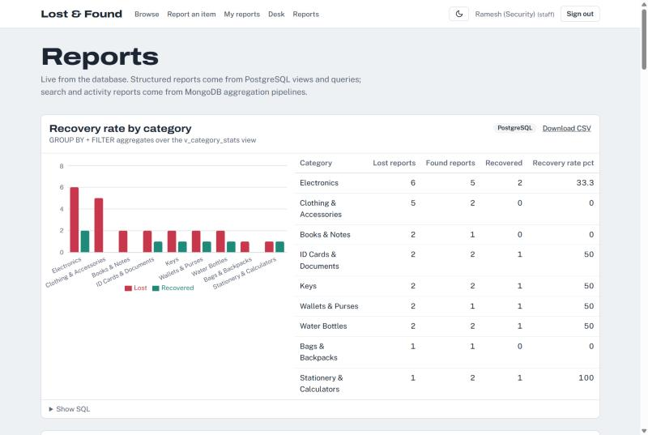
Figure 8.1: Reports page, recovery rate by category (chart, result table and the SQL behind it)
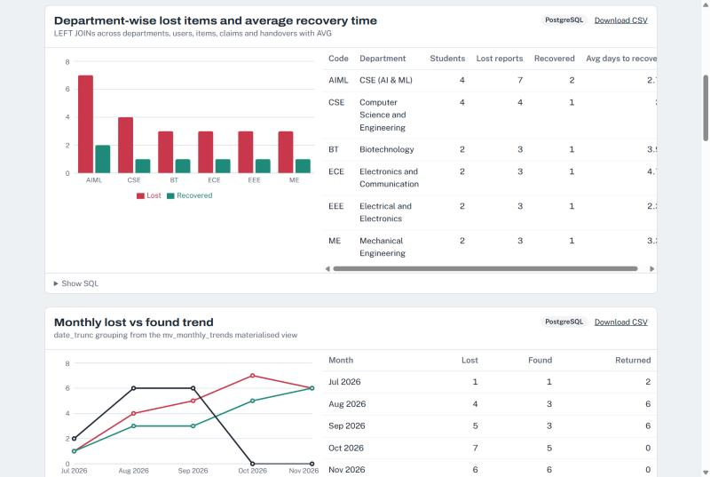
Figure 8.2: Department-wise report and the monthly trend from the materialised view
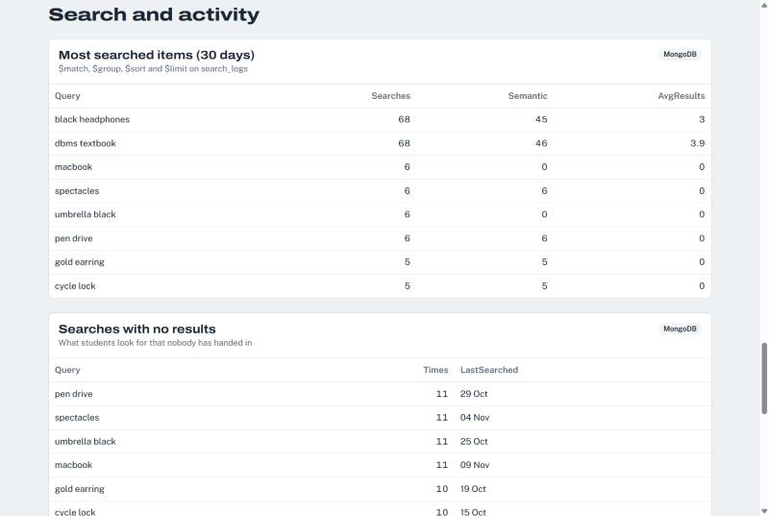
Figure 8.3: MongoDB aggregation reports: most searched items and searches with no results

Next.js-Project Tree Structure
The project is a single Next.js application. Pages under app/ form the frontend, Route Handlers under app/api/ form the backend API, and lib/ holds the database code shared by both. node_modules/ and build output are not shown.
DBMS_Project/
├── app/ Next.js pages (frontend) and API routes (backend)
│ ├── page.js home page
│ ├── layout.js, globals.css shared layout, fonts, light/dark theme
│ ├── login/, register/ sign in and create account
│ ├── items/
│ │ ├── page.js browse and search (meaning or exact words)
│ │ ├── new/page.js report a lost or found item
│ │ └── [id]/page.js item details, suggested matches, claims
│ ├── dashboard/page.js student's reports, claims and notifications
│ ├── admin/
│ │ ├── page.js staff desk: moderation, claims, handovers
│ │ ├── reports/page.js SQL and MongoDB reports with charts
│ │ ├── users/page.js user management (admin)
│ │ └── audit/page.js audit log (admin)
│ └── api/ backend API (Route Handlers)
│ ├── auth/ register, login, logout
│ ├── items/ report, moderate, delete; [id]/claims
│ ├── claims/[id]/ approve, reject, withdraw; handover
│ ├── matches/[id]/ hide a wrong match
│ ├── notifications/ list and mark read
│ ├── reports/[key]/ report data as JSON or CSV
│ └── admin/ users, housekeeping
├── components/ React components (forms, charts, item tag, nav)
├── lib/
│ ├── db.js PostgreSQL pool and transaction helper
│ ├── mongo.js MongoDB logs, notifications, aggregations
│ ├── auth.js sessions (JWT) and role checks
│ ├── validators.js input validation (zod)
│ ├── data.js read queries used by the pages
│ ├── matching.js, embeddings.js embeddings and match suggestions
│ └── reports.js loads report SQL from sql/05_reports.sql
├── sql/
│ ├── 01_schema.sql DDL: tables, keys, constraints, indexes
│ ├── 02_functions.sql functions, procedures, triggers
│ ├── 03_views.sql views and materialised view
│ ├── 04_seed.sql sample data
│ ├── 05_reports.sql report queries used by the app
│ └── 06_demo_queries.sql demonstration queries
├── scripts/ db-setup, embed-items, mongo-dev, mongo-seed
├── public/ static files and uploaded photos
├── docs/ project report and diagrams
├── .env.example environment variables (no real secrets)
├── next.config.mjs, package.json project configuration
└── README.md setup and run instructions
Request flow for a change (for example approving a claim): page button → PATCH /api/claims/[id] → apiUser() checks the session and role → zod validates the body → withTransaction() runs CALL sp_approve_claim(...) in PostgreSQL → notifications and an activity log are written to MongoDB → the page refreshes with the new data.
Source code: github.com/vishnu23-sys/DBMS_Project

Few sample Screenshots of application code and demo

Application code
Transaction helper (lib/db.js). Every write runs inside BEGIN/COMMIT, with ROLLBACK on any error. The acting user is stored with set_config so the audit trigger can record who made each change:
export async function withTransaction(userId, fn) {
const client = await pool.connect();
try {
await client.query('BEGIN');
if (userId) await client.query("SELECT set_config('app.user_id', $1, true)", [String(userId)]);
const result = await fn(client);
await client.query('COMMIT');
return result;
} catch (err) {
await client.query('ROLLBACK');
throw err;
} finally {
client.release();
}
}
Role check on the server (lib/auth.js). API routes call this before any change. It re-checks in the database that the account is still active and what its current role is:
export async function apiUser(roles) {
const session = await getSession();
if (!session) throw new HttpError(401, 'Sign in to continue');
const user = await queryOne('SELECT role, is_active FROM users WHERE user_id = $1', [session.userId]);
if (!user?.is_active) throw new HttpError(403, 'This account has been deactivated');
session.role = user.role;
if (roles && !roles.includes(user.role)) throw new HttpError(403, 'You do not have access to this action');
return session;
}
API route that approves or rejects a claim (app/api/claims/[id]/route.js), calling the stored procedure inside a transaction:
if (!isStaff(session)) throw new HttpError(403, 'Only staff can review claims');

// other pending claims that approval will auto-reject
const competing = action === 'approve'
? await query(`SELECT claimant_id FROM claims WHERE item_id = $1 AND claim_id <> $2 AND status = 'pending'`,
[claim.item_id, claimId])
: [];

await withTransaction(session.userId, (db) =>
db.query(action === 'approve' ? 'CALL sp_approve_claim($1, $2, $3)' : 'CALL sp_reject_claim($1, $2, $3)',
[claimId, session.userId, note]),
);
Stored procedure sp_approve_claim (sql/02_functions.sql). FOR UPDATE locks the claim, so two staff members cannot approve it at the same moment:
CREATE OR REPLACE PROCEDURE sp_approve_claim(p_claim_id INT, p_reviewer_id INT, p_note TEXT DEFAULT NULL)
LANGUAGE plpgsql AS $$
DECLARE
v_claim claims%ROWTYPE;
v_role VARCHAR(10);
BEGIN
SELECT role INTO v_role FROM users WHERE user_id = p_reviewer_id AND is_active;
IF v_role IS NULL OR v_role NOT IN ('staff', 'admin') THEN
RAISE EXCEPTION 'User % is not allowed to review claims', p_reviewer_id;
END IF;

SELECT * INTO v_claim FROM claims WHERE claim_id = p_claim_id FOR UPDATE;
IF NOT FOUND THEN
RAISE EXCEPTION 'Claim % does not exist', p_claim_id;
END IF;
IF v_claim.status <> 'pending' THEN
RAISE EXCEPTION 'Claim % is already %', p_claim_id, v_claim.status;
END IF;

PERFORM 1 FROM items WHERE item_id = v_claim.item_id FOR UPDATE; -- lock the item

UPDATE claims
SET status = 'approved', reviewed_by = p_reviewer_id, reviewed_at = now(), review_note = p_note
WHERE claim_id = p_claim_id;

UPDATE claims
SET status = 'rejected', reviewed_by = p_reviewer_id, reviewed_at = now(),
review_note = 'Another claim for this item was approved'
WHERE item_id = v_claim.item_id AND claim_id <> p_claim_id AND status = 'pending';

UPDATE items SET status = 'claimed'
WHERE item_id IN (v_claim.item_id, v_claim.lost_item_id)
AND status IN ('open', 'matched');

UPDATE matches SET status = 'confirmed'
WHERE found_item_id = v_claim.item_id AND lost_item_id = v_claim.lost_item_id;

UPDATE matches SET status = 'dismissed'
WHERE found_item_id = v_claim.item_id AND status = 'suggested';
END;
$$;

Application demo
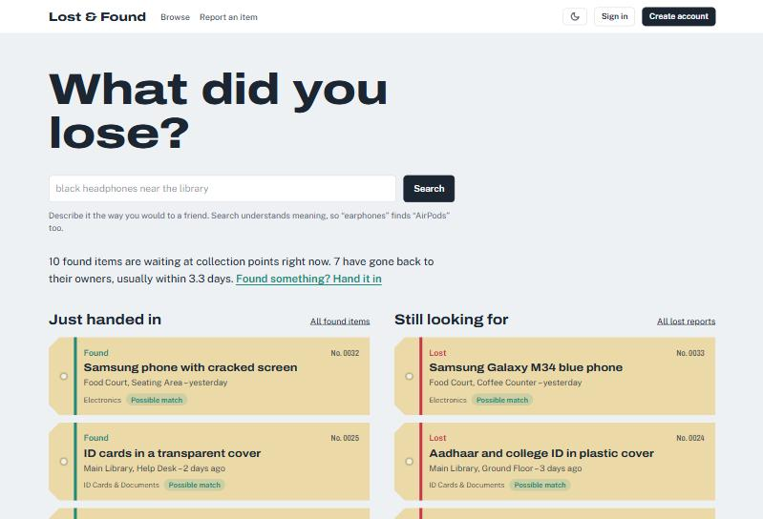
Figure 10.1: Home page. Approved reports are public, like a notice board; lost and found reports are colour-coded.
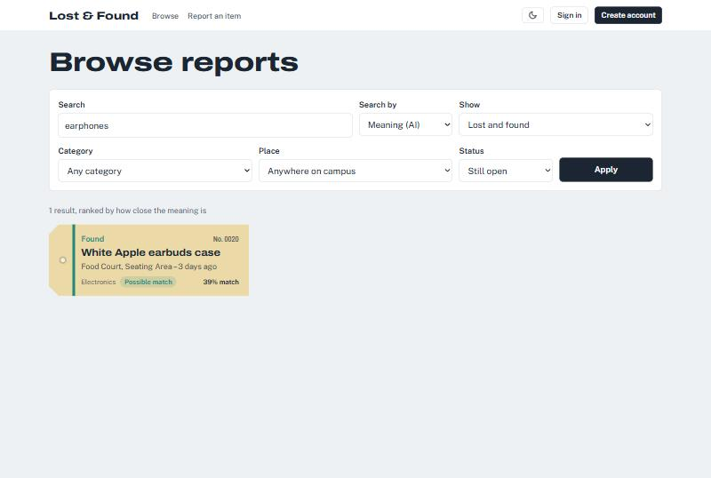
Figure 10.2: Search by meaning. "earphones" finds the "White Apple earbuds case" with a 39% meaning match.
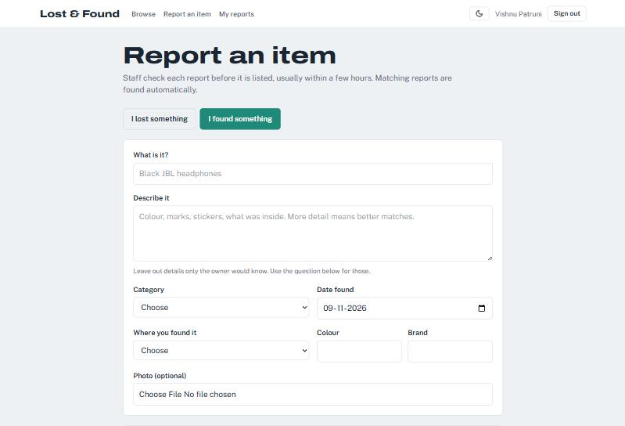
Figure 10.3: Report form for a found item (signed in as a student).
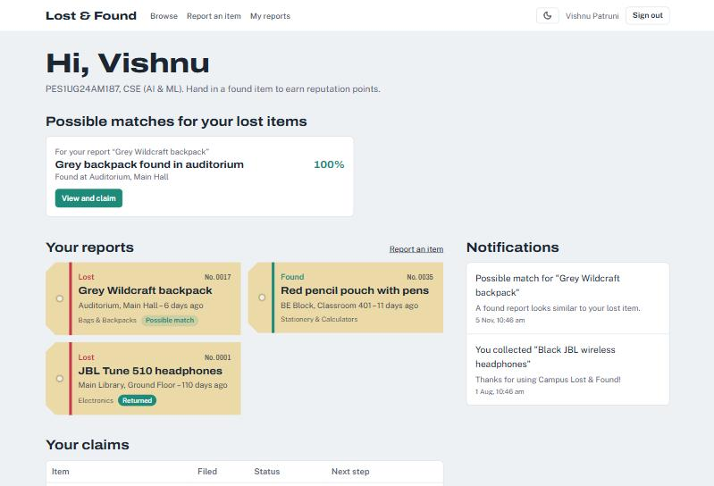
Figure 10.4: Student dashboard with a 100% suggested match, the student's reports and notifications from MongoDB.
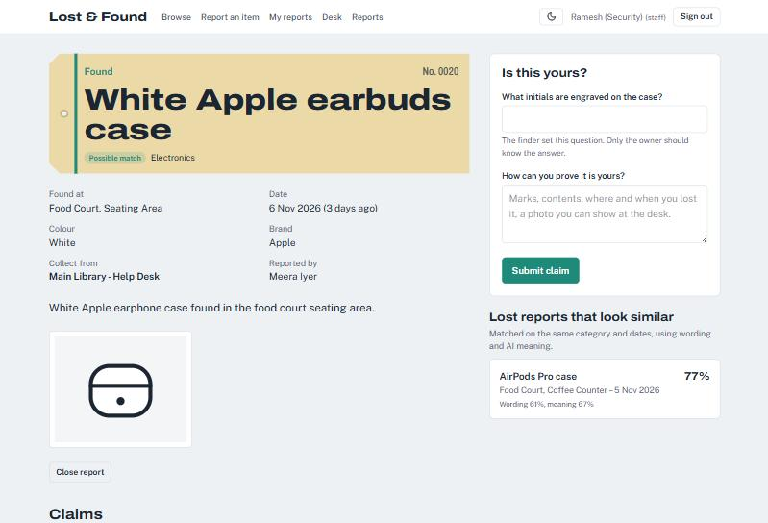
Figure 10.5: Item page with the claim form, the finder's ownership question and a similar lost report (wording 61%, meaning 67%).
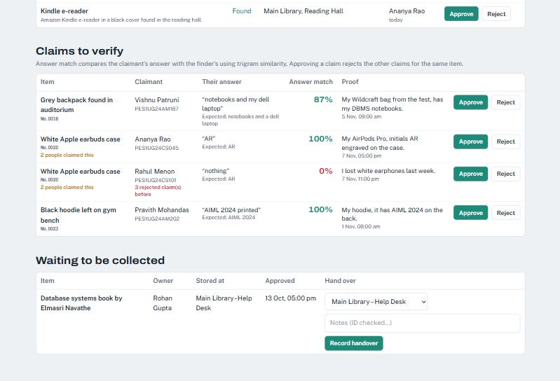
Figure 10.6: Staff desk. Two claims on the same item: Ananya's answer matches 100%, Rahul's 0% and he has 3 earlier rejected claims.
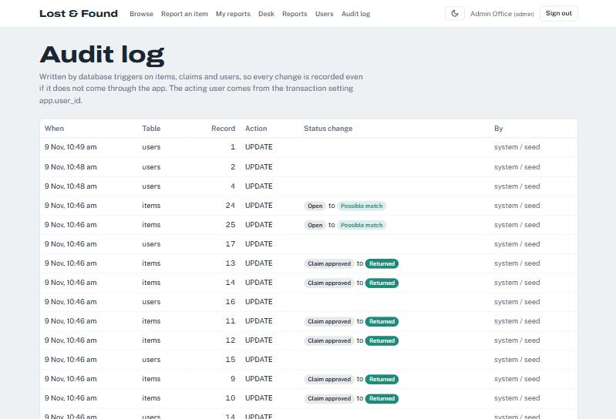
Figure 10.7: Audit log (admin), written by database triggers.
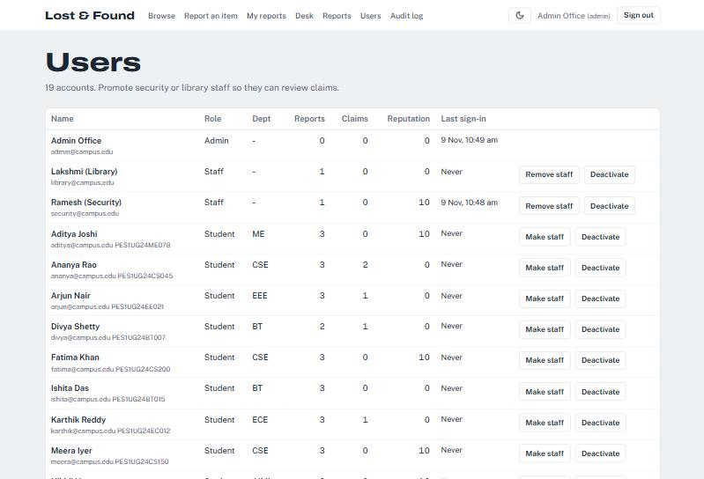
Figure 10.8: User management (admin): roles, report and claim counts, reputation.

Evaluation Rubrics

# | Criteria | Distribution | Status
1 | Database Design | ER diagram , relational schema with keys, relationships, and constraints | Completed
2 | Database Creation | SQL database implementation - DDL with constraints , NoSQL/Vector database creation , Technology justification | Completed
3 | SQL Operations and Queries | DML operations , Nested/correlated/Recursive SQL queries, Join SQL queries | Completed
4 | Advanced Database Concepts | Advanced database concepts (Procedure/function, trigger, CTE) , NoSQL/Vector feature RUD | Completed
5 | Web Application and Database Integration | Next.js interface , Backend/API and database integration | Completed
6 | Authentication and Authorization | Authentication implementation (front end and backend) and minimum two roles and role-based access control in database | Completed
7 | Documentation, Git/GitHub, Demonstration, Testing, and Originality | Documentation, Git/GitHub , Originality and individual contribution | Documentation and GitHub completed; individual contributions in progress

