SpendWise – Backend REST API Project
Team ID: SWTID-2026-498
Team Leader:
VISHNUPRASANTH M - Role: Project Architecture, JWT Authentication, Middlewar
Team member:
VINOTH V- Role: Database Design, MongoDB Integration, Mongoose Models
Team member:
VISHAL M- Role: API Routes, Controllers, CRUD Operations
Team member:
YOKESH K P- Role: API Testing Postman Validation, Documentation & Screenshots

Abstract
SpendWise is a simple backend application developed to demonstrate how modern REST APIs are built using Node.js, Express, MongoDB, and JWT authentication.
The project focuses on implementing secure user authentication and CRUD operations for managing user transactions.
It is designed as a beginner‑friendly project for students and developers who want to understand backend architecture, database integration, and protected API routes.

Problem Statement
Many beginner developers understand frontend development but struggle to understand how backend systems handle authentication,
data storage, and secure APIs. There is a need for a simple project that demonstrates how backend technologies work together
to build a functional and secure REST API service.

Objectives
1. Implement user authentication using JWT.
2. Create secure REST APIs using Node.js and Express.
3. Perform CRUD operations for managing transactions.
4. Integrate MongoDB database using Mongoose.
5. Demonstrate protected routes using middleware.
6. Provide a beginner‑friendly backend architecture for learning purposes.

Technology Stack
Programming Language: JavaScript (Node.js)
Backend Framework: Express.js
Database: MongoDB
ODM Library: Mongoose
Authentication: JSON Web Token (JWT)
Security: Bcrypt for password hashing
Other Tools: Git, Postman / Thunder Client, VS Code

System Architecture
The system follows a modular backend architecture where different components are separated into folders
such as models, routes, controllers, middleware, and configuration files.

Flow:
Client → API Request → Routes → Controllers → Models → MongoDB Database → Response to Client

Middleware is used to verify JWT tokens and protect private routes.

Database Design
The application uses MongoDB as a NoSQL database.

Users Collection:
- _id
- name
- email
- password (hashed)
- createdAt

Transactions Collection:
- _id
- userId (reference to user)
- title / description
- amount
- createdAt

Relationship:
One user can have many transactions.

Features
• User Registration and Login
• JWT Based Authentication
• Protected API Routes
• CRUD Operations for Transactions
• MongoDB Integration using Mongoose
• Secure Password Hashing with Bcrypt

Project Setup
1. Install Node.js and MongoDB.
2. Create a project directory.
3. Initialize the project using:
npm init
4. Install required packages:
npm install express mongoose jsonwebtoken bcrypt cors dotenv
5. Create folder structure:
models/
routes/
controllers/
middleware/
config/

Project Execution
1. Start MongoDB database.
2. Configure environment variables in .env file.
3. Run the backend server using:
npm run dev
4. Test APIs using Postman or Thunder Client.
5. Perform register, login, and CRUD operations using the generated JWT token.

Testing
User Acceptance Testing ensures that the system works correctly.
APIs such as Register, Login, Create Transaction, Update Transaction, Delete Transaction,
and Get Transactions are tested using Postman.

Testing verifies:
• Authentication works correctly
• Protected routes require JWT tokens
• CRUD operations store and retrieve data properly

RESULT:
Output screenshot 1
Delete Transaction API Test

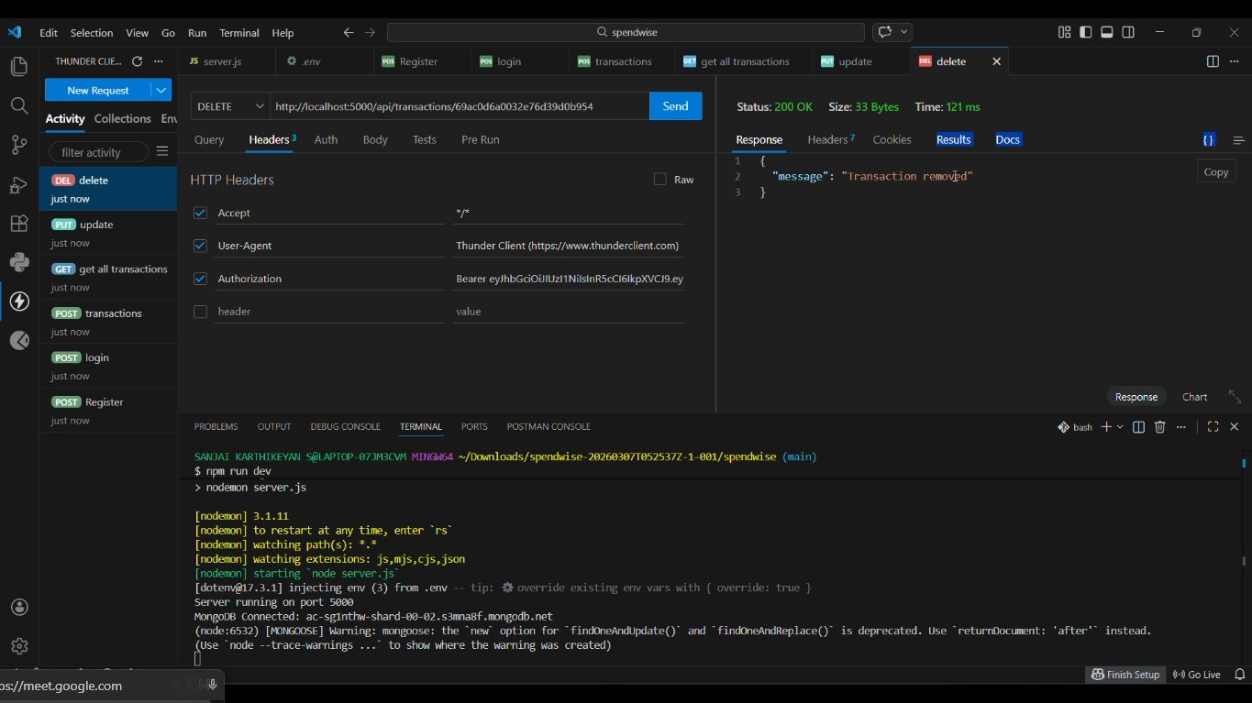

Output screenshot 2:
Create Transaction API Test
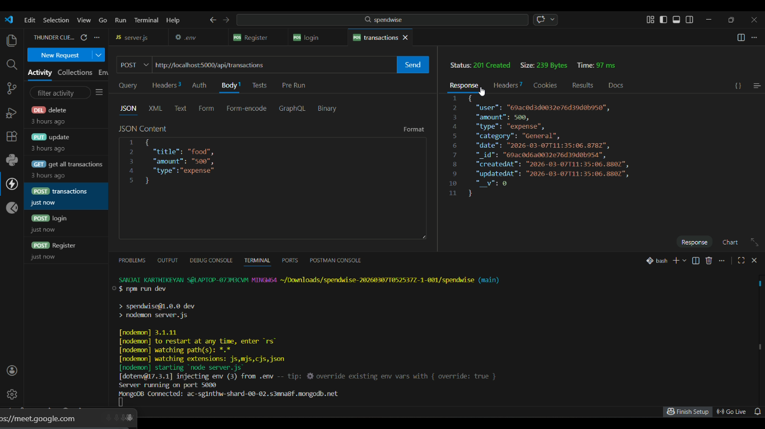
Output screenshot 3:
User Login API Test
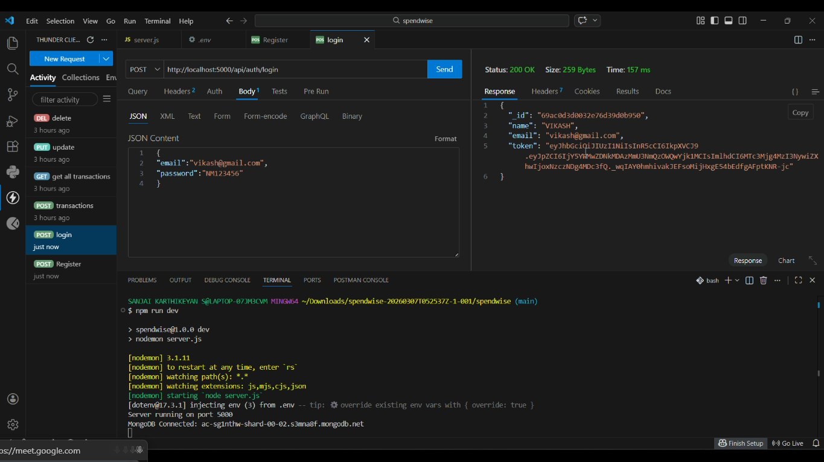

Output screenshot 4:
User Registration API Test
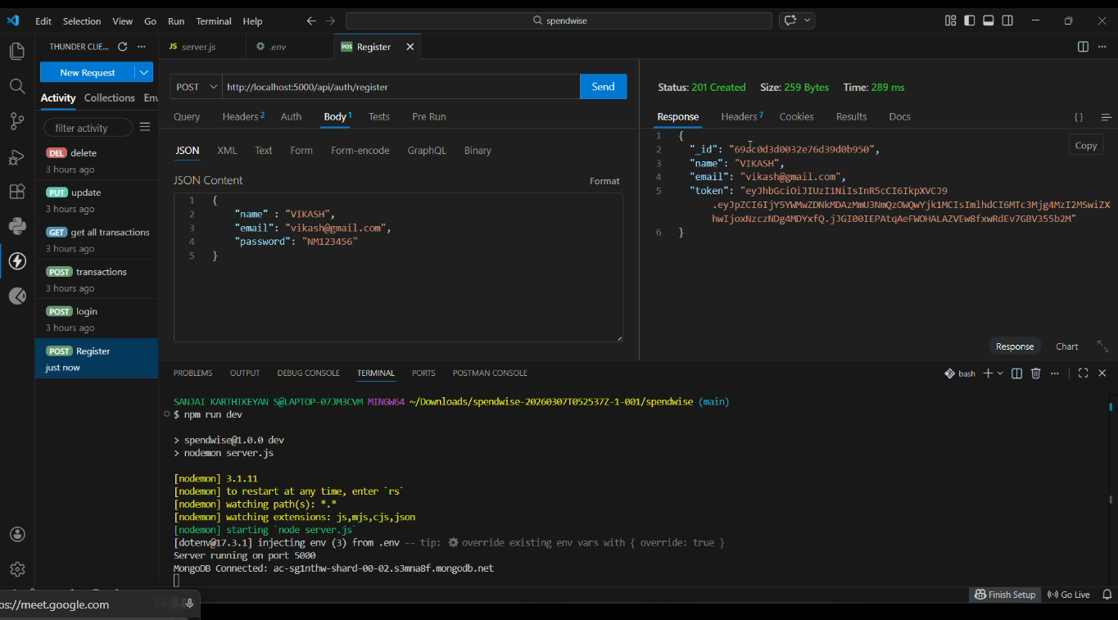

Output screenshot 5:
Environment Configuration and Server Running

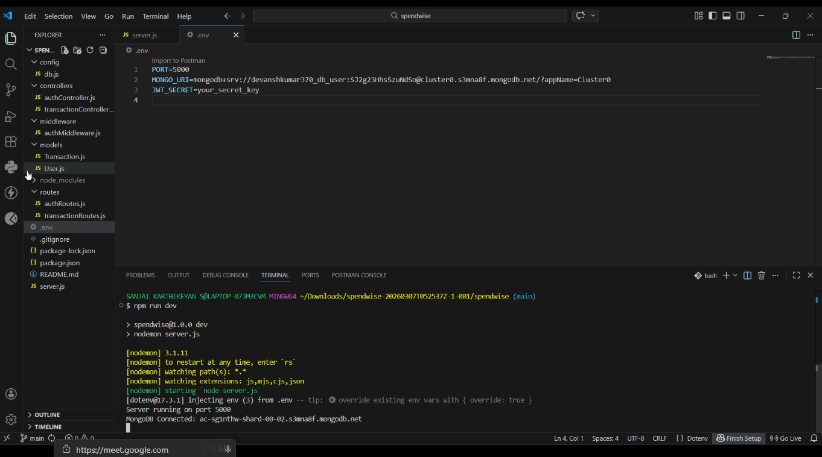

Conclusion
SpendWise successfully demonstrates how backend systems are built using Node.js, Express, and MongoDB.
The project helps beginners understand REST API development, authentication using JWT, database integration,
and middleware protection. It serves as a practical learning tool for students and developers who want to gain
hands‑on experience with backend development.

