HOUSE PRICE PREDICTION SYSTEM | Group Project
HOUSE PRICE PREDICTION SYSTEM
A PROJECT REPORT
Submitted in partial fulfillment of the requirements for the degree of Bachelor of Technology
SUBMITTED BY:
VISHNU CHOUDHARY (25MIM10161)
VIT BHOPAL UNIVERSITY
SCHOOL OF COMPUTER SCIENCE AND ENGINEERING
VIT BHOPAL UNIVERSITY | Page 1
HOUSE PRICE PREDICTION SYSTEM | Group Project
I. CERTIFICATE
This is to certify that the project entitled 'HOUSE PRICE PREDICTION SYSTEM' is a bona fide record of work carried out by the following students of VIT BHOPAL UNIVERSITY in partial fulfillment of the requirements for the degree of Bachelor of Technology:
VISHNU CHOUDHARY (25MIM10161)
The work embodied in this report has not been submitted elsewhere for any other degree or diploma.
____________________ ____________________
Internal Examiner External Examiner
VIT BHOPAL UNIVERSITY | Page 2
HOUSE PRICE PREDICTION SYSTEM | Group Project
1. Abstract
The real estate market is highly volatile, making it difficult for buyers and sellers to estimate accurate property values. This project, 'House Price Predictor', is a Machine Learning application designed to predict the price of a house based on specific parameters such as bedrooms, bathrooms, square footage, parking availability, condition, and construction year. The system utilizes the Scikit-Learn library to implement a Linear Regression algorithm and provides a user-friendly Graphical User Interface (GUI) built with Tkinter.
2. Introduction
Manual estimation of house prices is often inaccurate due to the complex relationship between various features (size, age, amenities) and market value.
Objective:
1. To develop a Python-based application that predicts house prices.
2. To implement Linear Regression for supervised learning.
3. To create an interactive GUI for easy user input.
3. System Analysis & Design
The project follows a standard Machine Learning pipeline: Data Loading -> Feature Selection -> Model Training -> Interface Design -> Prediction.
VIT BHOPAL UNIVERSITY | Page 3
HOUSE PRICE PREDICTION SYSTEM | Group Project
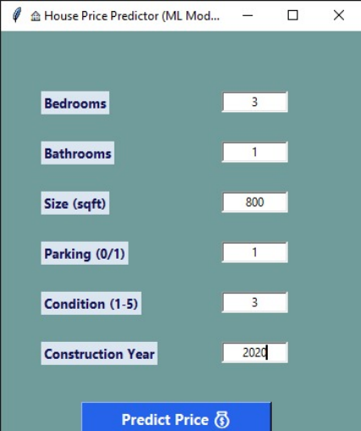Fig 3.1: System Flowchart / Dataset Structure
4. Implementation Details
The core logic is implemented in Python using the Pandas and Scikit-Learn libraries. Below is the key source code:
import pandas as pd
from sklearn.linear_model import LinearRegression
VIT BHOPAL UNIVERSITY | Page 4
HOUSE PRICE PREDICTION SYSTEM | Group Project
import tkinter as tk
from tkinter import messagebox
# 1. Load Data & Train Model
df = pd.read_csv("housing_dataset_large_with_year.csv")
X = df[['Bedrooms','Bathrooms','Size_sqft',
'Parking_space','Condition','Year']]
y = df['Price_INR']
model = LinearRegression()
model.fit(X, y)
# 2. Prediction Logic
def predict():
try:
features = [[
int(bed.get()), int(bath.get()),
float(size.get()), int(park.get()),
int(cond.get()), int(year.get())
]]
price = model.predict(features)[0]
messagebox.showinfo("Result", f"Rs {price:,.0f}")
except:
messagebox.showerror("Error", "Invalid Input")
# 3. GUI Initialization
root = tk.Tk()
root.title("House Price Predictor")
# ... (Widgets setup) ...
root.mainloop()
VIT BHOPAL UNIVERSITY | Page 5
HOUSE PRICE PREDICTION SYSTEM | Group Project
5. Results & Discussion
When the user runs the application, a window appears allowing input of house details. Upon clicking 'Predict', the model calculates the estimated cost.
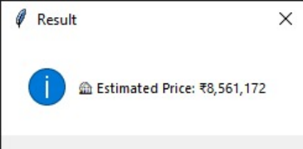Fig 5.1: Application Output Window
6. Conclusion
The House Price Prediction System successfully demonstrates how Machine Learning can be applied to real-world problems. The Tkinter GUI makes the powerful underlying algorithm accessible to non-technical users.
VIT BHOPAL UNIVERSITY | Page 6

