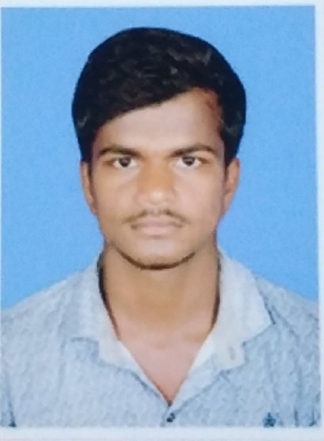

**kuppam vishnu**

1-22A , Cherlopalli

Thavanampalli, Chittoor - 517129

[urvishnuchini2711@gmail.com](mailto:urvishnuchini2711@gmail.com) **, +**91 9381103462

**CAREER OBJECTIVE :**

To be the part of a reputed organization which provides steady career growth along with job satisfaction, challenges and give value contribution in the success of organization.

**ACADEMIC QUALIFICATION :**

|  |  |  |  |  |
| --- | --- | --- | --- | --- |
| **Course** | **Institution** | **Board/**  **University** | **Year of Completion** | **Percentage** |
| B. Tech  (CSE) | Vemu Institute of Technology, Chittoor | JNTU Ananthapur | 2022 | 78 |
| Intermediate | Mother Theresa Junior College,  Chittoor | State Board | 2018 | 97.4 |
| Xth | Keshava Reddy E.M. School  Thondavada | State Board | 2016 | 9.2 |

**TECHNICAL SKILLS :**

* Programming Languages : Basics of C ,Java , Data Structures , HTML ,CSS.
* Operating system : WINDOWS.
* Package : MS OFFICE.

**AREAS OF INTEREST :**

* SOFTWARE DEVELOPMENT
* WEB DEVELOPER

**PAPER/POSTER PRESENTATION :**

* Presented a paper on **“ Solid Waste Management** ” in VEMU INSTITUTE OF TECHNOLOGY.

**WORKSHOPS ATTENDED :**

* Attended a workshop on **C languag**e conducted by Vemu Institute of Technology.

**AWARDS AND ACHIEVEMENTS :**

* Awarded the **1st prize** in **PAPER PRESENTATION** in Vemu Institute of Technology.
* Created **STUDENTS INNOVATION CLUB** website based on HTML ,CSS.

**STRENGTHS :**

* Leadership Skills
* Adaptability
* Self-confident
* Ability to work under pressure.

**EXTRA CURRICULAR ACTIVITIES :**

* I have been selected as an **NSS volunteer** in our college.
* Selected as a Technical **Team lead** in our College Campus Radio.

**PERSONAL DETAILS :**

* Father’s Name : k.Rama Moorthy Reddy
* Date of Birth : 27-01-1999
* Languages Known : English, Telugu .
* Hobbies : Browsing internet, Dancing.

**DECLARATION :**

I Vishnu do here by confirm that the information given above is true to the best of my knowledge.

**Date :**

**Place :**

**(Vishnu .k)**