ACRME Architecture Decision Records (ADRs)

⚠️ ARCHIVED — SUPERSEDED by the split, v2.2 ADRs (2 Sep 2026)
This consolidated ADR document is archived. The authoritative decision records are the individual, v2.2-aligned ADRs in docs/adr/: ADR-001 (region selection), ADR-002 (quota & capacity — single governed pool), ADR-003 (capacity during DR), ADR-004 (forecast & increase), and ADR-005 (distributed DR reference model). See docs/adr/README.md for the index. This consolidated file has had its region references corrected (Belgium → Switzerland North) but does not carry the full single-pool (QUA-004) and max-not-sum (DR-017) reconciliation — use the split ADRs and the FDD/TDD for current decisions.
Project: Azure Capacity Reservation Management Engine (ACRME)
Classification: Principal Cloud Architect — Architecture Governance
Version: 1.2
Date: August 2026
Status: Accepted
Change note (v1.2): Made this a self-contained, reference-free document — removed external document and section citations so it can be read without any companion document — and added rendered architecture diagrams (placement pipeline, input modes, quota-group model, engine state machine, emergency-transfer tiers, capacity-increase lifecycle). (v1.1): Added the region-classification model, Scenario 1/2 input modes, the exception workflow, the validation-rule framework, capacity-hold concurrency and corrected scoring (ADR-001); group accounting formulas, the dual-validation detector and groupType preview status (ADR-002); the five-state engine state machine, the EngineModeState entity and DR-activation semantics (ADR-003); and the 10-step steady-state lifecycle with the auto-decrease exclusion (ADR-004).

About This Document
An Architecture Decision Record (ADR) captures a single significant architectural decision, the context that forced the decision, the options considered, the choice made, and its consequences. ADRs are immutable once accepted — a superseding decision is recorded as a new ADR rather than editing the original.
This document records the four foundational ACRME architecture decisions:
ADR | Title | Status | Supersedes
ADR-001 | Region Selection | Accepted | —
ADR-002 | Quota and Capacity Management | Accepted | —
ADR-003 | Capacity Management during Disaster Recovery (DR) | Accepted | —
ADR-004 | Forecast and Increase of Capacity and Quota | Accepted | —
Evidence tags used throughout: [Documented] (traceable to Azure platform behaviour or documentation), [Decided] (an explicit ACRME design choice recorded in this ADR set), [Derived] (a logical consequence of a documented constraint or decision), [Assumed] (architectural judgement pending proof-of-concept validation).

ADR-001 — Region Selection
Status: Accepted
Date: August 2026
Deciders: Principal Cloud Architect, Platform Engineering, DR Owner
Related constraints: HC-1..HC-10 (hard constraints); VR-1..VR-11 (validation rules)

Context
Customers request capacity by supplying either a specific Azure region or an Azure geography (e.g. “US”, “Europe”, “Middle East”). The engine must derive three environment regions — Prod, NonProd/CVAL, and DR — that satisfy isolation, resilience, capacity, quota, and data-residency requirements.
Forces at play:
- Azure regions differ in SKU availability, zone count, capacity headroom, and quota posture. A naive “pick the nearest region” approach silently produces single-zone or capacity-starved placements.
- Some regions are Restricted Capacity Regions (sovereign clouds, limited-SKU regions) that must never be selected by automated placement.
- Certain geographies (notably the Middle East, with only UAE North and Saudi Arabia Central) do not have enough Standard regions to satisfy a three-region model in-geo, forcing a governed cross-geo DR path.
- Placement decisions must be deterministic, auditable, and replayable — the same inputs must always produce the same output, and every decision must be reconstructable for compliance.

Decision
Adopt a staged, constraint-then-score placement pipeline driven by environment-type-specific scoring formulas:
- Stage 1 — Eligibility pre-filtering. Reduce all Azure regions to Standard Capacity Regions within the customer’s geography.
  - HC-9 STANDARD_REGION_ONLY excludes Restricted regions before scoring. [Decided]
  - HC-8 GEOGRAPHY_CONTAINMENT confines the Prod anchor to the customer’s chosen geography. [Derived]
- Stage 2 — Hard-constraint gate. Each surviving region must pass HC-1..HC-7 and HC-10 (region separation, capacity floor, quota floor, DR separation class, zone availability, DR coverage floor, DR floor integrity, cross-geo extension approval). Any failure excludes the region from scoring entirely — hard constraints are binary gates, never scored penalties. [Decided]
- Stage 3 — Environment-type-specific scoring. Rank survivors using three formulas sharing default weights (α=0.30, β=0.20, γ=0.25, δ=0.15, ε=0.10) but with env-type-specific semantics for α (capacity signal) and δ (DR readiness): [Decided]
  - Prod: Prod_region = argmax(PS_Prod(r)) over eligible Standard regions in-geo.
  - NonProd/CVAL: argmax(PS_NonProd(r)) over survivors, excluding the Prod region.
  - DR: argmax(PS_DR(r)) over survivors, excluding the Prod region (but may share with NonProd).
- Selection order is sequential — Prod → NonProd → DR — not joint optimization. With 3–4 regions the greedy sequential result equals the joint-optimal result in nearly all practical cases, while remaining transparent and auditable. [Decided]
- Middle East special handling. Prod and NonProd are chosen in-geo via argmax(PS_Prod) over {UAE North, Saudi Arabia Central}; DR is assigned to Switzerland North via the only approved Cross-Geo Extension paths (Saudi Arabia → Switzerland North, UAE North → Switzerland North). Switzerland North must itself pass HC-1..HC-10; if it fails, the placement is rejected with an ops alert — the engine never silently substitutes another region. [Decided]
- Determinism & audit. All candidate sets, sub-scores, the winning score, and the active PlacementPolicy version are written to the OperationRecord for replay (VR-8, VR-9). Even the 3-region edge case (single eligible candidate) runs the full scoring path so the score is logged as a capacity-health signal. [Decided]
- Operating mode. In Phase 1 the engine runs region selection in recommendation/shadow mode — it produces and logs the ranked recommendation but does not autonomously place. Autonomous placement is gated on POC validation of the scoring formulas.
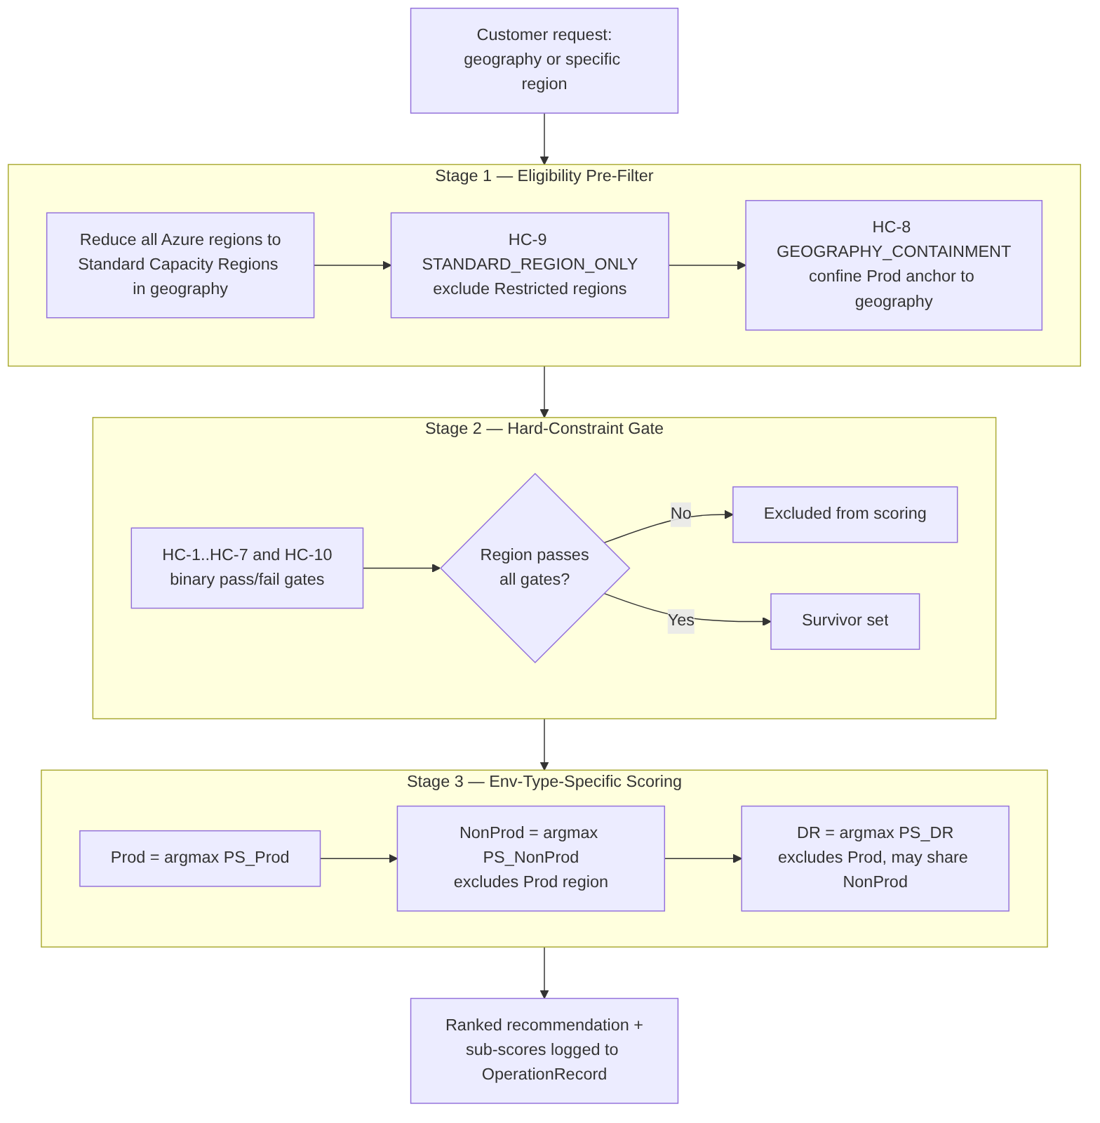
Figure 1. ACRME staged placement pipeline — Stage 1 eligibility pre-filter, Stage 2 hard-constraint gate, Stage 3 environment-type-specific scoring, then sequential Prod → NonProd → DR selection.

Region Classification Model (normative)
Every Azure region carries exactly one classification tier, stored in PlacementPolicy as config-as-code (versioned, auditable, replayable) — classification is a governance decision, not a live capability query. [Documented]
Tier | Eligibility | Regions
Standard Capacity Region | Eligible for dynamic selection, scoring, and all env assignments (Prod/CVAL/DR) — the only regions that enter the pipeline | NA: West US 3, Central US, Canada Central · EU: Sweden Central, Switzerland North · ME: Saudi Arabia, UAE North · APAC: Japan East, Southeast Asia, Australia East
Restricted Capacity Region | Exception-only (Scenario 2 + Prod + approval); never scored, ranked, or recommended | East US 2, North Europe, West Europe, East Asia, Australia Southeast (all: Azure physical capacity constraint)
Cross-Geo Extension Region | DR-only, for geographies that cannot meet the 3-region minimum in-geo | Saudi Arabia → Switzerland North; UAE North → Switzerland North (Middle East only)
Restricted regions are excluded by a pre-filter ahead of all hard constraints (HC-9), never as a scoring penalty.

Prod Region Input Modes
The Prod region is the anchor; CVAL and DR are selected sequentially from it. The customer supplies the anchor one of two ways, and both converge on a single validated Prod anchor: [Documented]
- Scenario 1 — geography supplied. The engine derives Prod via argmax(PS_Prod) over Standard Capacity Regions in that geography only. Ties break deterministically by the Standard-region list order for the geography; the first-listed region is the deterministic cold-start default when no snapshot exists. Geography exhaustion → reject (never silently cross-geo or use a Restricted region).
- Scenario 2 — specific region supplied. If Standard, validate against HC-1..HC-10 and adopt as the anchor (PS_Prod used only for post-selection validation). If Restricted, route to the Exception Deployment Workflow.
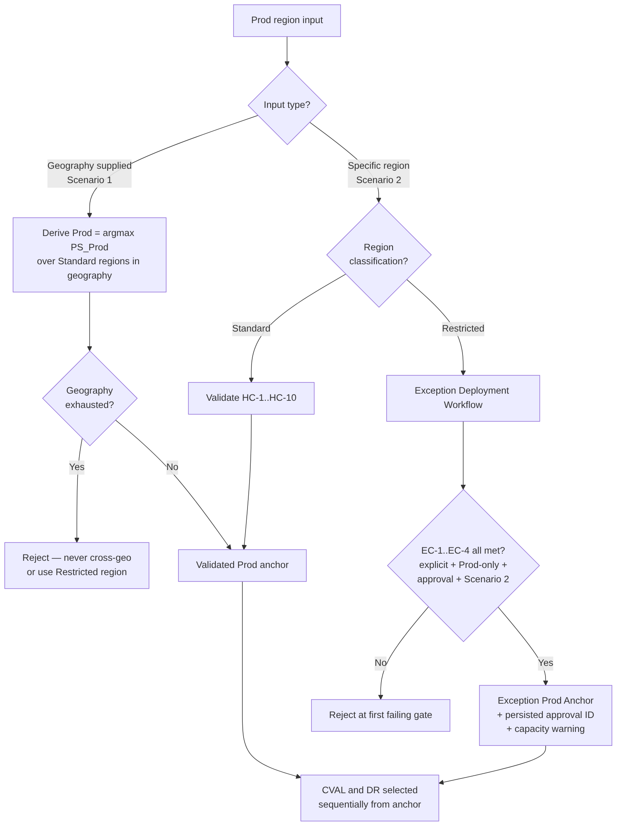
Figure 2. Prod region input modes — geography-supplied (Scenario 1) versus specific-region (Scenario 2), including the restricted-region Exception Deployment Workflow.

Exception Deployment Workflow (Scenario 2 — Restricted region)
A Restricted region is used only if all four conditions hold; failure rejects at the first failing gate: [Documented]
# | Condition | Check
EC-1 | Explicit request | Customer named the region; engine never recommended it
EC-2 | Production only | CVAL and DR may never use a Restricted region
EC-3 | Exception approval | A named, revocable approval record exists for the customer–region pair
EC-4 | Scenario 2 input | Restricted regions can never be engine-derived
On success the region becomes the Exception Prod Anchor, the placement is marked an Exception Deployment, a capacity-constraint warning is emitted to the caller, and the approval ID + restriction status are mandatory OperationRecord fields (commit blocked if absent). CVAL/DR still select from Standard regions via normal scoring.

Validation Rule Framework (VR-1..VR-11)
Rule | Check | Failure action
VR-1 | Region exists in classification list | Reject if unknown
VR-2 | Automated placement uses Standard only | Exclude before scoring if Restricted
VR-3 | Scenario 2 Restricted: EC-1..EC-4 all met | Reject at first failing condition
VR-4 | Scenario 1 derived Prod in-geo Standard | Geography-scoped exhaustion error
VR-5 | Standard region passes HC-1..HC-10 | Exclude; exhaustion error if all excluded
VR-6 | Middle East DR = Switzerland North via approved path | Block with ops alert if Switzerland North fails HC-1..HC-10
VR-7 | Exception approval ID persisted before commit | Block commit if absent
VR-8 | Capacity-constraint warning emitted | Block commit if suppressed
VR-9 | Snapshot age within policy limit | Trigger targeted ARM refresh
VR-10 | Capacity hold acquired before commit | Block commit if hold absent
VR-11 | Restricted regions absent from all recommendation outputs | Post-scoring filter (defence-in-depth)

Capacity Holds & Concurrency
Before returning a committed assignment the engine creates a capacity hold keyed by region, SKU, zone, environment, and policy version, using optimistic concurrency; the hold expires if Azure provisioning does not begin. This closes the concurrent-placement race. [Documented]

Corrected Scoring Model (pilot)
- Default weights retained for pilot comparison: α=0.30, β=0.20, γ=0.25, δ=0.15, ε=0.10; every component is clamped Clamp(x) = max(0, min(1, x)). [Assumed]
- To avoid double-counting the same signal under α and δ, the CVAL/NonProd formula is proposed as PS_NonProd = 0.35·Capacity + 0.25·Quota + 0.25·Distribution + 0.05·DR_Overflow_Integrity + 0.10·Zones. [Assumed]
- Distribution uses demand units, not customer count: Distribution = 1 − Region_Assigned_Demand / Total_Assigned_Demand. [Assumed]
- Revised weights are proposed, not empirically validated — advisory until pilot measurement.

Governance & Compliance Controls
- The classification list lives in PlacementPolicy; any change requires a policy-version increment, a Decision Log entry, and replay of the prior 30 days of placements against the new classification before activation. [Documented]
- Exception approval records are revocable engine artefacts; a revoked approval blocks future exception deployments for the customer–region pair with no code change.
- Every classification change is audited with approver identity, timestamp, previous/new classification, and affected geography.
- Switzerland North’s regional capacity-planning targets must include potential Middle East DR demand on top of in-geo Europe demand.

Consequences
Positive: - Deterministic, replayable placement with a complete audit trail satisfies compliance and post-incident review. - Hard constraints guarantee no placement ever violates isolation, zone, quota, or residency rules regardless of score. - Restricted regions are structurally impossible to select automatically; exceptions flow through a governed Scenario 2 workflow with a persisted, revocable approval ID. - Env-type-specific formulas let Prod optimise for capacity/isolation while DR optimises for overflow readiness.
Negative / trade-offs: - Three formulas plus 16 per-CRG-type RegionalSnapshot fields increase implementation and snapshot-maintenance cost. - Sequential selection is greedy; if the region count ever exceeds 6, joint optimization should be revisited. - Cross-geo extension paths are a manual governance artefact — adding a path requires a PlacementPolicy update, governance approval, and a Decision Log entry. - Worked scoring examples remain a known gap until per-CRG-type inputs are finalised.
Neutral: - CRG_Score (Regional Capacity Weight) is demoted from a primary scoring input to a monitoring-only signal.

Alternatives Considered
Alternative | Why Rejected
Joint optimization (select all three regions simultaneously) | Higher combinatorial complexity; opaque and harder to audit; identical result to sequential for 3–4 regions. [Decided]
Single generic PS(r, env_type) formula | α and δ have fundamentally different meanings per env type; a single formula needs so many branches it becomes three formulas anyway. [Decided]
Geographic distance as a scored soft objective | Operators already choose geographically independent region sets at design time; HC-4 as a hard constraint is sufficient and simpler. [Decided]
Silent fallback region for failed Middle East DR | Violates governance and residency guarantees; the engine must fail loudly and require an approved extension path. [Documented]

ADR-002 — Quota and Capacity Management
Status: Accepted
Date: August 2026
Deciders: Principal Cloud Architect, Platform Engineering, FinOps
Related constraints: HC-2, HC-3, HC-7 (hard constraints)

Context
Each customer needs three CRGs per region (Prod, NonProd, DR). Azure tracks compute quota per subscription per region per SKU family; quota exhaustion silently blocks CR creation and VM deployment. The engine must:
- Prevent a NonProd surge from consuming quota that Prod CR creation needs (isolation).
- Make emergency capacity transfer (see ADR-003) quota-neutral where possible — i.e. reshuffle capacity without waiting hours for an Azure quota-increase approval during a crisis.
- Provide clean per-environment cost attribution for chargeback.
- Enforce a protected DR reservation that NonProd growth can never erode.
Azure Quota Groups (Preview) allow multiple subscriptions/CRGs to share a group-level quota pool, but Azure does not natively support intra-group sub-reservations — so any sub-partition of a group pool must be enforced by the engine.

Decision
Adopt a Two-Quota-Group-per-region model with an engine-enforced DR floor:
- Two groups per region: one Prod-only group and one shared NonProd+DR group. [Decided]
- Prod_Group_Limit(R) = base_subscription_quota_limit × (1 + emergency_transfer_headroom_vcpu / base_limit)
NonProd_DR_Group_Limit(R) = base_subscription_quota_limit × (1 + emergency_transfer_headroom_vcpu / base_limit)
- Engine-enforced DR floor inside the NonProd+DR group (Azure has no native sub-reservation): [Decided]
- DR_Floor_vCPU(R) = potential_dr_demand(R) × vCPU_per_instance × dr_ratio_max
Effective_NonProd_Ceiling(R) = NonProd_DR_Group_Limit(R) − DR_Floor_vCPU(R)
- The floor is always sized at dr_ratio_max (0.40) — the upper bound of the DR ratio range — so it never needs to grow if the operating ratio is later raised (0.30 → 0.40). Only actual Prod demand growth expands the floor. [Decided]
- Hard-constraint enforcement at placement:
  - HC-2 CAPACITY_FLOOR — CR headroom ≥ 2 × requested_vm_count × SKU_vCPU.
  - HC-3 QUOTA_FLOOR — env-type-aware group headroom check (Prod group / effective NonProd ceiling / DR headroom). Reads from the QuotaGroup entity, not legacy per-subscription QuotaRecord. [Decided]
  - HC-7 DR_FLOOR_INTEGRITY — rejects NonProd placement that would push nonprod_quota_used above the effective ceiling, evaluated after HC-3. [Decided]
- Legacy per-subscription quota tracking is retained for monitoring/audit only and superseded for all placement and scoring checks by group-level fields. [Decided]
- Continuous protection: the reconciliation loop watches for floor violations and emits DRFloorViolationDetected; NonProd CRG scale operations that approach the ceiling are operator-gated.
Worked topology example: Prod group 128 vCPU; NonProd+DR group 80 vCPU; DR floor 32 vCPU → effective NonProd ceiling 48 vCPU.
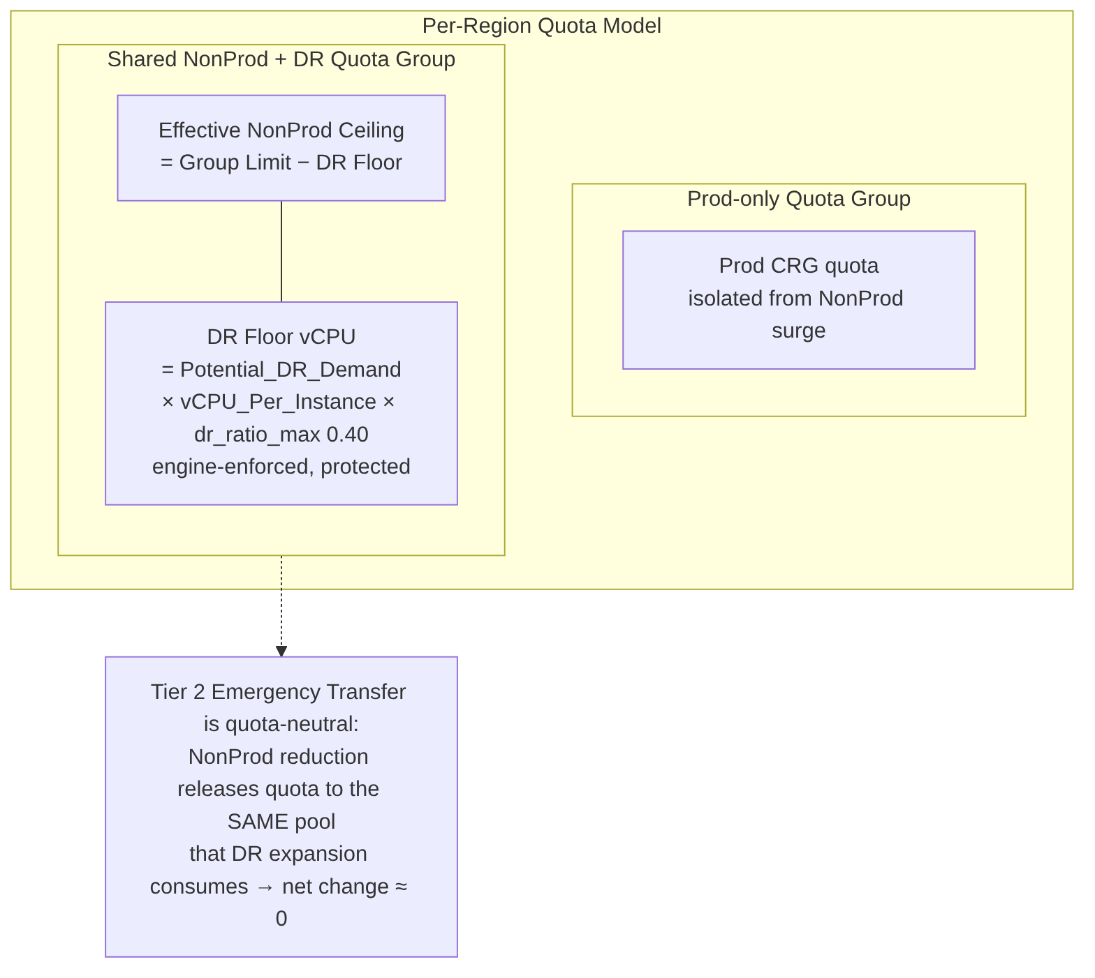
Figure 3. Two-quota-group-per-region model — an isolated Prod-only group and a shared NonProd+DR group with the engine-enforced DR floor and the effective NonProd ceiling.

Group Accounting Formulas (normative)
All four are engine accounting controls — they do not create a native Azure sub-reservation: [Documented]
DR_Floor_vCPU = Potential_DR_Demand × vCPU_Per_Instance × DR_Ratio_Max
Effective_NonProd_Ceiling = NonProd_DR_Group_Limit − DR_Floor_vCPU
NonProd_Headroom = Effective_NonProd_Ceiling − NonProd_Used_vCPU
Group_Headroom = Group_Limit − Group_Used

Exact Enforcement Controls
- Every NonProd increase performs a group check and a subscription check. [Documented]
- Every DR increase performs a group check, subscription check, SKU check, capacity check, and active-incident check.
- A separate detector recalculates the DR floor from authoritative assignment/allocation data. Any disagreement between the command-time and detector calculations disables automatic NonProd expansion (fail-safe) and raises DRFloorViolationDetected.
- Group propagation is polled — no fixed propagation SLA is assumed.

groupType Preview Dependency
The Quota-Group groupType property (AllocationGroup = advisory vs EnforcedGroup = enforced) is preview-only in the Azure Quota REST API and is not GA. [Documented] The engine’s accounting controls are deliberately engine-level and do not depend on groupType enforcement. If EnforcedGroup is ever relied upon to drop the engine’s own subscription-level check, that dependency must pass a preview-acceptance proof-of-concept and a recorded decision first. Engineering constraint: pin the exact preview API version in all quota-group calls and add version-drift detection to the platform health check.

Consequences
Positive: - Prod isolation is enforced at the Azure control-plane level — a NonProd surge cannot starve Prod. - Tier 2 Emergency Capacity Transfer becomes truly quota-neutral (ARM operations only, no Azure approval gate) because NonProd and DR draw from the same group pool (see ADR-003). - Clean chargeback: one Azure billing record per group per region. - The DR floor guarantees a protected reservation NonProd can never erode.
Negative / trade-offs: - The DR floor is a soft ceiling the engine must maintain continuously — Azure won’t enforce it. A bug could allow NonProd to breach the floor; mitigated by DRFloorViolationDetected alerting and operator gates. [Decided] - Sizing the floor at dr_ratio_max over-reserves quota slightly at lower operating ratios — a deliberate reliability-over-cost trade, reviewed quarterly. [Decided] - Quota_Score and HC-3 must be environment-type-aware (three code paths). - Hard dependency on Azure Quota Groups GA — validated by proof-of-concept before rollout; if groupQuotas returns 404 in the target tenant/region, escalate to Azure Support.

Alternatives Considered
Alternative | Why Rejected
Single shared quota pool (all three CRGs) | Breaks Prod isolation — a NonProd surge can consume Prod’s quota. [Decided]
Three separate groups (one per CRG) | Maximum isolation but makes Tier 3 transfer non-atomic — releasing NonProd quota lands in the wrong group, forcing an Azure quota request mid-crisis (hours of RTO impact). [Decided]
Per-subscription quota only (legacy) | Cannot make emergency transfer quota-neutral without risky cross-subscription coordination. [Decided]
DR floor sized at current ratio | Undersizes the floor if the ratio is later increased, blocking DR expansion. [Decided]

ADR-003 — Capacity Management during Disaster Recovery (DR)
Status: Accepted
Date: August 2026
Deciders: Principal Cloud Architect, DR Owner, Platform Engineering, Security
Related constraints: HC-1, HC-4, HC-6 (hard constraints)

Context
When a primary region fails, customers must recover in their DR region within a committed RTO. Pre-positioning a full 1:1 DR reserve is prohibitively expensive, yet under-provisioning risks a failed failover. During a crisis, waiting on Azure quota-increase approvals (hours) is unacceptable. The engine must also strictly separate routine growth from destructive crisis operations so that reconciliation can never accidentally trigger VM disruption.
Two capabilities are needed: - A way to reuse otherwise-idle NonProd capacity as DR overflow. - A safe, tiered escalation model for expanding DR capacity during a declared event.

Decision
Adopt NonProd/DR co-location with a coverage floor, a formal two-mode engine state, and a three-tier emergency transfer model:
- NonProd and DR may share a region (HC-1 constraint removed). This lets the NonProd CRG’s effective_free (after dr_overflow_reserve) count as DR overflow headroom. [Decided]
  - HC-6 DR_COVERAGE_FLOOR guarantees the combined pool can absorb demand before DR placement is accepted:
  - dr_crg_free_slots(R) + nonprod_crg_effective_free(R) ≥ prod_vm_count × dr_ratio_max
  - HC-4 DR_SEPARATION_CLASS still guarantees Prod and DR sit in non-correlated failure domains (HIGH separation for non-paired regions).
- Two separate operating systems gated by engine_mode: [Decided]
  - STEADY_STATE — organic growth via the reconciliation loop and CapacityIncreaseRequest (see ADR-004). Emergency Transfer is rejected in this mode.
  - DR_EVENT_ACTIVE — crisis operations only. The auto-increase trigger is suppressed in this mode. Mode transitions are operator-gated with dual approval (state machine EngineModeState), never automatic. [Decided]
- Three-tier Emergency Capacity Transfer escalation: [Decided]
  - Tier 1 — DirectExpansion (automated): expand DR CR quantity using free headroom in the DR group. No approval beyond DR-event declaration.
  - Tier 2 — QuotaNeutralTransfer (policy-gated): reduce a NonProd CR (releasing quota to the shared NonProd+DR group pool) and expand the DR CR from that same pool. Net group headroom change ≈ 0 — quota-neutral, no VM execution-state change (only NonProd SLA is removed). This is possible only because of the two-group model (see ADR-002).
  - Tier 3 — DestructiveTransfer (dual approval + elevated RBAC): the only tier that modifies VM-to-CRG associations. The operator supplies an explicit vm_disassociation_list (no automated VM selection in Phase 1); executed via 6-step Path B with Path A fallback per VM. VMSS entries are rejected in Phase 1.
- Quota-neutral math (Tier 2):
- NonProd CR reduction → releases quota to shared NonProd+DR GROUP pool
DR CR expansion → consumes from the SAME pool
⇒ net group headroom change ≈ 0 (ARM operations only; no Azure quota approval)
- DR reserve sizing is 30–40% of Prod (dr_ratio_min=0.30, dr_ratio_max=0.40, dr_ratio_target=0.35); the protected floor uses dr_ratio_max (see ADR-002).
- Phase-1 safety posture: Tier 2 is approval-gated; Tier 3 is blocked pending the consumer-credential model and the engine-mode state machine. No invented SLA — propagation/approval times are measured and reported as unknown until observed.
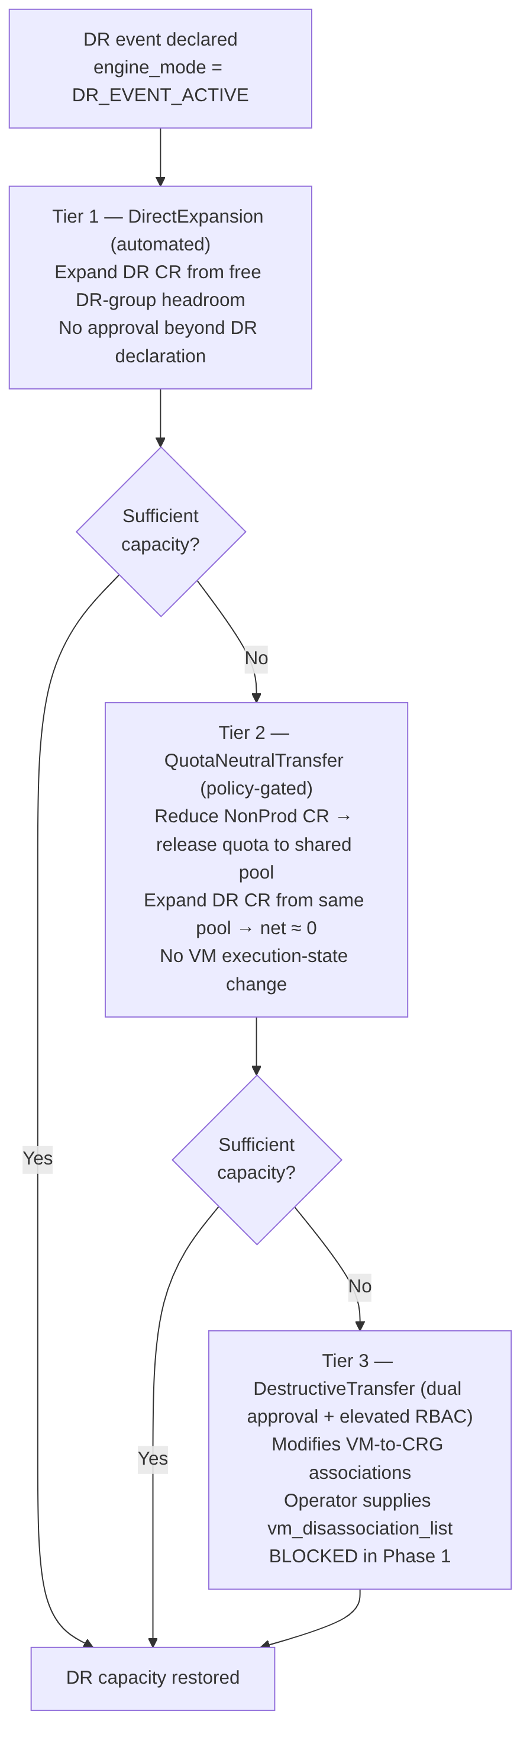
Figure 4. Three-tier Emergency Capacity Transfer escalation — Tier 1 automated, Tier 2 quota-neutral, Tier 3 destructive (blocked in Phase 1).

Full Engine State Machine (normative)
engine_mode is not a two-value flag but a five-state machine persisted in Cosmos DB with conditional writes, transition guards, and recovery tests — a production blocker until implemented: [Documented]
State | Meaning | Permitted transitions
STEADY_STATE | Organic growth only; Emergency Transfer rejected | → DR_DECLARATION_PENDING
DR_DECLARATION_PENDING | DR requested, awaiting dual approval + validation | → DR_EVENT_ACTIVE (approved) · → STEADY_STATE (rejected/expired)
DR_EVENT_ACTIVE | Crisis operations only; auto-increase suppressed | → FAILBACK_PENDING · → INCIDENT_HOLD
FAILBACK_PENDING | Failback requested, being validated | → STEADY_STATE (completed) · → DR_EVENT_ACTIVE (validation failed) · → INCIDENT_HOLD
INCIDENT_HOLD | State conflict / critical failure — safe hold | → DR_EVENT_ACTIVE · → FAILBACK_PENDING (on recovery approval)
All transitions are operator-gated with dual approval — never automatic.
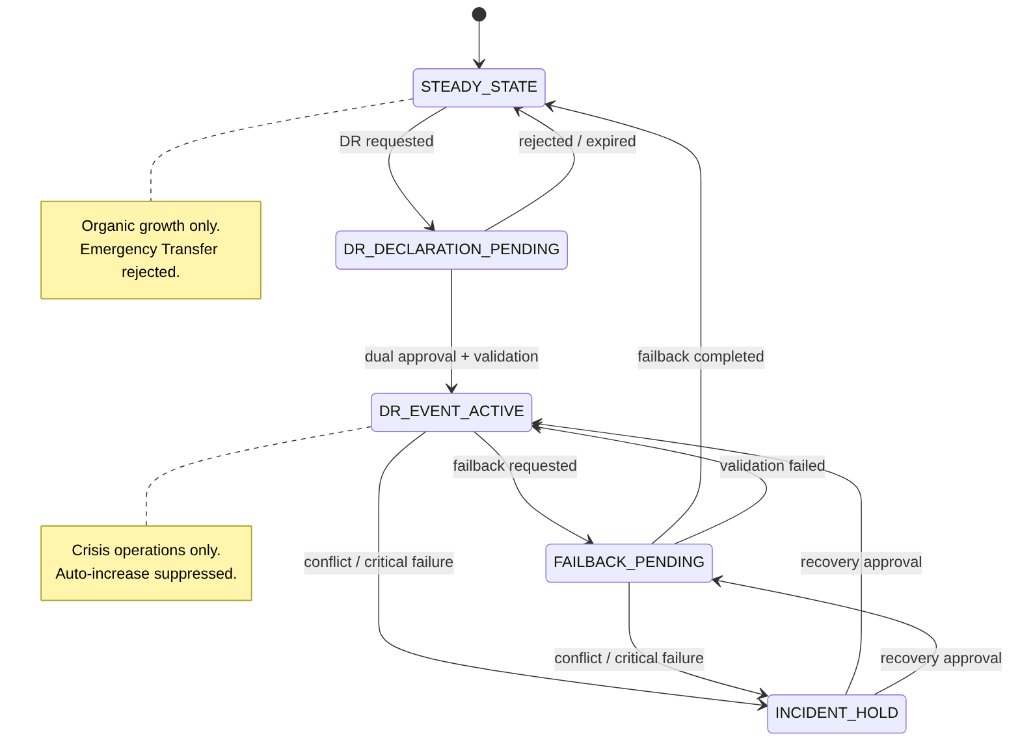
Figure 5. Five-state engine mode machine — every transition is operator-gated with dual approval.

EngineModeState Entity
Must carry: environment/control-plane scope · current mode · state version · incident ID · requested-by · approved-by · transition timestamp · transition reason · active operation IDs · lease owner + expiry · recovery checkpoint. [Documented]

DR Activation Semantics
Entering DR_EVENT_ACTIVE only establishes the operating mode in which separately-governed emergency operations may be evaluated — it does not automatically authorize Tier 2 or Tier 3. Each tier is independently gated. The DR orchestrator validates group and subscription quota and CR/sharing state before starting any approved failover deployment, and records active-or-incident-hold state back to the state service. [Documented]

Consequences
Positive: - Idle NonProd capacity doubles as DR overflow, cutting the cost of pre-positioned DR reserve while HC-6 guarantees sufficiency. - The engine_mode gate makes it structurally impossible for routine reconciliation to trigger destructive VM operations. - Tier 2 delivers meaningful crisis capacity with zero VM disruption and zero Azure quota wait — the common escalation path avoids Tier 3 entirely. - Every operation is tagged with its operating mode for a clean audit trail.
Negative / trade-offs: - Co-location adds risk that NonProd over-consumption erodes DR overflow; mitigated by HC-6, dr_overflow_reserve, and floor alerting. - engine_mode must be a formal Cosmos DB state propagated to every reconciliation cycle, with operator-gated, dual-approval transitions. - Tier 3 is blocked until the consumer-credential model (Managed Identity vs cross-tenant service-principal) and the engine-mode state machine are resolved — a known Phase-1 limitation. - Tier 3 requires a rare, audited break-glass role (ACRME.SuperAdmin) for single-approver override. - Requires per-CRG-type RegionalSnapshot fields to evaluate HC-6.

Alternatives Considered
Alternative | Why Rejected
Keep DR_region ≠ NonProd_region | Prevents using NonProd as DR overflow — the whole point of co-location. [Decided]
Remove separation with no compensating HC | Risks NonProd over-consumption leaving no DR headroom. [Decided]
Unified capacity engine with mode flags | Mode flags create complex conditionals and risk triggering VM disassociation during routine reconciliation. [Decided]
Emergency transfer as an extension of auto-increase | Conflates policy-driven growth with operator-gated crisis response; could run destructive ops without a DR declaration. [Decided]
Two tiers only (automated + destructive) | Loses the quota-neutral Tier 2 — the critical low-risk intermediate that avoids Tier 3 in most crises. [Decided]
Four tiers (separate VMSS tier) | VMSS disassociation deferred as a Phase-1 limitation rather than a distinct tier. [Decided]

ADR-004 — Forecast and Increase of Capacity and Quota
Status: Accepted
Date: August 2026
Deciders: Principal Cloud Architect, Platform Engineering, FinOps, Capacity Planning
Related constraints: HC-3 (applied at increase-execution time)

Context
Reserved capacity must grow ahead of demand — but Azure quota increases take time to approve, and over-reservation wastes money. The engine needs to forecast demand, recommend right-sized capacity, and drive quota/CR increases with enough lead time, without ever autonomously performing material or destructive changes in Phase 1. This growth path must be architecturally distinct from crisis operations (see ADR-003).

Decision
Adopt forecast-driven, approval-gated capacity growth operating exclusively in STEADY_STATE:
- Forecasting analyses historical CR allocation and projects demand over a configurable window (default 30/60/90 days), exposing raw time series and derived recommendations via API. [Documented]
- Capacity sizing formula: [Documented]
- Forecast_Quantity = ceil(Forecast_Peak × (1 + Growth_Buffer) + DR_Buffer)
- Increase when forecast demand exceeds current reserved quantity within the window; right-size down when demand is consistently below current, honouring a configurable buffer.
- Lead-time alerting: when forecast demand approaches a quota limit (default 80%), emit ForecastApproachingQuotaLimit with a 14-day lead time — enough for quota-increase processing. [Documented]
- Auto-increase is approval-gated in Phase 1. The trigger uses utilisation thresholds with debounce/cooldown to avoid thrashing; a CapacityIncreaseRequest entity carries the full lifecycle (create → approve → execute → retry → cancel), and Phase 1 requires operator approval before execution. [Decided]
- Quota increases are initiated via the Azure Support REST API (Microsoft.Capacity/.../serviceLimits) — at group level where Quota Groups apply (see ADR-002) — subject to the same operator-approval gate. [Documented]
- Mode isolation. Auto-increase runs only in STEADY_STATE and is suppressed during DR_EVENT_ACTIVE, keeping organic growth strictly separate from crisis transfer (see ADR-003). [Decided]
- Non-destructive guarantee. Increases only ever raise CR quantity or request more quota; guarded reduction (right-sizing) never drops a CR below its allocated count (the platform floor) and is itself approval-gated.

Steady-State Capacity Lifecycle (normative 10-step policy)
The steady-state increase runs strictly separate from DR crisis operations and follows a fixed sequence, with no assumed quota-propagation SLA: [Documented]
- Detect threshold crossing.
- Re-read current CR, quota, sharing, and assignment state.
- Create CapacityIncreaseRequest.
- Calculate target quantity (Forecast_Quantity formula above).
- Require operator approval (Phase 1).
- Submit the quota action only if validated as required.
- Wait for confirmed quota state without assuming a propagation SLA.
- Update CR quantity.
- Confirm the actual quantity.
- Refresh the snapshot and close the request.
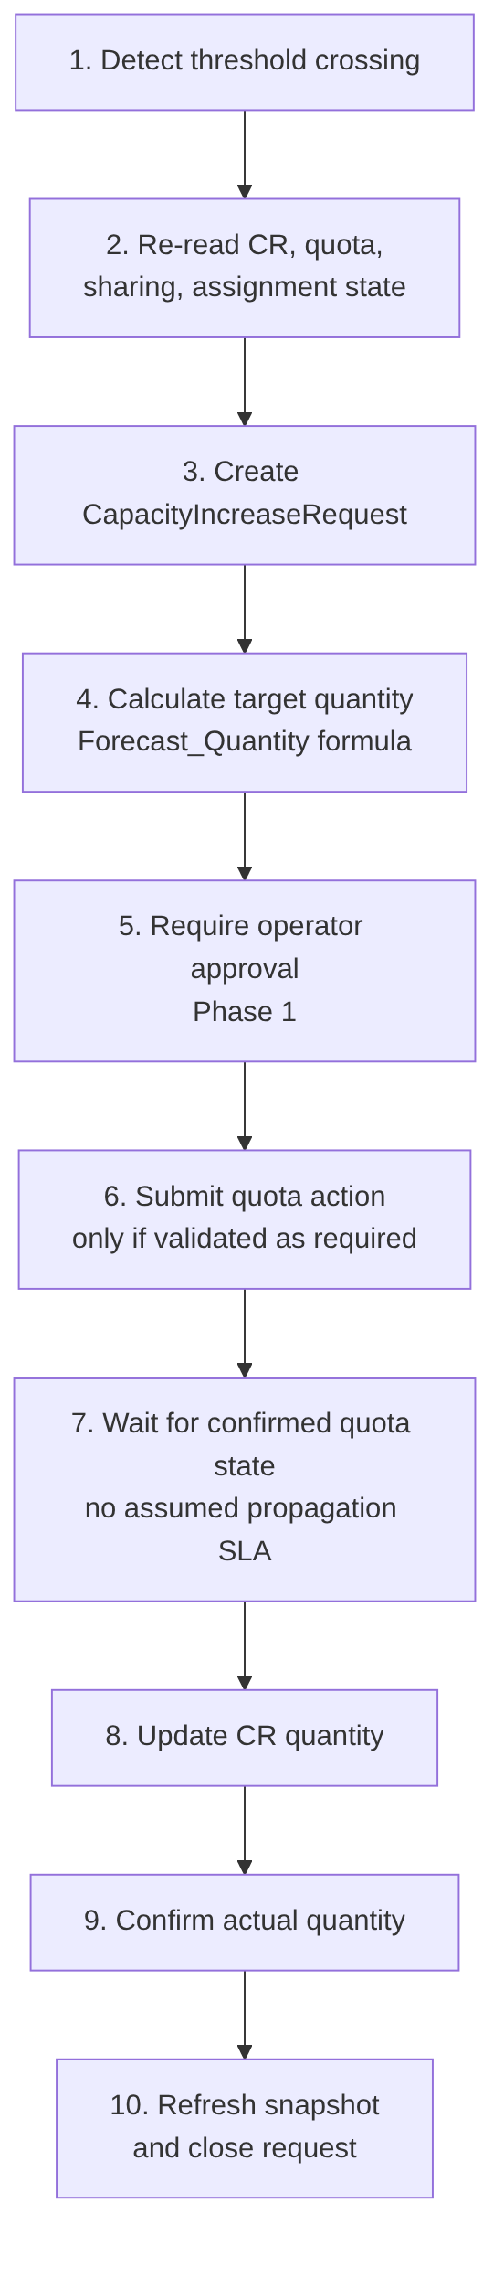
Figure 6. Ten-step steady-state capacity-increase lifecycle, running only in STEADY_STATE behind an operator-approval gate.

Auto-Decrease Exclusion
Auto-decrease is excluded from Phase 1: it can remove future capacity and interact with running VMs. Right-sizing down remains operator-driven and guarded by the platform floor (never below allocated count). [Documented]

Forecast Advisory Posture
Forecast recommendations stay advisory until model accuracy and false-positive rates are measured; the horizon is 30/60/90 days and Growth_Buffer/DR_Buffer are policy percentages, not fixed constants. [Documented]

Consequences
Positive: - Capacity grows ahead of demand with sufficient lead time for quota approvals — reducing capacity-exhaustion incidents. - The debounce/cooldown and approval gate prevent runaway or thrashing increases. - CapacityIncreaseRequest gives a fully auditable, retryable, cancellable growth workflow. - Right-sizing recovers cost from over-reserved CRs without risking allocated VMs.
Negative / trade-offs: - Approval-gated in Phase 1 means growth is not instantaneous — acceptable because Emergency Transfer (see ADR-003) covers crisis speed. - Forecast accuracy depends on history; workload-tagged per-workload forecasts are only partially covered. - Threshold, buffer, and cooldown values are empirical and require tuning during the pilot; SLA/propagation times are measured, not invented. - the CapacityIncreaseRequest lifecycle (entity, approval, retry, cancellation) is still a backlog item requiring an end-to-end approved-increase test.

Alternatives Considered
Alternative | Why Rejected
Fully autonomous auto-increase | Removes human control over material cost/quota changes; unacceptable in Phase 1. [Documented]
Auto-increase escalating into emergency tiers | Conflates growth with crisis response; could run emergency ops without a DR declaration. [Decided]
Fixed-timer cooldown | Less adaptive than recovering the budget incrementally using observed success rates. [Assumed]
No lead-time alerting (react on exhaustion) | Quota approvals take too long; reacting at exhaustion guarantees deployment failures. [Documented]
Sizing without a DR buffer | Under-reserves relative to DR obligations; the formula includes an explicit DR_Buffer term. [Documented]

Appendix A — ADR Summary
ADR | Hard Constraints Applied | Key Open Items
ADR-001 Region Selection | HC-1, HC-4, HC-5, HC-8, HC-9, HC-10 | Worked scoring examples pending final per-CRG-type inputs
ADR-002 Quota & Capacity | HC-2, HC-3, HC-7 | Azure Quota Groups GA validated by proof-of-concept before rollout
ADR-003 Capacity during DR | HC-1, HC-4, HC-6 | Consumer-credential model and engine-mode state machine; quota-release latency measured
ADR-004 Forecast & Increase | HC-3 (at execution) | Workload-tagged forecasts; CapacityIncreaseRequest lifecycle end-to-end test

Appendix B — Status Legend
Status | Meaning
Proposed | Under discussion; not yet ratified
Accepted | Ratified and in force
Deprecated | No longer recommended but not yet replaced
Superseded | Replaced by a later ADR (referenced explicitly)

Appendix C — Evidence Tag Taxonomy
Tag | Meaning
[Documented] | Traceable to Azure platform behaviour or documentation
[Decided] | An explicit ACRME design choice recorded in this ADR set
[Derived] | A logical consequence of a documented constraint or decision
[Assumed] | Architectural judgement pending proof-of-concept validation

Document Status: Accepted
Next Review: After proof-of-concept validation of Azure Quota Groups GA and quota-release latency, and on resolution of the consumer-credential model and engine-mode state-machine items.

