VISVESVARAYA TECHNOLOGICAL UNIVERSITY

“JnanaSangama”, Belgaum -590014, Karnataka.



LAB REPORT on

# Analysis and Design of Algorithms

*Submitted by*

VISHNU KUMAR (1BM20CS190)

*in partial fulfilment for the award of the degree of*

BACHELOR OF ENGINEERING

*in*

## COMPUTER SCIENCE AND ENGINEERING



## B.M.S. COLLEGE OF ENGINEERING

(Autonomous Institution under VTU)

## BENGALURU-560019

May-2022 to July-2022

B. M. S. College of Engineering,

Bull Temple Road, Bangalore 560019

(Affiliated To Visvesvaraya Technological University, Belgaum)

### Department of Computer Science and Engineering



CERTIFICATE

This is to certify that the Lab work entitled “Analysis and Design of Algorithms” carried out by VISHNU KUMAR (1BM20CS190), who is bonafide student of B. M. S. College of

Engineering. It is in partial fulfilment for the award of Bachelor of Engineering in Computer Science and Engineering of the Visvesvaraya Technological University, Belgaum during the year 2022. The Lab report has been approved as it satisfies the academic requirements in respect of a Analysis and Design of Algorithms - (19CS4PCADA) work prescribed for the said degree.

Vikranth B.M Dr. Jyothi S Nayak

Assistant Professor Professor and Head

Department of CSE Department of CSE

BMSCE, Bengaluru BMSCE, Bengaluru

Index Sheet

|  |  |  |
| --- | --- | --- |
| Sl. No. | Experiment Title | Page No. |
| 1 | Write a recursive program to Solve  a) Towers-of-Hanoi problem b) To find GCD |  |
| 2 | Implement Recursive Binary search and Linear search and determine the time required to search an element. Repeat the experiment for different values of N and plot a graph of the time taken versus N. |  |
| 3 | Sort a given set of N integer elements using Selection Sort technique and compute its time taken. Run the program for different values of N and record the time taken to sort. |  |
| 4 | Write program to do the following:   1. Print all the nodes reachable from a given starting node in a digraph using BFS method. 2. Check whether a given graph is connected or not using DFS method. |  |
| 5 | Sort a given set of N integer elements using Insertion Sort technique and compute its time taken. |  |
| 6 | Write program to obtain the Topological ordering of vertices in a given digraph. |  |
| 7 | Implement Johnson Trotter algorithm to generate permutations. |  |
| 8 | Sort a given set of N integer elements using Merge Sort technique and compute its time taken. Run the program for different values of N and record the time taken to sort. |  |
| 9 | Sort a given set of N integer elements using Quick Sort technique and compute its time taken. |  |
| 10 | Sort a given set of N integer elements using Heap Sort technique and compute its time taken. |  |
| 11 | Implement Warshall’s algorithm using dynamic programming |  |
| 12 | Implement 0/1 Knapsack problem using dynamic programming. |  |
| 13 | Implement All Pair Shortest paths problem using Floyd’s algorithm. |  |
| 14 | Find Minimum Cost Spanning Tree of a given undirected graph using Prim’s algorithm. |  |
| 15 | Find Minimum Cost Spanning Tree of a given undirected graph using Kruskals algorithm. |  |
| 16 | From a given vertex in a weighted connected graph, find shortest paths to other vertices using Dijkstra’s algorithm. |  |
| 17 | Implement “Sum of Subsets” using Backtracking. “Sum of Subsets” problem: Find a subset of a given set S = {s1,s2,……,sn} of n positive integers whose sum is equal to a given positive integer d. For example, if S = {1,2,5,6,8} and d = 9 there are two solutions {1,2,6} and {1,8}. A suitable message is to be displayed if the given problem instance doesn’t have a solution. |  |
| 18 | Implement “N-Queens Problem” using Backtracking. |  |

Course Outcome

|  |  |
| --- | --- |
| CO1 | Ability to analyze time complexity of Recursive and Non-Recursive algorithms using asymptotic notations. |
| CO2 | Ability to design efficient algorithms using various design techniques. |
| CO3 | Ability to apply the knowledge of complexity classes P, NP, and NP-Complete and prove certain problems are NP-Complete |
| CO4 | Ability to conduct practical experiments to solve problems using an appropriate designing method and find time efficiency. |

1. Write a recursive program to Solve

a) Towers-of-Hanoi problem b) To find GCD Program:

a)

#include<stdio.h>

void TOH(int n,char S,char T,char D){

if(n==1)

printf("move disk 1 from %c to %c \n",S,D); else{

TOH(n-1,S,D,T);

printf("move disk %d from %c to %c\n",n,S,D);

TOH(n-1,T,S,D);

}

}

int main(){

int n;

printf("Enter no of disks:"); scanf("%d",&n);

TOH(n,'S','T','D');

}

Result:

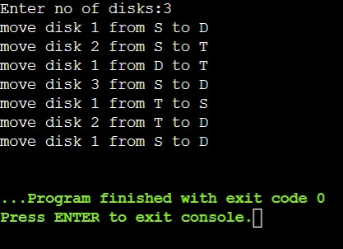

b)

#include<stdio.h> int gcd(int a, int b)

{ if(b!=0) return gcd(b, a%b); else return a;

}

int main()

{ int n1, n2, result; printf("Enter two numbers: "); scanf("%d %d",&n1,&n2); result = gcd(n1,n2); printf("GCD of %d and %d = %d",n1,n2,result); return 0;

}

Result:

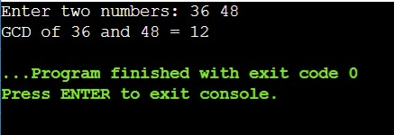

2. Implement Recursive Binary search and Linear search and determine the time required to search an element. Repeat the experiment for different values of N and plot a graph of the time taken versus N.

#include<stdio.h>

#include<time.h>

#include<stdlib.h>

int bin_srch(int[] , int , int, int);

int lin_srch(int [], int, int, int);

int n , a[10000];

int main()

{

int ch , key , search_status ,temp;

clock_t end, start;

unsigned long int i , j;

while(1)

{

printf("\n1:Binary Search\t 2: Linear Search\t 3: Exit\n");

scanf("%d", &ch);

switch(ch)

{

case 1:

n = 1000;

while(n<=5000)

{

for(i=0; i<n ; i++)

a[i] = i;

key = a[n-1];

start = clock();

search_status = bin_srch(a , 0 , n-1 , key);

if(search_status == -1)

printf("\nKey not found");

else

printf("key found at position %d", search_status);

for(j = 0; j<500000000 ; j++)

temp = 38/600;

end = clock();

printf("\nTime for n = %d is %f Secs " , n , (((double)(end-start))/CLOCKS_PER_SEC));

n = n+ 1000;

}

break;

case 2 :

n = 1000;

while(n<=5000)

{

for(i = 0 ; i< n ; i++)

a[i] = i;

key = a[n-1];

start = clock();

search_status = lin_srch(a, 0, n-1, key);

if(search_status == -1)

printf("\nKey Not Found");

else

printf("\nKey found at position %d", search_status);

for(j = 0 ; j<500000000 ; j++)

temp = 38/600;

end = clock();

printf("\nTime for n = %d is %f Secs" , n , (((double)(end-start))/CLOCKS_PER_SEC));

n = n+1000;

}

break;

default:

exit(0);

}

}

}

int bin_srch(int a[], int low , int high , int key)

{

int mid;

if(low > high)

return -1;

mid = (low + high)/2;

if(key == a[mid])

return mid;

if(key< a[mid])

return bin_srch(a , low , mid-1 , key);

else

return bin_srch(a , mid+1 , high , key);

}

int lin_srch(int a[] , int i , int high , int key)

{

if(i > high)

return -1;

if(key == a[i])

return i;

else

return lin_srch(a, i+1 , high ,key);

}

Result:

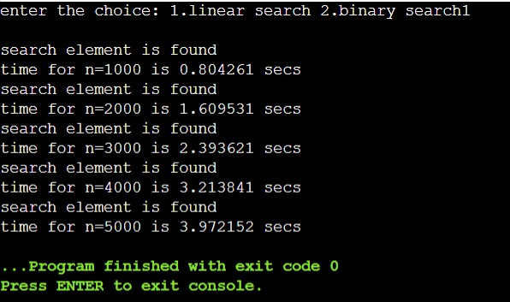

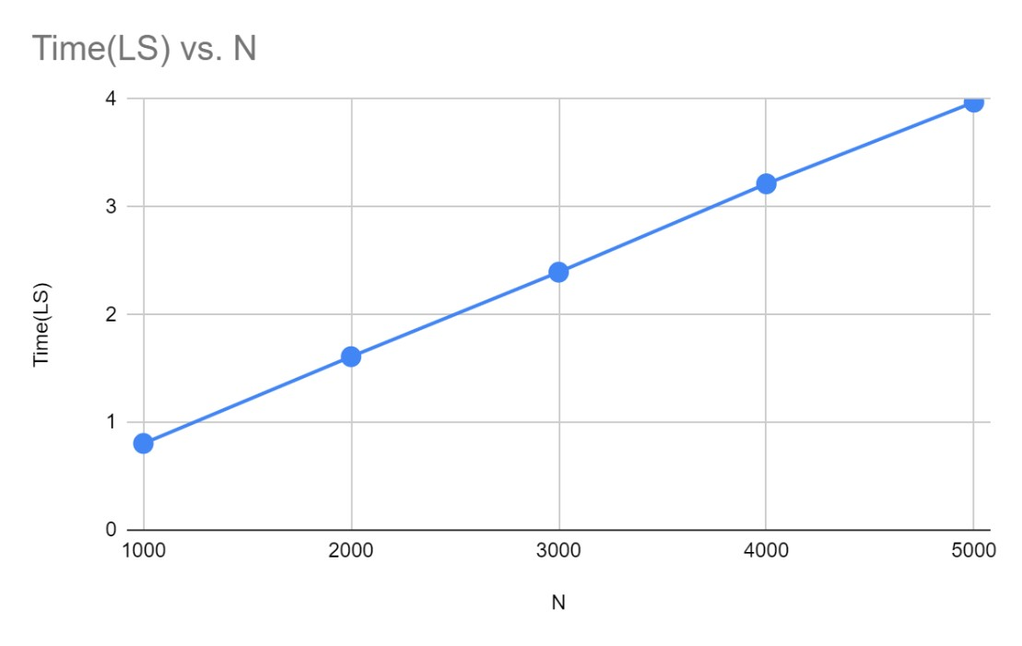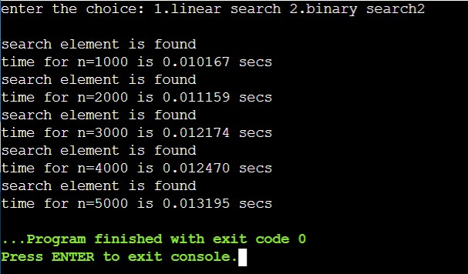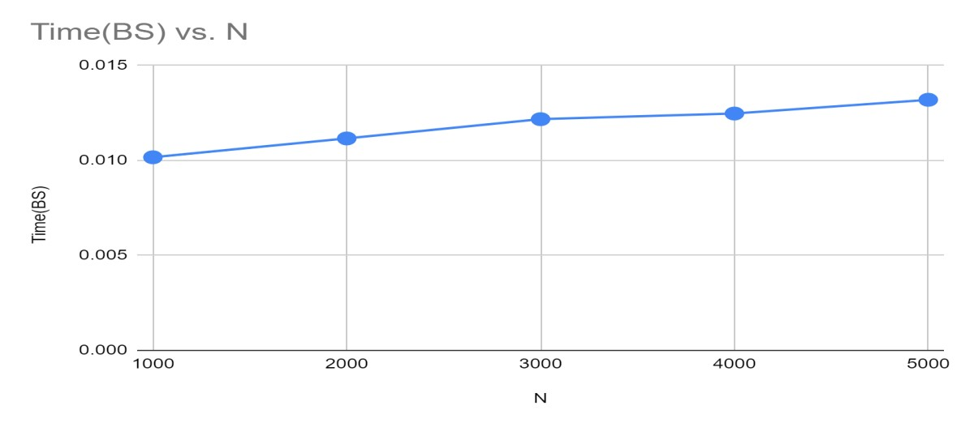

3.Sort a given set of N integer elements using Selection Sort technique and compute its time taken. Run the program for different values of N and record the time taken to sort.

#include<stdio.h>

#include<stdlib.h>

#include<time.h>

void selsort(int n, int a[]);

void main()

{

int a[15000],n,i,j,ch,temp;

clock_t start,end;

while(1)

{

printf("\n 1:For manual entry of N value and array elements ");

printf("\n 2:To display time taken for sorting elements in the range");

printf("\n 3:To exit ");

printf("\n Enter your choice:");

scanf("%d", &ch);

switch(ch)

{

case 1: printf("\nEnter the number of elements: ");

scanf("%d",&n);

printf("\nEnter array elements: ");

for(i=0;i<n;i++)

{

scanf("%d",&a[i]);

}

start=clock();

selsort(n,a);

end=clock();

printf("\nSorted array is: ");

for(i=0;i<n;i++)

printf("%d\t",a[i]);

printf("\n Time taken to sort %d numbers is %f Secs",n, (((double)(end-start))/CLOCKS_PER_SEC));

break;

case 2:

n=500;

while(n<=14500)

{

for(i=0;i<n;i++)

{

a[i]=n-i;

}

start=clock();

selsort(n,a);

//Dummy loop to create delay

for(j=0;j<500000;j++)

{ temp=38/600;}

end=clock();

printf("\n Time taken to sort %d numbers is %f Secs ",n, (((double)(end-start))/CLOCKS_PER_SEC));

n=n+1000;

}

break;

case 3: exit(0);

}

}

}

void selsort(int n,int a[])

{

int i,j,t,small,pos;

for(i=0;i< n-1;i++)

{

pos=i;

small=a[i];

for(j=i+1;j<n;j++)

{

if(a[j]<small)

{

small=a[j];

pos=j;

}

}

t=a[i];

a[i]=a[pos];

a[pos]=t;

}

}

Result:

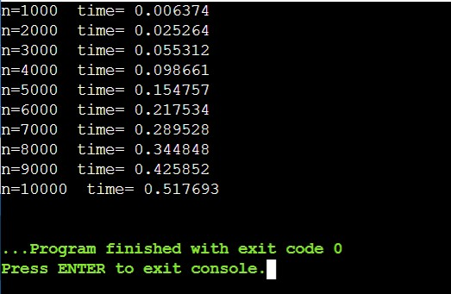

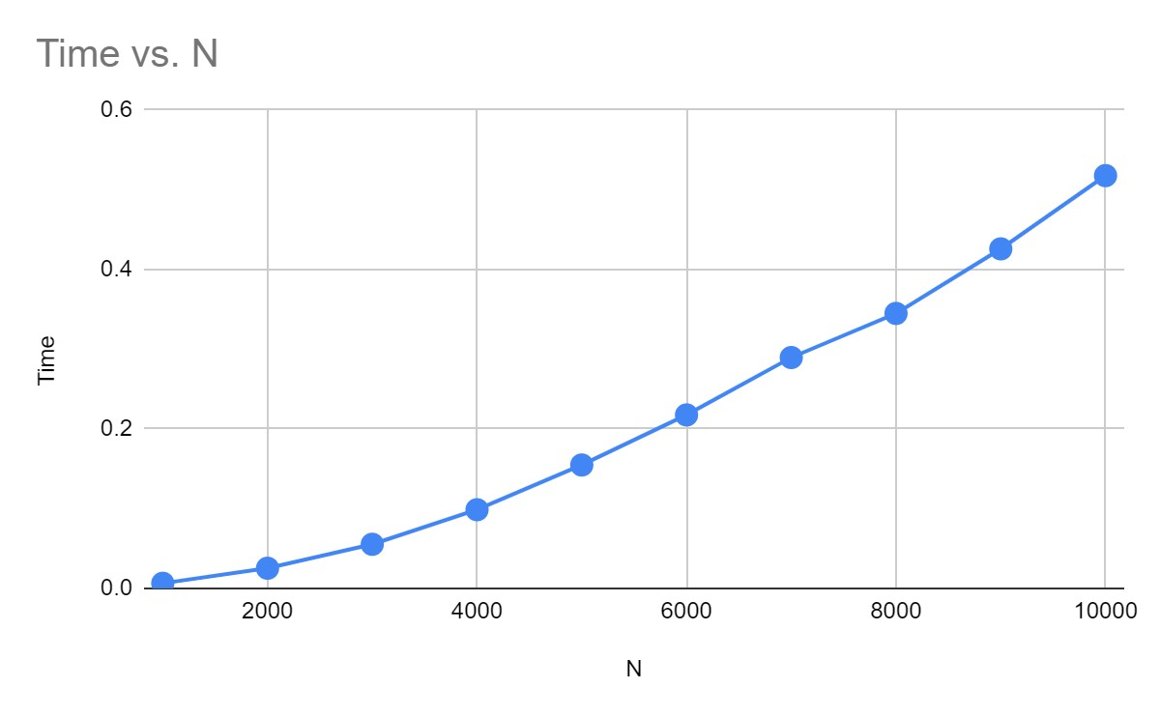

4. Write program to do the following:

1. Print all the nodes reachable from a given starting node in a digraph

using BFS method.

1. Check whether a given graph is connected or not using DFS method.

a) #include<stdio.h>

int a[10][10], n;

void bfs(int);

void main() {

int i, j, src;

printf("\n Enter the no of nodes: ");

scanf("%d", &n);

printf("\n Enter the adjacency matrix: \n");

for(i = 1; i <= n; i++) {

for(j = 1; j <= n; j++) {

scanf("%d", &a[i][j]);

}

}

printf("\n Enter the source node: \t");

scanf("%d", &src);

bfs(src);

getch();

}

void bfs(int src) {

int q[10], f=0, r=-1, vis[10], i, j;

for(j = 1; j <= n; j++) {

vis[j]=0;

}

vis[src] = 1;

r = r + 1;

q[r] = src;

while(f <= r) {

i = q[f];

f = f + 1;

for(j = 1; j <= n; j++) {

if(a[i][j] == 1 && vis[j] != 1) {

vis[j] = 1;

r = r + 1;

q[r] = j;

}

}

}

for(j = 1; j <= n; j++) {

if(vis[j] != 1) {

printf("\n Node %d is not reachable\n", j);

}

else {

printf("\n Node %d is reachable\n", j);

}

b)

#include<stdio.h> #include<conio.h> int a[10][10],n,vis[10]; int dfs(int);

void main()

{ int i,j,src,ans; for(j=1;j<=n;j++)

{

vis[j]=0;

printf("\nenter the no of nodes:\t");

scanf("%d",&n); printf("\nenter the adjacency matrix:\n"); for(i=1;i<=n;i++)

{

for(j=1;j<=n;j++)

{

scanf("%d",&a[i][j]);

}

}

printf("\nenter the source node:\t"); scanf("%d",&src); ans=dfs(src); if(ans==1)

{

printf("\ngraph is connected\n");

}

else

{

printf("\ngragh is not connected\n");

}

getch();

int dfs(int src)

{ int j; vis[src]=1; for(j=1;j<=n;j++)

{

if(a[src][j]==1&&vis[j]!=1)

{ dfs(j);

}

}

for(j=1;j<=n;j++)

{ if(vis[j]!=1)

{

return 0;

}

}

return 1;

}

Result:

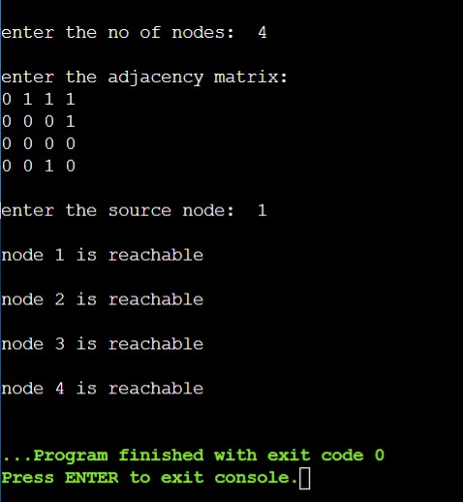

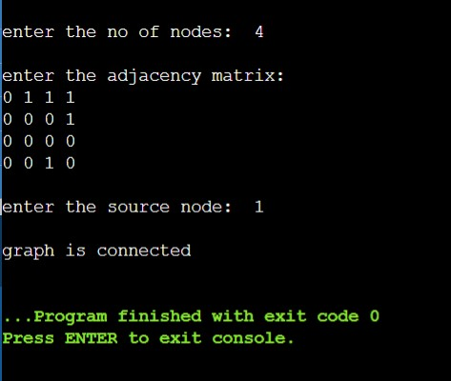

5. Sort a given set of N integer elements using Insertion Sort technique and compute its time taken.

#include<stdio.h>

#include<time.h>

#include<stdlib.h>

void insertionSort(int n, int a[]);

void main()

{

int a[15000],n,i,j,ch,temp;

clock_t start,end;

while(1)

{

printf("\n 1. For manual entry of N value and array elements ");

printf("\n 2. To display time taken for sorting number elements N “);

printf("\n 3. To exit ");

printf("\n Enter your choice : ");

scanf("%d",&ch);

switch(ch)

{

case 1 : printf("\n Enter the number of elements : ");

scanf("%d",&n);

printf("\n Enter the array elements : ");

for(i=0;i<n;i++)

scanf("%d",&a[i]);

start = clock();

insertionSort(n,a);

for(j=0;j<50000000;j++)

temp = 38/600;

end=clock();

printf("\n Sorted array is : ");

for(i=0;i<n;i++)

printf("%d \t",a[i]);

printf("\n Time taken to sort %d elements is %1.10f seconds. \n",n , (((double)(end - start))/CLOCKS_PER_SEC));

break;

case 2 : n = 500;

while(n <= 14500)

{

for(i=0;i<n;i++)

a[i] = rand()%1000;

start = clock();

insertionSort(n,a);

for(j=0;j<500000;j++)

temp = 38/600;

end = clock();

printf("\n Time taken to sort %d elements is %f seconds. \n",n , (((double)(end - start))/CLOCKS_PER_SEC));

n = n + 1000;

}

break;

case 3 : exit(0);

}

}

}

void insertionSort(int n, int a[])

{

for(int step = 1; step < n; step++)

{

int key = a[step];

int j = step - 1;

while (key < a[j] && j >= 0)

{

a[j + 1] = a[j];

--j;

}

a[j + 1] = key;

}

}

Result:

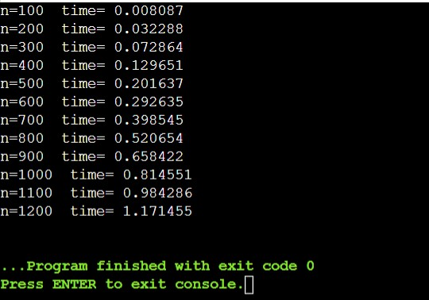

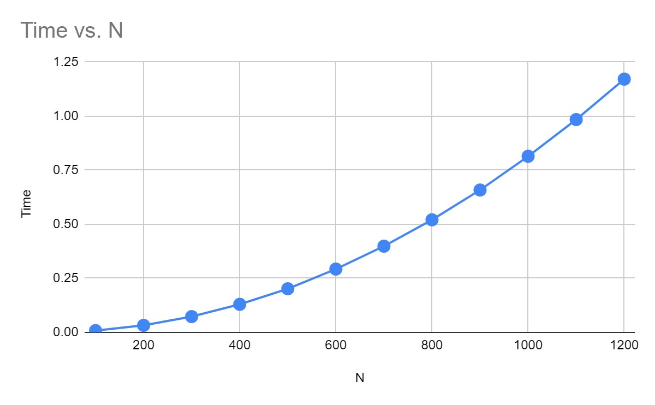

6.Write program to obtain the Topological ordering of vertices in a given digraph.

#include<stdio.h>

#include<conio.h>

void source_removal(int n, int a[10][10]) {

int i, j, k, u, v, top, s[10], t[10], indeg[10], sum;

for(i = 0; i < n; i++) {

sum = 0;

for(j = 0; j < n; j++) {

sum += a[j][i];

}

indeg[i]=sum;

}

top = -1;

for(i=0;i<n;i++) {

if(indeg[i] == 0) {

s[++top] = i;

}

}

k = 0;

while(top != -1) {

u = s[top--];

t[k++] = u;

for(v = 0; v < n; v++) {

if(a[u][v] == 1) {

indeg[v] = indeg[v] - 1;

if(indeg[v] == 0)

s[++top] = v;

}

}

}

for(i = 0;i < n; i++) {

printf("%d\n", t[i]);

}

}

void main() {

int i, j, a[10][10], n;

printf("Enter number of nodes\n");

scanf("%d", &n);

printf("Enter the adjacency matrix\n");

for(i = 0; i < n; i++) {

for(j = 0; j < n; j++) {

scanf("%d", &a[i][j]);

}

}

source_removal(n,a);

}

Output:

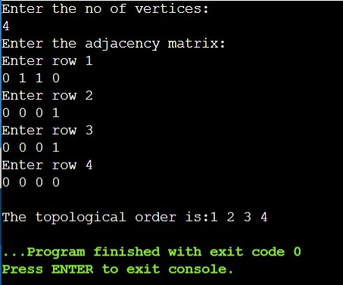

7.Implement Johnson Trotter algorithm to generate permutations.

#include <stdio.h>

#include <stdlib.h>

int flag = 0; int swap(int *a,int *b)

{

int t = *a; *a = *b;

*b = t;

}

int search(int arr[],int num,int mobile)

{ int g;

for(g=0;g<num;g++)

{

if(arr[g] == mobile)

return g+1;

else { flag++;

}

}

return -1;

}

int find_Moblie(int arr[],int d[],int num)

{ int mobile = 0; int mobile_p = 0;

int i;

for(i=0;i<num;i++)

{

if((d[arr[i]-1] == 0) && i != 0)

{

if(arr[i]>arr[i-1] && arr[i]>mobile_p)

{

mobile = arr[i]; mobile_p = mobile;

} else { flag++;

}

}

else if((d[arr[i]-1] == 1) & i != num-1)

{

if(arr[i]>arr[i+1] && arr[i]>mobile_p)

{

mobile = arr[i]; mobile_p = mobile;

} else { flag++;

} } else

{ flag++;

}

}

if((mobile_p == 0) && (mobile == 0)) return 0; else return mobile;

}

void permutations(int arr[],int d[],int num)

{ int i;

int mobile = find_Moblie(arr,d,num); int pos = search(arr,num,mobile); if(d[arr[pos-1]-1]==0) swap(&arr[pos-1],&arr[pos-2]); else

swap(&arr[pos-1],&arr[pos]); for(int i=0;i<num;i++)

{

if(arr[i] > mobile)

{

if(d[arr[i]-1]==0) d[arr[i]-1] = 1; else d[arr[i]-1] = 0; }

}

for(i=0;i<num;i++)

{

printf(" %d ",arr[i]);

}

}

int factorial(int k)

{ int f = 1; int i = 0; for(i=1;i<k+1;i++)

{ f = f*i;

}

return f;

}

int main()

{ int num = 0;

int i;

int j; int z = 0;

printf("Johnson trotter algorithm to find all permutations of given numbers \n");

printf("Enter the number\n"); scanf("%d",&num); int arr[num],d[num]; z = factorial(num);

printf("total permutations = %d",z); printf("\nAll possible permutations are: \n"); for(i=0;i<num;i++)

{ d[i] = 0; arr[i] = i+1; printf(" %d ",arr[i]);

}

printf("\n"); for(j=1;j<z;j++)

{

permutations(arr,d,num); printf("\n");

} return 0;

}

Output:

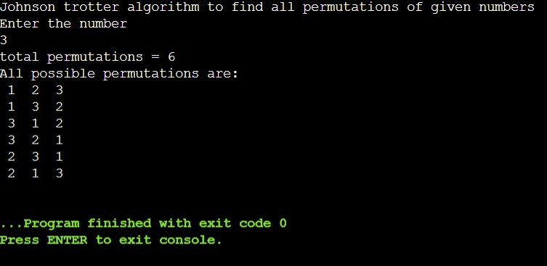

8.Sort a given set of N integer elements using merge sort technique and compute its time taken. Run the program for different values of N and record the time taken to sort.

#include<stdio.h>

#include<stdlib.h> #include<time.h>

void mergesort(int a[],int i,int j); void merge(int a[],int i1,int j1,int i2,int j2); int main()

{

clock_t start,end; int a[3000],n,i;

printf("Enter no of elements:"); scanf("%d",&n);

printf("Enter array elements:"); for(i=0;i<n;i++) a[i] = rand()%1000; start = clock(); mergesort(a,0,n-1); end = clock();

printf("\nSorted array is :"); for(i=0;i<n;i++) printf("%d ",a[i]); printf("\nSeconds taken %lf",(double)(end-start)/CLOCKS_PER_SEC); return 0;

}

void mergesort(int a[],int i,int j)

{

int mid;

if(i<j)

{

mid=(i+j)/2; mergesort(a,i,mid); mergesort(a,mid+1,j); merge(a,i,mid,mid+1,j);

}

}

void merge(int a[],int i1,int j1,int i2,int j2)

{

int temp[3000]; int i,j,k; i=i1; j=i2; k=0;

while(i<=j1 && j<=j2)

{for(int j=0;j<100000;j++); if(a[i]<a[j])

temp[k++]=a[i++]; else temp[k++]=a[j++];

}

while(i<=j1) temp[k++]=a[i++]; while(j<=j2) temp[k++]=a[j++]; for(i=i1,j=0;i<=j2;i++,j++) a[i]=temp[j];

}

Output:

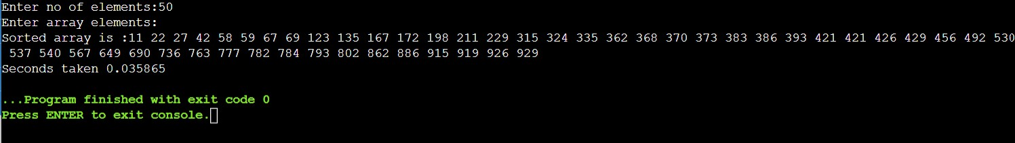

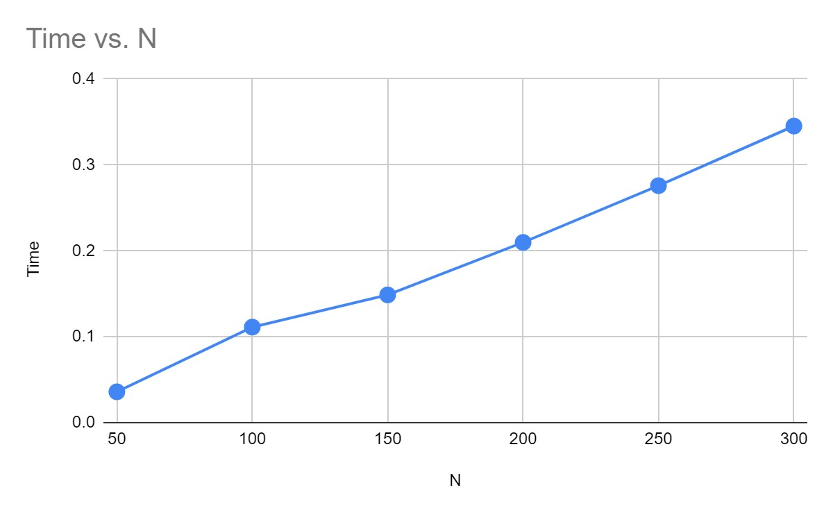

9.Sort a given set of N integer elements using Quick sort technique and compute its time taken.

#include<stdio.h>

#include<time.h> #include<stdlib.h>

void quicksort(int number[5000],int first,int last){ int i, j, pivot, temp; if(first<last){ pivot=first; i=first; j=last; while(i<j){

for(int x=0;x<100000;x++);

while(number[i]<=number[pivot]&&i<last) i++;

while(number[j]>number[pivot]) j--; if(i<j){

temp=number[i]; number[i]=number[j]; number[j]=temp;

}

}

temp=number[pivot]; number[pivot]=number[j]; number[j]=temp; quicksort(number,first,j-1); quicksort(number,j+1,last);

}

}

int main(){ clock_t start,end; int i, count, number[5000]; printf("No. of elements: "); scanf("%d",&count);

printf("Enter %d elements: ", count); for(i=0;i<count;i++) number[i] = rand()%1000; start = clock();

quicksort(number,0,count-1); end = clock();

printf("Order of Sorted elements: "); for(i=0;i<count;i++) printf(" %d",number[i]);

printf("\nSeconds taken %lf",(double)(end-start)/CLOCKS_PER_SEC); return 0;

}

Output:

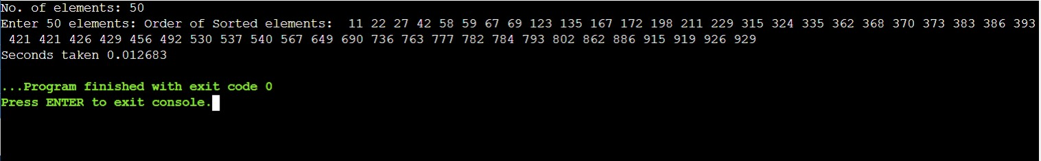

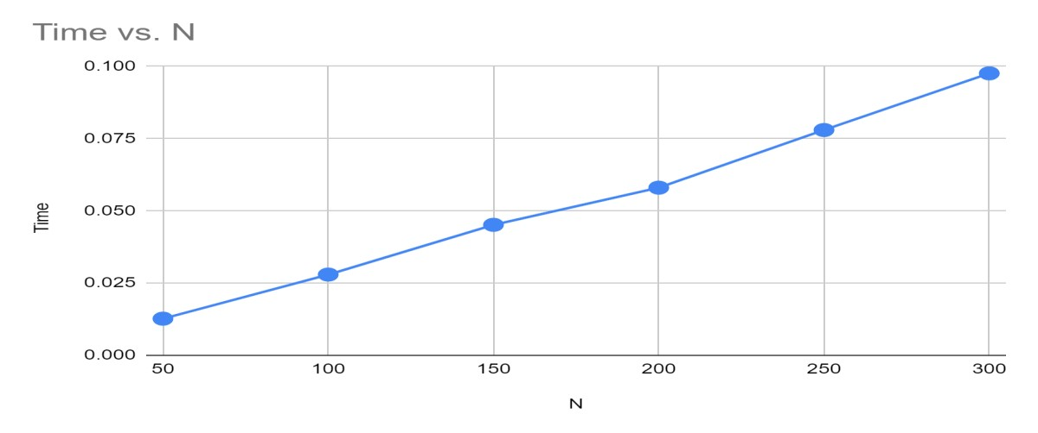

10. Heap Sort

#include <stdio.h>

#include<time.h>

#include<stdlib.h>

void swap(int* a, int* b) {

int temp = *a;

*a = *b;

*b = temp;

}

void heapify(int arr[], int n, int i) {

int largest = i;

int left = 2 * i + 1;

int right = 2 * i + 2;

if (left < n && arr[left] > arr[largest])

largest = left;

if (right < n && arr[right] > arr[largest])

largest = right;

if (largest != i) {

swap(&arr[i], &arr[largest]);

heapify(arr, n, largest);

}

}

void heapSort(int arr[], int n) {

for (int i = n / 2 - 1; i >= 0; i--)

heapify(arr, n, i);

for (int i = n - 1; i >= 0; i--) {

swap(&arr[0], &arr[i]);

heapify(arr, i, 0);

}

}

int main() {

int arr[15000], n, i, j, ch, temp;

clock_t start, end;

while(1) {

printf("\n1:For manual entry of N value and array elements");

printf("\n2:To display time taken for sorting number of elements N in the range 500 to 14500");

printf("\n3:To exit");

printf("\nEnter your choice:");

scanf("%d", &ch);

switch(ch) {

case 1: printf("\nEnter the number of elements: ");

scanf("%d", &n);

printf("\nEnter array elements: ");

for(i = 0; i < n; i++) {

scanf("%d", &arr[i]);

}

start = clock();

heapSort(arr, n);

end = clock();

printf("\nSorted array is: ");

for(i = 0; i < n; i++)

printf("%d\t", arr[i]);

printf("\n Time taken to sort %d numbers is %f Secs", n, (((double)(end - start))/CLOCKS_PER_SEC));

break;

case 2:

n = 500;

while(n <= 14500) {

for(i = 0; i < n; i++) {

//a[i]=random(1000);

arr[i] = n - i;

}

start = clock();

heapSort(arr, n);

//Dummy loop to create delay

for(j = 0; j < 500000; j++) {

temp = 38/600;

}

end = clock();

printf("\n Time taken to sort %d numbers is %f Secs", n, (((double)(end-start))/CLOCKS_PER_SEC));

n = n + 1000;

}

break;

case 3: exit(0);

}

getchar();

}

}

Output :

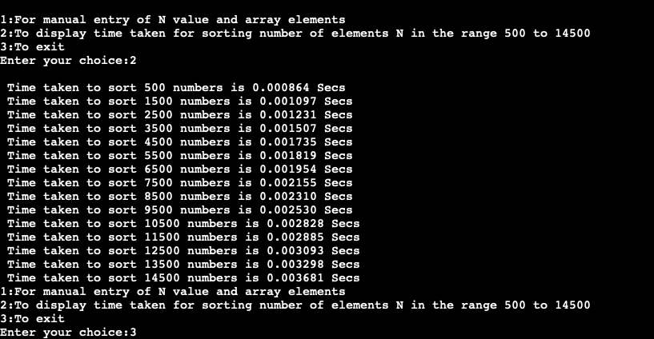

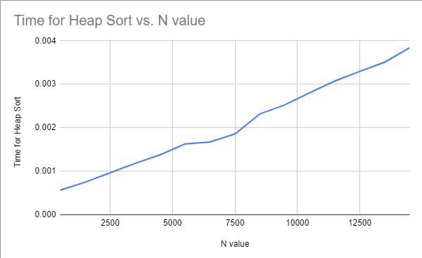Graph :

11. Implement Warshall’s algorithm using dynamic programming

#include<stdio.h>

#include<conio.h>

#include<math.h>

int max(int,int);

void warshal(int p[10][10],int n)

{

int i,j,k;

for(k=1;k<=n;k++)

for(i=1;i<=n;i++)

for(j=1;j<=n;j++)

p[i][j]=max(p[i][j],p[i][k]&&p[k][j]);

}

int max(int a,int b)

{ ;

if(a>b)

return(a);

else

return(b);

}

void main()

{

int p[10][10]={0},n,e,u,v,i,j;

printf("n Enter the number of vertices:");

scanf("%d",&n);

printf("n Enter the number of edges:");

scanf("%d",&e);

for(i=1;i<=e;i++)

{

printf("n Enter the end vertices of edge %d:",i);

scanf("%d%d",&u,&v);

p[u][v]=1;

}

printf("n Matrix of input data: n");

for(i=1;i<=n;i++)

{

for(j=1;j<=n;j++)

printf("%dt",p[i][j]);

printf("n");

}

warshal(p,n);

printf("n Transitive closure: n");

for(i=1;i<=n;i++)

{

for(j=1;j<=n;j++)

printf("%dt",p[i][j]);

printf("n");

}

getch();

}

Output :

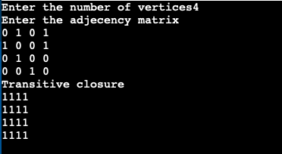

|  |
| --- |
| 12. Implement 0/1 Knapsack problem using dynamic programming. |
| #include<stdio.h>  #include<conio.h>  void knapsack();  int max(int,int);  int i , j, n, m, p[10], w[10], v[10][10];  void main() {  clrscr();  printf("\nEnter the num of items: \t");  scanf("%d", &n);  printf("\nEnter the weight of the each item: \n");  for(i = 1; i <= n; i++) {  scanf("%d", &w[i]);  }  printf("\nEnter the profit of each item: \n");  for(i = 1; i <= n; i++) {  scanf("%d", &p[i]);  }    printf("\nEnter the knapsack&'s capacity: \t");  scanf("%d", &m);  knapsack();  getch();  }  void knapsack() {  int x[10];  for(i = 0; i <= n; i++) {  for(j = 0; j <= m; j++) {  if(i == 0 || j == 0) {  v[i][j] = 0;  }  else if(j - w[i] < 0) {  v[i][j] = v[i - 1][j];  }  else {  v[i][j] = max(v[i - 1][j], v[i - 1][j - w[i]] + p[i]);  }  }  }  printf("\nThe output is: \n");  for(i = 0; i <= n; i++) {  for(j = 0; j <= m; j++) {  printf("%d\t", v[i][j]);  }  printf("\n\n");  }  printf("\nThe optimal solution is %d", v[n][m]);  printf("\nThe solution vector is: \n");  for(i = n; i >= 1; i--) {  if(v[i][m] != v[i - 1][m]) {  x[i] = 1;  m = m - w[i];  }  else {  x[i] = 0;  }  }  for(i = 1; i <= n; i++) {  printf("%d\t", x[i]);  }  }  int max(int x, int y) {  if(x > y) {  return x;  }  else {  return y;  }  }  Output : |
| 13. Implement All Pair Shortest paths problem using Floyd’s Algorithm |

#include<stdio.h>

#include<conio.h>

int a[10][10], n;

void floyds();

int min(int,int);

void main() {

int i, j;

clrscr();

printf("\nEnter the num of vertices: \t");

scanf("%d", &n);

printf("\nEnter the cost matrix: \n");

for(i = 1; i <= n; i++) {

for(j = 1; j <= n; j++) {

scanf("%d", &a[i][j]);

}

}

floyds();

getch();

}

void floyds() {

int i, j, k;

for(k = 1; k <= n; k++) {

for(i = 1; i <=n; i++) {

for(j = 1; j <= n; j++) {

a[i][j] = min(a[i][j], a[i][k] + a[k][j]);

}

}

}

printf("\nAll pair shortest path matrix is: \n");

for(i = 1; i <= n; i++) {

for(j = 1; j <= n; j++) {

printf("%d\t", a[i][j]);

}

printf("\n\n");

}

}

int min(int x, int y) {

if(x < y) {

return x;

}

else {

return y;

}

}

Output :

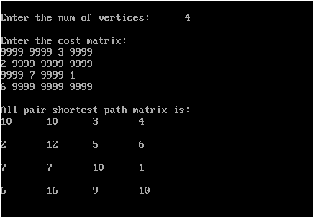

14. Minimal spanning tree using Kruskal’s algorithm

#include<stdio.h>

void kruskals();

int c[10][10], n;

void main() {

int i, j;

printf("\nEnter the num of vertices: \t");

scanf("%d", &n);

printf("\nEnter the cost matrix: \n");

for(i = 1; i <= n; i++) {

for(j = 1; j <= n; j++) {

scanf("%d", &c[i][j]);

} }

kruskals();

}

void kruskals() {

int i, j, u, v, a, b, min;

int ne = 0, mincost = 0;

int parent[10];

for(i = 1; i <= n; i++)

parent[i] = 0;

while(ne != n - 1) {

min = 9999;

for(i = 1; i <= n; i++) {

for(j = 1; j <= n; j++) {

if(c[i][j] < min) {

min = c[i][j];

u = a = i;

v = b = j;

}}}

while(parent[u] != 0)

u = parent[u];

while(parent[v] != 0)

v = parent[v];

if(u != v) {

printf("\n%d----->%d = %d\n", a, b, min);

parent[v] = u;

ne = ne + 1;

mincost = mincost + min;

}

c[a][b] = c[b][a] = 9999;

}

printf("\nmincost = %d", mincost);

}

Output :

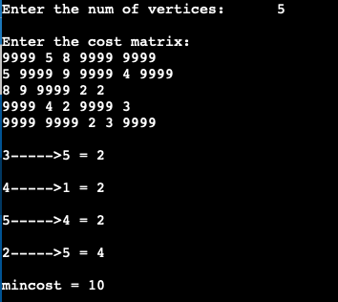

15. Find Minimum Cost Spanning Tree of a given undirected graph using Prim’s algorithm.

#include<stdio.h>

#include<conio.h>

void prims();

int c[10][10], n;

void main() {

int i, j;

printf("\n Enter the num of vertices: \t");

scanf("%d", &n);

printf("\n Enter the cost matrix: \n");

for(i = 1; i <= n; i++) {

for(j = 1; j <= n; j++) {

scanf("%d", &c[i][j]);

}

}

prims();

getch();

}

void prims() {

int i, j, u, v, min;

int ne = 0, mincost = 0;

int elec[10];

for(i = 1; i <= n; i++) {

elec[i] = 0;

}

elec[1] = 1;

while(ne != n - 1) {

min = 9999;

for(i = 1; i <= n; i++) {

for(j = 1; j <= n; j++) {

if(elec[i] == 1) {

if(c[i][j] < min) {

min=c[i][j];

u = i;

v = j;

}

}

}

}

if(elec[v] != 1) {

printf("\n%d-----> %d = %d\n", u, v, min);

elec[v] = 1;

ne = ne + 1;

mincost = mincost + min;

}

c[u][v] = c[v][u] = 9999;

}

printf("\n mincost = %d", mincost);

}

Output :

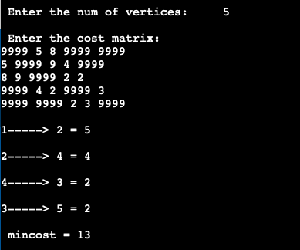

16 . From a given vertex in a weighted connected graph, find shortest paths to other vertices using Dijkstra’s algorithm.

#include<stdio.h>

void dijkstras();

int c[10][10], n, src;

void main() {

int i,j;

printf("\nEnter the num of vertices: \t");

scanf("%d", &n);

printf("\nEnter the cost matrix: \n");

for(i = 1; i <= n; i++) {

for(j = 1; j <= n; j++) {

scanf("%d", &c[i][j]);

}

}

printf("\nEnter the source node: \t");

scanf("%d", &src);

dijkstras();

}

void dijkstras() {

int vis[10], dist[10], u, j, count, min;

for(j = 1; j <= n; j++) {

dist[j] = c[src][j];

}

for(j = 1; j <= n; j++) {

vis[j] = 0;

}

dist[src] = 0;

vis[src] = 1;

count = 1;

while(count != n) {

min = 9999;

for(j = 1; j <= n; j++) {

if(dist[j] < min && vis[j] != 1) {

min = dist[j];

u = j;

}

}

vis[u] = 1;

count++;

for(j = 1; j <= n; j++) {

if(min + c[u][j] < dist[j] && vis[j] != 1) {

dist[j] = min + c[u][j];

}

}

}

printf("\nThe shortest distance is: \n");

for(j = 1; j <= n; j++) {

printf("\n%d----->%d = %d", src, j, dist[j]);

}

}

Output :

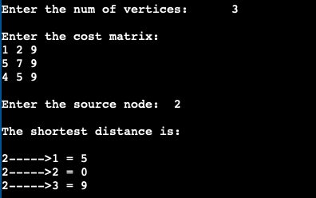

17. Implement “Sum of Subsets” using Backtracking. “Sum of Subsets” problem: Find a subset of a given set S = {s1,s2,……,sn} of n positive integers whose sum is equal to a given positive integer d. For example, if S = {1,2,5,6,8} and d = 9 there are two solutions {1,2,6} and {1,8}. A suitable message is to be displayed if the given problem instance doesn’t have a solution.

#include<stdio.h>

#include<conio.h>

int count, w[10], d, x[10];

void subset(int cs, int k, int r) {

int i;

x[k] = 1;

if(cs + w[k] == d) {

printf("\nSubset solution = %d\n", ++count);

for(i = 0; i <= k; i++) {

if(x[i] == 1)

printf("%d", w[i]);

}

} else if(cs + w[k] + w[k+1] <= d)

subset(cs + w[k], k + 1, r - w[k]);

if((cs + r - w[k] >= d) && (cs + w[k + 1]) <= d) {

x[k] = 0;

subset(cs, k + 1, r - w[k]);

}

}

void main() {

int sum = 0,i,n;

printf("Enter the number of elements: \n");

scanf("%d", &n);

printf("Enter the elements in ascending order: \n");

for(i = 0; i < n ; i++)

scanf("%d", &w[i]);

printf("Enter the required sum: \n");

scanf("%d", &d);

for(i = 0; i < n; i++)

sum += w[i];

if(sum < d) {

printf("No solution exists\n");

return;

}

printf("The solution is: \n");

count = 0;

subset(0, 0, sum);

getch();

}

Output :

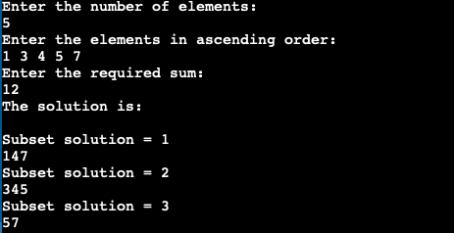

18. N-Queens problem using backtracking

#include<stdio.h>

#include<conio.h>

void nqueens(int n) {

int k, x[20], count = 0;

k = 1;

x[k] = 0;

while(k != 0) {

x[k]++;

while(place(x, k) != 1 && x[k] <= n)

x[k]++;

if(x[k] <= n) {

if(k == n) {

printf("\nSolution is %d\n", ++count);

printf("Queen\t\tPosition\n");

for(k = 1; k = n; k++)

printf("%d\t\t%d\n", k, x[k]);

} else {

k++;

x[k] = 0;

}

} else

k--;

}

}

int place(int x[], int k) {

int i;

for(i = 1; i <= k - 1; i++) {

if(i + x[i] == k + x[k]||i - x[i] == k - x[k]||x[i] == x[k])

return 0;

}

return 1;

}

void main() {

int n;

clrscr();

printf("Enter the number of Queens: \n");

scanf("%d", &n);

nqueens(n);

getch();

}

Output :

