727721eucs183

Vishnu.R

1.

**package** com.ca1;

**import** org.openqa.selenium.By;

**import** org.openqa.selenium.WebDriver;

**import** org.openqa.selenium.WebElement;

**import** org.openqa.selenium.chrome.ChromeDriver;

**import** org.openqa.selenium.chrome.ChromeOptions;

**import** io.github.bonigarcia.wdm.WebDriverManager;

**public** **class** ca1{

**public** **static** **void** main(String[] args) {

// **TODO** Auto-generated method stub

ChromeOptions co=**new** ChromeOptions();

co.addArguments ("--remote-allow-origins=*");

WebDriverManager.*chromedriver*().setup ();

WebDriver driver=**new** ChromeDriver(co);

driver.get ("https://www.amazon.in/");

driver.manage().window().maximize() ;

String currentTitle=driver.getTitle();

System.***out***.println(currentTitle);

String expectedTitle="Online Shopping site in India: Shop Online for Mobiles, Books, Watches, Shoes and More - Amazon.in";

**if**(currentTitle.equals(expectedTitle)) {

System.***out***.println("Title Matched");

}

**else** {

System.***out***.println("Title not Matched");

}

WebElement txtBoxl=driver.findElement(By.*xpath*("//*[@id=\"twotabsearchtextbox\"]"));

txtBoxl.sendKeys("macbook");

driver.findElement(By.*xpath*("//*[@id=\"nav-search-submit-button\"]")).click();

//displaying 5 products

String txt1=driver.findElement(By.*xpath*("//*[@id=\"search\"]/div[1]/div[1]/div/span[1]/div[1]/div[3]/div/div/div/div/div/div/div/div[2]/div/div/div[1]/h2/a/span")).getText();

System.***out***.println(txt1);

String txt2=driver.findElement(By.*xpath*("//*[@id=\"search\"]/div[1]/div[1]/div/span[1]/div[1]/div[4]/div/div/div/div/div/div/div/div[2]/div/div/div[1]/h2/a/span")).getText();

System.***out***.println(txt2);

String txt3=driver.findElement(By.*xpath*("//*[@id=\"search\"]/div[1]/div[1]/div/span[1]/div[1]/div[5]/div/div/div/div/div/div[2]/div/div/div[1]/h2/a/span")).getText();

System.***out***.println(txt3);

String txt4=driver.findElement(By.*xpath*("//*[@id=\"search\"]/div[1]/div[1]/div/span[1]/div[1]/div[6]/div/div/div/div/div/div[2]/div/div/div[1]/h2/a/span")).getText();

System.***out***.println(txt4);

String txt5=driver.findElement(By.*xpath*("//*[@id=\"search\"]/div[1]/div[1]/div/span[1]/div[1]/div[7]/div/div/div/div/div/div[2]/div/div/div[1]/h2/a/span")).getText();

System.***out***.println(txt5);

//filter

driver.findElement(By.*xpath*("//*[@id=\"p_36/7252032031\"]/span/a/span")).click();

driver.findElement(By.*xpath*("//*[@id=\"p_n_pattern_browse-bin/1464446031\"]/span/a/span")).click();

}

}

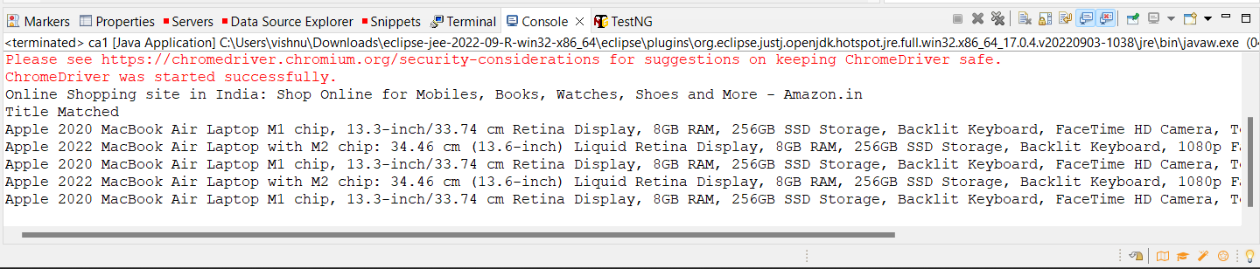

2.

package com.q2;

import org.openqa.selenium.By;

import org.openqa.selenium.WebDriver;

import org.openqa.selenium.WebElement;

import org.openqa.selenium.chrome.ChromeDriver;

import org.openqa.selenium.chrome.ChromeOptions;

import io.github.bonigarcia.wdm.WebDriverManager;

public class q2 {

public static void main(String[] args) {

// TODO Auto-generated method stub

ChromeOptions co=new ChromeOptions();

co.addArguments ("--remote-allow-origins=*");

WebDriverManager.chromedriver().setup ();

WebDriver driver=new ChromeDriver(co);

driver.get ("https://www.amazon.in/");

driver.manage().window().maximize() ;

String currentTitle=driver.getTitle();

System.out.println(currentTitle);

String expectedTitle="Online Shopping site in India: Shop Online for Mobiles, Books, Watches, Shoes and More - Amazon.in";

if(currentTitle.equals(expectedTitle)) {

System.out.println("Title Matched");

}

else {

System.out.println("Title not Matched");

}

WebElement txtBoxl=driver.findElement(By.xpath("//*[@id=\"twotabsearchtextbox\"]"));

txtBoxl.sendKeys("macbook");

driver.findElement(By.xpath("//*[@id=\"nav-search-submit-button\"]")).click();

//displaying 5 products

String txt1=driver.findElement(By.xpath("//*[@id=\"search\"]/div[1]/div[1]/div/span[1]/div[1]/div[3]/div/div/div/div/div/div/div/div[2]/div/div/div[1]/h2/a/span")).getText();

System.out.println(txt1);

String txt2=driver.findElement(By.xpath("//*[@id=\"search\"]/div[1]/div[1]/div/span[1]/div[1]/div[4]/div/div/div/div/div/div/div/div[2]/div/div/div[1]/h2/a/span")).getText();

System.out.println(txt2);

String txt3=driver.findElement(By.xpath("//*[@id=\"search\"]/div[1]/div[1]/div/span[1]/div[1]/div[5]/div/div/div/div/div/div[2]/div/div/div[1]/h2/a/span")).getText();

System.out.println(txt3);

String txt4=driver.findElement(By.xpath("//*[@id=\"search\"]/div[1]/div[1]/div/span[1]/div[1]/div[6]/div/div/div/div/div/div[2]/div/div/div[1]/h2/a/span")).getText();

System.out.println(txt4);

String txt5=driver.findElement(By.xpath("//*[@id=\"search\"]/div[1]/div[1]/div/span[1]/div[1]/div[7]/div/div/div/div/div/div[2]/div/div/div[1]/h2/a/span")).getText();

System.out.println(txt5);

//filter

driver.findElement(By.xpath("//*[@id=\"p_36/7252032031\"]/span/a/span")).click();

driver.findElement(By.xpath("//*[@id=\"p_n_pattern_browse-bin/1464446031\"]/span/a/span")).click();

}

}

Output

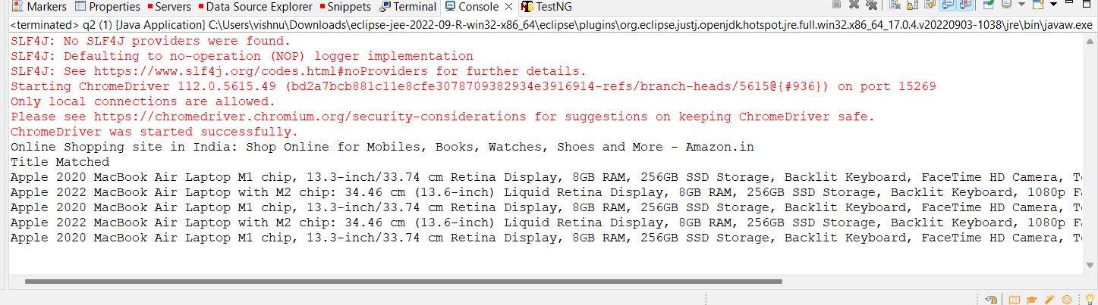

3.

**package** com.test.q3;

**import** org.openqa.selenium.By;

**import** org.openqa.selenium.WebDriver;

**import** org.openqa.selenium.WebElement;

**import** org.openqa.selenium.chrome.ChromeDriver;

**import** org.openqa.selenium.chrome.ChromeOptions;

**import** io.github.bonigarcia.wdm.WebDriverManager;

**public** **class** q3{

**public** **static** **void** main(String[] args) {

ChromeOptions co=**new** ChromeOptions();

co.addArguments ("--remote-allow-origins=*");

WebDriverManager.chromedriver().setup ();

WebDriver driver=**new** ChromeDriver(co);

driver.get ("https://www.amazon.in/");

driver.manage().window().maximize() ;

String currentTitle=driver.getTitle();

System.out.println(currentTitle);

String expectedTitle="Online Shopping site in India: Shop Online for Mobiles, Books, Watches, Shoes and More - Amazon.in";

**if**(currentTitle.equals(expectedTitle)) {

System.out.println("Title Matched");

}

**else** {

System.out.println("Title not Matched");

}

driver.findElement(By.xpath("//*[@id=\"nav-link-accountList\"]")).click();

WebElement txtBoxl=driver.findElement(By.xpath("//*[@id=\"ap_email\"]"));

txtBoxl.sendKeys("vishnujasprit@gmail.com");

driver.findElement(By.xpath("//*[@id=\"continue\"]")).click();

WebElement txtBox2=driver.findElement(By.xpath("//*[@id=\"ap_password\"]"));

txtBox2.sendKeys("vishnu@93");

driver.findElement(By.xpath("//*[@id=\"signInSubmit\"]")).click();

driver.findElement(By.xpath("//*[@id=\"nav-link-accountList\"]")).click();

driver.findElement(By.xpath("//*[@id=\"a-page\"]/div[2]/div/div[2]/div[1]/a/div/div")).click();

driver.findElement(By.xpath("//*[@id=\"a-autoid-2-announce\"]")).click();

driver.findElement(By.xpath("//*[@id=\"ordersInPackage-container\"]/div/div/a[1]")).click();

}

Output

