Somnath Kumar A

727721eucs147

CC1:-

1)

<project xmlns="http://maven.apache.org/POM/4.0.0" xmlns:xsi="http://www.w3.org/2001/XMLSchema-instance" xsi:schemaLocation="http://maven.apache.org/POM/4.0.0 https://maven.apache.org/xsd/maven-4.0.0.xsd">

<modelVersion>4.0.0</modelVersion>

<groupId>com.test</groupId>

<artifactId>test</artifactId>

<version>0.0.1-SNAPSHOT</version>

<dependencies>

<!-- https://mvnrepository.com/artifact/org.seleniumhq.selenium/selenium-java -->

<dependency>

<groupId>org.seleniumhq.selenium</groupId>

<artifactId>selenium-java</artifactId>

<version>4.9.0</version>

</dependency>

<!-- https://mvnrepository.com/artifact/io.github.bonigarcia/webdrivermanager -->

<dependency>

<groupId>io.github.bonigarcia</groupId>

<artifactId>webdrivermanager</artifactId>

<version>5.3.2</version>

</dependency>

<!-- https://mvnrepository.com/artifact/org.testng/testng -->

<dependency>

<groupId>org.testng</groupId>

<artifactId>testng</artifactId>

<version>7.7.1</version>

<scope>test</scope>

</dependency>

<dependency>

<groupId>com.aventstack</groupId>

<artifactId>extentreports</artifactId>

<version>3.1.3</version>

</dependency>

</dependencies>

</project>

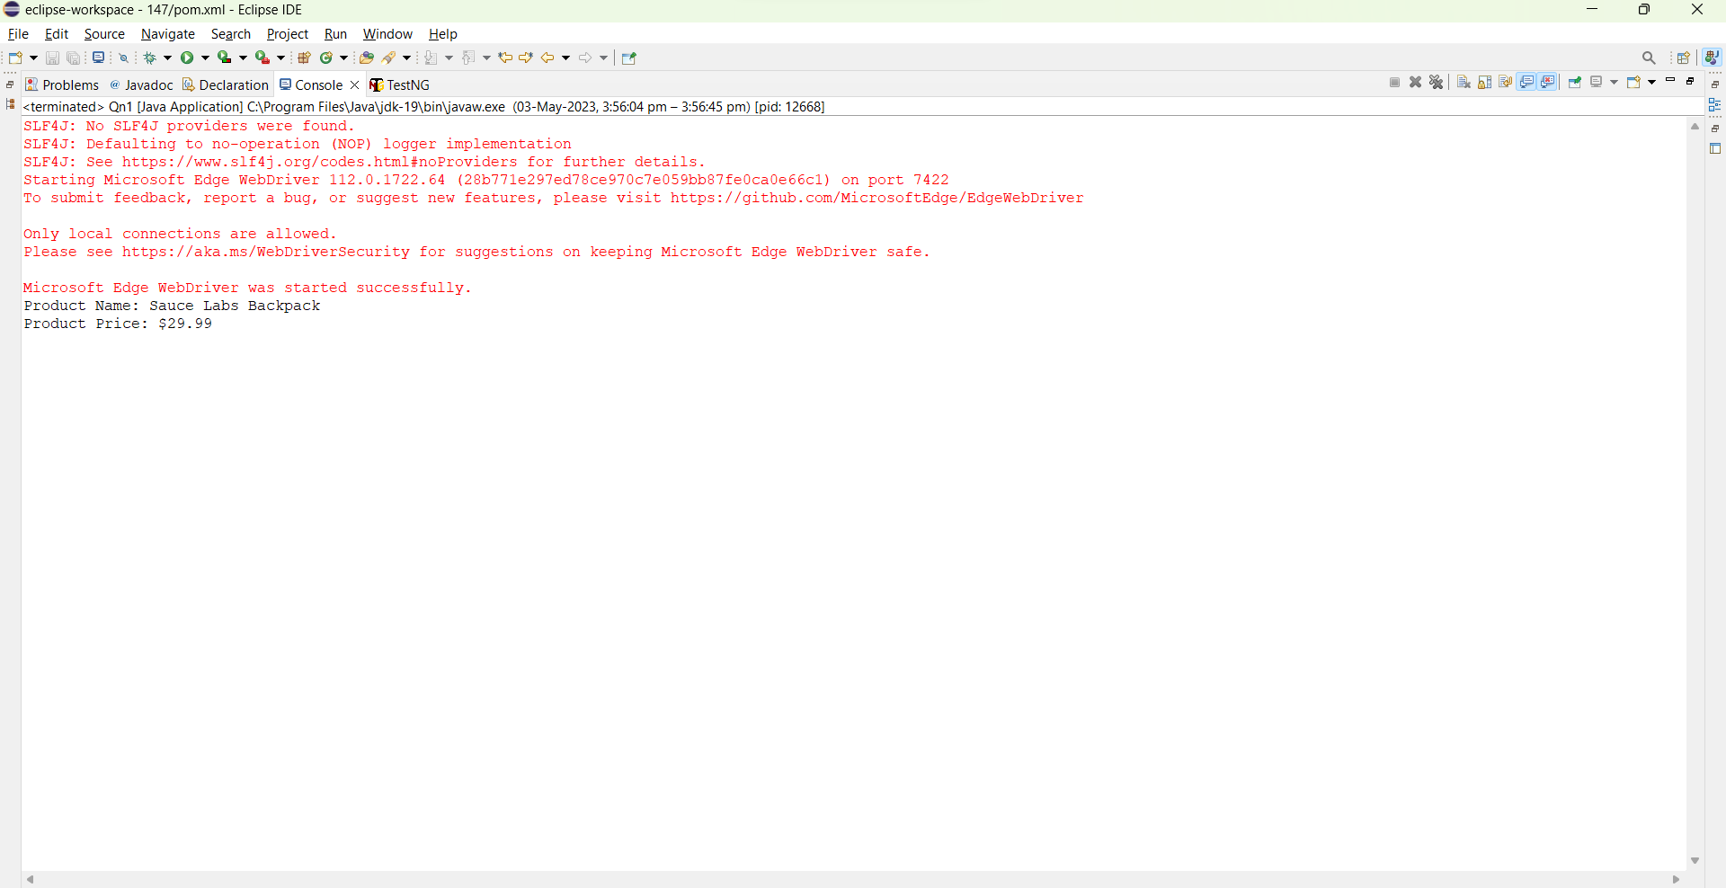

2)

**package** CC1;

**import** org.openqa.selenium.By;

**import** org.openqa.selenium.WebDriver;

**import** org.openqa.selenium.chrome.ChromeDriver;

**import** org.openqa.selenium.chrome.ChromeOptions;

**import** io.github.bonigarcia.wdm.WebDriverManager;

**public** **class** Qn2 {

**public** **static** **void** main(String[] args) **throws** InterruptedException {

ChromeOptions co=**new** ChromeOptions();

co.addArguments("--remote-allow-origins=*");

WebDriverManager.*chromedriver*().setup();

WebDriver driver;

driver=**new** ChromeDriver();

driver.get("https://www.saucedemo.com/");

driver.manage().window().maximize();

Thread.*sleep*(4000);

driver.findElement(By.*xpath*("//*[@id=\"user-name\"]")).click();

driver.findElement(By.*xpath*("//*[@id=\"user-name\"]")).sendKeys("standard_user");

driver.findElement(By.*xpath*("//*[@id=\"password\"]")).click();

driver.findElement(By.*xpath*("//*[@id=\"password\"]")).sendKeys("secret_sauce");

driver.findElement(By.*xpath*("//*[@id=\"login-button\"]")).click();

Thread.*sleep*(4000);

driver.findElement(By.*xpath*("//*[@id=\"header_container\"]/div[2]/div/span/select")).click();

driver.findElement(By.*xpath*("//*[@id=\"header_container\"]/div[2]/div/span/select/option[1]")).click();

String f1 = driver.findElement(By.*xpath*("//*[@id=\"header_container\"]/div[2]/div/span/select")).getText();

Thread.*sleep*(3000);

System.***out***.println("Filtering from: " + f1);

Thread.*sleep*(3000);

String p1 = driver.findElement(By.*xpath*("//*[@id=\"item_4_title_link\"]/div")).getText();

System.***out***.println("First product name: " + p1);

driver.findElement(By.*xpath*("//*[@id=\"header_container\"]/div[2]/div/span/select")).click();

driver.findElement(By.*xpath*("//*[@id=\"header_container\"]/div[2]/div/span/select/option[2]")).click();

String f2 = driver.findElement(By.*xpath*("//*[@id=\"header_container\"]/div[2]/div/span/select")).getText();

Thread.*sleep*(3000);

System.***out***.println("Filtering from: " + f2);

String p2 = driver.findElement(By.*xpath*("//*[@id=\"item_3_title_link\"]/div")).getText();

Thread.*sleep*(3000);

System.***out***.println("First product name: " + p2);

driver.findElement(By.*xpath*("//*[@id=\"header_container\"]/div[2]/div/span/select")).click();

driver.findElement(By.*xpath*("//*[@id=\"header_container\"]/div[2]/div/span/select/option[3]")).click();

Thread.*sleep*(3000);

String f3 = driver.findElement(By.*xpath*("//*[@id=\"header_container\"]/div[2]/div/span/select")).getText();

Thread.*sleep*(3000);

System.***out***.println("Filtering from: " + f3);

String p3 = driver.findElement(By.*xpath*("//*[@id=\"item_3_title_link\"]/div")).getText();

Thread.*sleep*(3000);

System.***out***.println("First product name: " + p3);

driver.findElement(By.*xpath*("//*[@id=\"header_container\"]/div[2]/div/span/select")).click();

driver.findElement(By.*xpath*("//*[@id=\"header_container\"]/div[2]/div/span/select/option[4]")).click();

String f4 = driver.findElement(By.*xpath*("//*[@id=\"header_container\"]/div[2]/div/span/select")).getText();

System.***out***.println("Filtering from: " + f4);

String p4 = driver.findElement(By.*xpath*("//*[@id=\"item_5_title_link\"]/div")).getText();

System.***out***.println("First product name: " + p4);

driver.close();

}

}

