Scalability Audit of ShopSphere
CSA06 – Design and Analysis of Algorithms | CO1 – Assessment Tool 1 | Question 1
Student Name | ____________________
Student Reg. No. | ____________________
Course | CSA06 – Design and Analysis of Algorithms
Source code | Source_Code/shopsphere_audit.py
Conventions. $log$ means $\log_{2}$. “Basic operation” = the operation whose count dominates the running time. The paper says the servers execute “10 basic operations per second”, but the exponent was lost in the PDF; this report assumes ${10}^{8}$ operations/second and shows in (g) that the conclusions are checked against ${10}^{7}$ and ${10}^{9}$ as well. The nightly window is 10 min = 600 s, i.e. a budget of $6×{10}^{10}$ operations at ${10}^{8}$ ops/s.

(a) Understanding the Problem
Module | Input size | Basic operation | Where it occurs | Expected growth
M1 Duplicate detector | $n$ = number of products | Title + seller comparison (IF Product[i]... = Product[j]...) | Innermost statement, executed once per pair $\left(i,j\right)$, $i<j$ | Quadratic: each product is compared with all later ones, so $≈n^{2}/2$
M2 API rate limiter | $n$ = number of requests (window limit) | Audit(Request[j]) | Body of the FOR j loop; the loop runs $i$ times where $i$ doubles each pass | Linear: the geometric series $1+2+4+…$ is dominated by its last term, so $≈n$ (not $nlogn$)
M3 Product search | $n$ = catalogue size | Key comparison with a catalogue entry | S1: each scanned entry. S2: each probe of the middle entry | S1 linear; S2 logarithmic (the search range halves each step)
M4 Recommendation engine | $n$ = size of the customer–product data | Basic work is the linear merge ($f\left(n\right)=n$) at each recursion node; the count is governed by the recurrence | Combine step after the recursive calls | Current $4T\left(n/2\right)$: quadratic. Redesign $2T\left(n/2\right)$: $nlogn$
M5 Sales analytics | $n$ = number of sales records | Record comparison/move while sorting at each level, $f\left(n\right)=nlogn$ | Sort at every recursion level | Slightly above $nlogn$; each of $logn$ levels costs $nlogn$ at the top, giving $n\log^{2}n$
M5 report generator | $n$ = records | Elementary step counted in $f\left(n\right)$ | Whole routine | $3n^{2}$ term dominates, so quadratic
Justification (brief). In M1 and M2 the dominant operation is the one in the innermost loop body, because every other statement (loop control, i ← i × 2) executes fewer times. In M3 the key comparison is the only operation repeated with the data size. In M4 and M5 the work outside the recursive calls ($n$ and $nlogn$) is the repeated cost that the recurrence adds up.

(b) Analysing the Iterative Modules

M1 – Duplicate-Listing Detector
Basic operation: the comparison inside the inner loop. For a fixed $i$, $j$ runs from $i+1$ to $n−1$, which is $n−1−i$ iterations. Summing over $i=0…n−2$:
$$C_{1}\left(n\right)=\sum_{i=0}^{n−2}{\left(n−1−i\right)}=\left(n−1\right)+\left(n−2\right)+…+1=\frac{\left(n−1\right)n}{2}=\frac{n^{2}−n}{2}.$$
- Time complexity: $C_{1}\left(n\right)=1/2n^{2}−1/2n=Θ\left(n^{2}\right)$. The count is identical in best, average and worst case, because the loops do not depend on the data (MarkDuplicate is called at most once per pair and is not the dominant operation).
- Space complexity: only $i$, $j$ and a counter are used besides the input, so $Θ\left(1\right)$ extra space.
- Check: $n=1000⇒499,500$ comparisons (program: 499,500).

M2 – API Rate Limiter
In the $t$-th pass ($t=0,1,2,…$) the value of $i$ is $2^{t}$, and the inner loop executes $i$ times. The WHILE condition $i<n$ holds as long as $2^{t}<n$, i.e. $t≤⌈\log_{2}n⌉−1$. So the outer loop runs $⌈\log_{2}n⌉$ times and
$$C_{2}\left(n\right)=\sum_{t=0}^{⌈\log_{2}n⌉−1}{2^{t}}=2^{⌈\log_{2}n⌉}−1.$$
Since $n≤2^{⌈\log_{2}n⌉}<2n$ we get $n−1≤C_{2}\left(n\right)≤2n−1$. For $n$ a power of two, $C_{2}\left(n\right)=n−1$.
Is the Θ(n log n) claim correct? No. The team member multiplied (number of outer iterations) × (maximum inner iterations), which is only an upper bound, $O\left(nlogn\right)$. The inner loop runs up to $n$ times only in the last pass; in the earlier passes it runs $n/2,n/4,…$ times, which form a geometric series that sums to about $n$, not to $nlogn$. Formally, $n−1≤C_{2}\left(n\right)≤2n−1$ gives
$$C_{2}\left(n\right)=Θ\left(n\right) \left(\text{tight bound}\right),$$
and $C_{2}\left(n\right)≠Ω\left(nlogn\right)$ because $C_{2}\left(n\right)/\left(nlogn\right)≤2/logn→0$. The claim is a valid (loose) $O$ bound but not a $Θ$ bound.
Verification, n = 1024. $i$ takes the values $1,2,4,8,16,32,64,128,256,512$ (10 passes; $i=1024$ fails $i<n$):
$$1+2+4+…+512=2^{10}−1=1023.$$
The formula gives $2^{⌈\log_{2}1024⌉}−1=2^{10}−1=1023$, and the program counts 1023. The claimed $nlogn=1024⋅10=10,240$ is ten times too large; $1023/1024≈0.999≈n$.
- Space complexity of M2: $Θ\left(1\right)$.

(c) Recurrence for Search Version S2 – Backward Substitution
$$T\left(n\right)=T\left(n/2\right)+1, T\left(1\right)=1, n=2^{k}.$$
$$\begin{matrix}T\left(n\right) & =T\left(n/2\right)+1 \\ & =\left[T\left(n/4\right)+1\right]+1=T\left(n/2^{2}\right)+2 \\ & =\left[T\left(n/8\right)+1\right]+2=T\left(n/2^{3}\right)+3 \\ & ⋮ \\ & =T\left(n/2^{i}\right)+i \left(\text{general step, }i\text{ substitutions}\right).\end{matrix}$$
The recursion stops at $n/2^{i}=1$, i.e. $i=\log_{2}n=k$. Then
$$T\left(n\right)=T\left(1\right)+\log_{2}n=1+\log_{2}n.$$
Exact closed form: $T\left(n\right)=\log_{2}n+1$ for $n=2^{k}$ (in general $⌊\log_{2}n⌋+1$). Check by induction: $T\left(1\right)=\log_{2}1+1=1$; if $T\left(n/2\right)=\log_{2}n$ then $T\left(n\right)=\log_{2}n+1$. Program check: $n=2^{20}⇒T=21$.
Time complexity: $T\left(n\right)=Θ\left(logn\right)$. For $n={10}^{6}$ at most 20 comparisons.
Implementation | Time | Extra space
Iterative binary search (lo, hi, mid) | $Θ\left(logn\right)$ | $Θ\left(1\right)$
Recursive binary search | $Θ\left(logn\right)$ | $Θ\left(logn\right)$, because the call stack reaches depth $⌊\log_{2}n⌋+1$ (measured: 20 for $n={10}^{6}$)

(d) Applying the Master Theorem
For $T\left(n\right)=aT\left(n/b\right)+f\left(n\right)$ compare $f\left(n\right)$ with $n^{\log_{b}a}$:
- $f\left(n\right)=O\left(n^{\log_{b}a−ε}\right)⇒T=Θ\left(n^{\log_{b}a}\right)$.
- $f\left(n\right)=Θ\left(n^{\log_{b}a}\right)⇒T=Θ\left(n^{\log_{b}a}logn\right)$.
- $f\left(n\right)=Ω\left(n^{\log_{b}a+ε}\right)$ and regularity $⇒T=Θ\left(f\left(n\right)\right)$.

M4 – Recommendation engine
 | Current design $T\left(n\right)=4T\left(n/2\right)+n$ | Redesign $T\left(n\right)=2T\left(n/2\right)+n$
$a$ | 4 | 2
$b$ | 2 | 2
$f\left(n\right)$ | $n$ | $n$
$n^{\log_{b}a}$ | $n^{\log_{2}4}=n^{2}$ | $n^{\log_{2}2}=n$
Comparison | $f\left(n\right)=n=O\left(n^{2−ε}\right)$ with $ε=1$ | $f\left(n\right)=Θ\left(n\right)=Θ\left(n^{\log_{b}a}\right)$
Case | Case 1 | Case 2
Result | $Θ\left(n^{2}\right)$ | $Θ\left(nlogn\right)$
Exact solutions for $n=2^{k}$ (verified by program): current $T\left(n\right)=2n^{2}−n$; redesign $T\left(n\right)=n\log_{2}n+n$.
Effect of doubling the data.
- Current: $T\left(2n\right)/T\left(n\right)→4$ (quadratic), so doubling the data quadruples the work (measured 4.00).
- Redesign: $T\left(2n\right)/T\left(n\right)=\frac{2n\left(logn+1\right)+2n}{nlogn+n}→2$ from above, a little over double (measured 2.1–2.2 for $n=2^{10}$–$2^{18}$).
So removing replication reduces the exponent from 2 to essentially 1.

M5 – Sales analytics: $T\left(n\right)=2T\left(n/2\right)+nlogn$
$a=2, b=2, f\left(n\right)=nlogn, n^{\log_{b}a}=n$.
- Case 1 needs $f\left(n\right)=O\left(n^{1−ε}\right)$: $nlogn$ grows faster than $n$, so no.
- Case 3 needs $f\left(n\right)=Ω\left(n^{1+ε}\right)$ for some $ε>0$: $nlogn$ is smaller than $n^{1+ε}$ for any $ε>0$, so no.
- Case 2 needs $f\left(n\right)=Θ\left(n\right)$: $nlogn≠Θ\left(n\right)$, so no.
None of the three standard cases applies. The function lies in the gap between $n$ and $n^{1+ε}$.
Extended Master Theorem ($f\left(n\right)=Θ\left(n^{\log_{b}a}\log^{k}n\right)$ with $k≥0$ gives $T\left(n\right)=Θ\left(n^{\log_{b}a}\log^{k+1}n\right)$): here $k=1$, so $T\left(n\right)=Θ\left(n\log^{2}n\right)$.
Recursion-tree check. Level $i$ has $2^{i}$ nodes of size $n/2^{i}$, each costing $\frac{n}{2^{i}}log\frac{n}{2^{i}}$, so the level costs $n\left(logn−i\right)$:
$$T\left(n\right)=\sum_{i=0}^{k−1}{n}\left(k−i\right)+n⋅T\left(1\right)=n\frac{k\left(k+1\right)}{2}+n, k=\log_{2}n.$$
This equals $1/2n\log^{2}n+1/2nlogn+n=Θ\left(n\log^{2}n\right)$ (program-verified for $n=2^{1}…2^{16}$).

(e) Best, Average and Worst Cases
 | Best case | Average case | Worst case
S1 (sequential) | Key in first position: 1 comparison | See derivation below | Key last, or absent: $n$ comparisons
S2 (binary) | Key equals the middle entry on the first probe: 1 comparison | Successful: about $\log_{2}n−1$; unsuccessful: about $\log_{2}n$, i.e. $Θ\left(logn\right)$ | Key found at the last probe or absent: $⌊\log_{2}n⌋+1$ comparisons
For S2 the exact successful-search average over $n=2^{k}−1$ equally likely keys is $\frac{\left(k−1\right)2^{k}+1}{2^{k}−1}$ (program: 9.0098 for $n=1023$). For $n={10}^{6}$: best 1, worst 20.

S1 average with probability p of the key being present
If the product is present, it is at each of the $n$ positions with probability $1/n$ and costs $i$ comparisons at position $i$. Absent, it costs $n$ comparisons.
$$A\left(n,p\right)=p⋅\frac{1}{n}\sum_{i=1}^{n}{i}+\left(1−p\right) n=p⋅\frac{n+1}{2}+\left(1−p\right) n.$$
For $n=1,000,000$ and $p=0.5$:
$$A=0.5⋅\frac{1,000,001}{2}+0.5⋅1,000,000=250,000.25+500,000=750,000.25 \text{comparisons}.$$
Special cases: $p=1⇒\left(n+1\right)/2=500,000.5$; $p=0⇒n=1,000,000$. Overall $A=Θ\left(n\right)$, against at most 20 for S2.

(f) Proving an Asymptotic Bound
$f\left(n\right)=3n^{2}+10nlogn+50$. We must find $c_{1},c_{2},n_{0}>0$ with $c_{1}n^{2}≤f\left(n\right)≤c_{2}n^{2}$ for all $n≥n_{0}$.
Lower bound. Since $10nlogn+50>0$ for $n≥2$, $f\left(n\right)≥3n^{2}$. So $c_{1}=3$, valid for all $n≥1$.
Upper bound. For $n≥1$: $logn≤n$, so $10nlogn≤10n^{2}$; and $50≤50n^{2}$. Hence
$$f\left(n\right)≤3n^{2}+10n^{2}+50n^{2}=63n^{2}, c_{2}=63, n_{0}=1.$$
A tighter pair: we want $10nlogn+50≤n^{2}$, giving $f\left(n\right)≤4n^{2}$. At $n=63$: $10⋅63⋅5.977+50=3815.9≤3969$ (holds). At $n=64$: $10⋅64⋅6+50=3890≤4096$ (holds), and the gap $n^{2}−10nlogn$ keeps growing after $n=64$ (checked by program up to ${10}^{6}$). At $n=32$ the inequality fails ($1650>1024$), so $n_{0}=64$ is a convenient choice.
Result: $3n^{2}≤f\left(n\right)≤4n^{2}$ for all $n≥n_{0}=64$ (alternatively $c_{2}=63$, $n_{0}=1$). Therefore
$$f\left(n\right)=Θ\left(n^{2}\right). ◼$$
f(n) is not O(n). Suppose, for contradiction, that constants $c>0$ and $n_{0}$ exist with $f\left(n\right)≤cn$ for all $n≥n_{0}$. Since $f\left(n\right)≥3n^{2}$, this would require $3n^{2}≤cn$, i.e. $n≤c/3$ for all $n≥n_{0}$. This fails for every $n>max\left(n_{0},c/3\right)$, a contradiction. Hence $f\left(n\right)≠O\left(n\right)$. (Numerically $f\left(n\right)/n$ = 68 at $n=10$, 3,100 at $n={10}^{3}$, 300,166 at $n={10}^{5}$: unbounded.)

(g) Scalability Decision
Assumed speed ${10}^{8}$ ops/s. Window = 600 s = $6×{10}^{10}$ operations. Counts use the exact formulas derived above, with $\log_{2}{10}^{6}=19.93$ (M5 uses $⌊\log_{2}n⌋=19$, so it is an estimate for a non-power of two).
Module | Basic operations at $n={10}^{6}$ | Time at ${10}^{8}$ ops/s | Fits 10 min?
M1 duplicate detector, $n\left(n−1\right)/2$ | 499,999,500,000 ($≈5×{10}^{11}$) | 83.3 min | NO
M2 rate limiter, $2^{⌈logn⌉}−1$ | 1,048,575 | 10.5 ms | Yes
S2 binary search (one query) | 20 | negligible | Yes
M4 current, $2n^{2}−n$ | 1,999,999,000,000 ($≈2×{10}^{12}$) | 5.56 h | NO
M4 redesign, $nlogn+n$ | 20,931,568 ($≈2.1×{10}^{7}$) | 0.21 s | Yes
M5 analytics, $1/2n\log^{2}n$ | $≈1.91×{10}^{8}$ | 1.9 s | Yes
At today’s $n={10}^{5}$: M1 takes 50 s and M4 (current) 3.3 min, both inside the window. Over the year’s growth ($n×10$) both quadratic modules grow by 100×, M2 by about 8×, M4-redesign by about 12×.
Sensitivity to server speed ($n={10}^{6}$).
Module | ${10}^{7}$ ops/s | ${10}^{8}$ ops/s | ${10}^{9}$ ops/s
M1 | 13.9 h – fail | 83.3 min – fail | 8.3 min – OK (barely)
M4 current | 2.3 days – fail | 5.6 h – fail | 33 min – fail
M4 redesign, M5, M2, S2 | OK | OK | OK
Modules that fail the 10-minute window: M1 and M4 (current design) at the assumed speed. M4’s current design fails at every speed tested; M1 passes only if the servers reach ${10}^{9}$ ops/s, with almost no headroom.

Recommendations
- M4 – must be redesigned. Adopt the no-replication design, $T\left(n\right)=2T\left(n/2\right)+n=Θ\left(nlogn\right)$. That cuts $2×{10}^{12}$ operations to $2.1×{10}^{7}$ (about ${10}^{5}$ times fewer) and brings the run from hours to a fraction of a second.
- M1 – must be redesigned. Pairwise comparison is unnecessary. Insert each product’s key (title, seller) into a hash set and mark a duplicate when the key is already present: expected $Θ\left(n\right)$ time, $Θ\left(n\right)$ extra space, about ${10}^{6}$ operations instead of $5×{10}^{11}$. If memory is the concern, sort by (title, seller) in $Θ\left(nlogn\right)$ and compare neighbours.
- M2 – keep. It is $Θ\left(n\right)$ (about $n$ audits), not $nlogn$; there is no scalability risk.
- M3 – use S2. Use the sorted index (about 20 comparisons) rather than S1 (about 750,000 on average for $p=0.5$); keep the index sorted on insertion.
- M5 – acceptable, optimisable. $Θ\left(n\log^{2}n\right)$ is fine at this scale (about 2 s). Because sorting at every level is redundant, a single merge-sort-style pass would reduce it to $Θ\left(nlogn\right)$ if the data grows much further.
- Report generator, $f\left(n\right)=Θ\left(n^{2}\right)$. Watch it: if it processes $n={10}^{6}$ items it needs about $3×{10}^{12}$ operations (about 8 h at ${10}^{8}$ ops/s).

Appendix – Source Code and Output Screenshots
The program Source_Code/shopsphere_audit.py implements instrumented M1, M2, S1, S2 (iterative and recursive), the M4/M5 recurrences, and the scalability table. Each closed form in this report is asserted against the counted value.

Source code
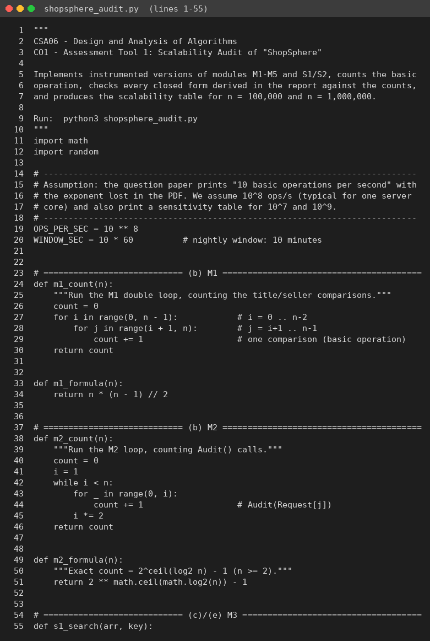
Source code, part 1
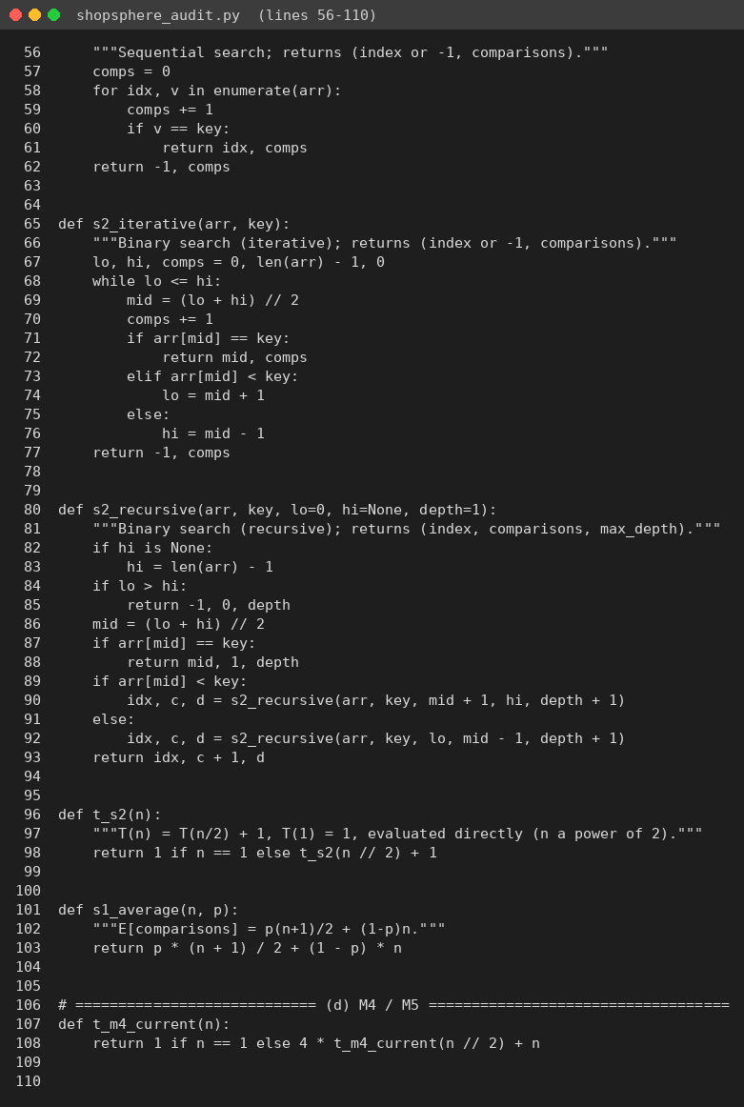
Source code, part 2
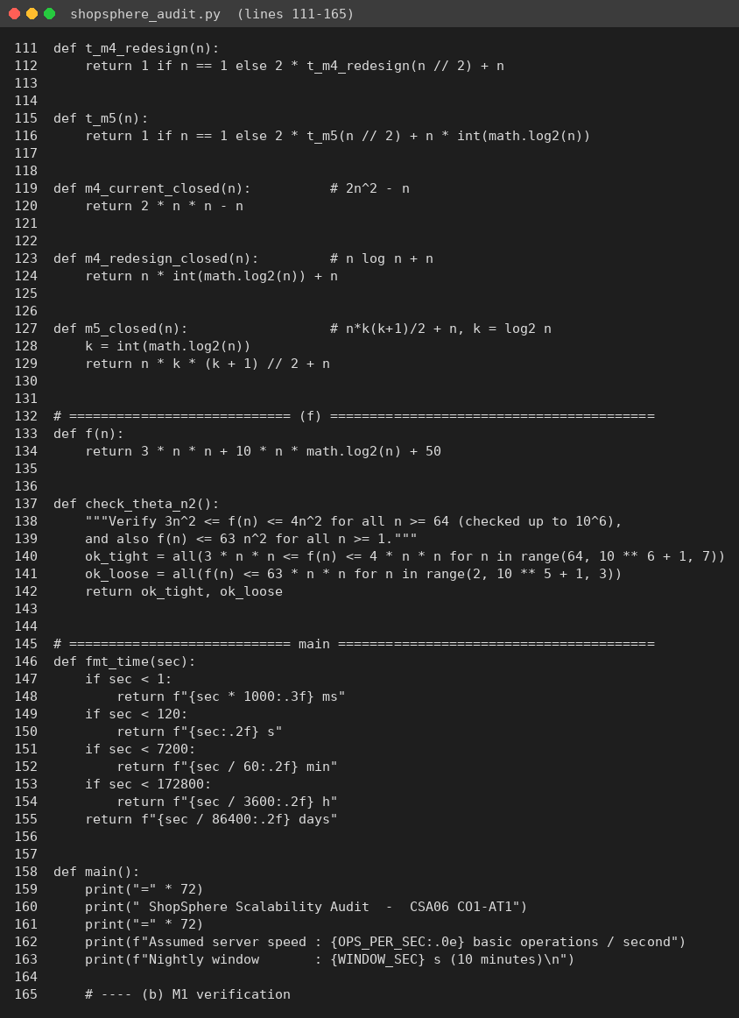
Source code, part 3
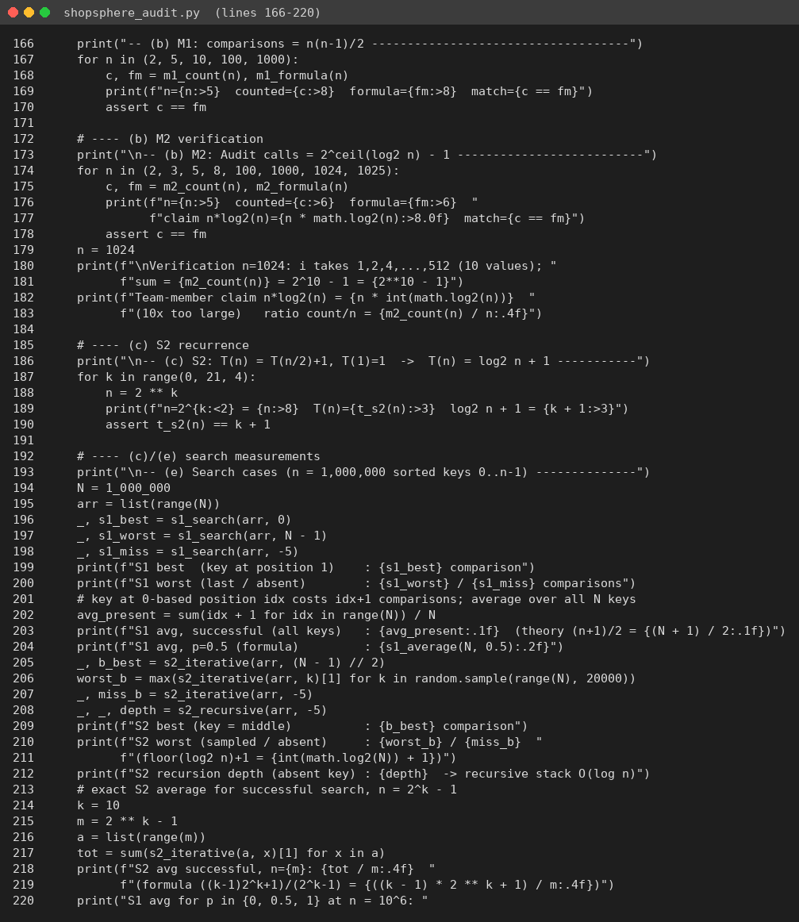
Source code, part 4
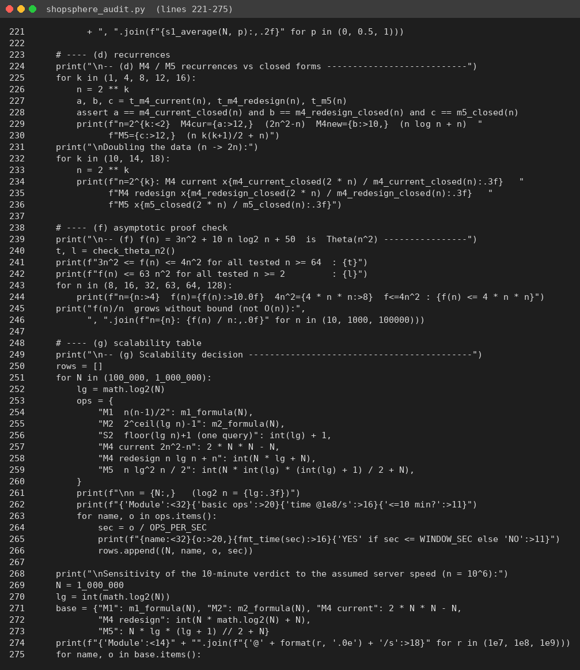
Source code, part 5
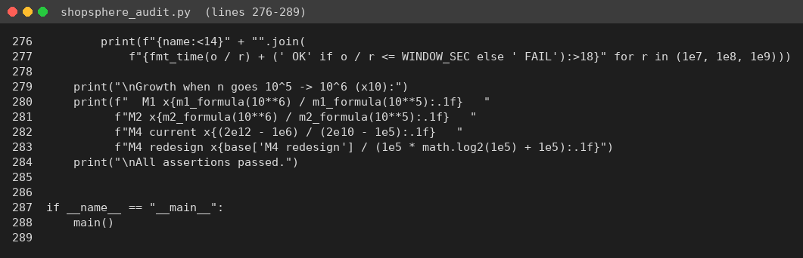
Source code, part 6

Program output
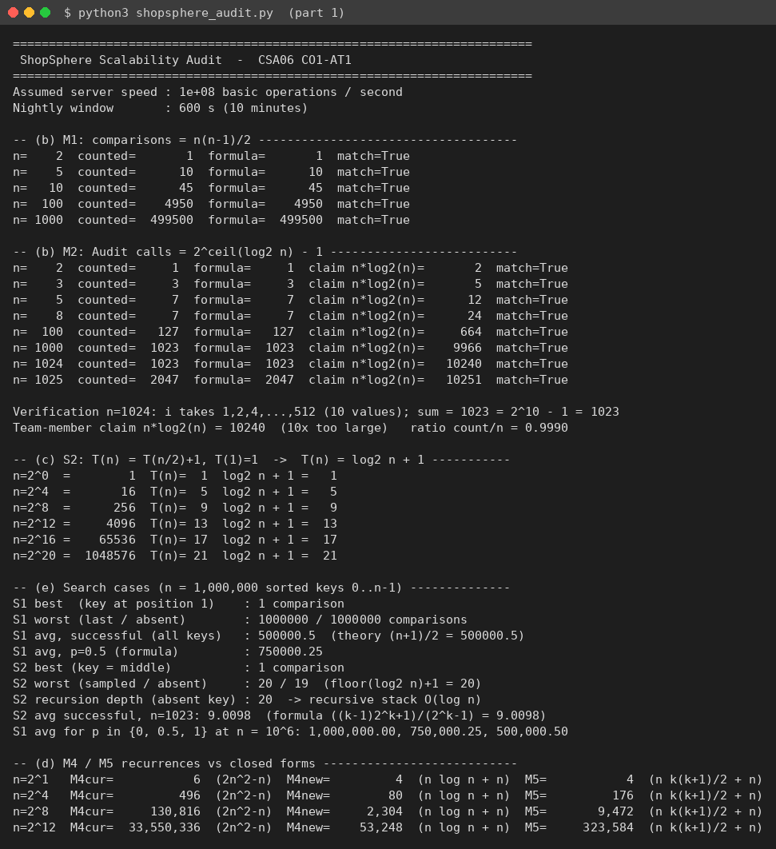
Output, part 1
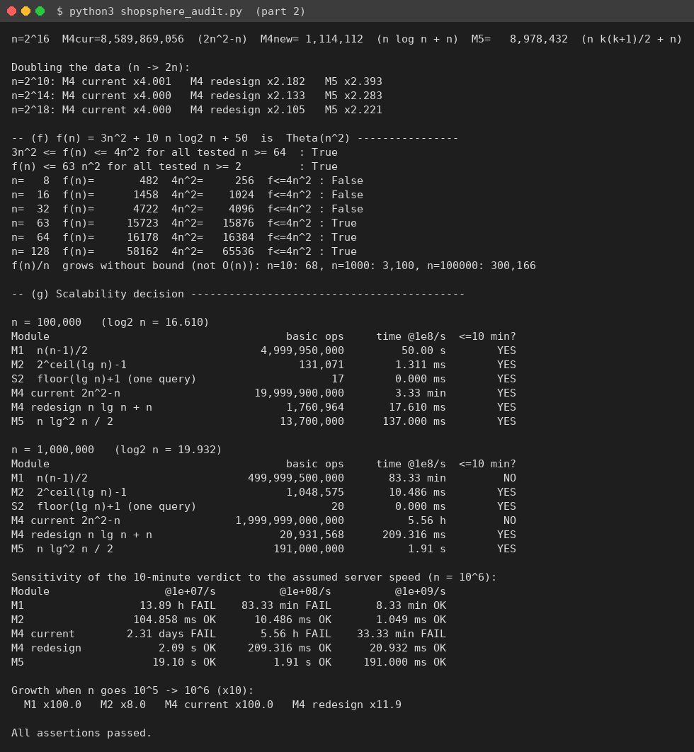
Output, part 2

