UNIT-1
EXPERIMENT-1:
AIM: To design and implement a C++ program that finds the roots of a quadratic equation ax^2+bx+c=0 using the quadratic formula and displays whether the roots are real and distinct, real and equal, or complex.
DESCRIPTION:
A quadratic equation is a second-degree polynomial equation in the form:
ax^2+bx+c=0, a≠0
The solutions (roots) of the equation can be found using the quadratic formula:
​​ x = (-b ± √ (b² - 4ac)) / (2a)
Where:
- a, b, c are coefficients of the equation.
- Δ=b^2−4ac is called the discriminant.
Cases:
- If Δ>0 → Roots are real and distinct.
- If Δ=0 → Roots are real and equal.
- If Δ<0 → Roots are complex and imaginary.
Algorithm:
- Start
- Input coefficients a, b, c.
- If a = 0, print “Not a quadratic equation” and stop.
- Calculate discriminant: Δ=b^2−4ac.
- If Δ > 0 (discriminant positive),
- Roots are real and distinct
- Calculate:
x₁ = (-b + √Δ) / (2a)
x₂ = (-b − √Δ) / (2a)
- Else if Δ = 0,
- Roots are real and equal
- Calculate:
x₁ = x₂ = -b / (2a)
- Else (Δ < 0),
- Roots are complex and imaginary
- Calculate:
Real Part = -b / (2a)
Imaginary Part = √(-Δ) / (2a)
- Display the roots based on the above case.
- End
PROGRAM:
// Find the roots of a quadratic equation (ax2 + bx + c)
// This code handles real and distinct, real and equal, and complex roots.

#include <iostream>
#include <cmath> // for sqrt() function
using namespace std;

int main()
{
float a, b, c;
cout << "Enter coefficients a, b and c: ";
cin >> a >> b >> c;

float discriminant = b*b - 4*a*c;
float root1, root2;

if (a == 0) {
cout << "This is not a quadratic equation (a cannot be 0)." << endl;
}
else if (discriminant > 0) {
// Real and distinct roots
root1 = (-b + sqrt(discriminant)) / (2*a);
root2 = (-b - sqrt(discriminant)) / (2*a);
cout << "Roots are real and distinct." << endl;
cout << "Root 1 = " << root1 << endl;
cout << "Root 2 = " << root2 << endl;
}
else if (discriminant == 0) {
// Real and equal roots
root1 = root2 = -b / (2*a);
cout << "Roots are real and equal." << endl;
cout << "Root = " << root1 << endl;
}
else {
// Complex roots
float realPart = -b / (2*a);
float imagPart = sqrt(-discriminant) / (2*a);
cout << "Roots are complex and imaginary." << endl;
cout << "Root 1 = " << realPart << " + " << imagPart << "i" << endl;
cout << "Root 2 = " << realPart << " - " << imagPart << "i" << endl;
}

return 0;
}
OUTPUT:

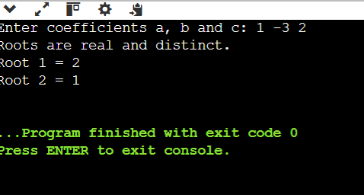
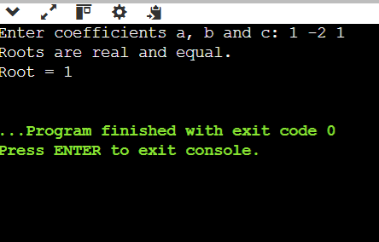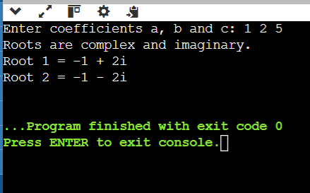

RESULT: The program correctly calculated and displayed the roots of a quadratic equation for all cases, verifying the correct implementation of the quadratic formula in C++.

EXPERIMENT-2:
AIM: To write a C++ program that calculates the factorial of a given positive integer using a recursive function.
DESCRIPTION:
This program prompts the user to enter a positive integer. It then calculates the factorial using a recursive function factorial(n), which calls itself with a decremented value until it reaches the base case (n = 0 or n = 1), returning 1.
If the user enters a negative number, the program displays an error message stating that factorial is not defined for negative numbers.
The program demonstrates the concept of recursion in C++
PROGRAM:
//Find factorial of a given number using recursion
#include <iostream>
using namespace std;

// Recursive function to calculate factorial
long factorial(int n)
{
if (n == 0 || n==1)
return 1;
else
return n * factorial(n - 1);
}
int main()
{
int number;
cout << "Enter a positive integer: ";
cin >> number;
if (number < 0)
{ cout << "Factorial is not defined for negative numbers." << endl;
}
else
{
long result = factorial(number);
cout << "Factorial of " << number << " = " << result << endl;
}
return 0;
}
OUTPUT:

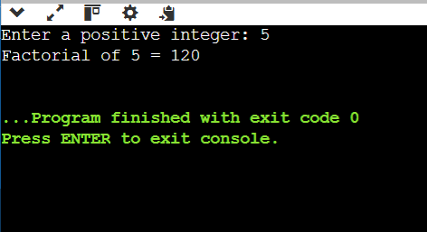
RESULT:
The program successfully calculates and displays the factorial of a positive integer using recursion and correctly handles invalid (negative) input.

EXPERIMENT-3:
AIM: To write a C++ program demonstrating the use of the scope resolution operator and namespaces.
DESCRIPTION:
The program declares a global variable x and a namespace MyNamespace containing an integer value and a function show().
Inside the main() function, a local variable x is declared which shadows the global x.
The program:
- Prints the local x.
- Accesses the global x using the scope resolution operator (::).
- Accesses the namespace variable and function using the namespace name and scope resolution operator.
This demonstrates variable scope, shadowing, and namespace usage in C++.
PROGRAM:
// Implement Scope Resolution Operation and namespace
#include <iostream>
using namespace std; // using standard namespace
int x = 100; // Global variable
namespace MyNamespace
{
int value = 50;
void show()
{ cout << "Inside MyNamespace, value = " << value << endl;
}
}
int main()
{ int x = 10; // Local variable
cout << "Local x = " << x << endl;
cout << "Global x = " << ::x << endl; // Using scope resolution to access global x
// Accessing namespace variable and function
cout << "Namespace value = " << MyNamespace::value << endl;
MyNamespace::show();
return 0;
}
OUTPUT:
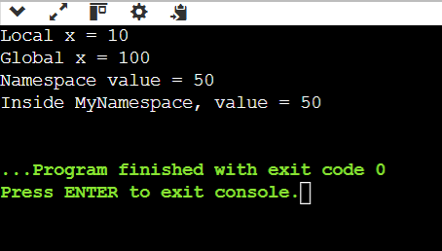
RESULT:
The program successfully displayed values of local and global variables, and accessed variables/functions from a namespace, verifying the correct use of scope resolution and namespace concepts.

EXPERIMENT-4:
AIM: To write a C++ program that demonstrates:
- The use of access specifiers (private, public, protected) and inheritance.
- The concept of default arguments in functions.
DESCRIPTION:
This combined program has two main parts:
- Access Specifiers Demonstration:
  - A class ClassA contains members with private, public, and protected access.
  - A derived class ClassB inherits from ClassA and accesses the public member pincode.
  - The program shows how private members cannot be accessed outside the class, public members can be accessed anywhere, and protected members are accessible only in derived classes.
- Default Arguments Demonstration:
  - A function greet() is defined with two parameters having default values: name = "Guest" and times = 1.
  - The function is called in three ways to demonstrate using both defaults, using one default, and using no defaults.
This program demonstrates object-oriented programming concepts and function overloading behavior using default arguments in C++.
PROGRAM:
#include <iostream>
using namespace std;
// ----------- Class Demonstrating Access Specifiers -----------
class ClassA
{
private:
int sno; // Private: Accessible only within ClassA
public:
int pincode; // Public: Accessible from anywhere
protected:
int mobno; // Protected: Accessible in derived classes
};
class ClassB : public ClassA
{
public:
void disp()
{
cout << "Pincode: " << pincode << endl; // Accessing public member
}
};
// ----------- Function with Default Arguments -----------
void greet(string name = "Guest", int times = 1)
{
for (int i = 0; i < times; i++) {
cout << "Hello, " << name << "!" << endl;
}
}
// ---------------- Main Function ----------------
int main()
{
// Demonstrating Access Specifiers
ClassA ob;
ob.pincode = 123; // Public member access
cout << "Accessing public member directly: " << ob.pincode << endl;

ClassB obb;
obb.pincode = 456;
obb.disp(); // Accessing public member via derived class

cout << endl;
// Demonstrating Default Arguments
greet(); // Uses both default arguments
greet("Anil"); // Uses default for 'times'
greet("Ravi", 3); // No default used

return 0;
}
OUTPUT:
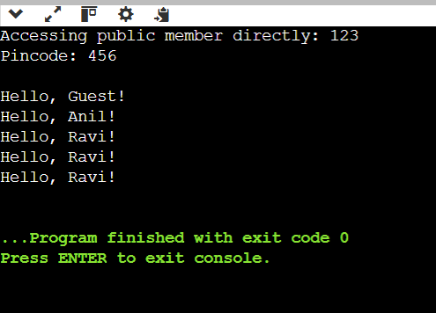

RESULT:
The program successfully displayed:
The behaviour of access specifiers and how they control variable accessibility in C++ classes.
The working of default arguments in functions by producing different outputs based on how the function was called.

