UNIT-2
EXPERIMENT-1
Aim: Program to illustrate inline functions and function overloading
Description :
In C++, an inline function is a function whose definition is expanded at the point of call, avoiding the overhead of a regular function call. This can improve performance for small, frequently used functions. Inline functions are declared using the inline keyword, but the compiler may choose to ignore the request in some cases.
Function overloading allows multiple functions to have the same name but different parameter lists (different number or type of arguments). The compiler distinguishes them based on the arguments provided during the function call. This improves code readability and reusability by using a single function name for related operations.
Algorithm:
Define one or more small functions as inline to execute faster without regular function call overhead. Then, create multiple functions with the same name but different parameter lists to demonstrate function overloading. Call these functions with various argument types or counts to show how the compiler chooses the correct version based on the function signature. This illustrates both the performance benefit of inline functions and the flexibility of function overloading.
Program:
#include<iostream>
using namespace std;

class Demo
{
public:
inline int square(int x)
{
return x * x;
}

inline float square(float x)
{
return x * x;
}
void add()
{
cout << "\nI am in add() - No Arguments";
}

void add(int a, int b)
{
cout << "\nI am in add(int, int) - The sum = " << a + b;
}

void add(float a, float b)
{
cout << "\nI am in add(float, float) - The sum = " << a + b;
}

void add(int a, float b)
{
cout << "\nI am in add(int, float) - The sum = " << a + b;
}
};

int main()
{
Demo obj;
cout << "Square of 5 (int) is: " << obj.square(5) << endl;
cout << "Square of 4.5 (float) is: " << obj.square(4.5f) << endl;
obj.add();
obj.add(10, 20);
obj.add(10.5f, 10.5f);
obj.add(10, 10.5f);

return 0;
}
Output:
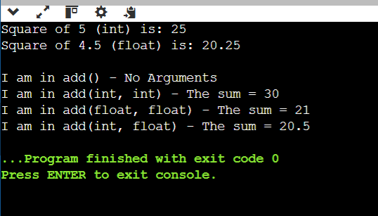

EXPERIMENT-2
Aim: Program to illustrate friend function
Description :

A friend function in C++ is a non-member function that can access the private and protected members of a class.
It is declared inside the class with the keyword friend and defined outside like a normal function.
Used when an external function needs direct access to class data.

Algorithm :

A friend function is declared inside a class with the friend keyword, which allows it to access the class’s private and protected members even though it is not a member of the class. The compiler grants special access rights to this function. The friend function is defined outside the class like a normal function but can directly use the class’s private data through an object of that class.

Procedure :

#include<iostream>
using namespace std;
class Demo{
private:
int x,y;
void fun1(){
cout<<"I am inside member function (fun1()) in the class"<<endl;
}
friend void add(Demo d);
};
void add(Demo d){
d.x=10;
d.y=20;
cout<<"sum ="<<d.x+d.y<<endl;
}
int main(){
Demo ob;
add(ob);
return 0;
}
Output :
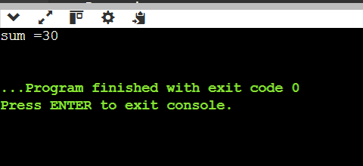

EXPERIMENT-3
Aim: Program to illustrate the use of Constructors and Destructors.
Description :

In C++, a constructor is a special member function that is automatically called when an object is created, used to initialize data members.
A destructor is a special member function that is automatically called when an object is destroyed, used to release resources or perform cleanup tasks.
- Constructor has the same name as the class and no return type.
- Destructor has the same name as the class preceded by a ~ (tilde) and no parameters.

Algorithm / Procedure:
When an object is created, the constructor is invoked automatically to initialize data members.
When the object goes out of scope or is explicitly deleted, the destructor is automatically invoked to free resources or perform cleanup.
The constructor typically sets initial values, and the destructor handles tasks like closing files, releasing memory, or printing a message before destruction.

Program :

#include <iostream>
using namespace std;
class Demo
{
public:
// Constructor
Demo() {
cout << "Constructor called: Object is created." << endl;
}
~Demo() {
cout << "Destructor called: Object is destroyed." << endl;
}
void display() {
cout << "Inside display function." << endl;
}
};
int main() {
{
Demo obj;
obj.display();
}
cout << "Back in main function." << endl;
return 0;
}
Output:

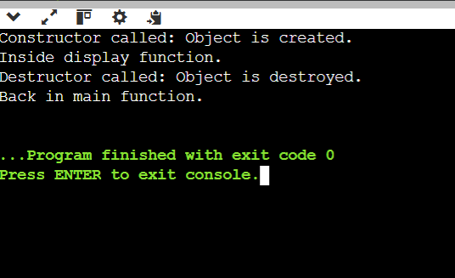
EXPERIMENT-4

Aim: Program illustrating Constructor overloading.

Description :
Constructor overloading in C++ means having multiple constructors in the same class with different parameter lists.
This allows objects to be initialized in different ways, depending on the number or type of arguments provided at the time of object creation.
The compiler determines which constructor to call based on the arguments passed.
Algorithm :
When an object is created, the compiler matches the arguments in the object’s declaration with the available constructors in the class.
The constructor with a matching parameter list is invoked to initialize the object’s data members.
This enables flexibility, as the same class can be initialized with no parameters, a single parameter, or multiple parameters.
Program :
#include<iostream>
using namespace std;
class Demo
{
public:
Demo()
{
cout<<"I am in Default Constructor";
}
Demo(int x)
{
cout<<"\nI am in One arg constructor"<<x;
}
Demo(char str[12])
{
cout<<"\nI am in one arg string constructor"<<str;
}
~Demo()
{
cout<<"\nI am in DESTRUCTOR";
}
};
int main()
{
Demo ob;
Demo ob1(10);
Demo ob2("CPP Demo Code");
}
Output :
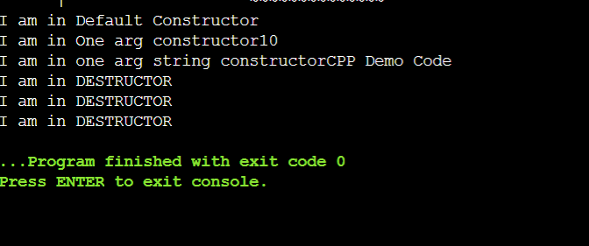

EXPERIMENT-5

Aim: Program illustrating Copy Constructor.
Description :
A copy constructor in C++ is a special constructor used to create a new object as a copy of an existing object.
It takes a reference to an object of the same class as its parameter.
If not defined explicitly, the compiler provides a default copy constructor that performs a shallow copy.
A user-defined copy constructor is used when deep copying or custom initialization is required.
Algorithm :
When a new object is initialized from an existing object of the same class, the copy constructor is called.
It receives a reference to the existing object and copies its data members to the new object.
This ensures the new object has the same values as the original one.
Program :
#include<iostream>
using namespace std;
class Student
{ int id;
public: Student(int i)
{ id = i;
cout << "\n\n\nConstructor called\n";
}
Student(Student &s)
{ id = s.id;
cout << "\n\n\n\nCopy constructor called\n";
}
void display()
{ cout << "ID: " << id << endl;
}
};
int main() {
Student s1(500);
Student s2 = s1;
s1.display();
s2.display();
return 0;
}
Output:
